Q1) 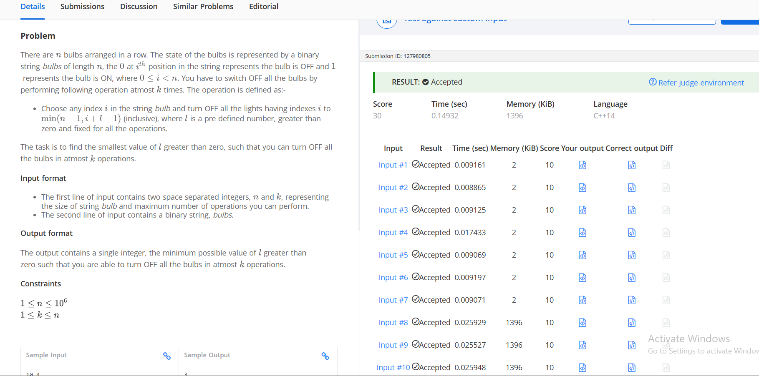

#include <iostream>
#include <string>
#include <vector>
#include <algorithm>

using namespace std;

(int n, int k, const string& bulbs, int L) {
int operations = 0;
for (int i = 0; i < n; ) {
if (bulbs[i] == '1') {
operations++;
i += L;
i++;
}
}
return operations <= k;
}

int main() {
int n, k;
if (!(cin >> n >> k)) return 0;
string bulbs;
cin >> bulbs;

int low = 1, high = n;
int ans = n;

while (low <= high) {
int mid = low + (high - low) / 2;
if (canPerform(n, k, bulbs, mid)) {
ans = mid;
high = mid - 1;
} else {
low = mid + 1;
}
}

cout << ans << endl;

return 0;
}

Q2) 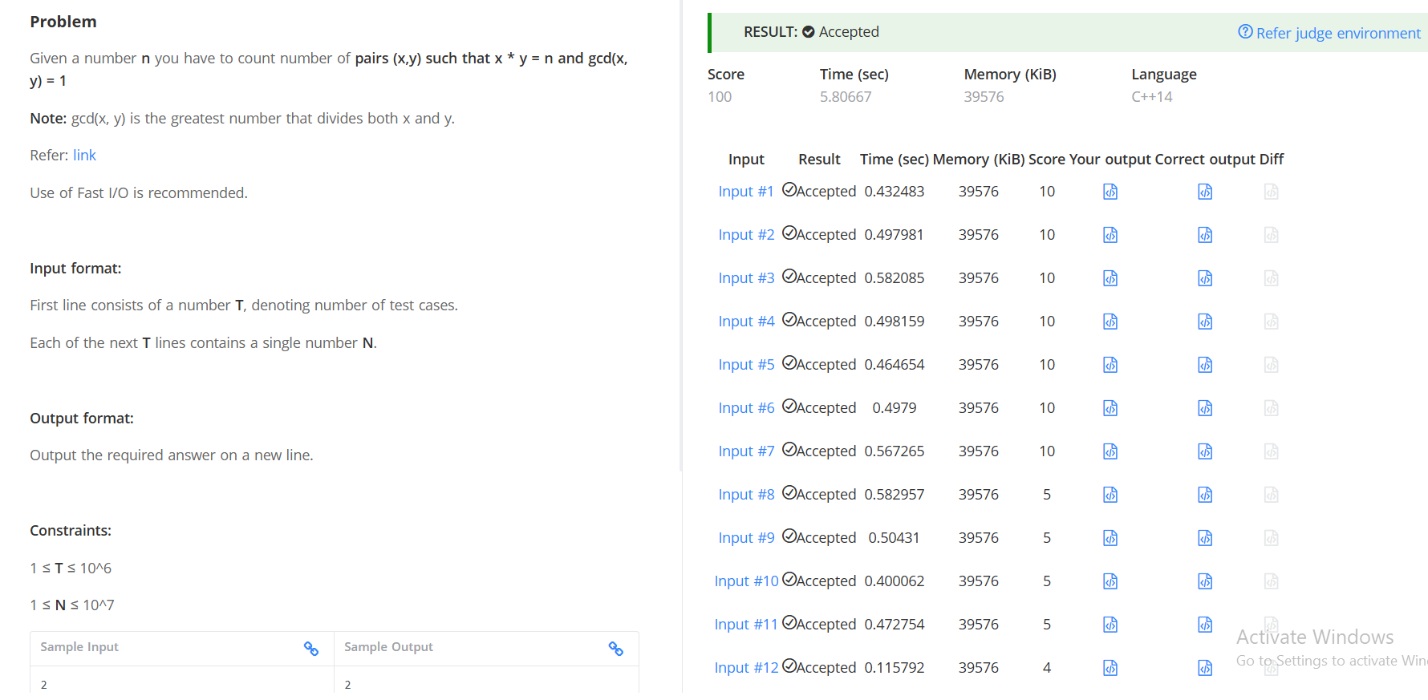
#include <iostream>
#include <vector>
using namespace std;

const int MAXN = 10000000;

vector<int> spf(MAXN + 1);

void sieve() {
for (int i = 0; i <= MAXN; i++)
spf[i] = i;

for (long long i = 2; i * i <= MAXN; i++) {
if (spf[i] == i) {
for (long long j = i * i; j <= MAXN; j += i) {
if (spf[j] == j)
spf[j] = i;
}
}
}
}

int main() {
ios::sync_with_stdio(false);
cin.tie(nullptr);

sieve();

int T;
cin >> T;

while (T--) {
int n;
cin >> n;

int distinctPrime = 0;

while (n > 1) {
int p = spf[n];
distinctPrime++;

while (n % p == 0)
n /= p;
}

cout << (1 << distinctPrime) << '\n';
}

return 0;
}

