Course Name: | Web Development Laboratory | Semester: | III
Date of Performance: | __29_ / _07__ / _2026_____ | DIV/ Batch No: | B2
Student Name: | SAANVI KULKARNI | Roll No: | 16010125118
Experiment No: 1

Title
Design and Development of an AI-based Smart Irrigation Advisory Web Portal Front-End using HTML5

Aim of the Experiment

To design and develop a multi-page, use-case-based web portal front-end using HTML5 for an AI-based Smart Irrigation Advisory System for Sugarcane Crop (KJS-AGR-01), demonstrating proper HTML5 document structure, semantic elements, formatting, lists, hyperlinks, images, image maps, tables, forms, and multimedia elements.

Objectives of the Experiment
- To develop structured and semantic HTML5 web pages for an AI-enabled smart irrigation advisory system.
- To create interactive web pages for farmer registration, irrigation recommendations, weather information, crop monitoring, and advisory services.
- To apply a real-world AI and IoT-based agriculture use case (Smart Irrigation Advisory System) as the context for front-end web development.
- To build a complete HTML5 front-end portal that can later be enhanced using CSS3, JavaScript, PHP, and React.

COs to be achieved
CO1: Developing webpages using HTML and CSS.

Books / Journals / Websites references
- (Students should write — e.g., MDN Web Docs HTML5 reference, W3C.)

Theory

HTML5 is the latest version of HyperText Markup Language used to create structured and interactive web pages. It introduces semantic elements such as <header>, <nav>, <main>, <section>, <article>, and <footer>, making web pages more organized, accessible, and search-engine friendly.

HTML5 also provides support for multimedia elements like <audio> and <video>, interactive forms, tables, hyperlinks, image maps, and embedded content through <iframe>. These features help developers create user-friendly web applications for various domains such as healthcare, education, business, and agriculture.

In this experiment, HTML5 is used to design the front-end of an AI-based Smart Irrigation Advisory System. The portal enables farmers to register their farms, view irrigation schedules, monitor weather conditions, access crop information, receive AI-generated irrigation recommendations, and visualize farm locations. The application serves farmers, agricultural officers, researchers, and sugar factory management by providing organized and easy-to-understand agricultural information.

Problem Statement

"AI-based Smart Irrigation Advisory Web Portal"
An agricultural organization wants to develop a basic HTML5-based web portal front-end for an AI-based Smart Irrigation Advisory System. The portal should display farm information, soil moisture status, weather forecasts, irrigation recommendations, crop information, and advisory services for farmers, agricultural officers, researchers, and sugar factory management.
Each task below contributes one page or feature of this portal, representing different modules of the Smart Irrigation Advisory System.

Task 1: Home Page – HTML5 Document Structure & Global Attributes

Use Case

Design the Home Page of the Smart Irrigation Advisory Portal.

Requirements

Use proper HTML5 document structure.

Display the system name "Smart Irrigation Advisory System".

Display organization name and agriculture logo text.

Show the current crop season and year.

Apply global attributes such as id, class, title, and style.

Add a tooltip explaining the purpose of the system.

Deliverable: index.html

Skills Tested: HTML document structure, global attributes.

Task 2: Irrigation Advisory Page – Formatting & Text-Level Tags

Use Case

Create a page describing the AI-based Irrigation Advisory System.

Requirements

Highlight important irrigation recommendations using <strong> and <mark>.

Use <em> to emphasize water conservation practices.

Use <small> for advisory notes and disclaimers.

Use <sup> and <sub> for units such as m³, cm³, H₂O, and temperature values.

Use <abbr> for agricultural abbreviations such as AI, IoT, GIS, GPS, and ET.

Deliverable: irrigation-advisory.html

Skills Tested: Formatting and text-level HTML tags.

Task 3: About System Page – Block & Inline Formatting

Use Case

Design an About the Smart Irrigation Advisory System page.

Requirements

Create separate <div> sections for:

Objectives

System Features

Benefits

Use <blockquote> to display a message from an Agricultural Expert.

Apply inline formatting within paragraphs.

Use different background colours for different sections.

Deliverable: about-system.html

Skills Tested: Block-level and inline elements.

Task 4: Farm Information & Sensors Page – Lists & Nested Lists

Use Case

Display agricultural resources and stakeholder information.

Requirements

Create an ordered list showing the irrigation advisory workflow.

Create an unordered list of data sources:

Soil Moisture Sensors

Weather Forecast

Satellite Images

Crop Information

Soil Reports

IoT Devices

Create nested lists showing stakeholders and their responsibilities:

Farmer

Agricultural Officer

Researcher

Sugar Factory Management

Create a description list explaining abbreviations such as AI, IoT, GIS, GPS, and ET.

Deliverable: farm-information.html

Skills Tested: Lists and nested lists.

Task 5: Navigation Page – Hyperlinks

Use Case

Create the navigation menu for the Smart Irrigation Advisory Portal.

Requirements

Link all internal web pages.

Add an external link to the KIAAR or Agricultural Department website.

Create an email link for agricultural support.

Add a telephone link for farmer helpline services.

Deliverable: navigation.html

Skills Tested: Hyperlinks.

Task 6: Farm Location Page – Images & Image Maps

Use Case

Provide an interactive map of agricultural fields.

Requirements

Display a farm or geofenced plot map image.

Create an image map with clickable farm regions.

Each region should open a page displaying crop details or irrigation information.

Add alternate text for accessibility.

Deliverable: farm-map.html

Skills Tested: Images and image maps.

Task 7: Irrigation Recommendation Page – Tables

Use Case

Display plot-wise irrigation recommendations.

Requirements

Create a table showing:

Plot ID

Farmer Name

Crop Stage

Soil Moisture (%)

Recommended Irrigation Date

Irrigation Duration

Weather Forecast

Recommendation Status

Use:

<caption>

<thead>

<tbody>

<tfoot>

rowspan

colspan

Deliverable: recommendation.html

Skills Tested: Tables.

Task 8: Farmer Registration Form – Forms

Use Case

Create an online farmer registration page.

Requirements

Include fields for:

Farmer Name

Mobile Number

Email Address

Village

Plot ID

Crop Variety

Farm Area

Irrigation Method (Dropdown)

Preferred Language (Radio Buttons)

Advisory Services Required (Checkboxes)

Submit and Reset buttons

Deliverable: farmer-registration.html

Skills Tested: HTML Forms.

Task 9: Media & Awareness Page – Multimedia

Use Case

Create an Agriculture Awareness page.

Requirements

Embed an irrigation awareness video using <video>.

Add an audio advisory on water conservation using <audio>.

Embed the farm location or Google Map using <iframe>.

Display a <noscript> message for users with JavaScript disabled.

Deliverable: media.html

Skills Tested: Multimedia, frames, and executable content.
Code :
Task 9:
<!DOCTYPE html>
<html>
<!-- #8FBC8F -->
<body>
<style>
.topbar {
height: 50px;
width: 100%;
background-color: #8FBC8F;
}

.spacer {
height: 30px;
}

.video-section,
.audio-section {
text-align: center;
margin: 30px 0;
}
</style>

<div class="topbar"></div>

<p style="font-family:impact; font-size: 390%;text-align:center; color: #006A4E "> <u> MULTIMEDIA PAGE FOR IRRIGATION AWARENESS </u> </p>

<div>
<p style= "font-family:verdana; font-size: 100%;text-align:center; color: black; ">
Check out the farm location link here 👇 <br> (Click to open the location in Google Maps.)
<br> <br>
<iframe src="https://www.google.com/maps/embed?pb=!1m18!1m12!1m3!1d3749.4671364118935!2d73.57828429999999!3d19.988899699999997!2m3!1f0!2f0!3f0!3m2!1i1024!2i768!4f13.1!3m3!1m2!1s0x3bddf3c6130185e3%3A0x4d6d3b09838b7ab0!2sSaukhya%20Farm!5e0!3m2!1sen!2sin!4v1784721679249!5m2!1sen!2sin"
width="400" height="250"
style="border:0;" allowfullscreen="" loading="lazy"
referrerpolicy="strict-origin-when-cross-origin"></iframe></p>
</p>
</div>
<p style="text-align:center"><br>🍀🍀🍀🍀🍀🍀🍀</p>
<div class="spacer"></div>

<hr>
<div>
<div class="video-section">
<p style="text-align:center;font-family:verdana; font-size: 100%;"><br> Check out the irrigation awareness video here: <br>
<video width="520" height="440" controls>
<source src="video irrigation.mp4" type="video/mp4">
</video>
</p>
<p style="text-align:center"><br>🍀🍀🍀🍀🍀🍀🍀</p>
<hr>
</div>

<div>
<p>
<noscript>
<p>Warning: JavaScript is disabled! Please enable it for full functionality.
</noscript></p>
<br>
</div>

<div class="audio-section">
<p style="text-align:center;font-family:verdana; font-size: 100%;"> Check out audio advisory for Water conservation in Agricultural Irrigation:
<br>
<br> (Click on the play button to listen to the advisory)
<br><br>
<audio controls>
<source src="agriculture_advisory.wav" type="audio/wav">
Your browser does not support the audio element.
</audio></div>
</p>
<br><br>
<p style="text-align: center; font-family:times new roman;color:gray"> Made by Saanvi</p>
<div class="topbar"></div>
</body>
</html>
Task 7:
<!DOCTYPE html>
<html>
<!-- #8FBC8F -->
<body style="background-color: white ;"> <!--#D0F0C0-->
<style>
.topbar {
height: 50px;
width: 100%;
background-color: #8FBC8F;
}

.spacer {
height: 30px;
}

</style>

<div class="topbar"></div>

<p style="font-family:impact; font-size: 390%;text-align:center; color: #006A4E "> <u> IRRIGATION RECOMMENDATION PAGE </u> </p>

<div>
<p style= "font-family:verdana; font-size: 100%;text-align:center; color: black; ">
Here some of recommendations for irrigation have been displayed in the table
according to the plot size, soil moisture and many other factors:
</p>
</div>

<table border="1" cellpadding="8" cellspacing="0" style="border-collapse:collapse; width:100%; text-align:center; border:2px solid black;">

<caption>
<h3>Irrigation Recommendations</h3>
</caption>
<thead>
<tr style="background-color:#8FBC8F;">
<th rowspan="2">Plot ID</th>
<th rowspan="2">Farmer Name</th>
<th rowspan="2">Crop Stage</th>
<th rowspan="2">Soil Moisture (%)</th>
<th colspan="2">Irrigation Schedule</th>
<th rowspan="2">Weather Forecast</th>
<th rowspan="2">Recommendation Status</th>
</tr>

<tr style="background-color:#8FBC8F;">
<th>Date</th>
<th>Duration</th>
</tr>
</thead>

<tbody>

<tr>
<td>P001</td>
<td>Ramesh Patil</td>
<td>Germination</td>
<td>24%</td>
<td>26-Jul-2026</td>
<td>60 min</td>
<td>Sunny</td>
<td>Irrigation Required</td>
</tr>

<tr>
<td>P002</td>
<td>Suresh Shinde</td>
<td>Vegetative</td>
<td>42%</td>
<td>28-Jul-2026</td>
<td>40 min</td>
<td>Partly Cloudy</td>
<td>Scheduled</td>
</tr>

<tr>
<td>P003</td>
<td>Shubha Kulkarni</td>
<td>Tillering</td>
<td>56%</td>
<td>30-Jul-2026</td>
<td>25 min</td>
<td>Light Rain</td>
<td>Delay Irrigation</td>
</tr>

<tr>
<td>P004</td>
<td>Mahesh Jadhav</td>
<td>Flowering</td>
<td>31%</td>
<td>26-Jul-2026</td>
<td>50 min</td>
<td>Sunny</td>
<td>Irrigation Required</td>
</tr>

<tr>
<td>P005</td>
<td>Priya Deshmukh</td>
<td>Maturity</td>
<td>71%</td>
<td>02-Aug-2026</td>
<td>No Irrigation</td>
<td>Heavy Rain</td>
<td>Not Required</td>
</tr>

<tr>
<td>P006</td>
<td>Sunil Pawar</td>
<td>Vegetative</td>
<td>38%</td>
<td>27-Jul-2026</td>
<td>45 min</td>
<td>Cloudy</td>
<td>Scheduled</td>
</tr>

<tr>
<td>P007</td>
<td>Kavita More</td>
<td>Flowering</td>
<td>29%</td>
<td>26-Jul-2026</td>
<td>55 min</td>
<td>Sunny</td>
<td>Urgent Irrigation</td>
</tr>

<tr>
<td>P008</td>
<td>Rahul Chavan</td>
<td>Ripening</td>
<td>67%</td>
<td>31-Jul-2026</td>
<td>15 min</td>
<td>Light Rain</td>
<td>Monitor Only</td>
</tr>

<tr>
<td>P009</td>
<td>Meena Joshi</td>
<td>Germination</td>
<td>21%</td>
<td>26-Jul-2026</td>
<td>70 min</td>
<td>Hot & Dry</td>
<td>Immediate Irrigation</td>
</tr>

<tr>
<td>P010</td>
<td>Vijay Gaikwad</td>
<td>Vegetative</td>
<td>49%</td>
<td>29-Jul-2026</td>
<td>35 min</td>
<td>Partly Cloudy</td>
<td>Scheduled</td>
</tr>

</tbody>

<tfoot>
<tr style="background-color:#8FBC8F;">
<td colspan="8">
Total Records: 10 | Recommendations made by eKISAN Irrigation Advisory System
</td>
</tr>
</tfoot>

</table>

<p style= "text-align: center; font-family:times new roman;color:gray"> -- Made by Saanvi --</p>
</body>
</html>
Task 2:
<!DOCTYPE html>
<html>
<body>
<style>
.topbar {
height: 50px;
width: 100%;
background-color: #8FBC8F;
}

.spacer {
height: 30px;
}

</style>
<div style="height: 50px; width: 100%; background-color: #8FBC8F;"></div>
<h1 style="font-family:impact; font-size: 390%;text-align:center; color: #006A4E "> <u> IRRIGATION ADVISORY PAGE </u> </h1>
<div class="spacer"></div>
<div>

<h3 style="font-family: arial; font-size: 200%;text-align:left; color: black "> IMPORTANT IRRIGATION RECOMMENDATIONS: </h3>

<p style= "font-family:verdana; font-size: 150%;text-align:left; color: black; ">
<u>Evapotranspiration (ET) & Moisture-Based Scheduling</u><br>
<ul style="font-family:verdana; font-size: 100%; text-align:left; color: black;">
<li>Calculate Net Water Requirement: Match irrigation volume to crop water loss (ET<sub>c</sub>).
<small> (Apply only the difference between plant water use and effective rainfall.)</small></li>
<li>Maintain the 50% Depletion Limit: Do not allow Management Allowed Depletion (MAD) to exceed 50% of available water
capacity in the root zone before applying the next irrigation cycle.</li>
<li>Monitor Soil Tension: </li>
</ul>
<br>
<ol>
<li> Coarse/Sandy Soil: Irrigate when soil water tension reaches 20–30 kPa.</li>
<li>Medium/Loam Soil: Irrigate when soil water tension reaches 40–50 kPa.</li>
<li>Heavy/Clay Soil: Irrigate when soil water tension reaches 50–70 kPa.</li>
</ol>
</p>
</div>

<div>
<h3 style="font-family:verdana; font-size: 200%;text-align:left; color: black; "><u>WATER CONSERVATION PRACTICES</u></h3>
<p style="font-family:verdana; font-size: 100%;text-align:left; color: black; ">
Smart irrigation methods save water by delivering it precisely when and where crops need it most.
Drip irrigation systems apply water directly to plant roots drop by drop, which drastically reduces evaporation and
wind drift. Implementing high-efficiency Drip Irrigation (DI) systems allows an individual emitter to release just 2,000 cm<sup>3</sup>
to 4,000 cm<sup>3</sup> of water per hour directly to the plant base.
This targeted micro-application cuts farm water waste by 30% to 50% compared to traditional flood methods.
Farmers combine this with <em> data-driven irrigation scheduling and soil moisture sensors to ensure fields are
watered only when actual soil deficits exist, preventing overwatering</em>.Soil and land management practices focus on trapping
moisture directly within the earth. Applying organic mulch, such as straw or wood chips, shields the topsoil from solar
radiation and slows down surface evaporation. Additionally, practicing <em>no-till farming</em> and planting cover crops builds
organic matter, improves soil structure, and significantly increases the land's natural water-holding capacity.
</p>
</div>

<div>
<h3 style="font-family:verdana; font-size: 200%;text-align:left; color: black; "><u>SOME FARMING TERMINOLOGIES:</u></h3>
<p style="font-family:verdana; font-size: 100%;text-align:left; color: black; ">
<small><em>HOVER ON WORDS TO SEE FULL FORMS</em></small><br>
<ul style="font-family:verdana; font-size: 100%; text-align:left; color: black;">
<li><abbr title="GOOD AGRICUTURAL PRACTICES"> GAP </abbr> </li>
<li><abbr title="High Yielding Varieties">HYV</abbr></li>
<li><abbr title="Integrated Nutrient Management">INM</abbr></li>
</ul>

</p>
</div>
<div style="height: 50px; width: 100%; background-color: #8FBC8F;"></div>
</body>
</html>

Output / Screenshot:
Task 9:
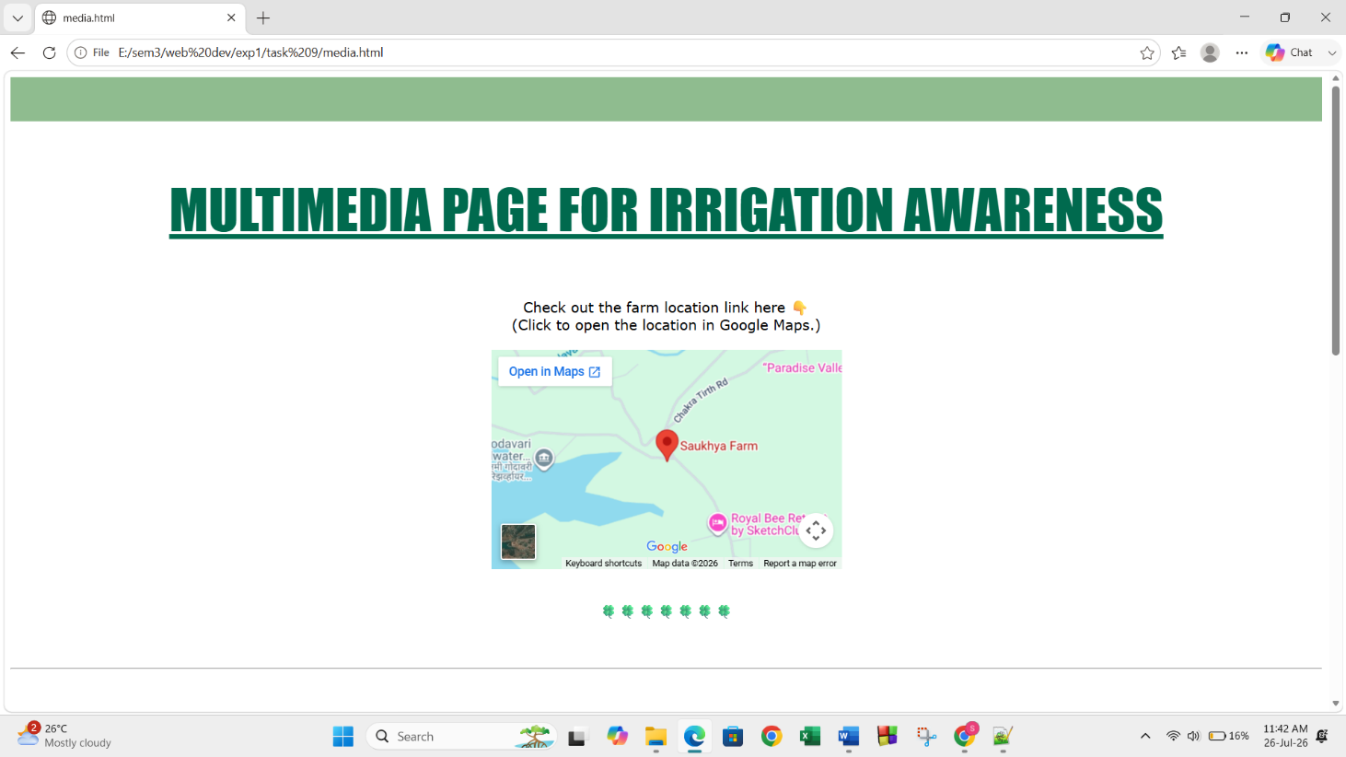
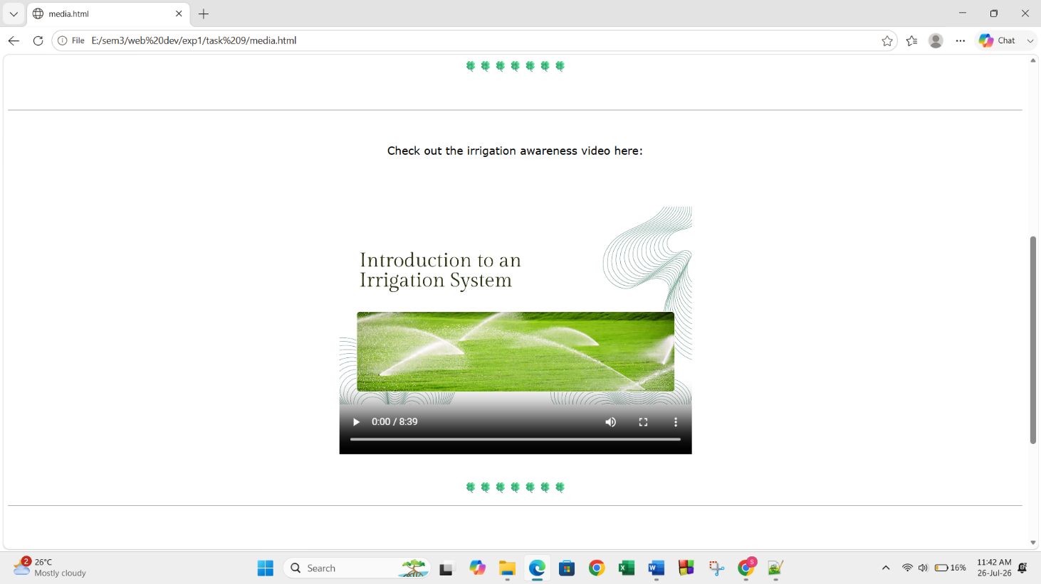

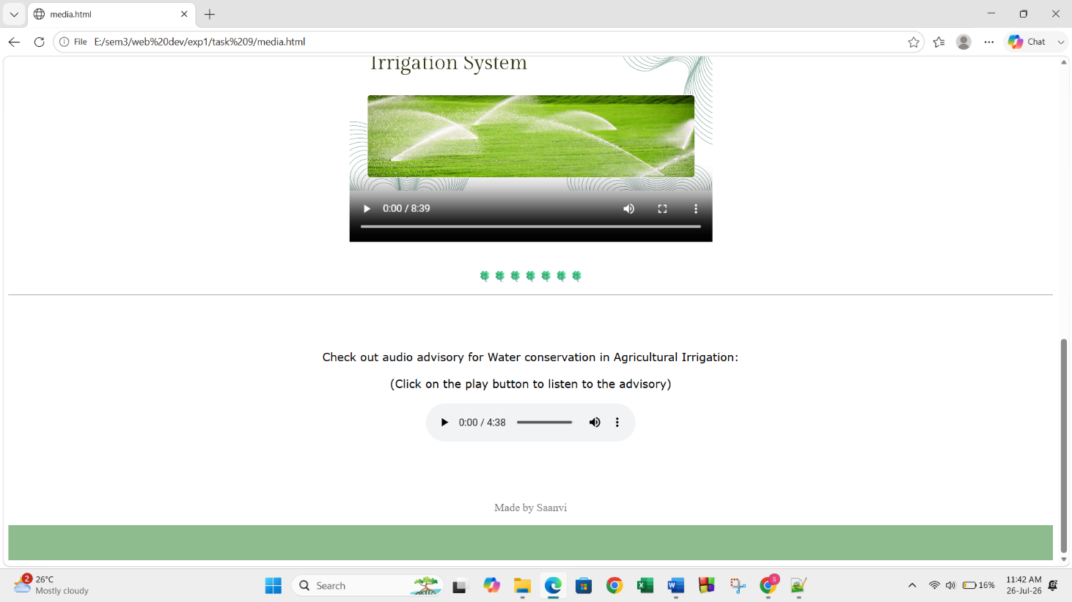

Task 7:
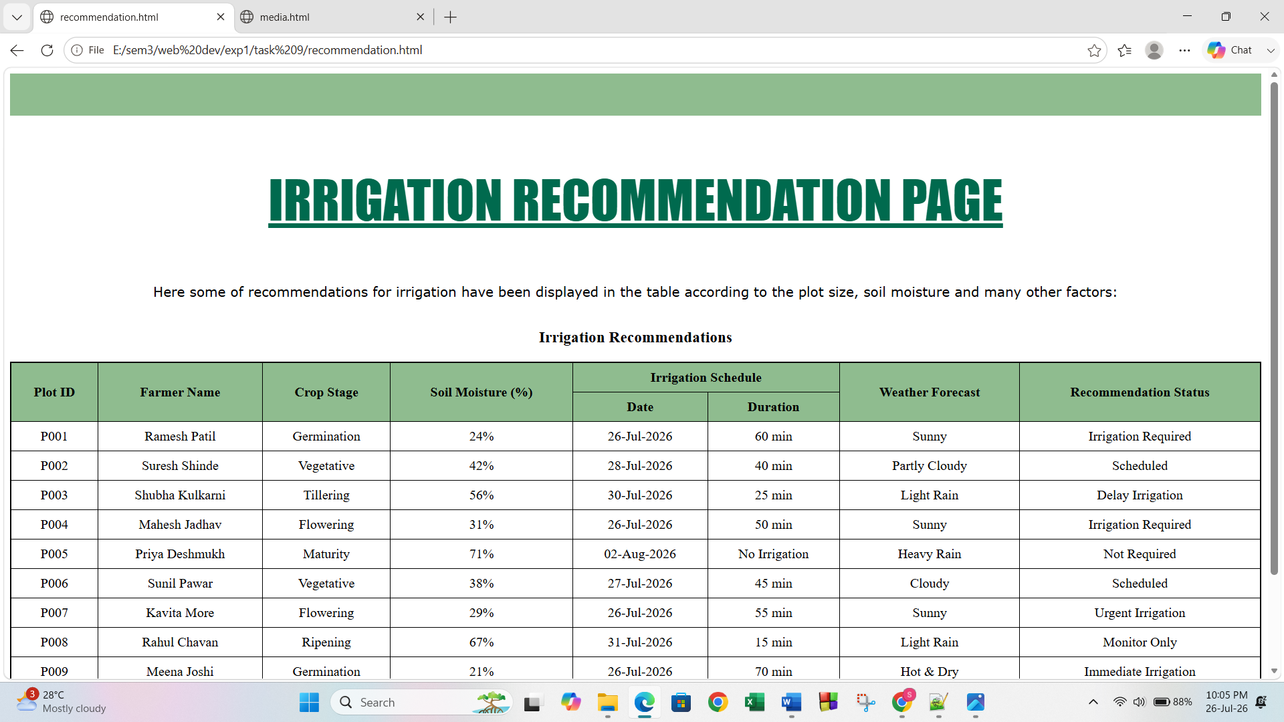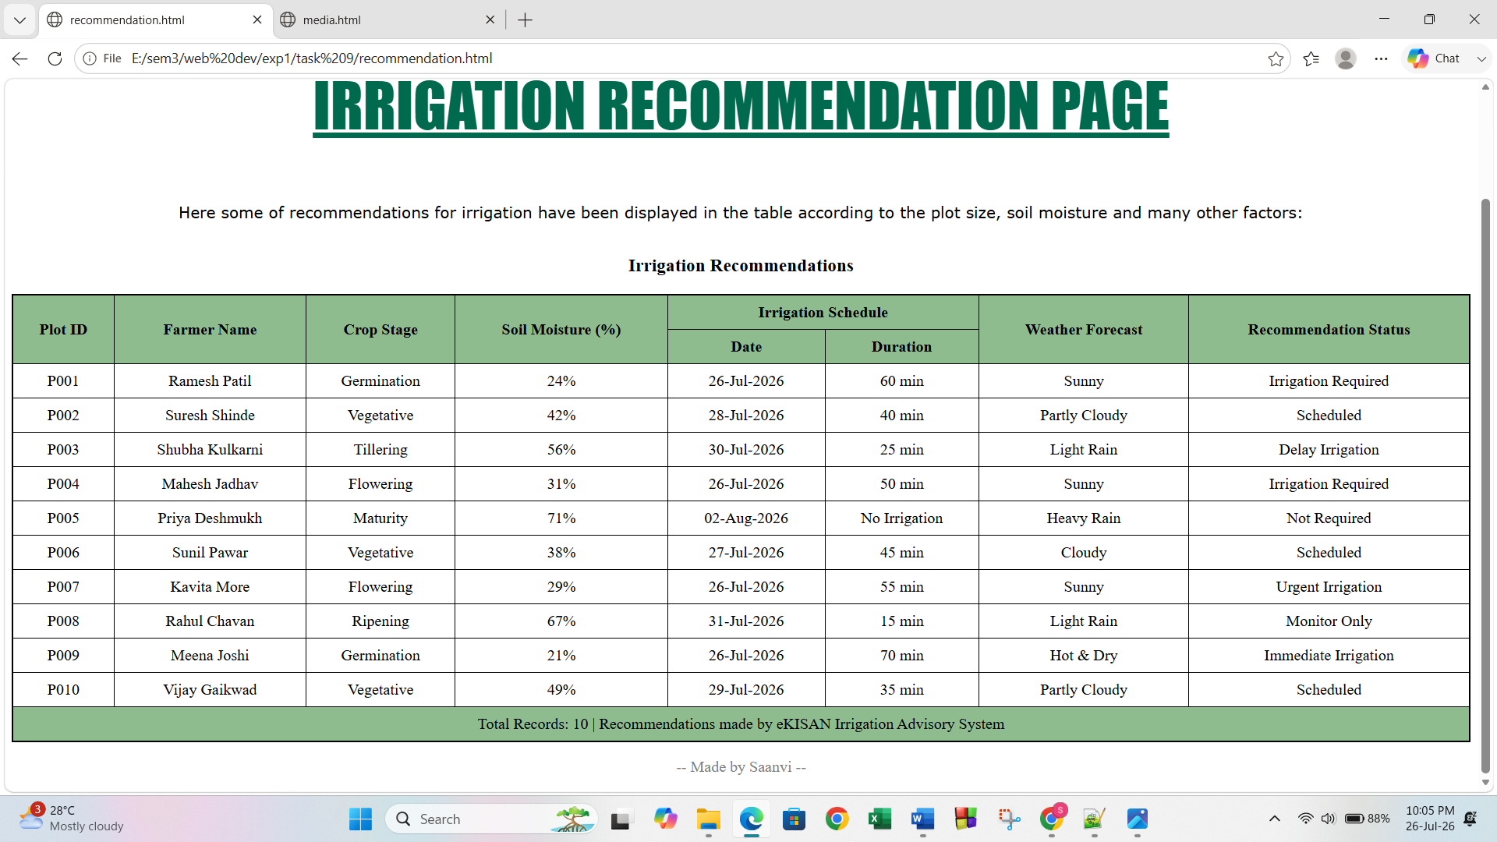
Task 2:
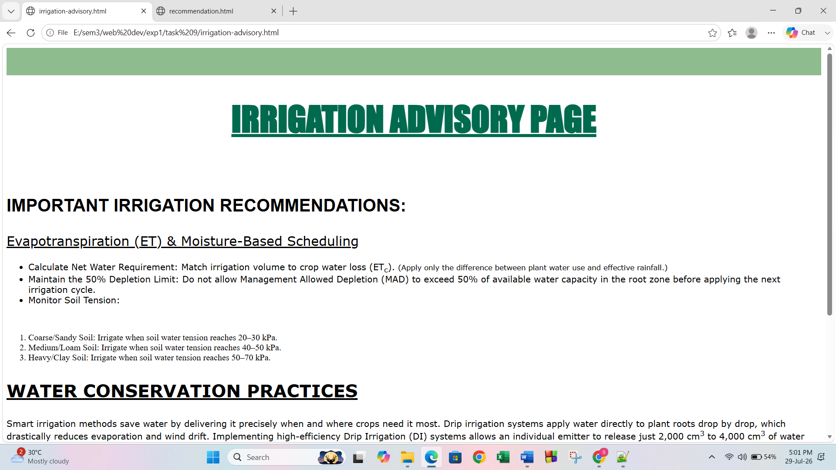
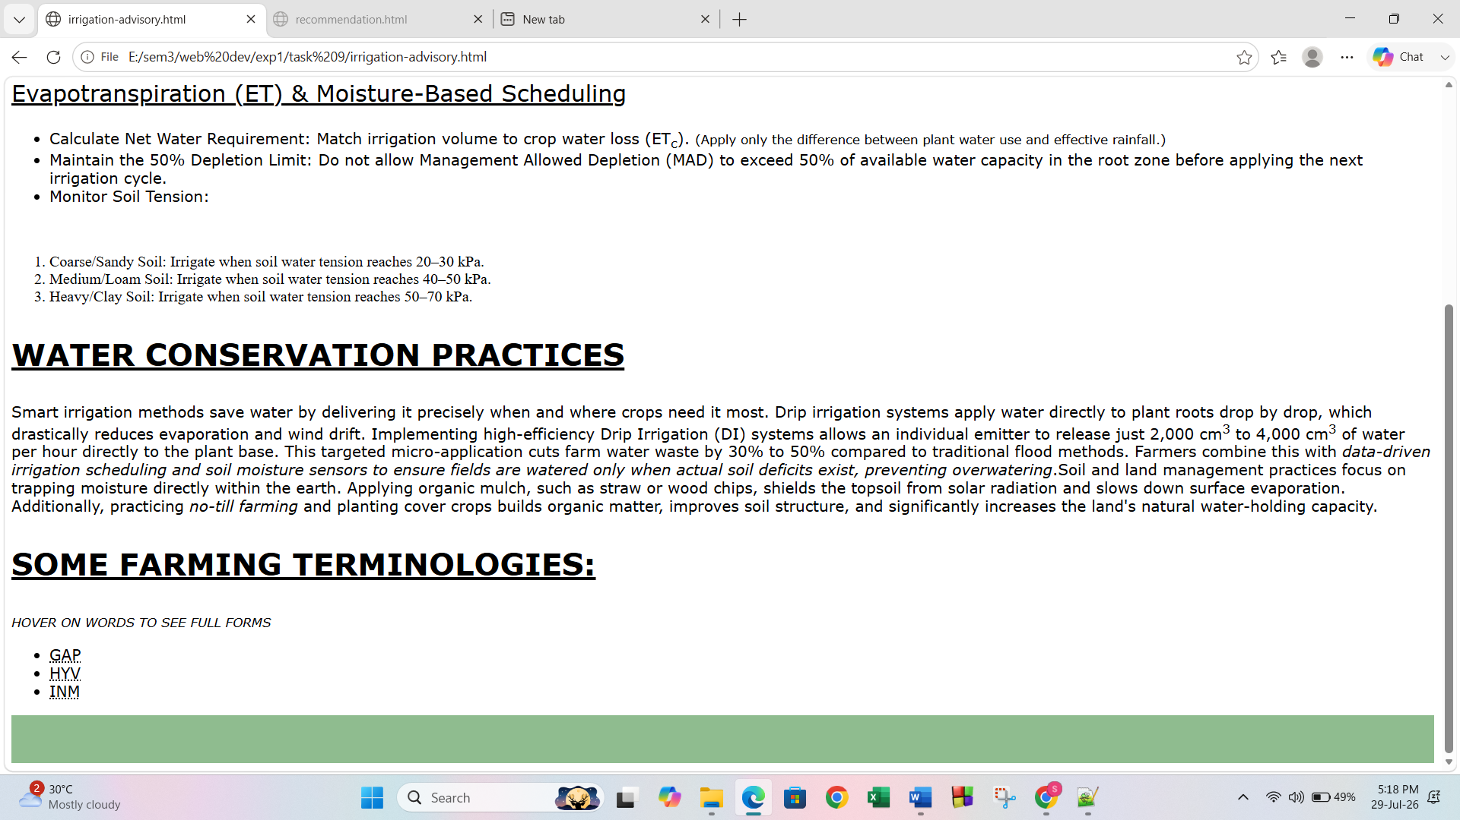

Conclusion and Discussion:
(students should write in your words)
(Also take feedback from fellow classmates and faculty to add here)
This experiment helps to learn about HTML and the various HTML tags. Through the three tasks assigned to me, I learned how to embed multimedia in html, use basic formatting tags and to make a table with data. Irrigation advisory system page, multimedia page and irrigation recommendation page was created for our topic AI-based Smart Irrigation Advisory system static Frontend.

