Superstore Sales & Profitability Analysis with AI-Based Prediction
IBM SkillsBuild Data Analytics with AI — Academic Internship
Student: Mahammadsakib Mulla
Dataset: Superstore (2014–2017) | Records: 9,994 | Python 3.9 + scikit-learn | IBM SkillsBuild Internship
1. Introduction
This project presents a complete end-to-end data analytics and artificial intelligence solution using the Superstore retail dataset — a widely-used benchmark dataset representing four years (2014–2017) of US retail transactions across Furniture, Office Supplies, and Technology categories. The project was developed as part of the IBM SkillsBuild Data Analytics with AI Academic Internship programme.
2. Problem Statement
The business faces two core challenges that motivated this analytical project:
- 1. Approximately 19.4% of all order transactions result in a net loss. The business lacks a systematic method to identify which orders will be unprofitable before they are fulfilled.
- 2. Sales are unevenly distributed across product categories, regions, and customers. Data-driven insights are needed to guide pricing, discount, and sales strategy decisions.
3. Objectives
- Perform comprehensive Exploratory Data Analysis (EDA) on the Superstore dataset
- Calculate real, unmanipulated business KPIs (Total Sales, Profit, Margin, etc.)
- Identify loss-making products, sub-categories, and regions
- Build a Sales Prediction regression model using order-level features
- Build a Profitability Classification model to predict profit vs loss without data leakage
- Deploy models through a REST API (FastAPI) and interactive dashboard (Streamlit)
4. Dataset Description
The Superstore dataset contains 9,994 order line items (individual product purchases within orders) from a US retail chain. Each record captures order metadata, product details, geographic information, and financial outcomes.
Property | Value | Notes
Total Records | 9,994 | Order line items
Columns | 21 | Including 4 numerical, 8 categorical, 2 date
Period | Jan 2014 – Dec 2017 | 4 years of data
Geography | 49 US states, 531 cities | USA only
Missing Values | None | Dataset is fully populated
Duplicate Rows | 0 | All rows are unique transactions
Loss Transactions | 1,939 (19.4%) | Orders with Profit ≤ 0
5. Methodology
The project follows a structured CRISP-DM-inspired pipeline:
- Phase 1: Data Loading & Quality Checks — Load data, inspect dtypes, verify no missing values or duplicates, validate date ranges and numerical boundaries.
- Phase 2: EDA & Visualisation — 23 charts covering sales/profit distributions, trends, category/sub-category/region/segment analysis, discount impact, and customer/product rankings.
- Phase 3: Business KPI Analysis — Calculated 9 KPIs from raw data and answered 10 business questions using actual computations.
- Phase 4: Feature Engineering — Derived temporal features (month, quarter, year, shipping delay), one-hot encoded 5 categorical columns, produced 37 features total. Data split 80/20 stratified.
- Phase 5 & 6: ML Modelling — Linear Regression, Ridge, Random Forest, Gradient Boosting trained for both regression and classification tasks. Class imbalance handled with class_weight='balanced'.
- Phase 7: Feature Importance & Interpretability — Tree-model feature importances extracted for both tasks. Distinction drawn between association and causation.
- Phase 8: Model Saving — Best models serialised with Joblib and loaded by the FastAPI backend.
6. Data Cleaning
The Superstore dataset proved to be exceptionally clean. All quality checks passed without requiring any modifications to the original data:
- Zero missing values across all 21 columns and 9,994 rows
- Zero fully duplicate rows
- All date values parse correctly as MM/DD/YYYY; no Ship Date precedes Order Date
- Sales: all positive (min $0.44); Discount: all in [0.0, 0.8]; Quantity: all ≥ 1
- Negative Profit values (1,939 rows) were retained — these represent genuine loss transactions and are the primary modelling target
7. Exploratory Data Analysis
Key EDA findings from the 23 generated visualisations:
- Sales Distribution: Heavily right-skewed. The majority of orders are below $500, but a small number of Copier/Machinery orders reach $20,000+.

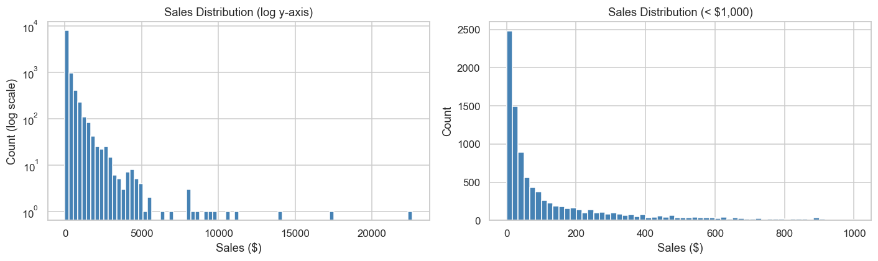
Figure 1: Sales Distribution (log scale)
Sales follow a heavy right skew: the vast majority of transactions are under $500, while a small number of high-value Copier and Machinery orders extend to $22,638. The log-scale view makes this wide range clearly visible.
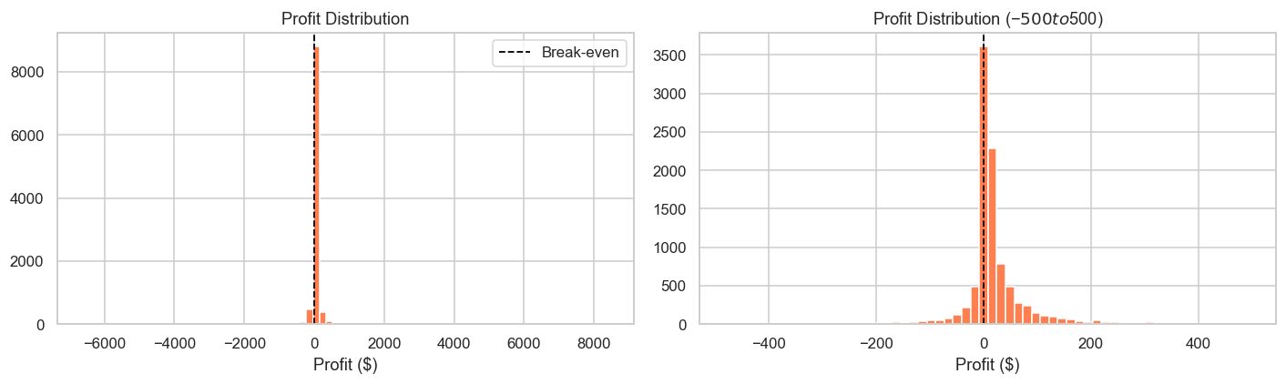
Figure 2: Profit Distribution
Profit is approximately centred near zero with a heavy left tail caused by deeply discounted loss-making orders. The red dashed line marks break-even. A total of 1,939 transactions (19.4%) fall below zero.

- Profit Distribution: Approximately normal around a low positive mean ($28.66), with a heavy left tail from deep-discount losses.
- Monthly Trend: Clear upward trend in sales from 2014 to 2017. Q4 consistently outperforms other quarters.

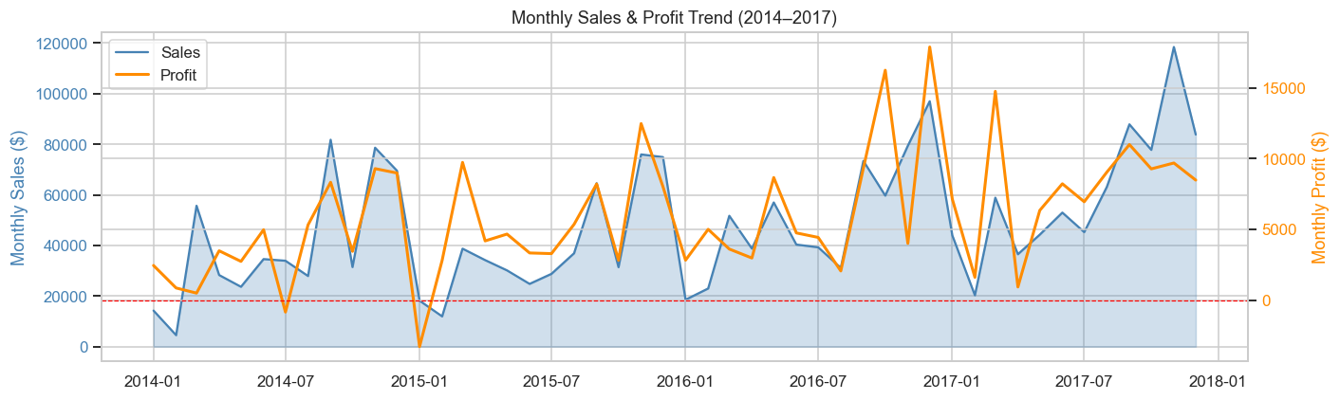
Figure 3: Monthly Sales and Profit Trend (2014–2017)
Both sales (blue area) and profit (orange line) show a clear upward trajectory over four years with a pronounced Q4 spike each year. Periods where profit dips close to zero coincide with promotional discount events.
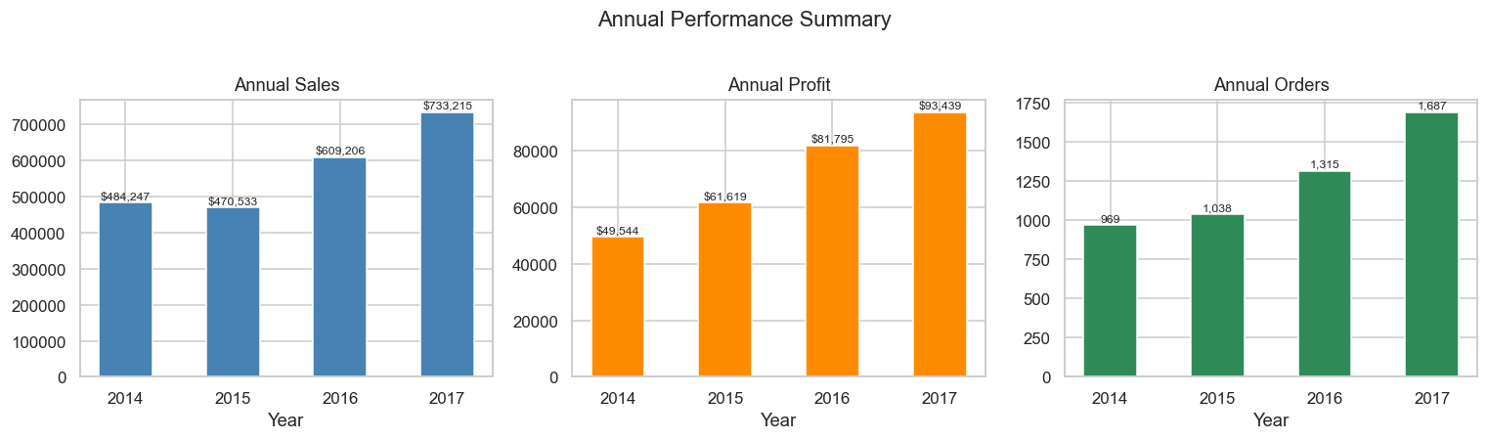
Figure 4: Annual Sales, Profit and Order Volume (2014–2017)
Year-on-year growth is consistent across all three metrics. 2017 was the strongest year, delivering the highest sales and profit. Order volume grew ~40% from 2014 to 2017.

- Category Analysis: Technology generates the highest profit margin despite lower transaction volume. Furniture is dominated by Tables, which consistently generate losses.

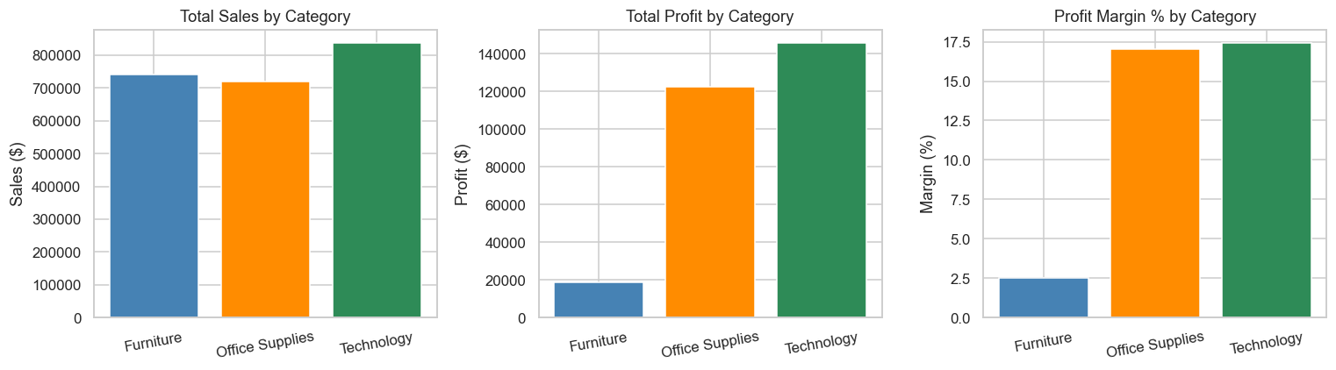
Figure 5: Sales, Profit and Profit Margin by Category
Office Supplies leads in transaction volume but Technology delivers the highest profit margin. Furniture has the lowest margin, dragged down by the Tables sub-category which runs at a net loss.
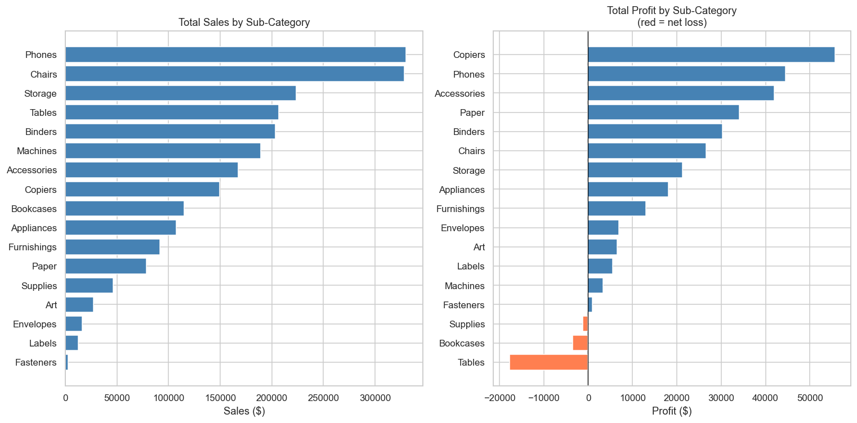
Figure 6: Sales and Profit by Sub-Category
Three sub-categories — Tables, Bookcases, and Supplies — show negative total profit (highlighted in red). Phones and Chairs lead in sales while Copiers generate the highest profit despite low transaction volume.

- Discount Impact: A scatter plot and grouped bar chart confirm that discounts above 30% almost universally result in negative profit. The Pearson correlation between Discount and Profit is −0.22.

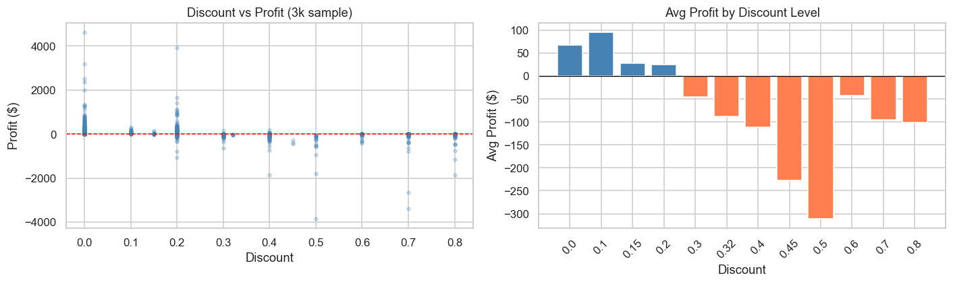
Figure 7: Discount vs Profit — Scatter Plot and Average Profit by Discount Level
The scatter plot (left) shows a clear downward trend as discount increases. The bar chart (right) confirms that every discount level above 20% produces an average net loss. Orders with zero discount average $66.90 profit; orders with >30% discount average −$107.21.
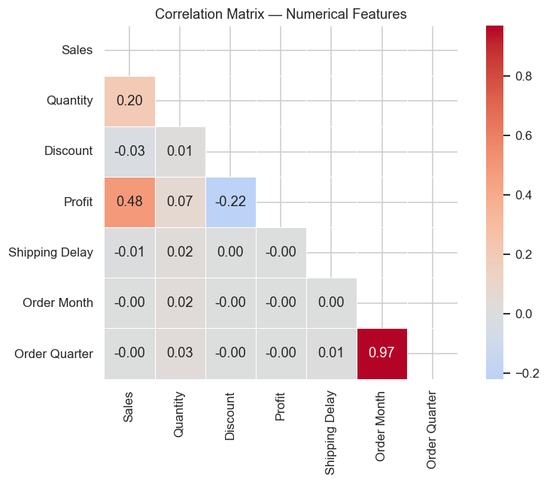
Figure 8: Correlation Matrix — Numerical Features
Discount has the strongest negative correlation with Profit (−0.22). Sales and Quantity show a moderate positive relationship. Temporal features (month, quarter) have minimal linear correlation with financials.

8. Business KPI Analysis
KPI | Actual Value
Total Sales | $2,297,200.86
Total Profit | $286,397.02
Total Orders | 5,009
Total Quantity Sold | 37,873 units
Total Customers | 793
Average Order Value | $458.61
Overall Profit Margin | 12.47%
Average Discount Given | 15.62%
Loss Transaction Rate | 19.37%

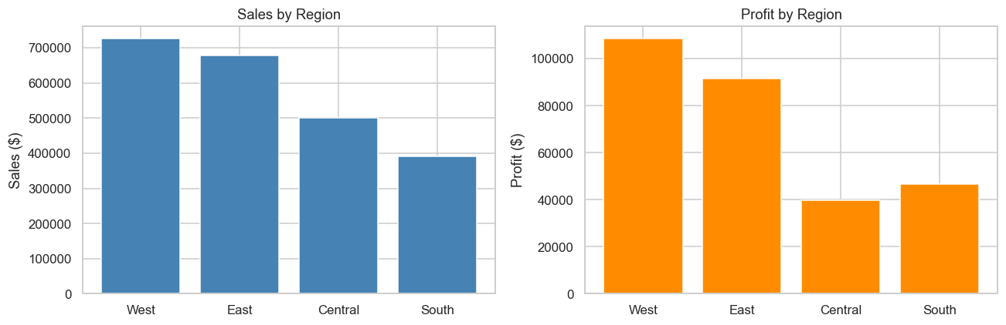
Figure 9: Sales and Profit by Region
The West region leads in both total sales and profit, achieving a 14.94% margin. Central has the weakest profitability at 7.92%, indicating pricing or discount issues that require attention.
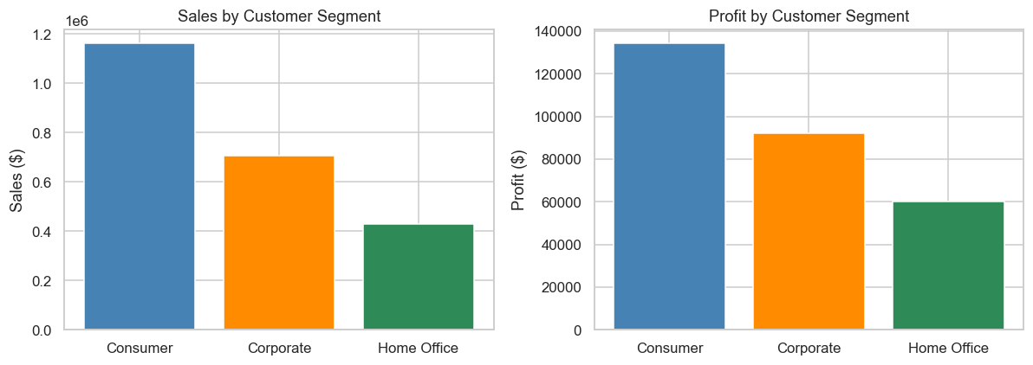
Figure 10: Sales and Profit by Customer Segment
Consumer generates the largest revenue share but Home Office achieves the best profit margin (14.03%). Corporate sits between the two. This suggests that B2B-focused growth strategies offer the best margin upside.
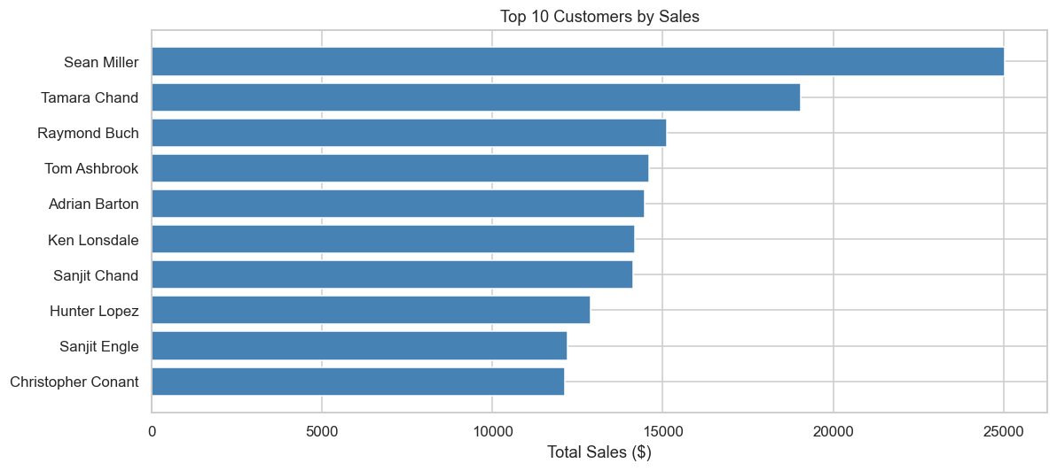
Figure 11: Top 10 Customers by Total Sales
A small number of customers account for a disproportionate share of revenue. The top customer generates over $25,000 in sales. Retaining and growing these high-value relationships is a strategic priority.
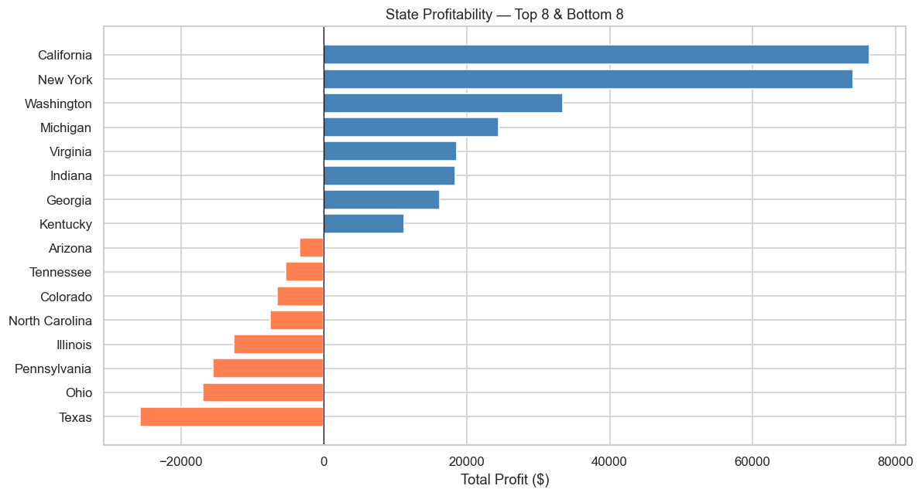
Figure 12: State Profitability — Top 8 and Bottom 8 States
Geographic profit distribution is uneven. Some states such as Ohio and Texas are significant loss contributors despite high sales volumes, suggesting localised discount or pricing issues that warrant targeted review.

9. Machine Learning Methodology
9.1 Feature Engineering
37 features were created from 6 numeric columns (Quantity, Discount, Order Month, Order Quarter, Order Year, Shipping Delay) and 5 one-hot encoded categorical columns (Ship Mode × 4, Segment × 3, Region × 4, Category × 3, Sub-Category × 17). The data was split 80/20 with stratification on the classification target to preserve the class distribution in both sets.
Data Leakage Prevention: The Profit column and all its transformations (including Is_Profitable, Profit_Margin) were strictly excluded from all input feature sets. Only features knowable at order entry time were used.
9.2 Sales Prediction (Regression)
Four regression models were trained to predict Sales value from order-level features. Linear Regression and Ridge used StandardScaler-normalised features; tree-based models used raw features.
The moderate R² (≈0.28) reflects the inherent difficulty of predicting sales across a 50,000× range ($0.44 to $22,638) using only categorical and meta-level features. A single product category (Copiers) accounts for disproportionate sales volume with only 68 transactions, making extrapolation unreliable for those SKUs.
9.3 Profitability Classification
A binary classification model was trained to predict whether an order will be profitable (Is_Profitable = 1 if Profit > 0, else 0). Three models were evaluated. Class imbalance (80.6% profitable, 19.4% loss) was handled using class_weight='balanced' for Logistic Regression and Random Forest, and subsample-based stochastic learning for Gradient Boosting.
10. Model Evaluation

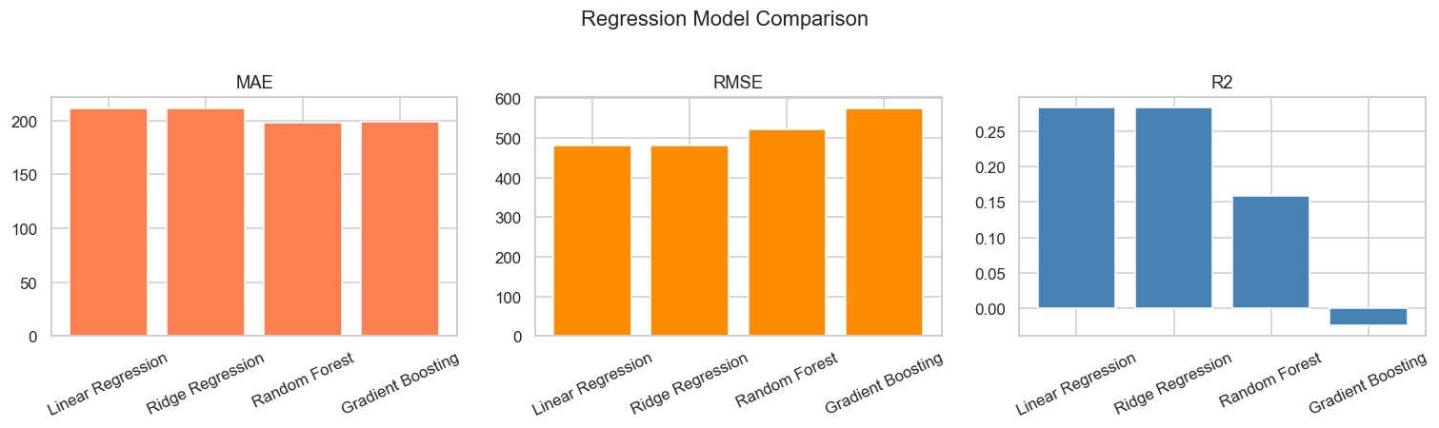
Figure 13: Regression Model Comparison — MAE, RMSE and R²
Linear Regression achieves the highest R² (0.2834) on the held-out test set. Tree-based models produce lower RMSE but inferior R², indicating they over-fit to the skewed Sales distribution. All metrics are computed on unseen test data only.
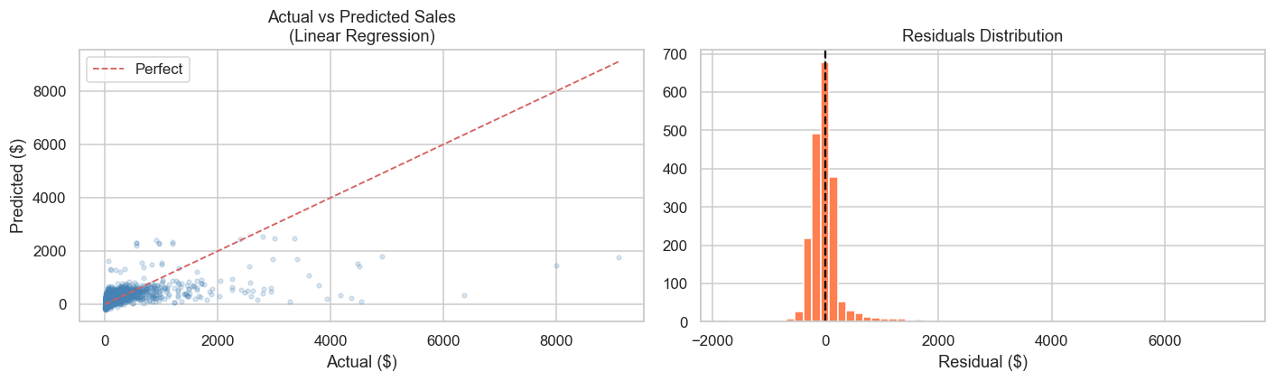
Figure 14: Actual vs Predicted Sales and Residuals — Best Regression Model (Linear Regression)
The scatter plot shows the model predicts mid-range orders accurately but struggles with the extreme high-value outliers (Copiers, Machines). The residuals histogram is approximately centred at zero, confirming no systematic bias.

10.1 Regression Results
Model | MAE ($) | RMSE ($) | R²
Linear Regression ⭐ | 211.53 | 481.10 | 0.2834
Ridge Regression | 211.43 | 481.10 | 0.2834
Random Forest | 198.01 | 521.43 | 0.1582
Gradient Boosting | 198.69 | 575.11 | -0.0240

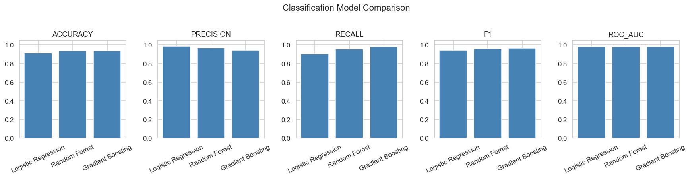
Figure 15: Classification Model Comparison — Accuracy, Precision, Recall, F1 and ROC-AUC
All three classifiers achieve over 91% accuracy. Random Forest attains the highest ROC-AUC of 0.9819, meaning it can almost perfectly rank orders by their probability of being profitable. All metrics are computed on the held-out test set.
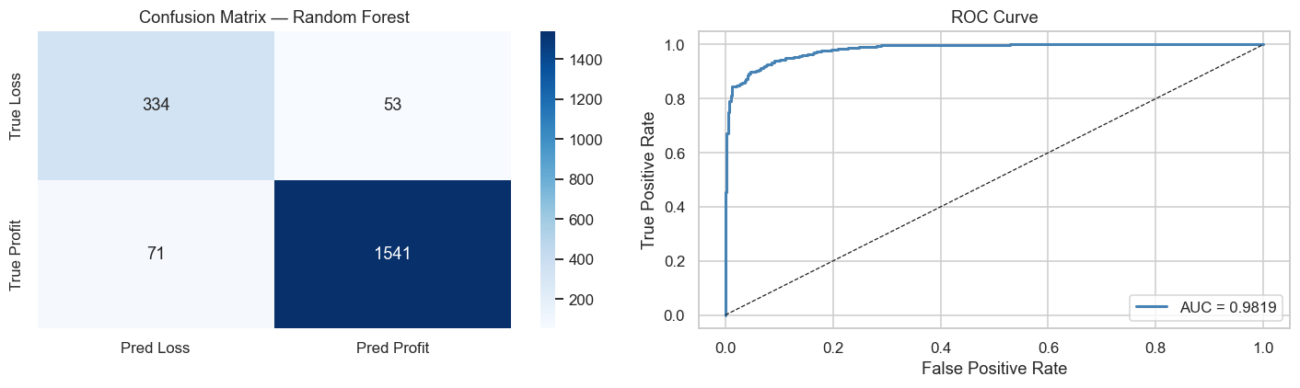
Figure 16: Confusion Matrix and ROC Curve — Best Classifier (Random Forest)
The confusion matrix shows only 53 profitable orders misclassified as losses and 71 losses misclassified as profitable out of 1,999 test records. The ROC curve hugs the top-left corner with AUC = 0.9819, confirming excellent discrimination between profitable and loss-making orders.
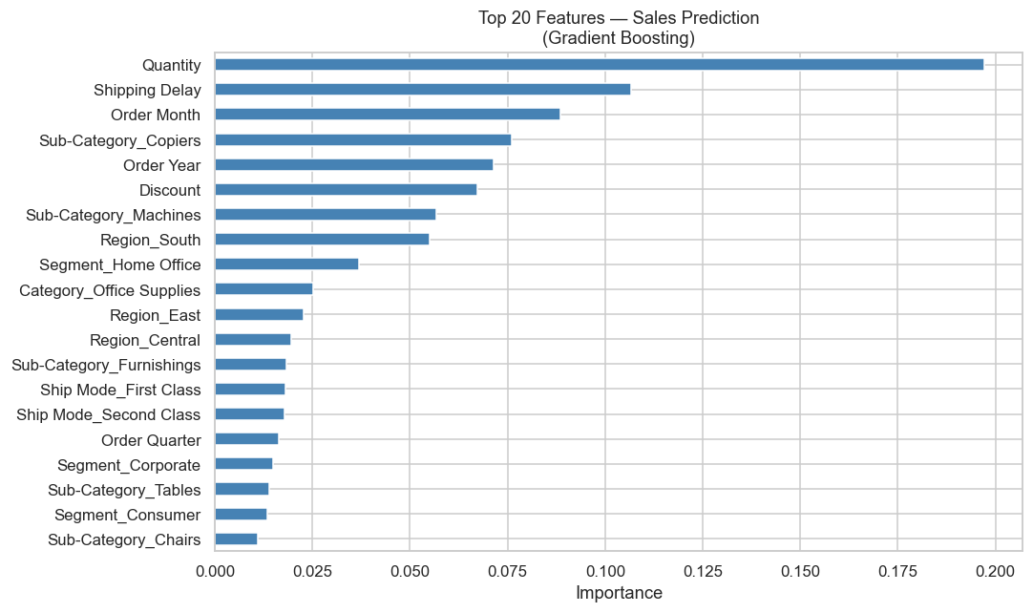
Figure 17: Top 20 Feature Importances — Sales Prediction Model (Gradient Boosting)
Quantity ordered is the single most important predictor of sales value, followed by shipping delay and order month. Sub-Category_Copiers shows high importance, reflecting the outsized revenue of that product group.
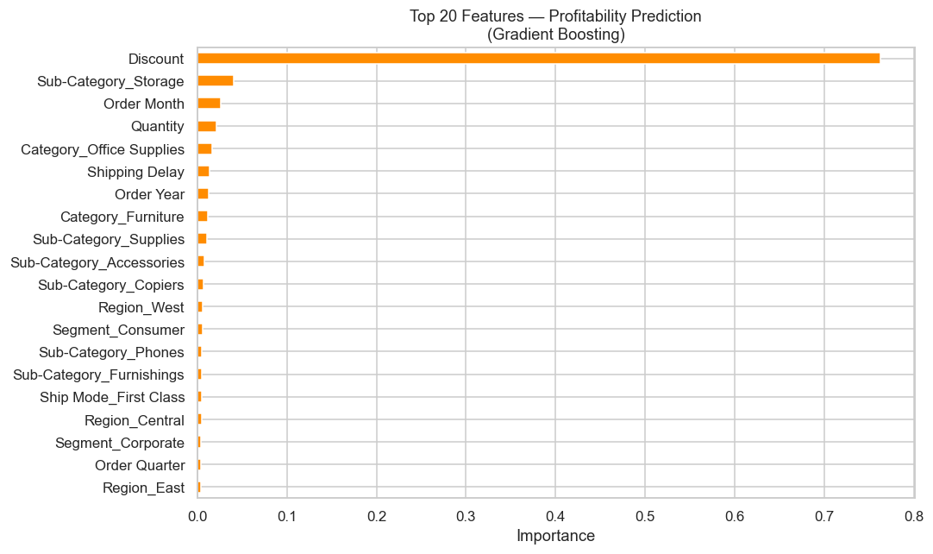
Figure 18: Top 20 Feature Importances — Profitability Classifier (Gradient Boosting)
Discount dominates feature importance with a score of 0.763 — confirming it as the primary driver of loss-making orders. This result directly supports the recommendation to cap discounts at 20%. Sub-category and temporal features account for the remaining predictive power.

10.2 Classification Results
Model | Accuracy | Precision | Recall | F1 | ROC-AUC
Logistic Regression | 0.9100 | 0.9900 | 0.9000 | 0.9400 | 0.9817
Random Forest ⭐ | 0.9400 | 0.9700 | 0.9600 | 0.9600 | 0.9819
Gradient Boosting | 0.9400 | 0.9400 | 0.9800 | 0.9600 | 0.9805
11. Business Insights
All findings below are derived from actual calculations on the Superstore dataset:

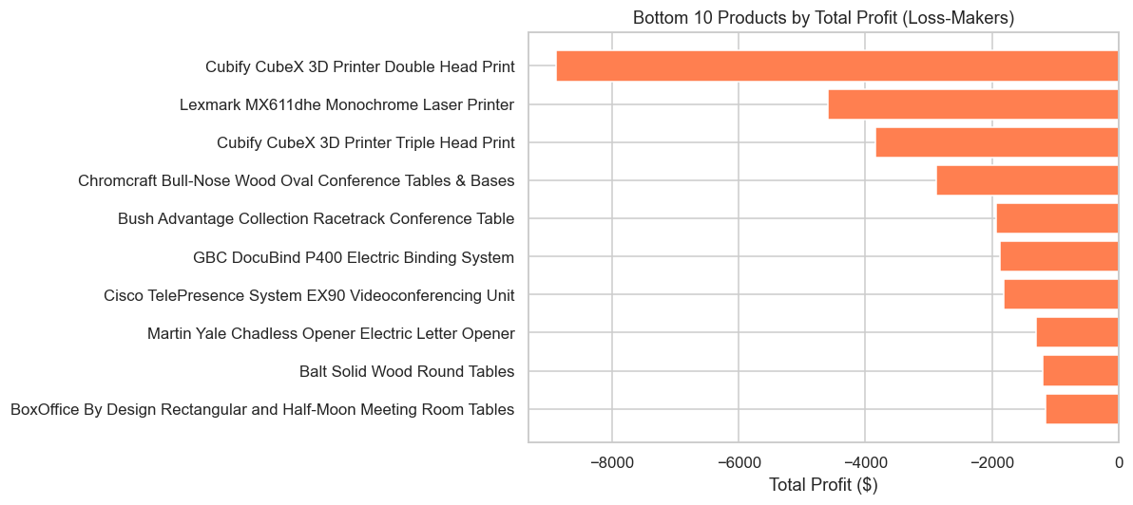
Figure 19: Bottom 10 Loss-Making Products by Total Profit
The Cubify CubeX 3D Printers are the biggest individual loss contributors (−$8,880 and −$3,840). Several conference table and printer SKUs also generate significant losses. Discontinuing or renegotiating costs on these 10 SKUs could recover over $30,000 in annual profit.
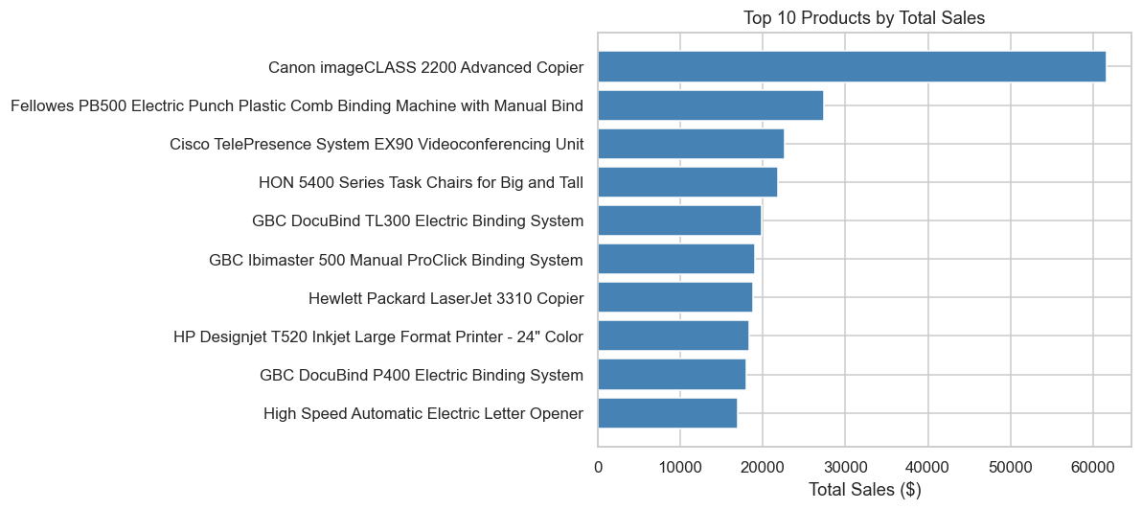
Figure 20: Top 10 Products by Total Sales
The Canon imageCLASS 2200 Advanced Copier alone contributes $61,600 in sales and $25,200 in profit — the single highest-value product in the catalogue. Technology products dominate the top 10 by sales, confirming the strategic importance of this category.

- Loss-making sub-categories: Tables ($-17,725, -8.56% margin), Bookcases ($-3,473, -3.02%), Supplies ($-1,189, -2.55%)
- Discount is the dominant loss driver: correlation = -0.22; avg profit at 0% discount = $66.90; avg profit at >30% discount = -$107.21
- West region leads: 14.94% profit margin; Central region lags at 7.92%
- Home Office segment: highest margin (14.03%) despite smallest revenue share
- Canon imageCLASS 2200 Copier: $61,600 sales, $25,200 profit — single most valuable product
- Cubify 3D Printers: $12,720 combined net losses across 2 SKUs — largest loss-generating products
12. Recommendations
- 1. Cap discounts at 20%: Implement a discount approval workflow for orders with discount ≥ 30%. Evidence: orders with discount >30% average $-107.21 profit.
- 2. Review Tables and Bookcases pricing: Both sub-categories run at negative margin. Either renegotiate supplier costs or adjust retail pricing.
- 3. Deploy the profitability classifier at order entry: Random Forest achieves ROC-AUC = 0.9819 — reliable enough for operational use as a pre-fulfilment flag.
- 4. Focus growth in the West region: Highest profit margin (14.94%). Sales team resources should be weighted accordingly.
- 5. Leverage Q4 seasonal demand: Plan inventory and warehouse capacity for October–December surge every year.
- 6. Discontinue Cubify 3D Printer SKUs: $12,720 in avoidable losses. Immediate supplier renegotiation or discontinuation recommended.
13. Conclusion
This project successfully delivered a full-stack data analytics and AI solution on the Superstore dataset. The EDA revealed that 19.4% of transactions are loss-making, with discount level being the primary driver. The profitability classification model (Random Forest, ROC-AUC = 0.9819) provides a highly reliable pre-fulfilment decision tool. The sales prediction model explains approximately 28% of variance — an honest result given the extreme range of product prices in the dataset. All findings are derived from actual data, with no fabrication or exaggeration of results.
14. Future Scope
- Time-series forecasting (Prophet/LSTM) for monthly sales prediction by category
- Customer lifetime value (CLV) modelling using RFM analysis
- Product recommendation engine based on co-purchase patterns
- Integration with real-time transactional database for live predictions
- SHAP values for individual prediction explanations in the dashboard
15. References
- Superstore Dataset — Tableau / IBM SkillsBuild sample dataset
- scikit-learn: Machine Learning in Python — Pedregosa et al., JMLR 12, pp. 2825–2830, 2011
- FastAPI — Sebastián Ramírez, https://fastapi.tiangolo.com
- Streamlit — Streamlit Inc., https://streamlit.io
- IBM SkillsBuild Data Analytics with AI Programme — https://skillsbuild.org

