When trying to create a project w/o a name, it's rightfully presenting error

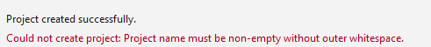
But it should diminish when there was another app state change, like creating another project
Same theme, once we moved to the next screen, presenting the message of project creation is not necessary
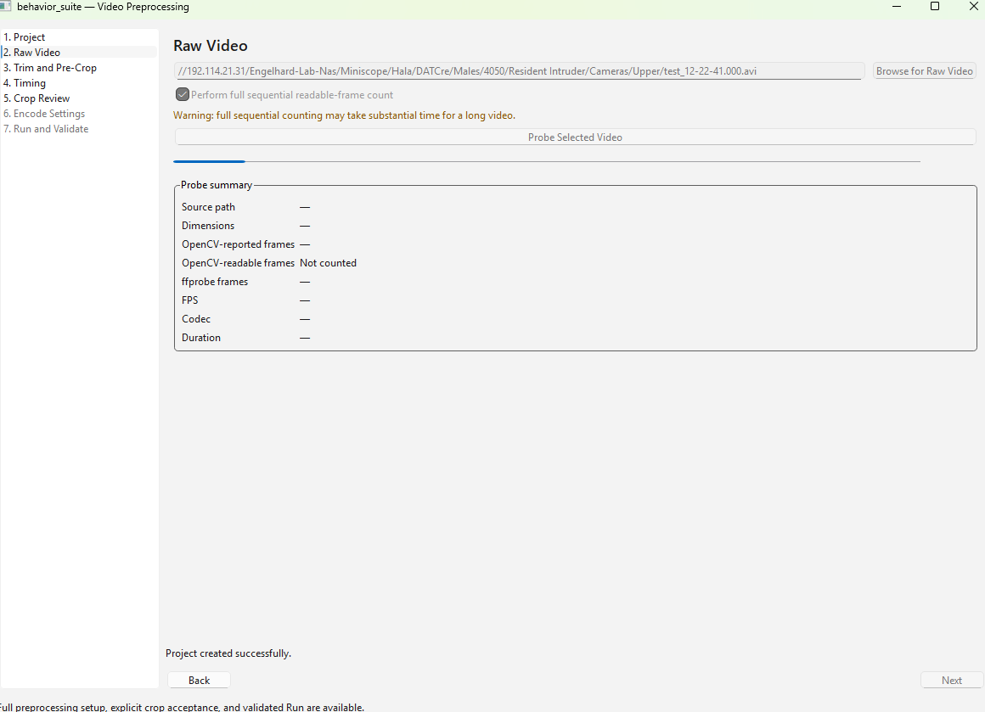

Consider adding a popping info when hoovering over an option/setting/param
Consider adding a better progress bar in full sequential counting
Consider adding a more clear indicator for showing that the ttl var was choosen
In raw video screen, in the browse for raw video section, when there is a path in the location text box and the user chooses browse for raw video, the initial path to pop should be the path in the text, if the path is valid, else, the repo path should be showen

