# AWS

## Module 1: Intro to cloud computing and AWS preview

Cloud computing – is where services provided to you via internet, by website or cli or SDKs

== virtualization + internet/intranet

Virtualization

Cloud service models

Cloud deployment models

Cloud Service provider

What is AWS?

AWS management console

AWS service domains-compute, networking, storage, database

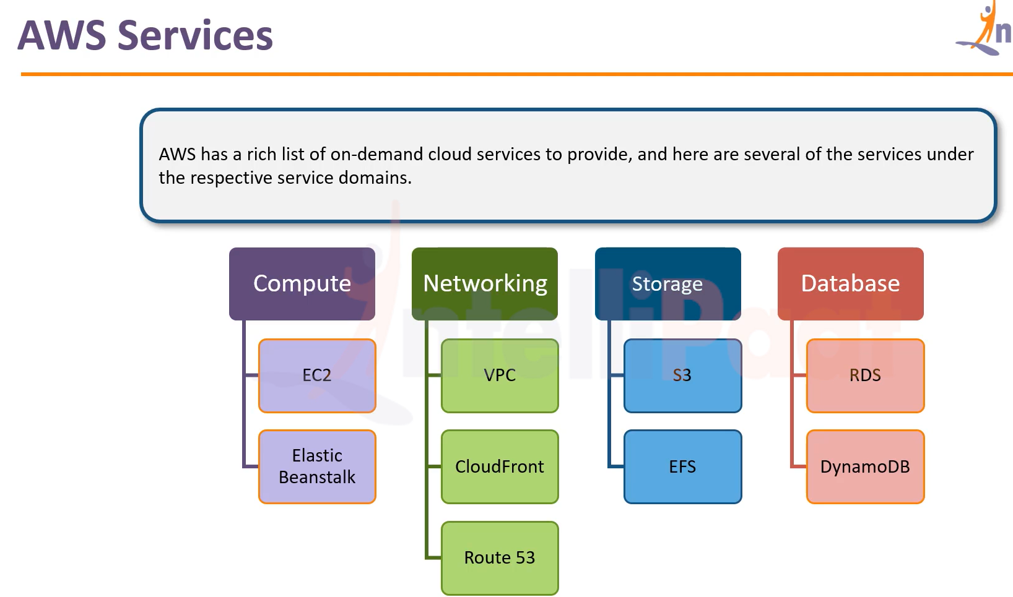

AWS Suite

On premise:

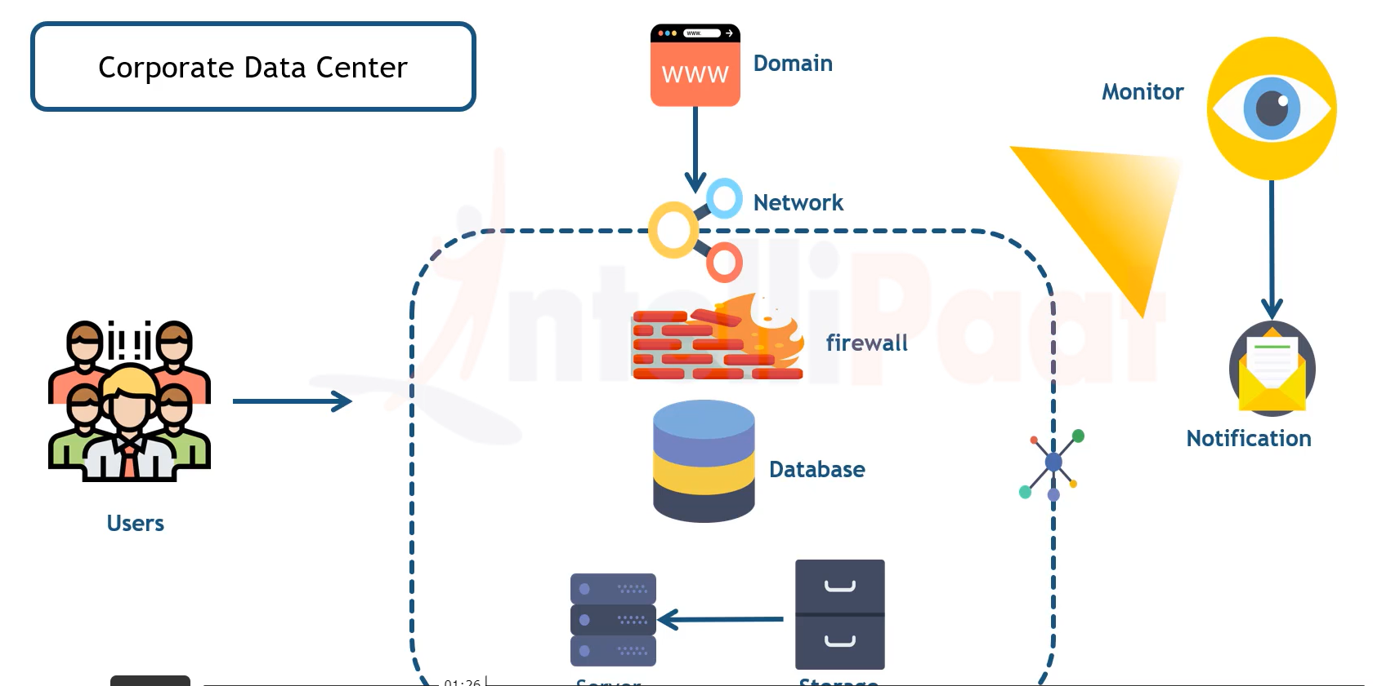

On AWS cloud:

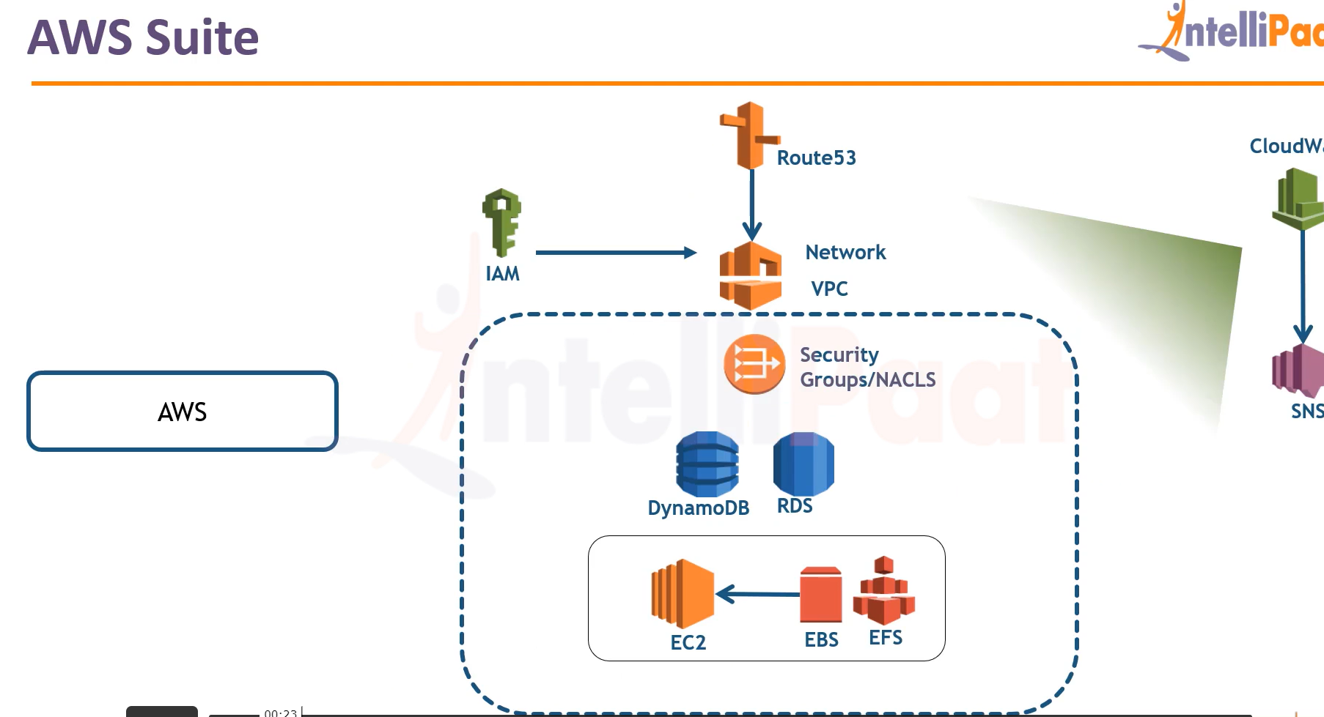

Starting off with AWS

Create AWS root account

<https://docs.aws.amazon.com/>

Virtualization in AWS

Types of hypervisor:

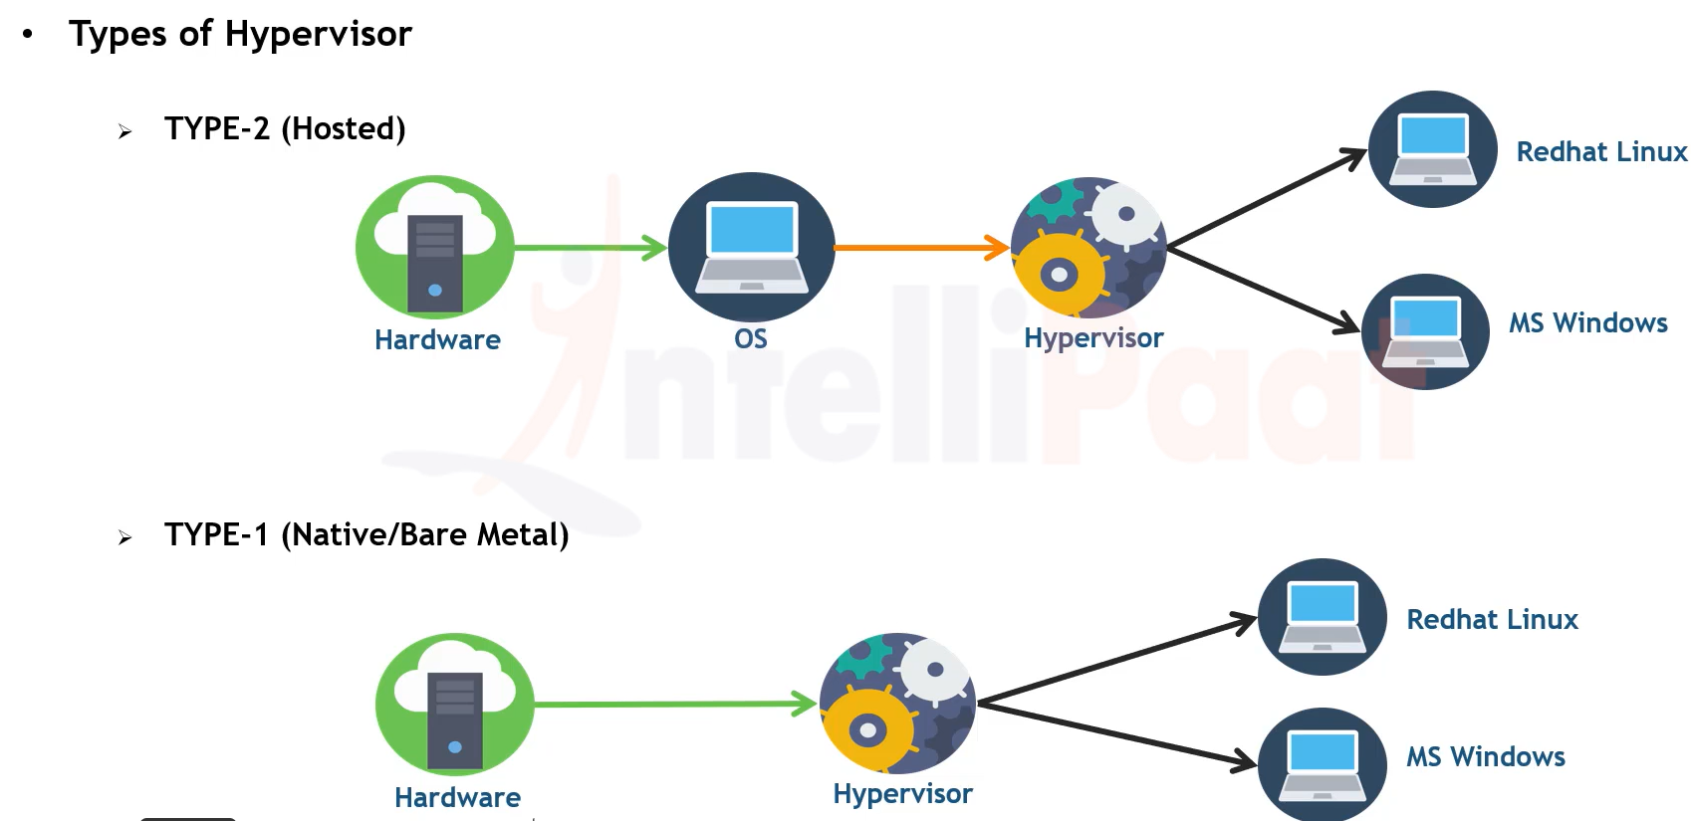

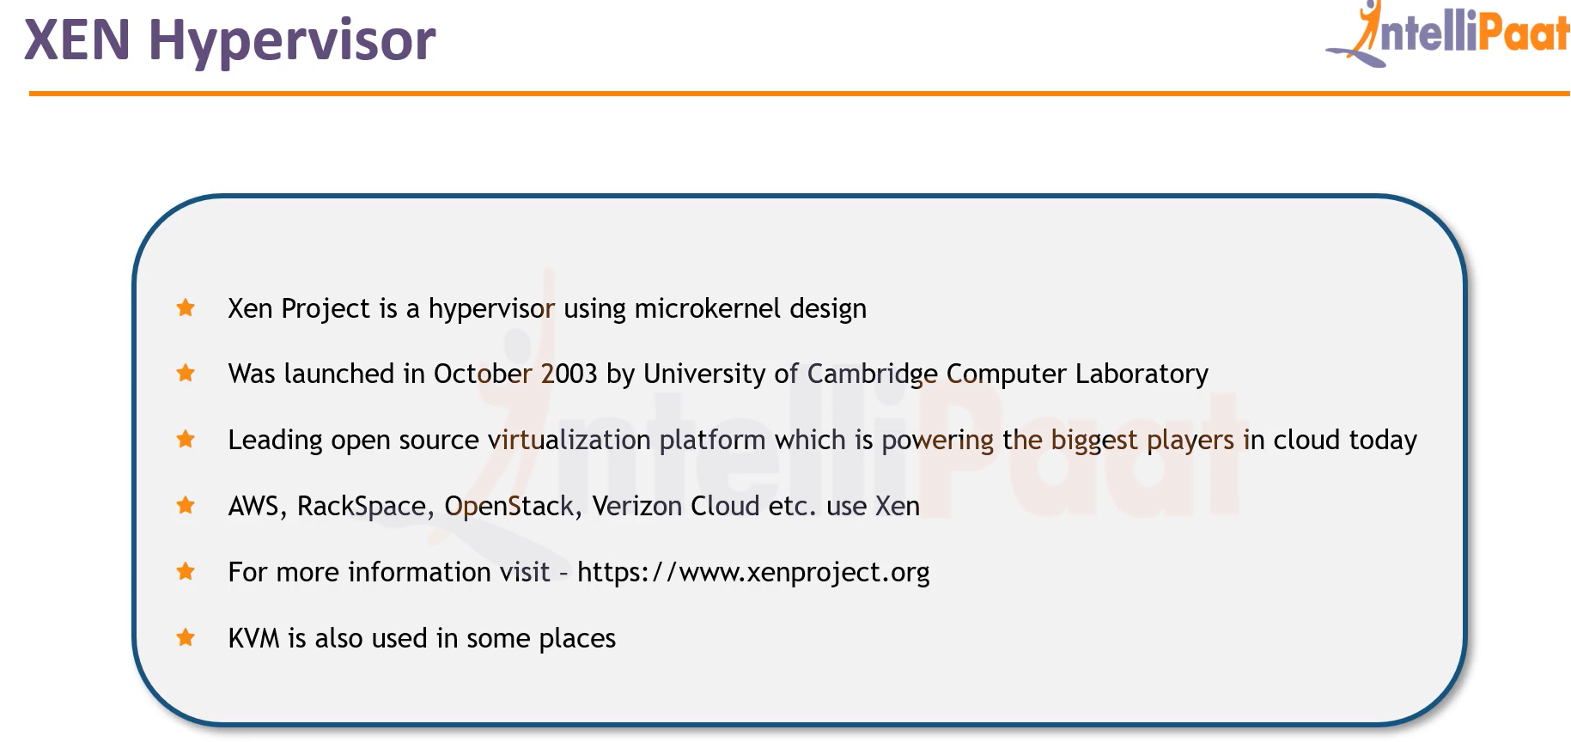

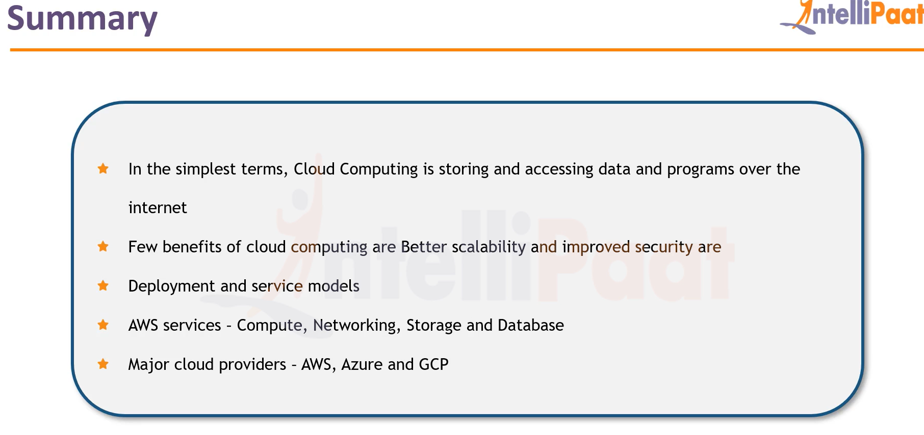

## Module 2: Introduction to EC2, EBS and EFS

## Launching an instance

## Creating and copying an AMI

## Creating and mounting EBS volume

## Creating and Mounting and EFS

## Module 2 assignment

<https://aws.amazon.com/free>