# Ansible

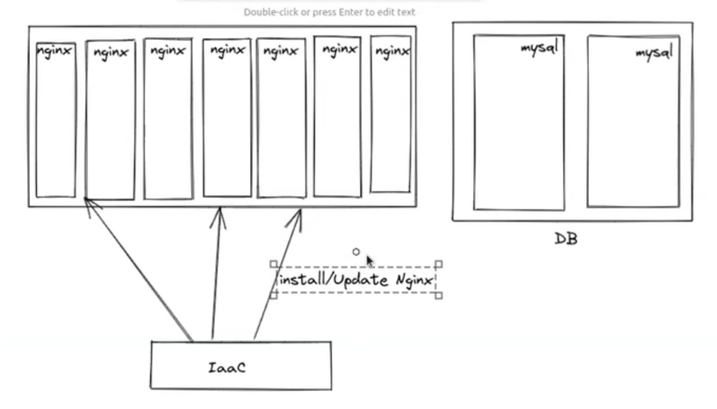

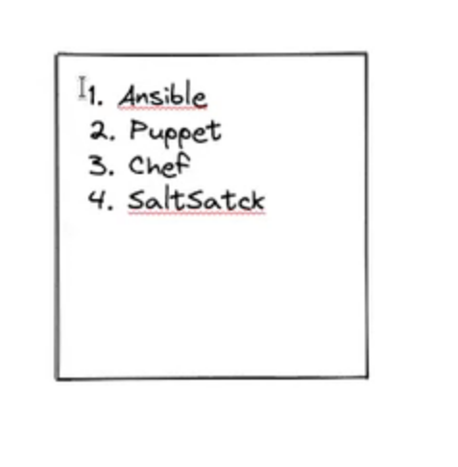

PULL BASE SYSTEM

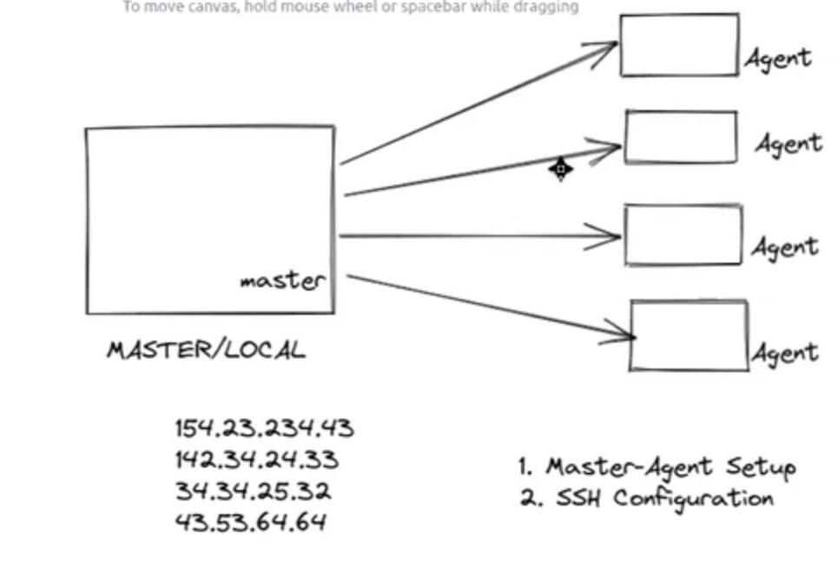

PUSH BASE SYSTEM-Ansible

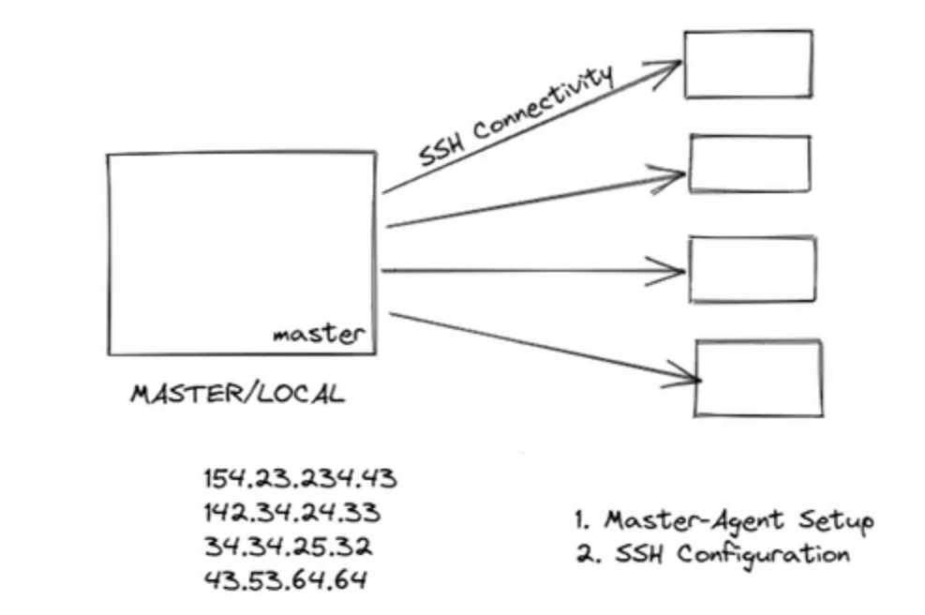

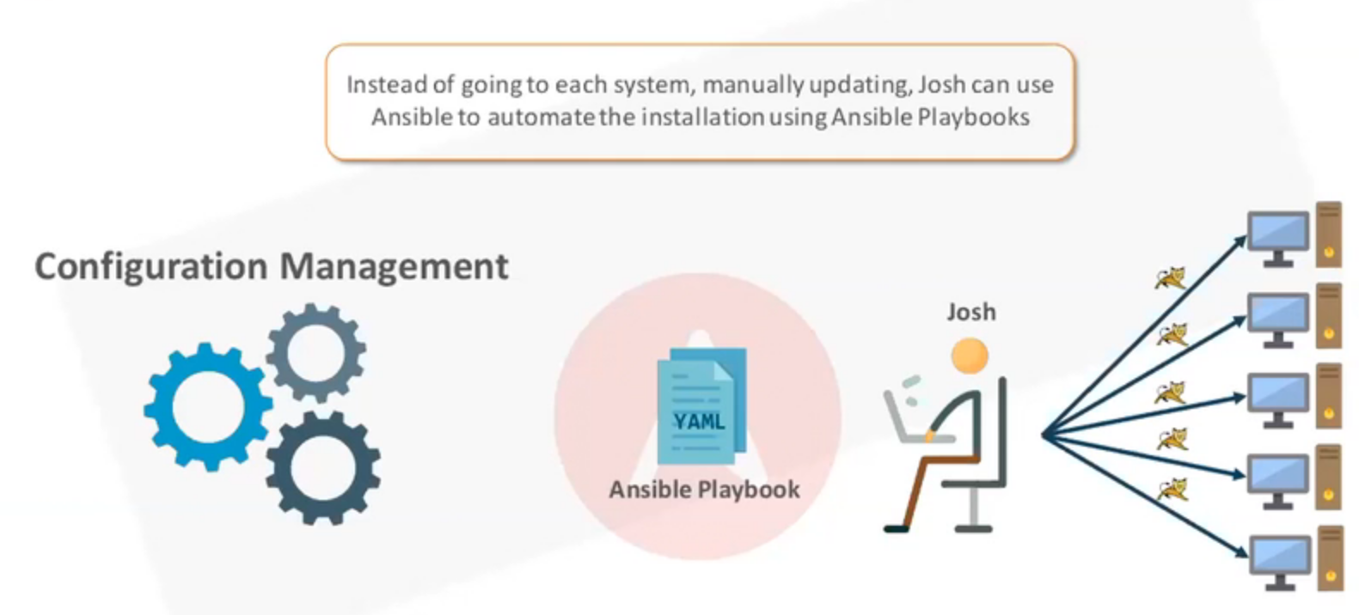

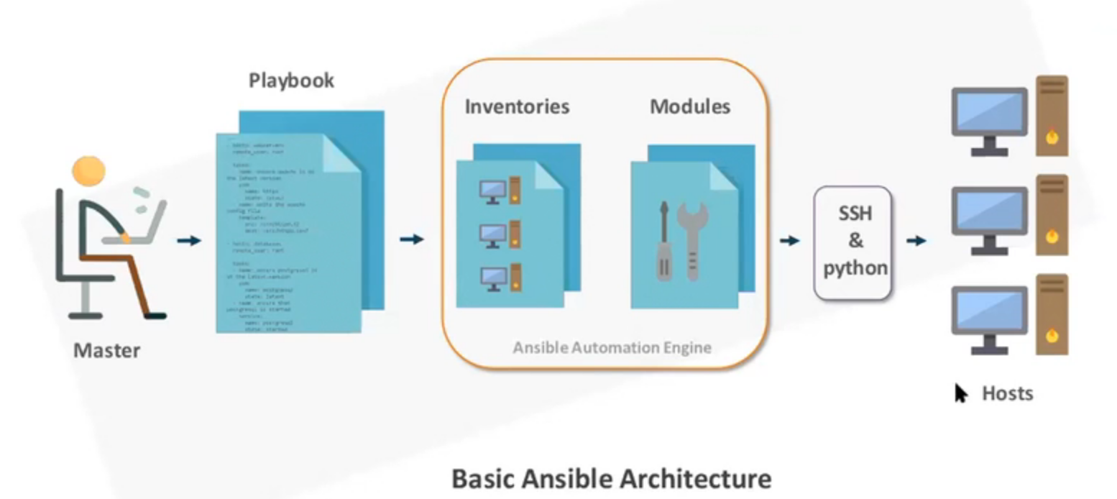

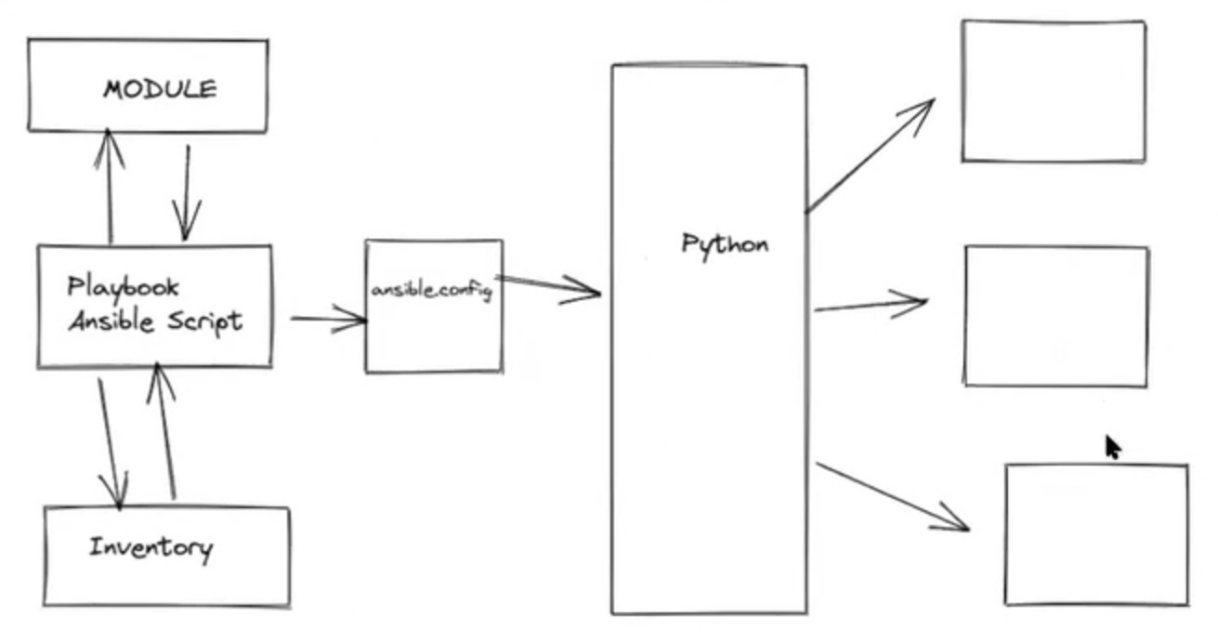

## Installation

Sudo apt install ansible

ubuntu@ip-172-31-31-36:/etc/ansible$ pwd

/etc/ansible

ubuntu@ip-172-31-31-36:/etc/ansible$ ansible

usage: ansible [-h] [--version] [-v] [-b] [--become-method BECOME_METHOD] [--become-user BECOME_USER] [-K] [-i INVENTORY] [--list-hosts]

[-l SUBSET] [-P POLL_INTERVAL] [-B SECONDS] [-o] [-t TREE] [-k] [--private-key PRIVATE_KEY_FILE] [-u REMOTE_USER] [-c CONNECTION]

[-T TIMEOUT] [--ssh-common-args SSH_COMMON_ARGS] [--sftp-extra-args SFTP_EXTRA_ARGS] [--scp-extra-args SCP_EXTRA_ARGS]

[--ssh-extra-args SSH_EXTRA_ARGS] [-C] [--syntax-check] [-D] [-e EXTRA_VARS] [--vault-id VAULT_IDS]

[--ask-vault-pass | --vault-password-file VAULT_PASSWORD_FILES] [-f FORKS] [-M MODULE_PATH] [--playbook-dir BASEDIR]

[-a MODULE_ARGS] [-m MODULE_NAME]

pattern

ansible: error: the following arguments are required: pattern

ubuntu@ip-172-31-31-36:/etc/ansible$ ls

ansible.cfg hosts

ubuntu@ip-172-31-31-36:/etc/ansible$ cd .ansible

-bash: cd: .ansible: No such file or directory

ubuntu@ip-172-31-31-36:/etc/ansible$ cd

ubuntu@ip-172-31-31-36:~$ cd .ansible/

ubuntu@ip-172-31-31-36:~/.ansible$ ls

tmp

ubuntu@ip-172-31-31-36:~/.ansible$ cd tmp

ubuntu@ip-172-31-31-36:~/.ansible/tmp$ pwd

/home/ubuntu/.ansible/tmp

[ubuntu@ip-172-31-31-36:~/.ansible/tmp$](mailto:ubuntu@ip-172-31-31-36:~/.ansible/tmp$)

hosts //////inventory file

ubuntu@ip-172-31-31-36:/etc/ansible$ ansible localhost -m ping

localhost | SUCCESS => {

"changed": false,

"ping": "pong"

}

## SSH connectivity

ubuntu@ip-172-31-31-36:~/.ssh$ touch id_rsa1

ubuntu@ip-172-31-31-36:~/.ssh$ ll

total 24

drwx------ 2 ubuntu ubuntu 4096 Dec 18 03:01 ./

drwxr-xr-x 18 ubuntu ubuntu 4096 Dec 18 02:53 ../

-rw------- 1 ubuntu ubuntu 391 Nov 24 08:29 authorized_keys

-rw------- 1 ubuntu ubuntu 2610 Nov 27 06:02 id_rsa

-rw-r--r-- 1 ubuntu ubuntu 576 Nov 27 06:02 id_rsa.pub

-rw-rw-r-- 1 ubuntu ubuntu 0 Dec 18 03:01 id_rsa1

-rw-r--r-- 1 ubuntu ubuntu 888 Nov 27 07:01 known_hosts

ubuntu@ip-172-31-31-36:~/.ssh$ ssh-keygen

Generating public/private rsa key pair.

Enter file in which to save the key (/home/ubuntu/.ssh/id_rsa):

id_rsa1 already exists.

Overwrite (y/n)? y

Enter passphrase (empty for no passphrase):

Enter same passphrase again:

Your identification has been saved in id_rsa

Your public key has been saved in id_rsa.pub

The key fingerprint is:

SHA256:tg/c5cCPd3v9I2vMzX9J105nHIb0mVYPxHGr0xPHRb4 ubuntu@ip-172-31-31-36

The key's randomart image is:

+---[RSA 3072]----+

| ooo+|

| .o++|

| . o+O|

| . .oB=|

| S o .ooEo|

| o o * ..O|

| + o * =+=|

| o . * *=|

| . ..+.B|

+----[SHA256]-----+

ubuntu@ip-172-31-31-36:~/.ssh$ ls

authorized_keys id_rsa id_rsa.pub known_hosts

ubuntu@ip-172-31-31-36:~/.ssh$ cat id_rsa.pub

ssh-rsa  ubuntu@ip-172-31-31-36

Go to remote agent server--------------------

ubuntu@ip-172-31-29-107:~$ cd .ssh/

ubuntu@ip-172-31-29-107:~/.ssh$ ls

authorized_keys

ubuntu@ip-172-31-29-107:~/.ssh$ vim authorized_keys

Paste the key

ubuntu@ip-172-31-31-36:~/.ssh$ ssh [ubuntu@3.16.40.232](mailto:ubuntu@3.16.40.232)

Add inventory----------------

ubuntu@ip-172-31-31-36:/etc/ansible$ sudo vi hosts

agent1 ansible_host=3.16.40.232 ansible_user=ubuntu ansible_port=22

agent2 ansible_host=18.217.77.238 ansible_user=ubuntu ansible_port=22

ubuntu@ip-172-31-31-36:/etc/ansible$ netstat -tulnp | grep LIST

ubuntu@ip-172-31-31-36:/etc/ansible$ ansible agent1 -m ping

agent1 | SUCCESS => {

"ansible_facts": {

"discovered_interpreter_python": "/usr/bin/python3"

},

"changed": false,

"ping": "pong"

}

ubuntu@ip-172-31-31-36:/etc/ansible$ ansible agent2 -m ping

agent2 | SUCCESS => {

"ansible_facts": {

"discovered_interpreter_python": "/usr/bin/python3"

},

"changed": false,

"ping": "pong"

}

ubuntu@ip-172-31-31-36:/etc/ansible$ ansible agent2 -m setup ////gives all info

Define group in inventory-------------

ubuntu@ip-172-31-31-36:/etc/ansible$ ls

ansible.cfg hosts

ubuntu@ip-172-31-31-36:/etc/ansible$ sudo vi hosts

agent1 ansible_host=3.16.40.232 ansible_user=ubuntu ansible_port=22

agent2 ansible_host=18.217.77.238 ansible_user=ubuntu ansible_port=22

[group1]

agent1

agent2

localhost

ubuntu@ip-172-31-31-36:/etc/ansible$ ansible group1 -m ping

The authenticity of host 'localhost (127.0.0.1)' can't be established.

ECDSA key fingerprint is SHA256:itKmhJXQNV1DgrKuoFP7ztzE5XyMiU73aXcadXgdHV0.

Are you sure you want to continue connecting (yes/no/[fingerprint])? agent3 | UNREACHABLE! => {

"changed": false,

"msg": "Failed to connect to the host via ssh: ssh: Could not resolve hostname agent3: Temporary failure in name resolution",

"unreachable": true

}

agent1 | SUCCESS => {

"ansible_facts": {

"discovered_interpreter_python": "/usr/bin/python3"

},

"changed": false,

"ping": "pong"

}

agent2 | SUCCESS => {

"ansible_facts": {

"discovered_interpreter_python": "/usr/bin/python3"

},

"changed": false,

"ping": "pong"

}

localhost | UNREACHABLE! => {

"changed": false,

"msg": "Failed to connect to the host via ssh: Host key verification failed.",

"unreachable": true

}

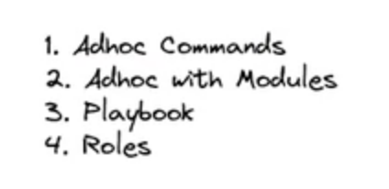

## Adhoc

ubuntu@ip-172-31-31-36:/etc/ansible$ ansible agent1 -a "touch /tmp/test"

[WARNING]: Consider using the file module with state=touch rather than running 'touch'. If you need to use command because file is insufficient you

can add 'warn: false' to this command task or set 'command_warnings=False' in ansible.cfg to get rid of this message.

agent1 | CHANGED | rc=0 >>

Installing packages via adhoc commands………………………………….

ubuntu@ip-172-31-31-36:/etc$ ansible agent1 -m apt -a "name=nginx state=present"

agent1 | FAILED! => {

"ansible_facts": {

"discovered_interpreter_python": "/usr/bin/python3"

},

"cache_update_time": 1638228811,

"cache_updated": false,

"changed": false,

"msg": "'/usr/bin/apt-get -y -o \"Dpkg::Options::=--force-confdef\" -o \"Dpkg::Options::=--force-confold\" install 'nginx'' failed: E: Could not open lock file /var/lib/dpkg/lock-frontend - open (13: Permission denied)\nE: Unable to acquire the dpkg frontend lock (/var/lib/dpkg/lock-frontend), are you root?\n",

"rc": 100,

"stderr": "E: Could not open lock file /var/lib/dpkg/lock-frontend - open (13: Permission denied)\nE: Unable to acquire the dpkg frontend lock (/var/lib/dpkg/lock-frontend), are you root?\n",

"stderr_lines": [

"E: Could not open lock file /var/lib/dpkg/lock-frontend - open (13: Permission denied)",

"E: Unable to acquire the dpkg frontend lock (/var/lib/dpkg/lock-frontend), are you root?"

],

"stdout": "",

"stdout_lines": []

}

ubuntu@ip-172-31-31-36:/etc$ ansible agent1 -m apt -a "name=nginx state=present" –become

OR

ubuntu@ip-172-31-31-36:/etc$ ansible agent1 -m apt -a "name=nginx state=present" –b

will not install again----------------

ubuntu@ip-172-31-31-36:/etc$ ansible agent1 -m apt -a "name=nginx state=present" -b

agent1 | SUCCESS => {

"ansible_facts": {

"discovered_interpreter_python": "/usr/bin/python3"

},

"cache_update_time": 1638228811,

"cache_updated": false,

"changed": false

}

Remove Nginx------------------------

ubuntu@ip-172-31-31-36:/etc$ ansible agent1 -m apt -a "name=nginx state=absent" -b

Use module copy-----------------

ubuntu@ip-172-31-31-36:~/mavenproject$ touch new

ubuntu@ip-172-31-31-36:~/mavenproject$ ansible agent1 -m copy -a "src=new dest=/tmp/test"

agent1 | SUCCESS => {

"ansible_facts": {

"discovered_interpreter_python": "/usr/bin/python3"

},

"changed": false,

"checksum": "da39a3ee5e6b4b0d3255bfef95601890afd80709",

"dest": "/tmp/test",

"gid": 1000,

"group": "ubuntu",

"mode": "0664",

"owner": "ubuntu",

"path": "/tmp/test",

"size": 0,

"state": "file",

"uid": 1000

}

ubuntu@ip-172-31-31-36:~/mavenproject$ echo "hello" > new

ubuntu@ip-172-31-31-36:~/mavenproject$ ansible agent1 -m copy -a "src=new dest=/tmp/test"

agent1 | CHANGED => {

"ansible_facts": {

"discovered_interpreter_python": "/usr/bin/python3"

},

"changed": true,

"checksum": "f572d396fae9206628714fb2ce00f72e94f2258f",

"dest": "/tmp/test",

"gid": 1000,

"group": "ubuntu",

"md5sum": "b1946ac92492d2347c6235b4d2611184",

"mode": "0664",

"owner": "ubuntu",

"size": 6,

"src": "/home/ubuntu/.ansible/tmp/ansible-tmp-1639807422.8382394-207803471415655/source",

"state": "file",

"uid": 1000

}

Install nginx and start the service on agent1 n agent2 --------------------

ubuntu@ip-172-31-31-36:~/mavenproject$ ansible group1 -m apt -a "name=* state=present" –b

ubuntu@ip-172-31-31-36:~/mavenproject$ ansible group1 -m apt -a "name=nginx state=present" –b

ubuntu@ip-172-31-31-36:~/mavenproject$ ansible group1 -m systemd -a "name=nginx state=started" –b

ansible group1 -m systemd -a "name=nginx state=stopped" –b

ansible group1 -m systemd -a "name=nginx state=reloaded" –b

ubuntu@ip-172-31-31-36:~/mavenproject$ vi inv

ubuntu@ip-172-31-31-36:~/mavenproject$ cat inv

agent1 ansible_host=3.16.40.232 ansible_user=ubuntu ansible_port=22

agent2 ansible_host=18.217.77.238 ansible_user=ubuntu ansible_port=22

[group1]

agent1

agent2

ubuntu@ip-172-31-31-36:~/mavenproject$ ansible group1 -m systemd -a "name=nginx state=stopped" -b -i inv

Vi inv

agent1 ansible_host=3.16.40.232

db1 ansible_host=18.217.77.238

[group1]

agent1

[group2]

db1

[all:vars]

ansible_user=ubuntu

ansible_port=22

[prod:children]

group1

group2

ubuntu@ip-172-31-31-36:~/mavenproject$ ansible group1 -m ping -i inv

agent1 | SUCCESS => {

"ansible_facts": {

"discovered_interpreter_python": "/usr/bin/python3"

},

"changed": false,

"ping": "pong"

}

ubuntu@ip-172-31-31-36:~/mavenproject$ ansible group2 -m ping -i inv

^[[A^[[A^[[Adb1 | SUCCESS => {

"ansible_facts": {

"discovered_interpreter_python": "/usr/bin/python3"

},

"changed": false,

"ping": "pong"

}

ubuntu@ip-172-31-31-36:~/mavenproject$ ansible all -m ping -i inv

agent1 | SUCCESS => {

"ansible_facts": {

"discovered_interpreter_python": "/usr/bin/python3"

},

"changed": false,

"ping": "pong"

}

db1 | SUCCESS => {

"ansible_facts": {

"discovered_interpreter_python": "/usr/bin/python3"

},

"changed": false,

"ping": "pong"

}

ubuntu@ip-172-31-31-36:~/mavenproject$ ansible prod -m ping -i inv

agent1 | SUCCESS => {

"ansible_facts": {

"discovered_interpreter_python": "/usr/bin/python3"

},

"changed": false,

"ping": "pong"

}

db1 | SUCCESS => {

"ansible_facts": {

"discovered_interpreter_python": "/usr/bin/python3"

},

"changed": false,

"ping": "pong"

}

## Playbook



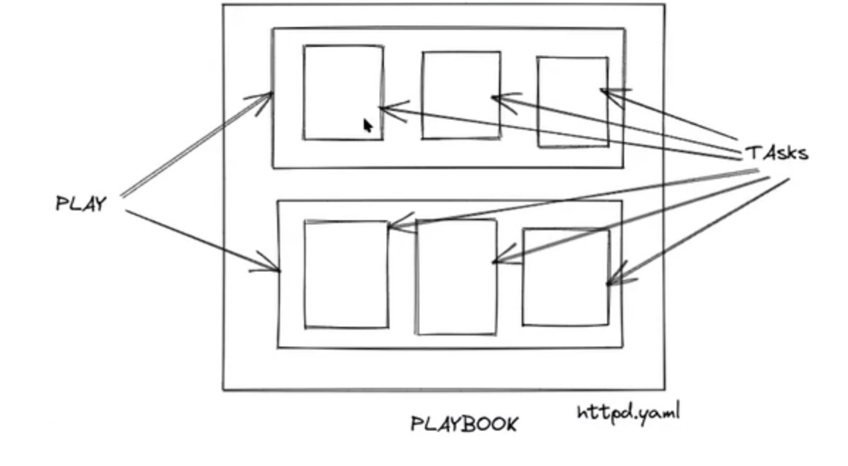

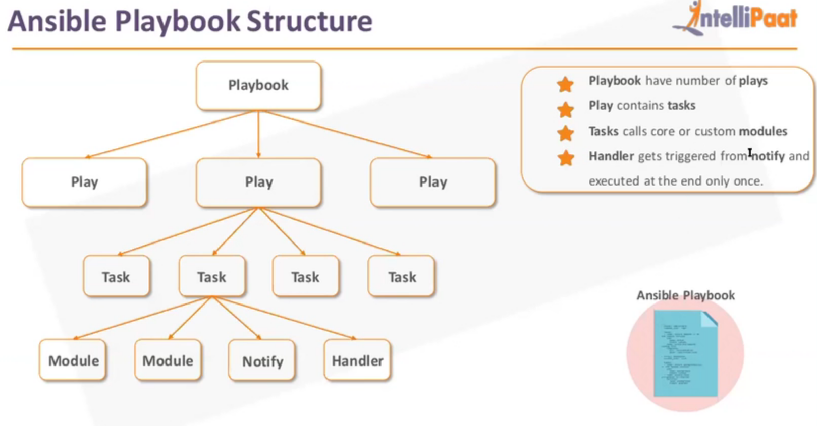

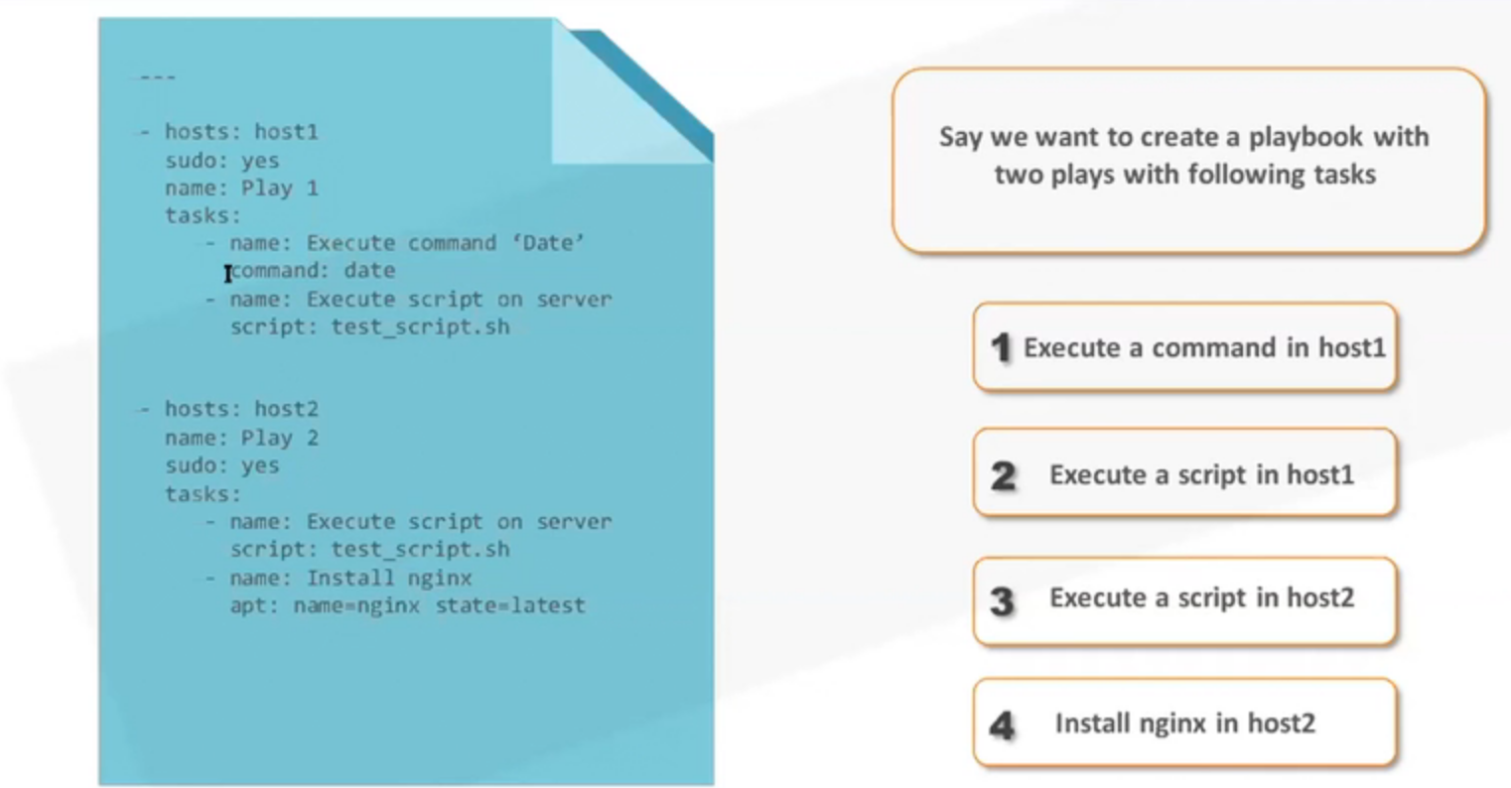

ubuntu@ip-172-31-31-36:~/mavenproject$ vi myfirstplaybook.yaml

- name: play1 for playbook

  hosts: all

  become: yes

  tasks:

   - name: installing nginx

     apt:

        name: nginx

        state: present

   - name: Restart service

     systemd:

        name: nginx

        state: restarted

- name: play2 for playbook

  hosts: group2

  become: yes

  tasks:

   - name: copying file

     copy:

        src: new

        destination: /tmp/new

///to check syntax in playbook using ansible

ubuntu@ip-172-31-31-36:~/mavenproject$ ansible-playbook -i inv myfirstplaybook.yaml --check

PLAY [play1 for playbook] ****************************************************************************************************************************

TASK [Gathering Facts] *******************************************************************************************************************************

ok: [agent1]

ok: [db1]

TASK [installing nginx] ******************************************************************************************************************************

changed: [agent1]

changed: [db1]

TASK [Restart service] *******************************************************************************************************************************

changed: [db1]

changed: [agent1]

PLAY [play2 for playbook] ****************************************************************************************************************************

TASK [Gathering Facts] *******************************************************************************************************************************

ok: [db1]

TASK [copying file] **********************************************************************************************************************************

fatal: [db1]: FAILED! => {"changed": false, "msg": "dest is required"}

PLAY RECAP *******************************************************************************************************************************************

agent1 : ok=3 changed=2 unreachable=0 failed=0 skipped=0 rescued=0 ignored=0

db1 : ok=4 changed=2 unreachable=0 failed=1 skipped=0 rescued=0 ignored=0

////now make changes

- name: play1 for playbook

  hosts: all

  become: yes

  tasks:

   - name: installing nginx

     apt:

        name: nginx

        state: present

   - name: Restart service

     systemd:

        name: nginx

        state: restarted

- name: play2 for playbook

  hosts: group2

  become: yes

  tasks:

   - name: Create a directory if it does not exist

     file:

       path: /tmp/new

       state: directory

   - name: copying file

     copy:

        src: new

        dest: /tmp/new

//////

ubuntu@ip-172-31-31-36:~/mavenproject$ vi myfirstplaybook.yaml

- name: play1 for playbook

  hosts: all

  become: yes

  tasks:

   - name: installing nginx

     apt:

        name: nginx

        state: present

   - name: taking backup of original html file

     command: mv /var/www/html/index.nginx-debian.html /var/www/html/index.nginx-debian.html_backup

   - name: updating index page

     copy:

         src: index.nginx-debian.html

         dest: /var/www/html/

   - name: Restart service

     systemd:

        name: nginx

        state: restarted

- name: play2 for playbook

  hosts: group2

  become: yes

  tasks:

   - name: Create a directory if it does not exist

     file:

       path: /tmp/new

       state: directory

   - name: copying file

     copy:

        src: new

        dest: /tmp/new

ubuntu@ip-172-31-31-36:~/mavenproject$ ansible-playbook -i inv myfirstplaybook.yaml –check

ubuntu@ip-172-31-31-36:~/mavenproject$ ansible-playbook -i inv myfirstplaybook.yaml



For debugging

ubuntu@ip-172-31-31-36:~/mavenproject$ ansible-playbook -i inv myfirstplaybook.yaml –v

////go upto 4 v’s

### Handlers

///so that servers do not go into downtime

ubuntu@ip-172-31-31-36:~/mavenproject$ vi myfirstplaybookwithhandlers.yaml



ubuntu@ip-172-31-31-36:~/mavenproject$ ansible-playbook -i inv myfirstplaybookwithhandlers.yaml --check

PLAY [play1 for playbook] ****************************************************************************************************************************

TASK [Gathering Facts] *******************************************************************************************************************************

ok: [db1]

ok: [agent1]

TASK [installing nginx] ******************************************************************************************************************************

ok: [db1]

ok: [agent1]

TASK [taking backup of original html file] ***********************************************************************************************************

skipping: [agent1]

skipping: [db1]

TASK [updating index page] ***************************************************************************************************************************

ok: [agent1]

ok: [db1]

PLAY [play2 for playbook] ****************************************************************************************************************************

TASK [Gathering Facts] *******************************************************************************************************************************

ok: [db1]

TASK [Create a directory if it does not exist] *******************************************************************************************************

ok: [db1]

TASK [copying file] **********************************************************************************************************************************

ok: [db1]

PLAY RECAP *******************************************************************************************************************************************

agent1 : ok=3 changed=0 unreachable=0 failed=0 skipped=1 rescued=0 ignored=0

db1 : ok=6 changed=0 unreachable=0 failed=0 skipped=1 rescued=0 ignored=0

//////the above do not have restart option so no downtime required

/////after changes to html file

ubuntu@ip-172-31-31-36:~/mavenproject$ vi index.nginx-debian.html

ubuntu@ip-172-31-31-36:~/mavenproject$ ansible-playbook -i inv myfirstplaybookwithhandlers.yaml –check

PLAY [play1 for playbook] ****************************************************************************************************************************

TASK [Gathering Facts] *******************************************************************************************************************************

ok: [db1]

ok: [agent1]

TASK [installing nginx] ******************************************************************************************************************************

ok: [agent1]

ok: [db1]

TASK [taking backup of original html file] ***********************************************************************************************************

skipping: [db1]

skipping: [agent1]

TASK [updating index page] ***************************************************************************************************************************

changed: [db1]

changed: [agent1]

RUNNING HANDLER [restart nginx] **********************************************************************************************************************

changed: [db1]

changed: [agent1]

PLAY [play2 for playbook] ****************************************************************************************************************************

TASK [Gathering Facts] *******************************************************************************************************************************

ok: [db1]

TASK [Create a directory if it does not exist] *******************************************************************************************************

ok: [db1]

TASK [copying file] **********************************************************************************************************************************

ok: [db1]

PLAY RECAP *******************************************************************************************************************************************

agent1 : ok=4 changed=2 unreachable=0 failed=0 skipped=1 rescued=0 ignored=0

db1 : ok=7 changed=2 unreachable=0 failed=0 skipped=1 rescued=0 ignored=0

### Use of variables



Run the above

## Roles

ubuntu@ip-172-31-31-36:~/mavenproject$ cd /etc/ansible/

ubuntu@ip-172-31-31-36:/etc/ansible$ ls

ansible.cfg hosts

ubuntu@ip-172-31-31-36:/etc/ansible$ mkdir roles

mkdir: cannot create directory ‘roles’: Permission denied

ubuntu@ip-172-31-31-36:/etc/ansible$ sudo mkdir roles

ubuntu@ip-172-31-31-36:/etc/ansible$ cd roles/

ubuntu@ip-172-31-31-36:/etc/ansible/roles$ sudo ansible-galaxy init firstrole --offline

- Role firstrole was created successfully

ubuntu@ip-172-31-31-36:/etc/ansible/roles$ tree firstrole/

Command 'tree' not found, but can be installed with:

sudo snap install tree # version 1.8.0+pkg-3fd6, or

sudo apt install tree # version 1.8.0-1

See 'snap info tree' for additional versions.

ubuntu@ip-172-31-31-36:/etc/ansible/roles$ sudo apt install tree

Reading package lists... Done

Building dependency tree

Reading state information... Done

The following packages were automatically installed and are no longer required:

apache2-bin apache2-data apache2-utils daemon libapr1 libaprutil1 libaprutil1-dbd-sqlite3 libaprutil1-ldap libjansson4 liblua5.2-0 ssl-cert

Use 'sudo apt autoremove' to remove them.

The following NEW packages will be installed:

tree

0 upgraded, 1 newly installed, 0 to remove and 19 not upgraded.

Need to get 43.0 kB of archives.

After this operation, 115 kB of additional disk space will be used.

Get:1 http://us-east-2.ec2.archive.ubuntu.com/ubuntu focal/universe amd64 tree amd64 1.8.0-1 [43.0 kB]

Fetched 43.0 kB in 0s (2550 kB/s)

Selecting previously unselected package tree.

(Reading database ... 139730 files and directories currently installed.)

Preparing to unpack .../tree_1.8.0-1_amd64.deb ...

Unpacking tree (1.8.0-1) ...

Setting up tree (1.8.0-1) ...

Processing triggers for man-db (2.9.1-1) ...

ubuntu@ip-172-31-31-36:/etc/ansible/roles$ tree firstrole/

firstrole/

├── README.md

├── defaults

│   └── main.yml

├── files

├── handlers

│   └── main.yml

├── meta

│   └── main.yml

├── tasks

│   └── main.yml

├── templates

├── tests

│   ├── inventory

│   └── test.yml

└── vars

└── main.yml

////find variable value for agents

ubuntu@ip-172-31-31-36:/etc/ansible/roles$ cd ~/mavenproject/

ubuntu@ip-172-31-31-36:~/mavenproject$ ansible agent1 -i inv -m setup

(((("ansible_os_family": "Debian")))

ubuntu@ip-172-31-31-36:~/mavenproject$ cd /etc/ansible/roles/firstrole/

ubuntu@ip-172-31-31-36:/etc/ansible/roles/firstrole$ ls

README.md defaults files handlers meta tasks templates tests vars

ubuntu@ip-172-31-31-36:/etc/ansible/roles/firstrole$ cd tasks/

ubuntu@ip-172-31-31-36:/etc/ansible/roles/firstrole/tasks$ ls

main.yml

ubuntu@ip-172-31-31-36:/etc/ansible/roles/firstrole/tasks$ ll

total 12

drwxr-xr-x 2 root root 4096 Dec 20 17:07 ./

drwxr-xr-x 10 root root 4096 Dec 20 17:07 ../

-rw-r--r-- 1 root root 30 Dec 20 17:07 main.yml

ubuntu@ip-172-31-31-36:/etc/ansible/roles/firstrole/tasks$ sudo vi main.yml

# tasks file for firstrole

- include: ubuntu.yml

when: ansible_os_family == 'Debian'

- include: redhat.yml

when: ansible_os_family == 'Redhat'

ubuntu@ip-172-31-31-36:/etc/ansible/roles/firstrole/tasks$ ll

total 12

drwxr-xr-x 2 root root 4096 Dec 20 17:23 ./

drwxr-xr-x 10 root root 4096 Dec 20 17:07 ../

-rw-r--r-- 1 root root 153 Dec 20 17:23 main.yml

ubuntu@ip-172-31-31-36:/etc/ansible/roles/firstrole/tasks$ touch ubuntu.yml

touch: cannot touch 'ubuntu.yml': Permission denied

ubuntu@ip-172-31-31-36:/etc/ansible/roles/firstrole/tasks$ sudo bash

root@ip-172-31-31-36:/etc/ansible/roles/firstrole/tasks# touch ubuntu.yml

root@ip-172-31-31-36:/etc/ansible/roles/firstrole/tasks# touch redhat.yml

root@ip-172-31-31-36:/etc/ansible/roles/firstrole/tasks# vim ubuntu.yml

root@ip-172-31-31-36:/etc/ansible/roles/firstrole/tasks# vim ubuntu.yml

root@ip-172-31-31-36:/etc/ansible/roles/firstrole/tasks# vim redhat.yml



root@ip-172-31-31-36:/etc/ansible/roles/firstrole/tasks# cd ..

root@ip-172-31-31-36:/etc/ansible/roles/firstrole# cd handlers/

root@ip-172-31-31-36:/etc/ansible/roles/firstrole/handlers# vi main.yml

# handlers file for firstrole

- name: restart nginx

service:

name: nginx

state: restarted

- name: start nginx

service:

name: nginx

state: restarted

root@ip-172-31-31-36:/etc/ansible/roles/firstrole/handlers# cd ../files/

root@ip-172-31-31-36:/etc/ansible/roles/firstrole/files# vi index.nginx-debian.html

root@ip-172-31-31-36:/etc/ansible/roles/firstrole/files# ls

index.nginx-debian.html

root@ip-172-31-31-36:/etc/ansible/roles/firstrole# tree

.

├── README.md

├── defaults

│   └── main.yml

├── files

│   └── index.nginx-debian.html

├── handlers

│   └── main.yml

├── meta

│   └── main.yml

├── tasks

│   ├── main.yml

│   ├── redhat.yml

│   └── ubuntu.yml

├── templates

├── tests

│   ├── inventory

│   └── test.yml

└── vars

└── main.yml

root@ip-172-31-31-36:/etc/ansible/roles/firstrole# cd ..

root@ip-172-31-31-36:/etc/ansible/roles# cd ..

root@ip-172-31-31-36:/etc/ansible# ls

ansible.cfg hosts roles

root@ip-172-31-31-36:/etc/ansible# vi role.yaml

- name: Call role

hosts: group1

become: yes

roles:

- firstrole

ubuntu@ip-172-31-31-36:/etc/ansible$ ansible-playbook -i /home/ubuntu/mavenproject/inv role.yaml --syntax-check

playbook: role.yaml

ubuntu@ip-172-31-31-36:/etc/ansible$ ansible-playbook -i /home/ubuntu/mavenproject/inv role.yaml

root@ip-172-31-31-36:/etc/ansible/roles/firstrole/vars# vi main.yml

---

# vars file for firstrole

packagename: nginx

/////edit Ubuntu.yaml n redhat.yaml as below

# Define redhat tasks

- name: installing nginx

yum:

name: '{{ packagename }}'

state: present

notify:

- restart nginx

- name: taking backup of original html file

command: mv /var/www/html/index.nginx-debian.html /var/www/html/index.nginx-debian.html_backup

notify:

- restart nginx

- name: updating index page

copy:

src: index.nginx-debian.html

dest: /var/www/html/

notify:

- restart nginx

- name: Start service

systemd:

name: nginx

state: started

ubuntu@ip-172-31-31-36:/etc/ansible$ ansible-playbook -i /home/ubuntu/mavenproject/inv role.yaml --syntax-check

playbook: role.yaml

ubuntu@ip-172-31-31-36:/etc/ansible$ ansible-playbook -i /home/ubuntu/mavenproject/inv role.yaml

/////meta for dependencies