# Puppet

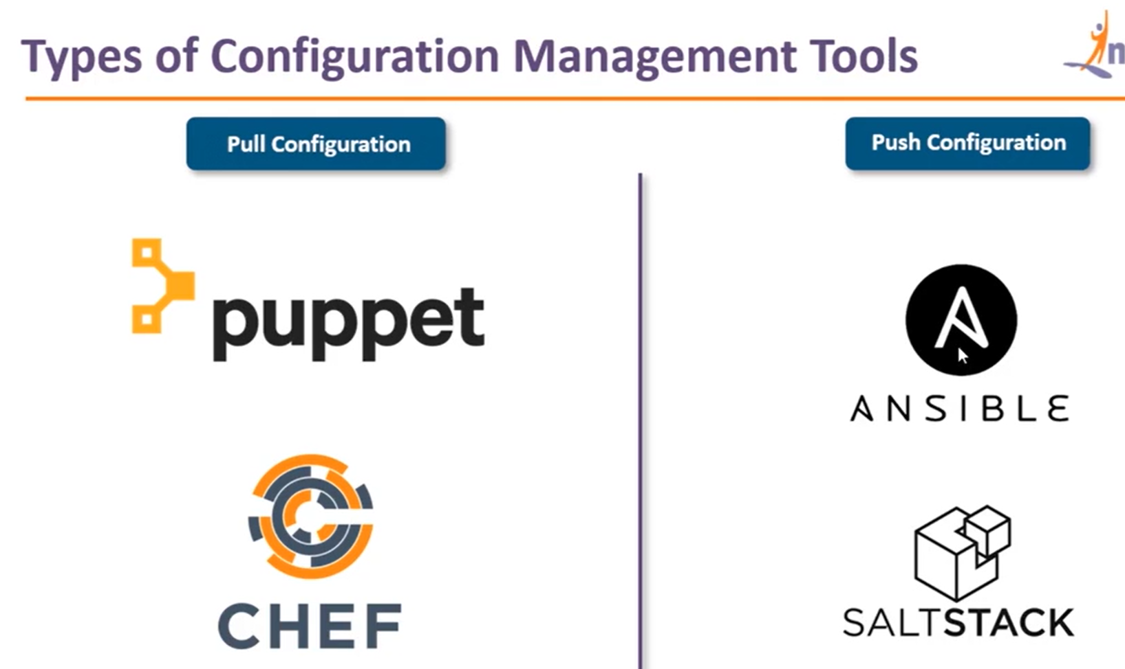

## Setup master-slave

### On master

1. sudo apt-get update
2. sudo apt-get install wget
3. wget https://apt.puppetlabs.com/puppet-release-bionic.deb
4. sudo dpkg -i puppet-release-bionic.deb
5. sudo apt-get install puppetmaster
6. apt policy puppet master
7. sudo systemctl status puppet-master.service
8. vim /etc/default/puppet-master
9. sudo vim /etc/default/puppet-master

*JAVA_ARGS="-Xms512m -Xmx512m"*

1. sudo systemctl restart puppet-master.service
2. sudo ufw allow 8140/tcp

### On Slave

1. sudo apt-get update
2. sudo apt-get install wget
3. wget https://apt.puppetlabs.com/puppet-release-bionic.deb
4. sudo dpkg -i puppet-release-bionic.deb
5. sudo apt-get update
6. sudo apt-get install puppet
7. apt policy puppet master

### Make changes to the hosts file which exists in /etc/hosts. And add the Puppet Master IP address along with the name “puppet” on both servers

Sudo vim /etc/hosts

54.175.117.192 puppet

### On slave

1. sudo systemctl start puppet
2. sudo systemctl enable puppet

### On master

1. sudo puppet cert list
2. sudo puppet cert sign –all
3. sudo mkdir -p /etc/puppet/code/environments/production/manifests
4. sudo vim /etc/puppet/code/environments/production/manifests/site.pp

*file {'/tmp/it_works.txt':*

*ensure => present,*

*mode => '0644',*

*content => "It works on ${ipaddress_eth0}!\n",*

}

1. sudo systemctl restart puppet-master

### On slave

1. sudo puppet agent --test
2. cd /tmp/
3. cat it_works.txt

## Coding/Creating manifests

### Basics

1. On master--🡪

* Cd /etc/puppet/code/environments/production/manifests/
* Sudo vim site.pp

node default {

package {'nginx':

ensure => installed,

}

file {'/tmp/status.txt':

content => 'nginx installed',

mode => '0644',

}

}

* On slave -🡪 sudo puppet agent --test
* Cat /tmp/status.txt

nginx installed

* 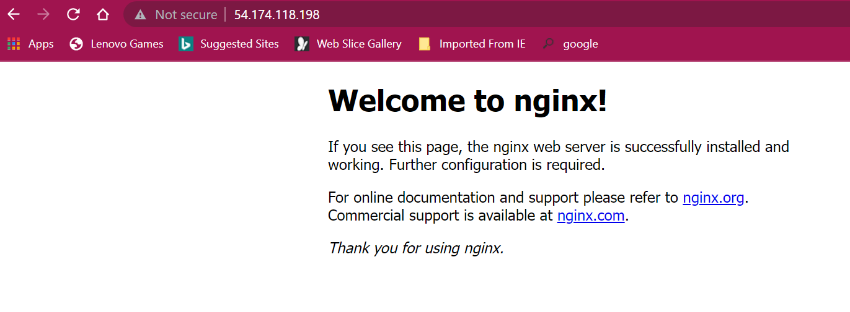

### Variables

* On master-🡪 sudo vim /etc/puppet/code/environments/production/manifests/site.pp

node default {

package {'nginx':

ensure => installed,

}

$text = "saarit devops "

file {'/tmp/status.txt':

content => $text,

mode => '0644',

}

}

* On slave-🡪 sudo puppet agent –test
* cat status.txt

saarit devops

### Loops

* On Slave-🡪 sudo apt-get purge nginx
* Sudo systemctl stop nginx.services
* Sudo apt-get remove nginx
* On master-🡪 sudo vim /etc/puppet/code/environments/production/manifests/site.pp

node default {

$packages = ['apache2','mysql-server']

package { $packages:

ensure => installed,

}

}

* On slave-🡪 sudo puppet agent –test

### Conditions

* On master-🡪 sudo vim /etc/puppet/code/environments/production/manifests/site.pp

node default {

exec {"condition":

command => "/bin/echo apache2 is installed > /tmp/status_apache.txt",

onlyif => "/bin/which apache2",

}

}

* On slave-🡪 sudo puppet agent –test
* /tmp$ cat status_apache.txt

apache2 is installed

* Sudo apt-get purge apache2
* /bin/which apache2

/usr/sbin/apache2

* sudo rm /usr/sbin/apache2
* sudo puppet agent –test

no file created

* On master -🡪 sudo vim /etc/puppet/code/environments/production/manifests/site.pp

node default {

exec {"condition":

command => "/bin/echo apache2 is not installed > /tmp/status_apache.txt",

unless => "/bin/which apache2",

}

}

* On slave🡪 sudo puppet agent –test
* /tmp$ cat status_apache.txt

apache2 is not installed

## Applying configurations using modules

Module (manifest(classes)),manifest(classes),…….)

### On master

* cd
* mkdir new
* cd new
* sudo apt install gem
* sudo gem install multi_json -v 1.5.1
* sudo puppet module generate devops-new

ubuntu@ip-172-31-85-185:~/new$ sudo puppet module generate devops-new

/usr/lib/ruby/vendor_ruby/puppet/util.rb:461: warning: URI.escape is obsolete

Warning: `puppet module generate` is deprecated and will be removed in a future release. This action has been replaced by Puppet Development Kit. For more information visit https://puppet.com/docs/pdk/latest/pdk.html.

(location: /usr/lib/ruby/vendor_ruby/puppet/face/module/generate.rb:142:in `generate')

We need to create a metadata.json file for this module. Please answer the

following questions; if the question is not applicable to this module, feel free

to leave it blank.

Puppet uses Semantic Versioning (semver.org) to version modules.

What version is this module? [0.1.0]

--> 1.0.0

Who wrote this module? [devops]

-->

What license does this module code fall under? [Apache-2.0]

-->

How would you describe this module in a single sentence?

--> devops

Where is this module's source code repository?

--> devops

Where can others go to learn more about this module?

--> devops

Where can others go to file issues about this module?

--> devops

----------------------------------------

{

"name": "devops-new",

"version": "1.0.0",

"author": "devops",

"summary": "devops",

"license": "Apache-2.0",

"source": "devops",

"project_page": "devops",

"issues_url": "devops",

"dependencies": [

{

"name": "puppetlabs-stdlib",

"version_requirement": ">= 1.0.0"

}

],

"data_provider": null

}

----------------------------------------

About to generate this metadata; continue? [n/Y]

--> y

Notice: Generating module at /home/ubuntu/new/new...

Notice: Populating templates...

Finished; module generated in new.

new/Gemfile

new/metadata.json

new/manifests

new/manifests/init.pp

new/spec

new/spec/classes

new/spec/classes/init_spec.rb

new/spec/spec_helper.rb

new/examples

new/examples/init.pp

new/README.md

new/Rakefile

* cd ~/new/new/manifests
* sudo vi init.pp

class new{

file{'/tmp/module_test.txt':

content=> "This file is created by a module",

mode=> '0644',

}

}

* sudo puppet module build new at cd ~/new/
* if fails, install pdk via apt install pdk
* cd new
* sudo pdk convert
* sudo pdk build
* sudo puppet module install /home/ubuntu/new/new/pkg/devops-new-1.0.0.tar.gz
* sudo vi /etc/puppet/code/environments/production/manifests/site.pp

node default{

include new

}

* On slave--🡪 sudo puppet agent –test
* ubuntu@ip-172-31-80-54:/tmp$ cat module_test.txt

This file was generated by a module

## Invoking classes based on nodes

### On master for nodes

### Node1

* ubuntu@ip-172-31-85-185:/etc/puppet/code/environments/production/modules$ sudo mkdir node1c
* ubuntu@ip-172-31-85-185:/etc/puppet/code/environments/production/modules$ cd node1c/
* ubuntu@ip-172-31-85-185:/etc/puppet/code/environments/production/modules/node1c$ sudo mkdir manifests
* ubuntu@ip-172-31-85-185:/etc/puppet/code/environments/production/modules/node1c$ cd manifests/
* ubuntu@ip-172-31-85-185:/etc/puppet/code/environments/production/modules/node1c/manifests$ vi init.pp
* ubuntu@ip-172-31-85-185:/etc/puppet/code/environments/production/modules/node1c/manifests$ sudo vi init.pp

*class node1c {*

*file {'/tmp/software.txt':*

*content => "this is software for node1",*

*mode => "0644",*

*}*

*}*

### On node 2

* ubuntu@ip-172-31-85-185:/etc/puppet/code/environments/production/modules/node1c/manifests$ cd ../../
* ubuntu@ip-172-31-85-185:/etc/puppet/code/environments/production/modules$ sudo mkdir node2c
* ubuntu@ip-172-31-85-185:/etc/puppet/code/environments/production/modules$ cd node2c/
* ubuntu@ip-172-31-85-185:/etc/puppet/code/environments/production/modules/node2c$ sudo mkdir manifests
* ubuntu@ip-172-31-85-185:/etc/puppet/code/environments/production/modules/node2c$ cd manifests/
* ubuntu@ip-172-31-85-185:/etc/puppet/code/environments/production/modules/node2c/manifests$ sudo vi init.pp

*class node2c {*

*file {'/tmp/software.txt':*

*content => "this is software for node1",*

*mode => "0644",*

*}*

*}*

### Main manifests

Edit site.pp

Node ‘nodename’ {

Include node1c

}