# MAVEN+JENKINS

## Maven

ubuntu@ip-172-31-31-36:~$ sudo apt install maven

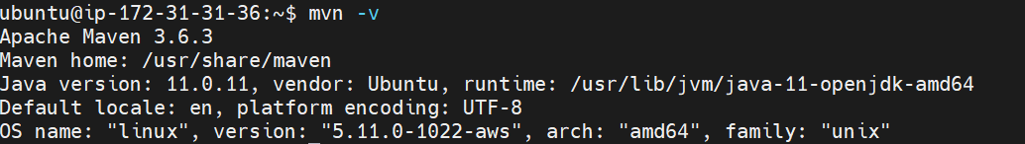

Run these commands where pom.xml, src directory is present

Mvn validate

Mvn compile

Mvn test

Mvn package

Mvn install

Mvn clean

Creates target folder

Mvn dependencies are in /home/ubuntu/.m2

## Via docker

C:\Users\Saarit\OneDrive\Desktop\Me\DevOps\jenkins+maven\mvnproject\mvn-project



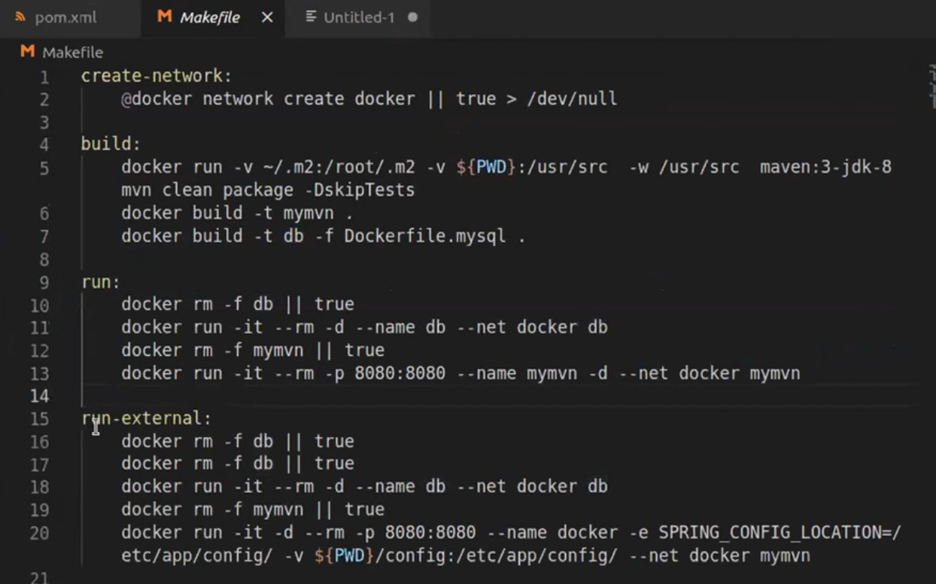

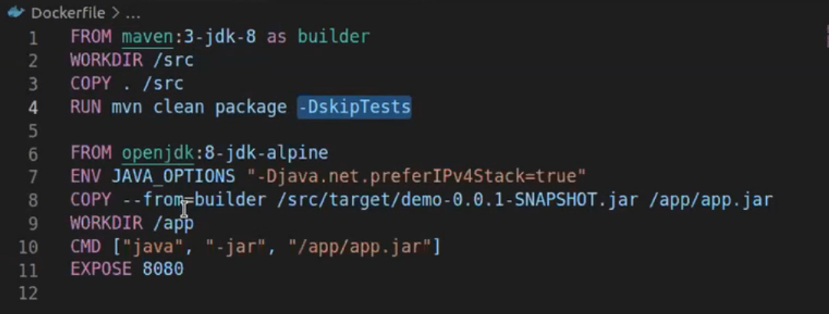

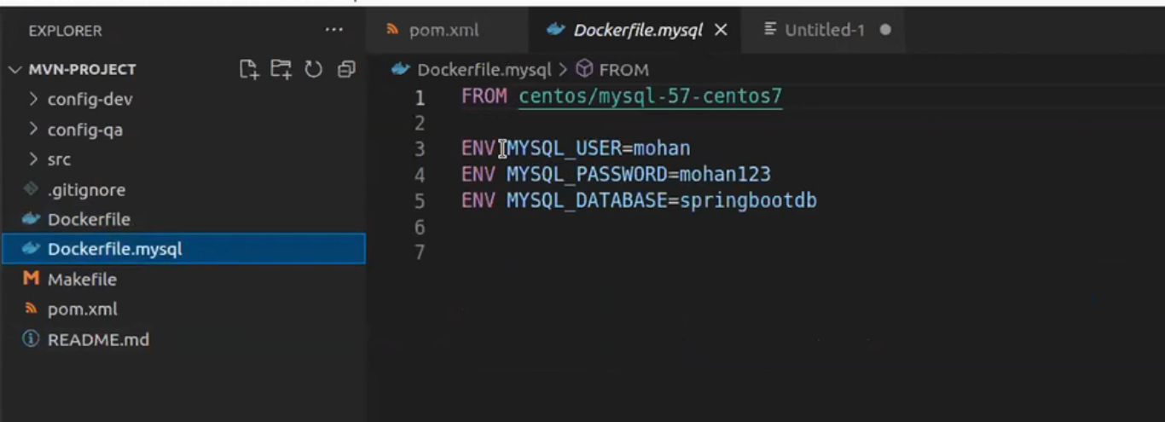

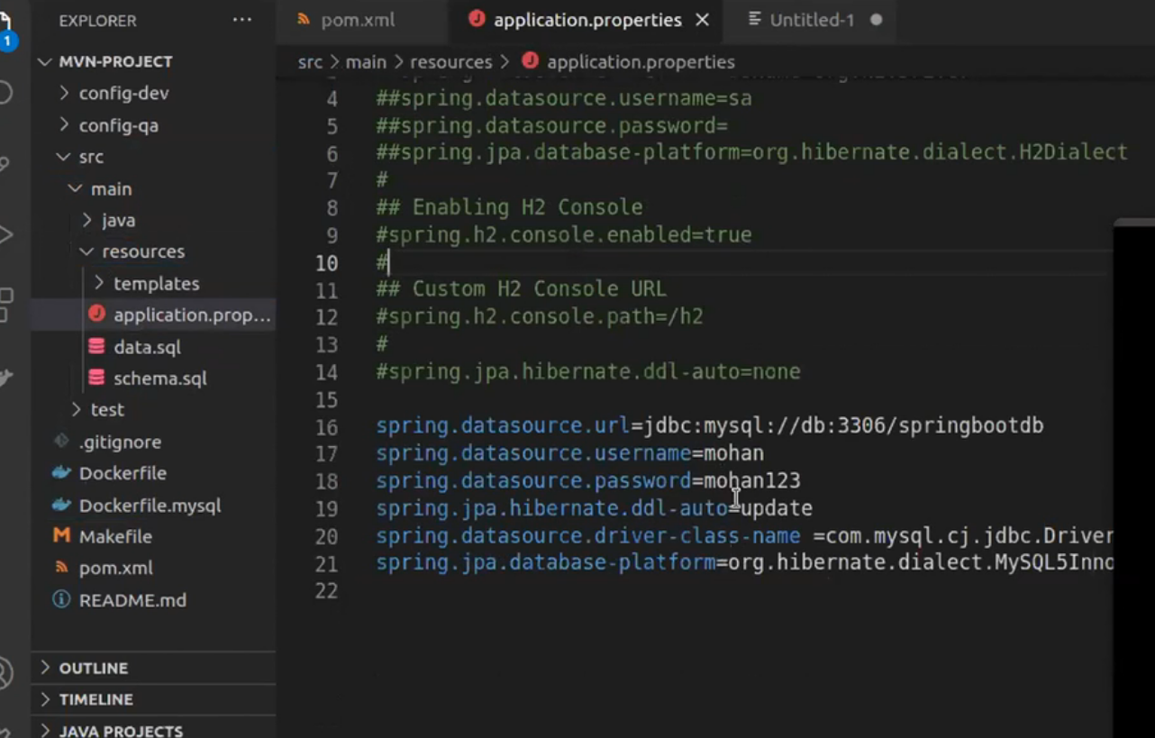

## CI

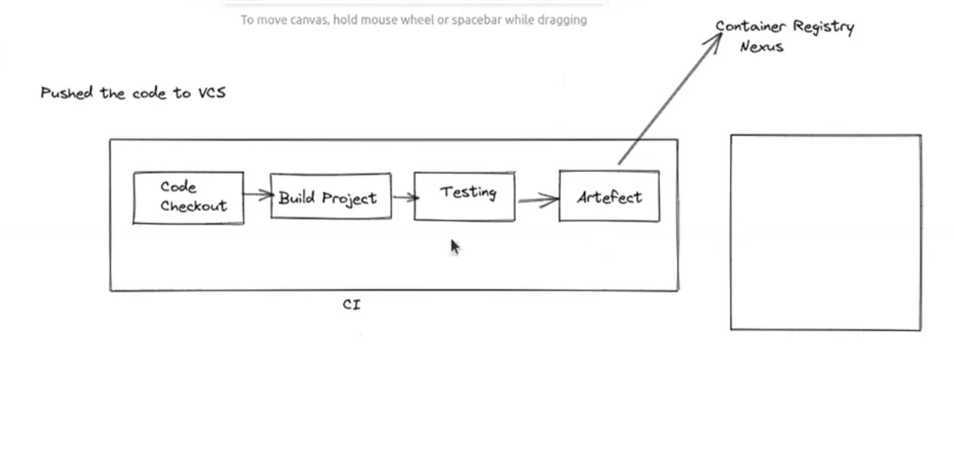

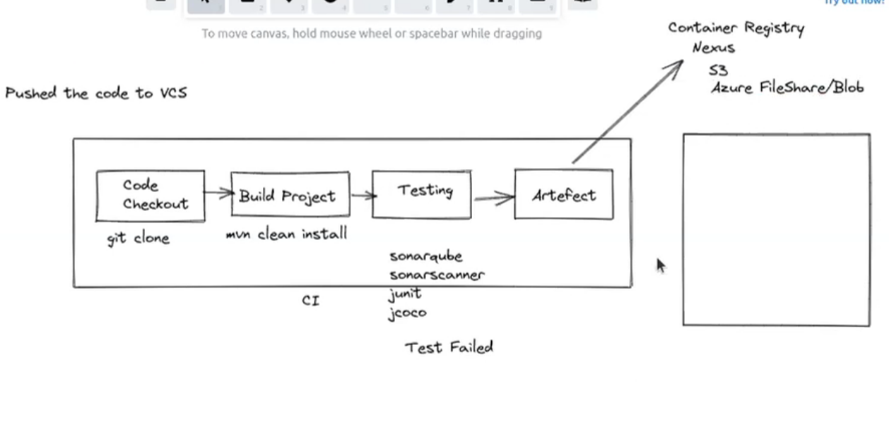

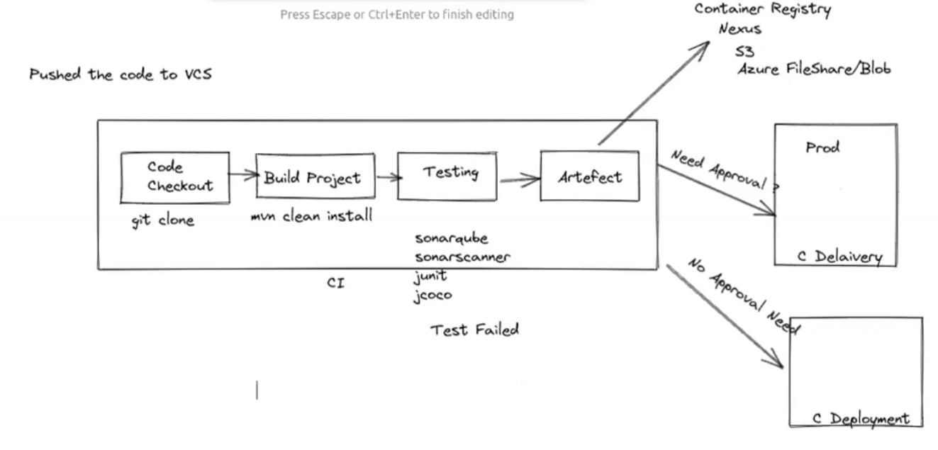

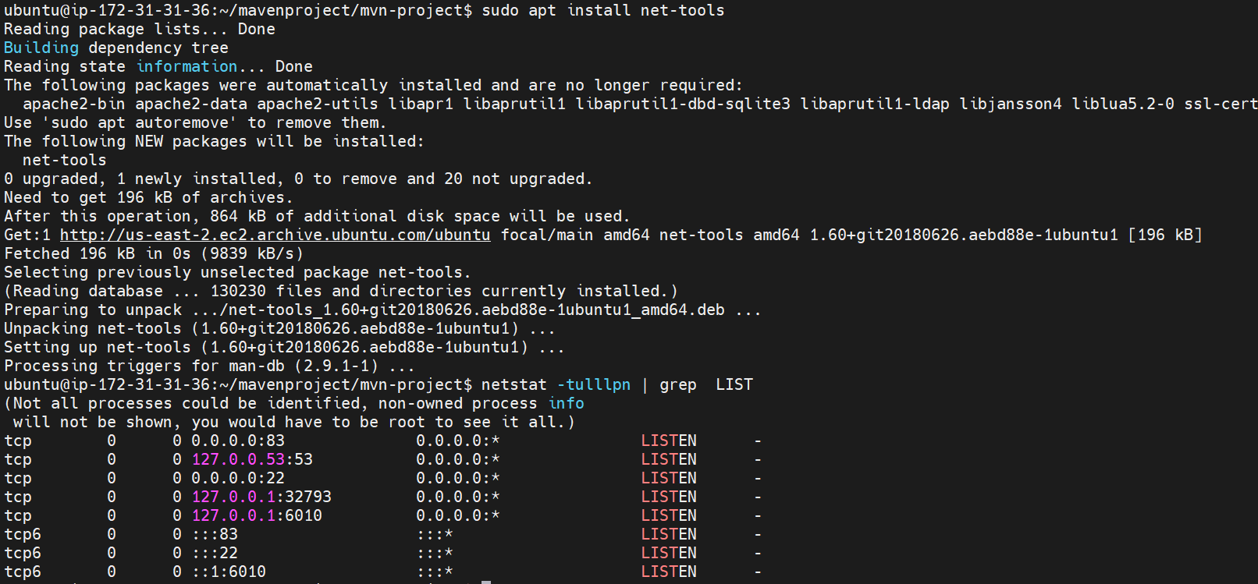

## Jenkins

<https://www.digitalocean.com/community/tutorials/how-to-install-jenkins-on-ubuntu-18-04>

ubuntu@ip-172-31-31-36:~/mavenproject/mvn-project$ sudo systemctl enable Jenkins ///add this also

////remove Jenkins

ubuntu@ip-172-31-31-36:~/mavenproject/mvn-project$ sudo systemctl stop jenkins

ubuntu@ip-172-31-31-36:~/mavenproject/mvn-project$ sudo apt-get remove --purge Jenkins

Install using docker

docker pull jenkins/jenkins

docker run --name myjenkinsNew -d -v /tmp/Jenkins:/var/Jenkins_home -p 8080:8080 -p 50000:50000 jenkins/Jenkins

docker exec –it {container name} bash

cat /var/jenkins_home/secrets/initialAdminPassword

OR

docker logs {container name}

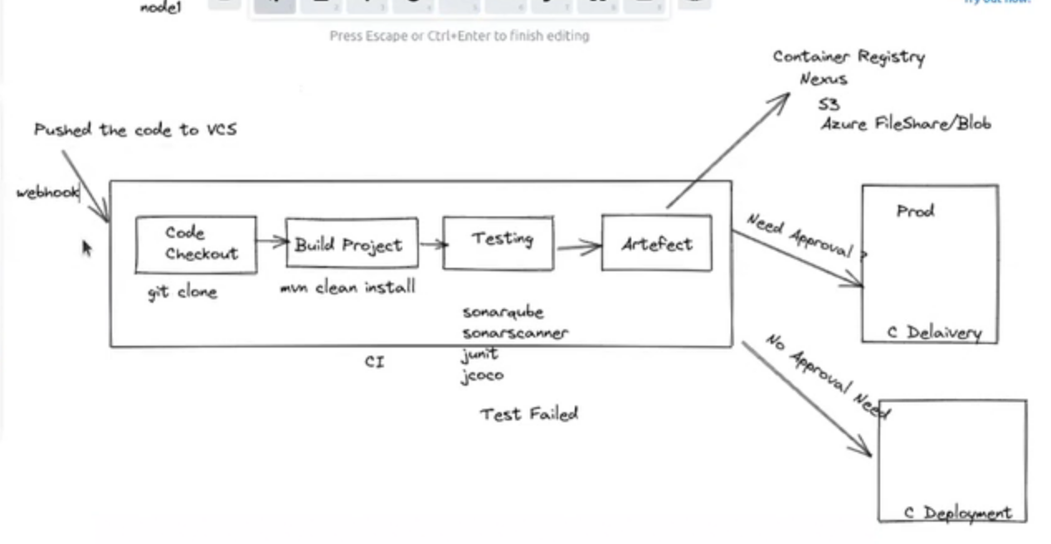

Webhooks only works on Jenkins installed on servers but if not on local.

See LMS video on jenkins (10/12/2021) (imp)

Look into cluster setup of jenkins with multiple masters

See LMS video on jenkins (14/12/2021) (imp)

## Pipeline

