A picture containing clipart

Description generated with very high confidence

KUBERNETES MODULE 4

Hands-on: 2

[**support@intellipaat.com**](mailto:support@intellipaat.com)

**+91-7022374614**

**US: 1-800-216-8930(Toll Free)**

**Creating a Persistent volume**

**Operation 1:** create EFS by doing the following



**Clone the above mentioned repository**

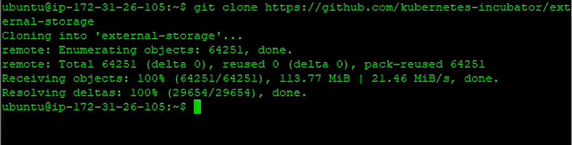

**Run the next two commands**





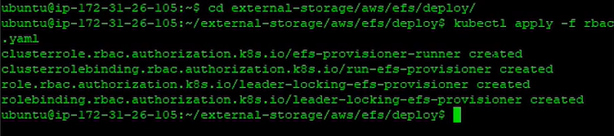

**Operation 2:** Create the following manifest file and make changes according to your configurations

**$ nano <file_name>.yaml**

**---**

**apiVersion: v1**

**kind: ConfigMap**

**metadata:**

**name: efs-provisioner**

**data:**

**file.system.id: fs-e4413b65**

**aws.region: us-east-1**

**provisioner.name: example.com/aws-efs**

**dns.name: ""**

**---**

**apiVersion: v1**

**kind: ServiceAccount**

**metadata:**

**name: efs-provisioner**

**---**

**kind: Deployment**

**apiVersion: apps/v1**

**metadata:**

**name: efs-provisioner**

**spec:**

**replicas: 1**

**selector:**

**matchLabels:**

**app: efs-provisioner**

**strategy:**

**type: Recreate**

**template:**

**metadata:**

**labels:**

**app: efs-provisioner**

**spec:**

**serviceAccount: efs-provisioner**

**containers:**

**- name: efs-provisioner**

**image: quay.io/external_storage/efs-provisioner:latest**

**env:**

**- name: FILE_SYSTEM_ID**

**valueFrom:**

**configMapKeyRef:**

**name: efs-provisioner**

**key: file.system.id**

**- name: AWS_REGION**

**valueFrom:**

**configMapKeyRef:**

**name: efs-provisioner**

**key: aws.region**

**- name: DNS_NAME**

**valueFrom:**

**configMapKeyRef:**

**name: efs-provisioner**

**key: dns.name**

**optional: true**

**- name: PROVISIONER_NAME**

**valueFrom:**

**configMapKeyRef:**

**name: efs-provisioner**

**key: provisioner.name**

**volumeMounts:**

**- name: pv-volume**

**mountPath: /persistentvolumes**

**volumes:**

**- name: pv-volume**

**nfs:**

**server: fs-e4413b65.efs.us-east-1.amazonaws.com**

**path: /**

**---**

**kind: StorageClass**

**apiVersion: storage.k8s.io/v1**

**metadata:**

**name: aws-efs**

**provisioner: example.com/aws-efs**

**---**

**kind: PersistentVolumeClaim**

**apiVersion: v1**

**metadata:**

**name: efs**

**annotations:**

**volume.beta.kubernetes.io/storage-class: "aws-efs"**

**spec:**

**accessModes:**

**- ReadWriteMany**

**resources:**

**requests:**

**storage: 1Mi**

**---**

Once done hit Ctrl+s and then Ctrl+x to exit

**Operation 3:** next thing to do is to create the yaml file.

**$ kubectl create -f <file_name>.yaml**

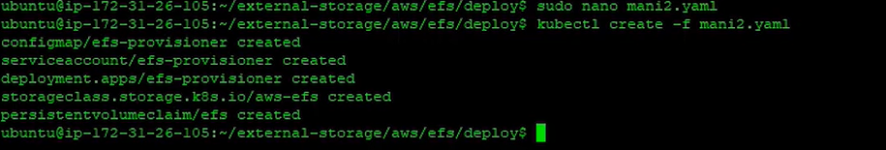

**Operation 4:** create a deployment calling the claims created and volume

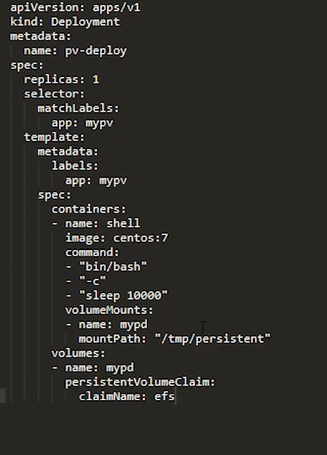



**Operation 5:** Exec into into pod add data and then delete the pod , check the presence of data in the new pod created automatically.