A picture containing clipart

Description generated with very high confidence

KUBERNETES MODULE 4

Hands-on: 3

[**support@intellipaat.com**](mailto:support@intellipaat.com)

**+91-7022374614**

**US: 1-800-216-8930(Toll Free)**

**Creating a Secret**

**Operation 1:** create the details of the secret

**$ echo -n "A19fh68B001j" > ./apikey.txt**

**$ kubectl create secret generic apikey --from-file=./apikey.txt**

**$ kubectl describe secrets/apikey**

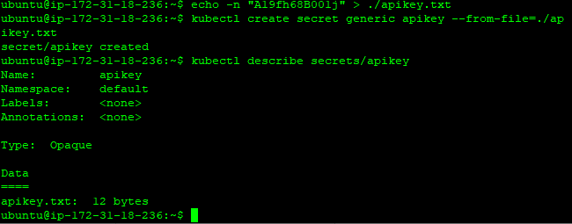

**Operation 2:** use the secret in a pod via a volume. Create a yaml file

**$ nano <file_name>.yaml**

**apiVersion: v1**

**kind: Pod**

**metadata:**

**name: consumesec**

**spec:**

**containers:**

**- name: shell**

**image: centos:7**

**command:**

**- "bin/bash"**

**- "-c"**

**- "sleep 10000"**

**volumeMounts:**

**- name: apikeyvol**

**mountPath: "/tmp/apikey"**

**readOnly: true**

**volumes:**

**- name: apikeyvol**

**secret:**

**secretName: apikey**

Once done hit Ctrl+s and then Ctrl+x to exit

**Operation 3:** next thing to do is to create the yaml file.

**$ kubectl create -f <file_name>.yaml**

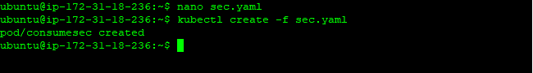

**Operation 4:** If we now exec into the container we see the secret mounted at /tmp/apikey

**kubectl describe pod <pod name>**

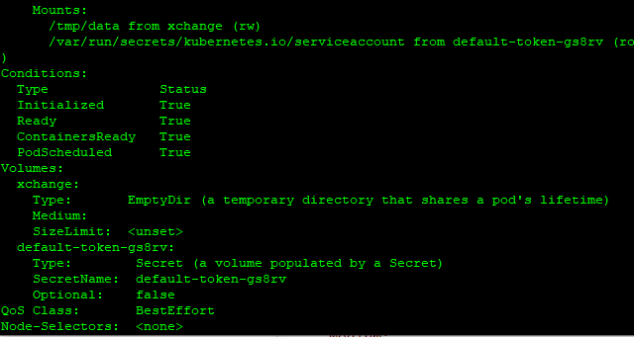

**Operation 5:** exec into the container we see the secret mounted at /tmp/apikey:

**$ kubectl exec -it consumesec -c shell -- bash**

**[root@consumesec /]# mount | grep apikey**

**[root@consumesec /]# cat /tmp/apikey/apikey.txt**

