A picture containing clipart

Description generated with very high confidence

KUBERNETES MODULE 4

Hands-on: 4

[**support@intellipaat.com**](mailto:support@intellipaat.com)

**+91-7022374614**

**US: 1-800-216-8930(Toll Free)**

**Creating a Taint on a node then a pod with tolerations but not to the taint**

**Operation 1:** get the node name by running the command

**$ kubectl get nodes**

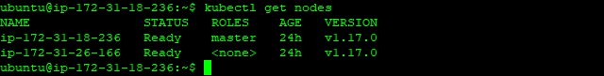

**Operation 2:** add a taint to a node using the following command

**$ kubectl taint nodes <node name> key=value:NoSchedule**

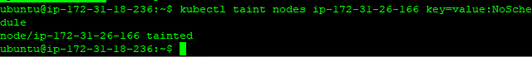

**Operation 3:** next thing to do is to create the yaml file.

**$ kubectl create -f <file_name>.yaml**

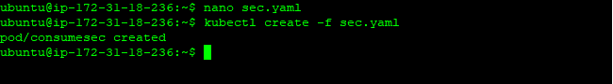

**Operation 4:** create a pod that uses tolerations

**pods/pod-with-toleration.yaml**

**apiVersion: v1**

**kind: Pod**

**metadata:**

**name: nginx**

**labels:**

**env: test**

**spec:**

**containers:**

**- name: nginx**

**image: nginx**

**imagePullPolicy: IfNotPresent**

**tolerations:**

**- key: "example-key"**

**operator: "Exists"**

**effect: "NoSchedule"**

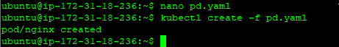

**Operation 5:** Run the command given below to confirm if the taints are working

**$ kubectl describe po <pod name>**

