Spinners

Spinners provide a quick way to select one value from a set. In the default state, a spinner shows its currently selected value. Touching the spinner displays a dropdown menu with all other available values, from which the user can select a new one.

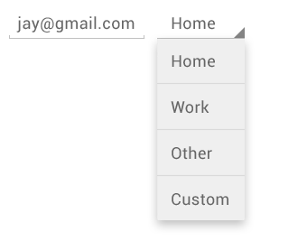

You can add a spinner to your layout with the Spinner object. You should usually do so in your XML layout with a <Spinner> element. For example:

<Spinner  
    android:id="@+id/planets_spinner"  
    android:layout_width="fill_parent"  
    android:layout_height="wrap_content" />

To populate the spinner with a list of choices, you then need to specify a SpinnerAdapter in yourActivity or Fragment source code.

## Populate the Spinner with User Choices

The choices you provide for the spinner can come from any source, but must be provided through anSpinnerAdapter, such as an ArrayAdapter if the choices are available in an array or aCursorAdapter if the choices are available from a database query.

For instance, if the available choices for your spinner are pre-determined, you can provide them with a string array defined in a string resource file:

<?xml version="1.0" encoding="utf-8"?>  
<resources>  
    <string-array name="planets_array">  
        <item>Mercury</item>  
        <item>Venus</item>  
        <item>Earth</item>  
        <item>Mars</item>  
        <item>Jupiter</item>  
        <item>Saturn</item>  
        <item>Uranus</item>  
        <item>Neptune</item>  
    </string-array>  
</resources>

With an array such as this one, you can use the following code in your Activity or Fragment to supply the spinner with the array using an instance of ArrayAdapter:

Spinner spinner = (Spinner) findViewById(R.id.spinner);  
// Create an ArrayAdapter using the string array and a default spinner layout  
ArrayAdapter<CharSequence> adapter = ArrayAdapter.createFromResource(this,  
        R.array.planets_array, android.R.layout.simple_spinner_item);  
// Specify the layout to use when the list of choices appears  
adapter.setDropDownViewResource(android.R.layout.simple_spinner_dropdown_item);  
// Apply the adapter to the spinner  
spinner.setAdapter(adapter);

method. For example, here's an implementation of the interface in an Activity:

public class SpinnerActivity extends Activity implements OnItemSelectedListener {  
    ...  
      
    public void onItemSelected(AdapterView<?> parent, View view,   
            int pos, long id) {  
        // An item was selected. You can retrieve the selected item using  
        // parent.getItemAtPosition(pos)  
    }  
  
    public void onNothingSelected(AdapterView<?> parent) {  
        // Another interface callback  
    }  
}

The AdapterView.OnItemSelectedListener requires the onItemSelected() and onNothingSelected()callback methods.

Then you need to specify the interface implementation by calling setOnItemSelectedListener():

Spinner spinner = (Spinner) findViewById(R.id.spinner);  
spinner.setOnItemSelectedListener(this);

If you implement the AdapterView.OnItemSelectedListener interface with your Activity orFragment (such as in the example above), you can pass this as the interface instance.