# Contents

Introduction 3

Amazon’s strategy 4

Global strategy 5

Regulations, Social, political, Economic and legal uncertainties 7

Government Regulations affecting Amazon 8

A major employer 8

Competitor analysis 10

Conclusion 11

References 12

# Table of Figures:

Figure 1: Amazon Ecosystem 3

Figure 2: Amazon's revenue model 4

Figure 3: Amazon's global strategy 6

Figure 4: Fulfillment by Amazon 7

Figure 5: Foreign Direct Investment Policy for E-commerce sector in India and its impact on Amazon (Economictimes 2019) 9

Figure 6: Global issues surrounding Amazon 10

Figure 7: Amazon and Alibaba 11

# Introduction

Retailing establishments typically family run were previously defined by the corner stores. Today with easy availability information and price comparison supported by robust computing systems, effective communications techniques, and great customer service, the way retail works has a massive impact on our shopping behavior.

“**To be Earth’s most customer-centric company where people can find and discover anything they want to buy online**”. (*Amazon* 2019)

The internet is the fastest growing channel in the retail world and amazon has been successful to capture the bulk of that growth**.** Jeffrey P. Bezos—part business genius, part class cutup has resolutely and methodically struck out a new business model for the Internet Age. Jeff Bezos decided to sell books on 22nd September 1994 ten months after launching the company. Bezos considered customer service as the corner stone of amazon.com and his most important weapon. Bezos stated “We know that if we can keep our competitors focused on us while we stay focused on the customer, that ultimately we’ll turn out all right”. (Brandt 2014)

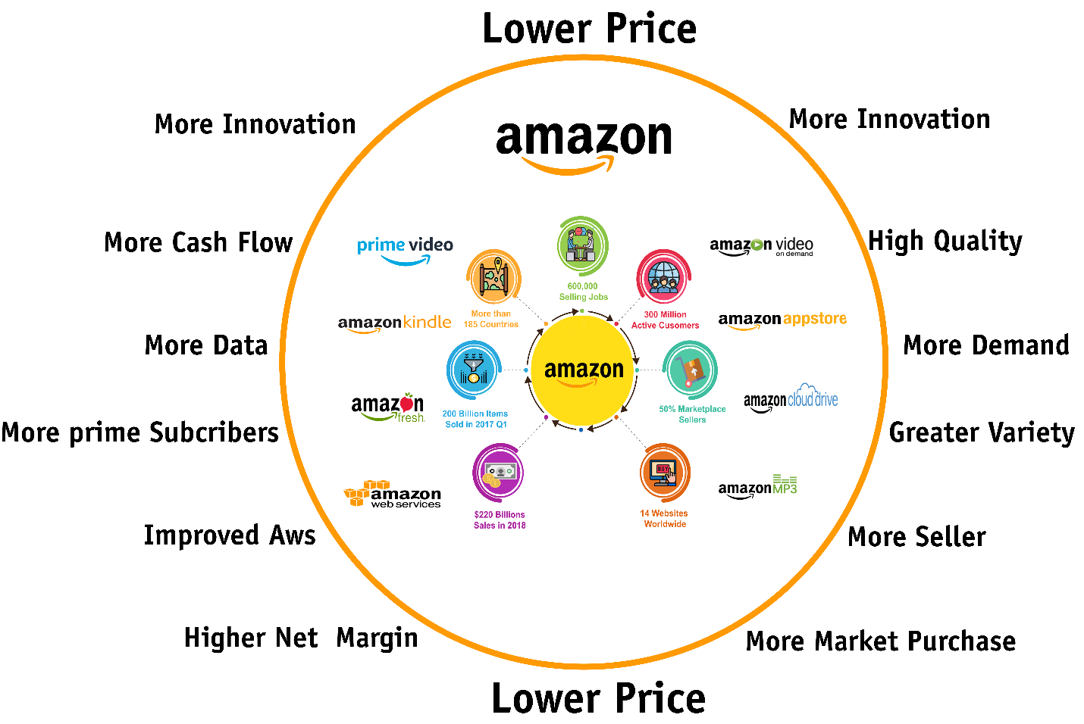

Figure 1: Amazon Ecosystem

With its ecosystem Amazon has managed to create a great shopping experience with very little human interaction. With an incomparable investment by irrationally generous lenders and visionary entrepreneurship amazon has become the world’s biggest store. Bezos realized a technological shift that every customer on amazon.com can be a sales person and every page can be a retail store and used it to reconstruct the entire retailing world. Being virtual allowed amazon to scale up easily across every retail industry with millions of users without the traditional drag of hiring thousands of employees and building brick and mortar infrastructures.

# Amazon’s strategy

To outrun potential competitor’s amazon introduced Amazon market place where third parties fill in the inventory therefore reinforcing the core value of selection. With amazon marketplace buyers and sellers got access to the world’s largest customer base with the largest e-commerce platform which let amazon expand its offerings without the expense of keeping its own inventory. As of today Amazon’s marketplace accounts for 40% of Amazon’s total sales. Sellers with no real pressure to spend on their own retail channels are comfortable with the massive customer flow. As amazon gets the data, when the items become attractive amazon can enter any business by choosing to sell the items themselves. (Rossman 2019)

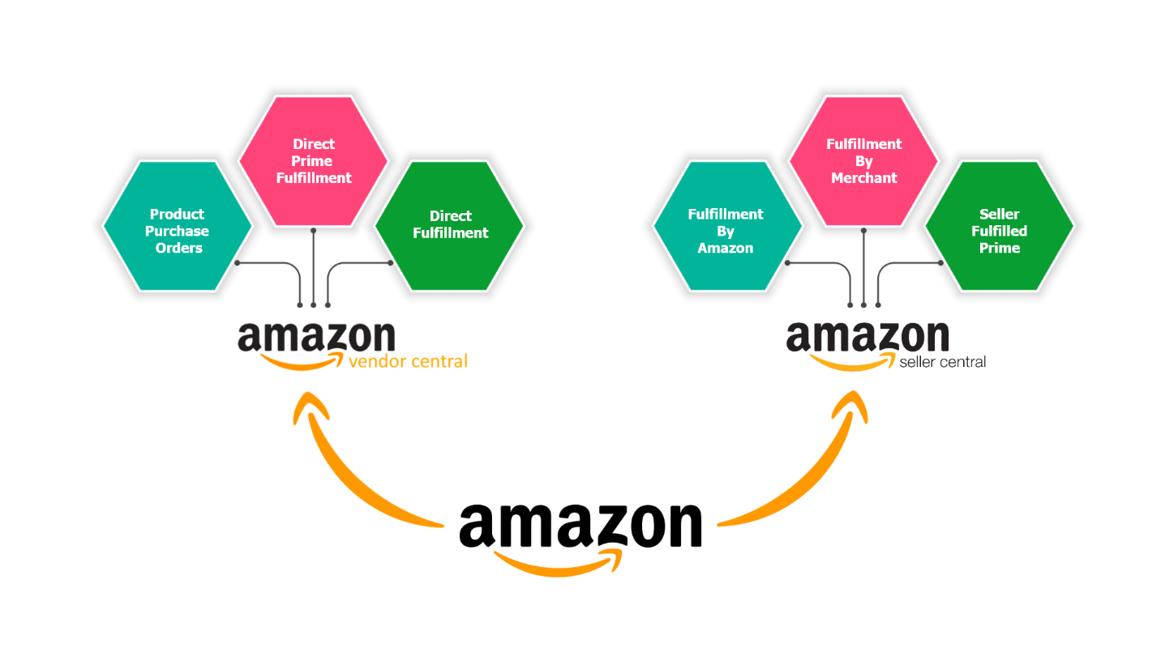

Figure 2: Amazon's revenue model

Amazon creates its revenue from retail (amazon.com and amazon marketplace), ad sales from amazon media and its cloud service (amazon web services). The immense value amazon has created for its customers has made amazon the most trusted and reputable brand on the planet. Amazon therefore leveraged on this brand equity extend its other better and more profitable businesses. It is widespread discussion that Amazon used retail platform has been used as a trojan horse to establish the brand loyalty to monetize into other businesses including the Amazon cloud services which has become the biggest cloud company in the world, amazon media group, amazon prime as the most nonexclusive club in America with its two hours shipping on selected products and also the video and music streaming**.** (Galloway n.d.)

With investments on massive automated warehouses near cities, fleet of delivery trucks and dedicated cargo aircrafts amazon can make customers deliveries within the desired timeframes. The Fulfillment by amazon service has provided comfort to sellers as they can store the items at amazon’s fulfillment centers and amazon will pick, pack and provide customer service for the items helping sellers reach more customers with amazon’s trusted customer service and returns.

As we enter the Omni channel era a time when the integration across brick and mortar, web and social media has become crucial for success, the amazon’s latest strategy for global domination is its cashier less grocery store Amazon go in Seattle. Amazon’s objective is to reach more customers in less time therefore it makes sense for amazon to open brick and mortar stores. Amazon also has book stores in Seattle, Chicago and New York. The question here is why would Amazon open a brick and mortar store, the simple answer is to sell its more recent business model innovations focused on hardware and new services like the Kindle e-readers, Fire Tablet, smartphone and TV, Echo (using the Alexa Artificial Intelligence voice-assistant), as customers want to see, touch and feel the innovative products before buying them. (Brandt 2011)

# Global strategy

Amazon Global selling is a great choice for retailers looking to expand businesses internationally. With operations in multiple international markets and customers worldwide, amazon connects millions of customers globally. From product catalogs, to communication in local languages, currency conversions, fulfilling international deliveries, customs and duties navigations, Amazon is a one-stop shop for global retail. Amazon’s global domination strategy involves a combination of further acquisitions and extension to other parts of the retail world. At present Amazon.com has a huge global presence amalgamating almost 47% of its sales outside it’s the USA, in countries such as in China, France, Japan and Canada (*Stockport* 2019). Amazons Global strategy offers various features that retailers can benefit as Amazon provides access to top international markets in North America, Europe and Asia increasing the value and trust in the Brand.

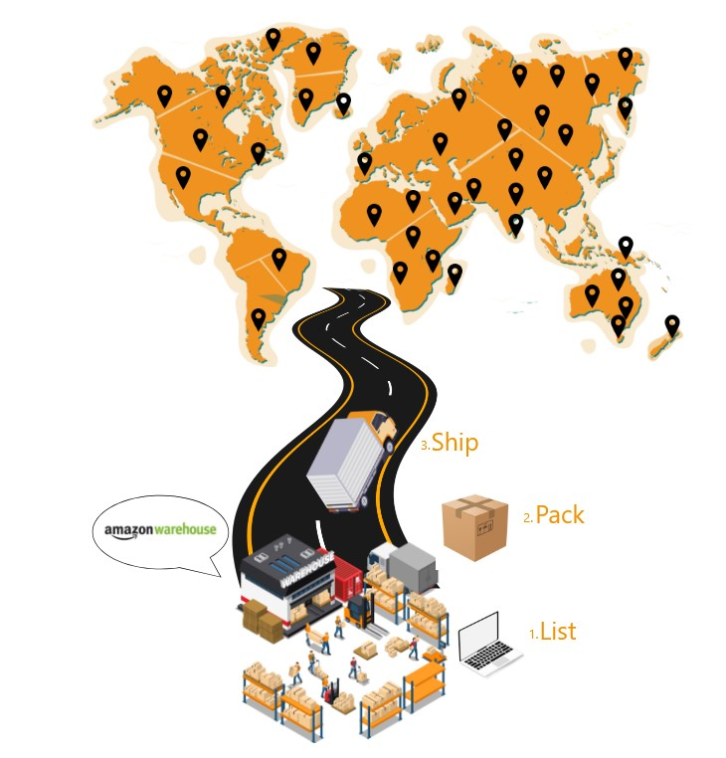

Figure 3: Amazon's global strategy

Amazon provides European marketplace account where retailers already selling in the any one of the European Marketplace like the Amazon.co.uk can grow further into other European countries using a single account without having to set up an account in every country. Amazon also provides retailers with its  [Building International Listings](https://www.youtube.com/watch?v=fBhA9GcdRPM) feature which permits them to manage product listing in all European countries through the their primary account i.e. the price updates in the primary is reflected in all other account automatically.

The fulfillment by Amazon is another feature which eliminates the challenges and complexities of fulfilling order as they will not be responsible for handling order details, custom details, shipments, taxes and returns. With FBA Amazon will pick pack and ship the products on behalf of the retailers. The FBA requires the retailers to store their inventory in Amazon’s warehouses. FBA provides customer support in local language. With no extra costs the [FBA Export](http://www.amazon.com/gp/help/customer/display.html/?nodeId=200240370) option identifies what products can or cannot be shipped to other countries. The option eliminates the single most frightening [challenges for global retail](https://tinuiti.com/blog/2015/04/global-retail-biggest-challenges-overcome-selling-internationally/) businesses by filtering import/export restrictions of countries and handling payments, accounts, international shipping, import/export duties etc**.** (Stone n.d.)

**(the everything store)**

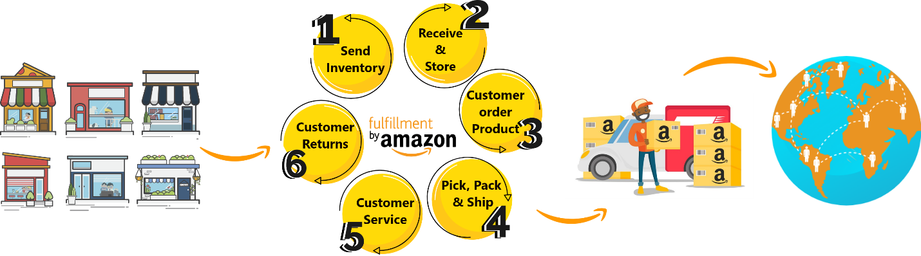

Figure 4: Fulfillment by Amazon

Amazon Currency Converter for Sellers (ACCS) is another one of Amazon’s powerful feature which allows retailers to obtain payments in the local currency and allows them to use the local banking services. Using the latest exchange rates, along with Amazons currency converter the system converts payments in local currency and deposits the payments to their local bank accounts. Since the option is available only in Amazon’s 10 international marketplace countries, retailers have to open a bank account in one of the marketplace countries in order to use the service.

This global expansion is achieved via the implementation, alliances and acquisitions in order to enhance its portfolio as well as increasing the customer base by enhancing the customer experience. With the cashless checkout technology at the amazon go store Bezos is delivering his vision to dominate the world retail. He is building an infrastructure that most customers are willing to pay toll to access. Amazon is also the top online retailer in Europe beating other best sellers like Tesco and Otto group. Amazon has already entered India and is planning to open stores in the rest of the world. In all parts of the world when it comes to grocery people still love to go to store and feel the things before buying them. Amazon with its expertise can apply technologies to set new standards in logistics, checkout and delivery settings in the grocery sector**.** (Galloway n.d.)

Amazon has also launched an international shopping wing where customers can get access to more than 45 million products shipped to them globally from the USA.

All this strategy would in turn give Amazon a good competitive advantage to accelerate it business objectives of global domination faster rather than starting from the scratch.

# Regulations, Social, political, Economic and legal uncertainties

Although Amazon presents a successful model in the retail industry as it is catering across the globe over the past two decades. Throughout the process of globalization with the application of technology amazon has stumble upon several challenges of building brand and trust, borderless economies, personalization, borderless economies etc. However, while trying to build its market share amazon has adopted different strategies globally for its sustenance and face many business regulations and laws regarding access to the online commerce and the taxation laws. For example, expanding amazon’s distribution centers might result into tax obligations. Government regulatory authorities implement laws governing pricing, content, distributions and user privacy laws to put additional burdens which in turn hurt the growth of Amazon’s services by increasing the cost of doing business. On the other hand, during international expansion, a major challenge for Amazon.com was the ability to understand how to serve international customers while applying to local customs and law regulations. (Pratap 2019)

# Government Regulations affecting Amazon

Although the hurdles for internet businesses are not the same as the traditional businesses. Still, there are multiple risk factors affecting the industry. Since amazon is the business leader in the sector it is affected by several political factors.

Amazon came from an online bookstore to becoming an online behemoth in just two decades. Yet even the biggest company is vulnerable to strenuous political pressure has to live with it. For example, after criticism from policymakers, Amazon stepped up in October 2018 with an announcement for increasing the minimum wages for the workers in the UK and the US. In the US workers ears no less than $15 an hour which is double the federal minimum and in the UK 28% increase for workers in London and 10% for rest of the UK as the government argues that a company boasting profits can afford to pay decent wages to its workers. Amazon was squeezed from multi directions by high profile adversaries. In the US the implausible alliance of Donald Trump and Bernie Sanders and in the UK the Archbishop of Canterbury and the GMB union.

Since Amazon is not a model employee, it is struggling to hire workers in the US and UK as the workers have more freedom to change their jobs if they are not happy. The events in the US and UK refutes the idea that powerful companies such as Amazon can do pretty much as they wish. Workers are being paid higher wages as a result adept PR, strong political campaigning and the channeling of populist resentment.

# A major employer

Amazon with its business extensions beyond retail to other industries with its cloud services (Amazon Web Services), smart consumer devices like the Alexa, kindle and services like amazon prime is disrupting the business model of other industry players. At present Amazon is the largest employer dwarfing other technology pioneers like the Facebook or google. At the same time Amazon’s work culture is considered intense with a reputation of creating a work environment with high employee burnout rate. While in the US Amazon’s recent acquisition of Whole Foods Market and its prospective expedition into the pharmaceuticals industry are generating positive headlines but it’s a bit different in Europe. Amazon’s next day delivery services in the UK could be investigated after customer complaints. Also, the UK Advertising Standards Authority is considering a formal inquiry into Amazon’s Prime Service. (*BBC* 2019). Across the English Channel the French a lawsuit seeking $1.18 million is filed against Amazon for as investigators claim Amazon imposed unfair commercial relationship with the local suppliers.Meanwhile Amazon ended a $118 tax dispute in Italy as loopholes were exploited to pay less taxes between 2011 and 2015. (*wpxi* 2019)

The new regulatory changes in Amazon’s most critical Asian market India is also a major concern for Amazon. Amazon’s long-term ambition in India has been hard hit by new regulations as Amazon entered India in 2013 with plans to operate differently than elsewhere as there are rules dictating how foreign e-commerce businesses can only act as a platform for other merchants rather than acting a retailer themselves. Except India Amazon sells 48% of total products itself whereas in India it is zero. Amazon tried to circumvent the regulations by selling goods via big merchants where Amazon owns stake. New regulations were immediately implemented to ban that practice as well. Other new regulations also constrain Indian e-commerce platforms from offering deals from brands that are exclusive to just one platform which makes it impossible for Amazon to offer heavy discounts on products as it has done in the past. Revenue growth is expected to fall at least 15 percent with such regulations in place. There is much uncertainty as to the impact of the government regulations change is going to have on the ambitions of Amazon in India. Amazon has said to operate by abiding the governmental regulations and offering the offering a great customer service and biggest selection of products and prices. With international growth of 15 percent year over year which is expected to decrease as a result of more regulatory Changes the moves in India remain critical for Amazon. (*Vox* 2019)

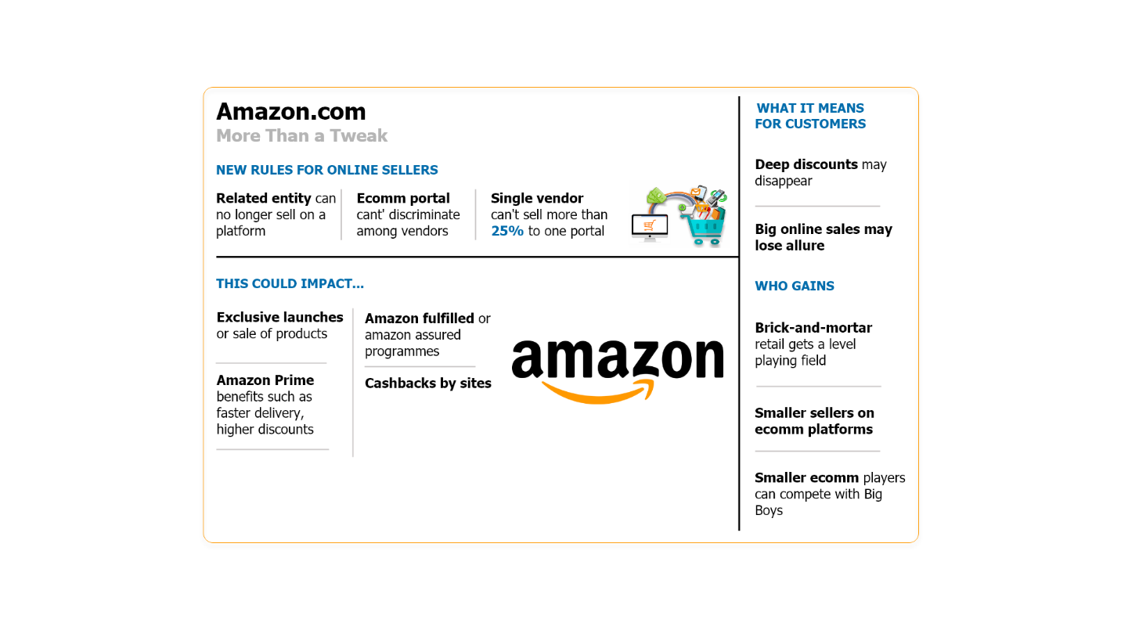

Figure 5: Foreign Direct Investment Policy for E-commerce sector in India and its impact on Amazon (Economictimes 2019)

Amazon is most particularly concerned with the populist wave hitting the Western world and the mounting cynicism towards economic and political openness Amazon anticipates. Globalization slowdown indicatives like the Brexit, protectionist measures, the wariness of public worried about the risk of devaluation of the social status and influence over political processes across the globe means a slower growth for Global platforms like Amazon. (*Economictimes* 2019)

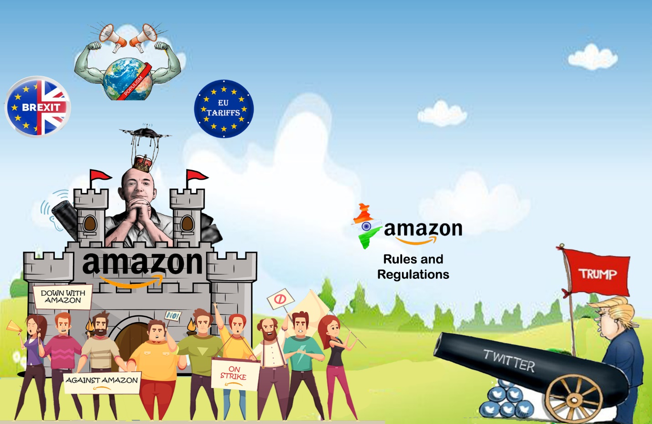

Figure 6: Global issues surrounding Amazon

# Competitor analysis

Amazon is facing fierce competition not only from American competition like Walmart, Costco, Best buy and Home Depot but the greatest threat to Amazon is its Chinese rival Alibaba who has grown to be one of the largest and the most valuable ecommerce platform in the world. Amazon generates its revenue from selling merchandise and digital media content like Amazon prime. On the other hand, Alibaba operates on a number of ecommerce sites aimed at different categories of sellers. Taobao is Alibaba’s one of the most profitable platforms and is responsible of more than 80% of the total sales. Even though both companies seem similar but they operation is quite different. While Amazon operates on an online platform that acts as a store which stays online and exercises control over the customer experience, Alibaba on the other hand is not involved in the direct sales and does not own physical warehouses like Amazon and is focused on helping businesses both small and large reach consumers. With the rise in populist wave hitting the western world Alibaba seems to have gone further by signing a free-trade agreement with Malaysia, as an effort to make sure free trade remained the norm. (Farooq 2019)

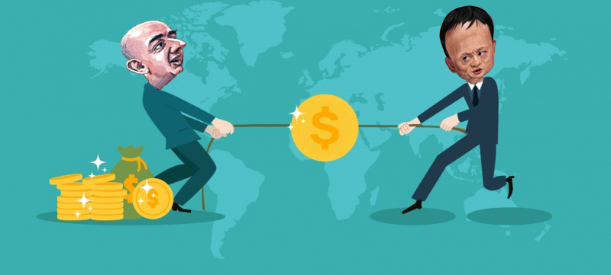

Figure 7: Amazon and Alibaba

# Conclusion

With no shortage of creative thinking on the side Amazon’s rivals, the next big innovation a new product or a service, new technological application, new supply chain innovation, or the acquisition of a company or organization to allow its customers to enjoy the products and services would empower Amazon to adapt to this new global political, cultural and economic reality of discontent characterized by fear and denial of yesterday’s norms. As Amazon is automating as many activities as possible, which sets the ethical stage for the company of trying to ditch its human workforce in favor of smart robots. For example, Amazon’s e-tailers in the Amazon Go have raised an ethical concern regarding the tendency to use robots to handle more goods and packages per day replacing human workers in daily tasks and physical distribution processes. To conclude even with all the global concerns the customer loyalty to Amazon is at an all-time high, with nearly 48 percent of people visiting the site at least a few times a week, and nearly 89 percent of people visiting the site at least once a month. Unfortunately for Amazons rivals, Amazon has successfully integrated itself in to daily lives of customers and will continue to do so as it expands more into Brick and mortar store with its automated models like the Amazon Go, the threat for its competitors is likely to grow even more.

# 

# References

*Amazon.Com: Online Shopping For Electronics, Apparel, Computers, Books, Dvds & More* (2019) available from <https://www.amazon.com/> [10 November 2019]

Brandt, R. (2014) *One Click*. New York: Portfolio

Rossman, J. (2019) *Think Like Amazon*. [S.l.]: McGraw-Hill

Brandt, R. (2011) *One Click*. Westminster, London: Penguin Publishing Group

*Stockport, G.J. (2010) Amazon.Com 2007-Early 2009. Crawley. - References - Scientific Research Publishing* (2019) available from <https://www.scirp.org/(S(i43dyn45teexjx455qlt3d2q))/reference/ReferencesPapers.aspx?ReferenceID=1242511> [7 December 2019]

Stone, B. (n.d.) *The Everything Store*.

Galloway, S. (n.d.) *The Four: The Hidden DNA Of Amazon, Apple, Facebook, And Google*.

Pratap, A. (2019) *A PESTEL Analysis Of Amazon* [online] available from <https://notesmatic.com/amazon-pestel-analysis/>[24 November 2019]

*Church Keeps Amazon Shares Despite Criticism* (2019)available from <https://www.bbc.com/news/uk-45516830> [26 November 2019]

*Italy Says Amazon Will Pay $118 Million To End Tax Dispute* (2019)available from <https://www.wpxi.com/news/italy-says-amazon-will-pay-118-million-to-end-tax-dispute/664567821> [26 November 2019]

*Amazon’S Invincibility Is Showing Some Cracks — And A Big One Is In India* (2019)available from <https://www.vox.com/2019/2/1/18205635/amazon-india-regulations-q4-earnings-prime-online-retail.> [28 December 2019]

*Govt Tightens Norms For Etailers, Bars Exclusive Deals* (2019)available from <https://economictimes.indiatimes.com/news/economy/policy/government-tighten-norms-for-e-commerce-companies-for-sale-of-products/articleshow/67258251.cms> [30 November 2019]

Farooq, U. (2019) *Amazon Competitors | Competitor Analysis Of Amazon.Com Online Retailer* [online] available from <https://www.marketingtutor.net/amazon-competitors/> [2 December 2019]