**GETS is a trade nam e of Qualifications and Assessm ents International Lim ited, UK with registration num ber 7866740**

**UK NARIC Executive Sum m ary on CEFR Mapping is available at https://bit.ly/2ph8nhz**

**Test Centre: NP002, Nepal**

**Institutions can verify the scores from the GETS secure verification services by registering at http://www.getsworld.com /**

**This is a com puter generated report and requires no signature.**

**TR No.: GHE23001709NP00200408**

**B1**

**CEFR**

**5**

**NA**

**63** %

**W riting**

**Speaking**

**GETS LEVEL**

**72**

**GETS SCORE**

**NA**

**NA**

**63**%

**Listening**

**Reading**

**OVERALL**

**RESULTS**

**Gender**

**MALE**

**Date of Birth**

**08 Nov 2004**

**ID Type & Num ber**

**CTZN NO. - 52-02-78-06198**

**Fam ily Nam e**

**BASNET**

**First Nam e**

**AAYUSH**

**E-COMMERCE, Nepal**

**Participating InstitutioSnOFTW ARICA COLLEGE OF IT AND**

**Test Date**

**26 May 2024**

**Candidate Num ber**

**23001709**

**Com m on European Fram ework of Reference (CEFR) in 2019.**

**TEST REPORT**

**UK NARIC independently reviewed the GETS Higher against the**

Evaluation Warning : The document was created with Spire.PDF for java.

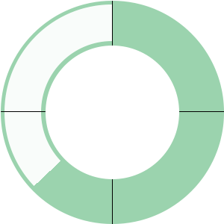





go beyond

HIGHER

Evaluation Warning : The document was created with Spire.PDF for java.

