GITHUB REPOSITORY: https://github.com/chelsangya/TinTin

1

Evaluation Warning : The document was created with Spire.PDF for java.

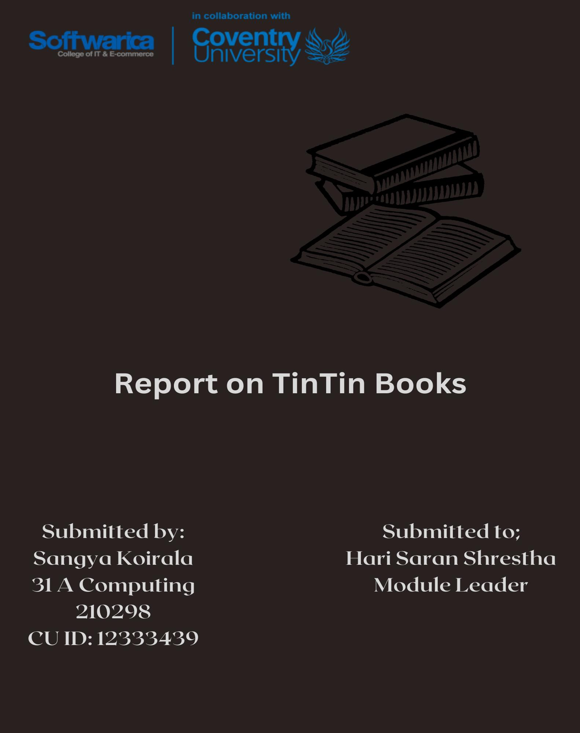

Thymeleaf .................................................................................................................................. 16

Spring Boot in Java ................................................................................................................... 16

Back-End........................................................................................................................................16

Snapshots ................................................................................................................................... 15

Merits and Demerits of PostgreSQL ......................................................................................... 14

PostgreSQL ............................................................................................................................... 14

Database System ....................................................................................................................... 14

Database Used ................................................................................................................................14

Checking the Responsive Design .............................................................................................. 12

Responsive Design and its Importance ..................................................................................... 11

Snapshots ................................................................................................................................... 10

Frond-End Technologies ............................................................................................................. 8

Frond-End ........................................................................................................................................8

Learning Outcomes ..................................................................................................................... 8

Objectives .................................................................................................................................... 7

Aim .............................................................................................................................................. 7

Features Included in the System .................................................................................................. 6

TinTin .......................................................................................................................................... 5

Introducing TinTin ...........................................................................................................................5

TABLE OF CONTENTS

2

Evaluation Warning : The document was created with Spire.PDF for java.



References ......................................................................................................................................26

Conclusion .....................................................................................................................................26

Diagrams ........................................................................................................................................25

Upcoming Features in the Future .............................................................................................. 22

Constraints ................................................................................................................................. 20

Issues Faced ............................................................................................................................... 20

Issues Faced During Development ................................................................................................20

Snapshot .................................................................................................................................... 19

Unit Testing ............................................................................................................................... 18

Testing............................................................................................................................................18

Admin ........................................................................................................................................ 18

Snapshots ................................................................................................................................... 17

Architecture ............................................................................................................................... 16

3

Evaluation Warning : The document was created with Spire.PDF for java.



**Figure 14** *Use Case Representation* ............................................................................................. 26

**Figure 13** *Rich Picture Representation* ........................................................................................ 25

**Figure 12** *Book Test* ..................................................................................................................... 19

**Figure 11** *User Test* ...................................................................................................................... 19

**Figure 10** *Cart Repository*............................................................................................................ 18

**Figure 9** *Cart Service* ................................................................................................................... 17

**Figure 8** *Cart Controller* .............................................................................................................. 17

**Figure 7** *Tables*............................................................................................................................. 15

**Figure 6** *Small Screen Contact Page* ........................................................................................... 13

**Figure 5** *Medium Screen Contact Page* ....................................................................................... 13

**Figure 4** *Full Screen Contact Page* .............................................................................................. 12

**Figure 3** *Header Section* .............................................................................................................. 11

**Figure 2** *Cart Page* ....................................................................................................................... 11

**Figure 1** *TinTin Dashboard*.......................................................................................................... 10

TABLE OF FIGURES

4

Evaluation Warning : The document was created with Spire.PDF for java.



2022)

Media, Website introduction – an essential element to connecting with your target audience

features in a user-friendly design. The website is easy to use and has a clean design. (Brick Road

admin as well as the customer can update and delete their profile. The website offers attractive

dynamic, the updates provided by the admin will instantly be provided to the customer. Both the

made by the admins will be displayed in the customer dashboard. As the dashboard is completely

visualization of the books. They can add new, update, as well as delete the books. The changes

as the admins. Their dashboard contains the details related to the books. They can check the data

needless to mention that they can buy those books online. Meanwhile, the staffs are considered

required for each book. They can review their cart and even make changes to the cart. And it is

customers. The customers can look at the books available in the site and select the quantity

accessed after logging in. It has addressed two different user segments: the staffs and the

TinTin is a website used by an online bookstore. It is a secure site which can only be

**TinTin**

**Introducing TinTin**

5

Evaluation Warning : The document was created with Spire.PDF for java.



names of the books in case of error.

The website even offers the feature of updating the books. It allows admins to correct the

***Update Books***

be displayed in the customer’s dashboard as well.

books to meet the demands of the customers, TinTin allows admins to add new books which will

The website lets admins add new books. As the store needs to restore the replenished

***Add Books***

email if they ever forget their own password.

details as well as the password. In addition to this, they can even reset their password via their

The website allows users to update the details in their profile. They can update their basic

***Update Profile***

books to the cart and order for them from anywhere with internet access.

The website allows users to find the books and select them. It enables them to add the

***Buy Books***

logging in.

the stock of the books while it allows customers to gain access to the user dashboard after

TinTin can only be accessed after logging in. It only allows admins to make changes in

***Authenticate Users***

The main features included on the website are:

**Features Included in the System**

6

Evaluation Warning : The document was created with Spire.PDF for java.



5. Improve researching skills to be aware about advanced techniques to enhance the website.

4. Implement PostgreSQL database in the project.

3. Use HTML, CSS, and Spring Boot to create a clean website.

2. Develop skills to make diagrams like use case, activity, and sequence diagrams.

1. Learn to collect all the requirements needed to develop a website.

The objectives of the project are:

**Objectives**

website that helps to complete the task online.

Automate the manual process of buying books from physical stores by providing a

**Aim**

stock when needed.

The website lets the admins watch the total number of orders. It helps in maintaining the

***Total Sales***

The people who do not follow the guidelines set by the store can easily be removed as a user.

The website lets admins delete some users. There might be users who misuse the site.

***Delete User***

accounts.

or decrement in the number of users interested in the store. It can be later used during removal of

The website lets the admins check the list of users. It helps in keeping track of increment

***View User List***

7

Evaluation Warning : The document was created with Spire.PDF for java.



elements and pages without the need to write any code. (Framer, what is framer? 2022)

a system. It is very easy to use. It offers animated contents and interactions between various

Framer is a prototyping tool that simplifies the process of creating interactive protypes of

1. Framer

tools have been explained here.

For creating prototypes of the project, Framer and Canva were used. The prototyping

***Prototyping***

(What is a front end (in a website) - definition & development)

As TinTin is a website, various tools and technologies were used to develop the site.

**Frond-End Technologies**

**Frond-End**

diagram helped in creating various tools required during the development of a product.

how a website is templated. The inclusion of activity diagram, use case diagram, and sequence

introducing the learner to a new database system. The use of Thymeleaf helped in learning about

scenario helped in preparing the learner for the future. The use of PostgreSQL database helped in

of Spring Boot as a back-end technology. The implementation of Spring Boot in real-world

resources and implementing them according to the need. It even helped in understanding the use

design. The development of this project even helped in improving the skills required to gather

The use of advanced technologies like Bootstrap and jQuery helped in further enhancing the

HTML, CSS, and JavaScript helped in developing the skills to create the design for the website.

Working on this project had been very fruitful. The use of front-end technologies such as

**Learning Outcomes**

8

Evaluation Warning : The document was created with Spire.PDF for java.



website, JavaScript was used for validation and manipulating HTML elements.

manipulating images and many other reasons. It is very easy to learn as well. For this

front-end validation, defining behavior of different HTML elements, updating the content,

JavaScript is a programming language that can be used for multiple reasons. It is used for

3. JavaScript

website easier.

styling of the front-end can be done using HTML only. But the use of CSS makes designing the

Cascading Style Sheets is a language that is used to style the code written in HTML. The

2. CSS

front-end of a website. It is easy to learn and implement.

HyperText Markup Language is a markup language used to create the structure of the

1. HTML

used in this project. The basic technologies are explained here.

In the case of actual front-end, HTML, CSS, and JavaScript were the basic technologies

***Basic Front-End Technologies***

website.

used to create high resolution posts and pictures. The images created in Canva were used in the

Canva is a tool used in graphic designing. It is used globally to create content. It can be

2. Canva

9

Evaluation Warning : The document was created with Spire.PDF for java.



*TinTin Dashboard*

**Figure 1**

The snapshots showing the front-end of TinTin website are included in this document.

**Snapshots**

jQuery.

written in longer length using basic JavaScript. Several lines of code is reduced to a single line in

websites. It makes the use of JavaScript easier. It shortens the code that could alternatively

jQuery is a fast JavaScript library. It is also getting popular for the development of

2. jQuery

easier alternatives to lengthier code written using basic CSS.

collection of CSS and JavaScript which can be used to create a responsive website. It offers

Bootstrap is a CSS framework. It is very popular for the development of websites. It has a

1. Bootstrap

technologies have been explained here.

For optimal results, Bootstrap and jQuery were also implemented. These advance

***Advanced Frameworks and Libraries***

10

Evaluation Warning : The document was created with Spire.PDF for java.

