**ASSIGNMENT1: Menu Driven Program Generation Using General Purpose Trees**

**Problem Statement:**

Create a code generation program that will take as an input from stdin a file containing the specifications of a menu and output a C code to stdout.

The input would look like the following:

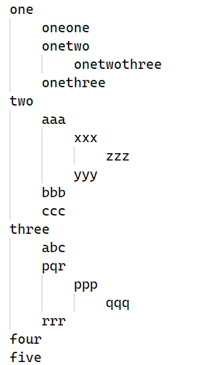

The levels are indented using a tab space (\t).

The output should be a single C file which when compiled and run, waits for input from stdin like in a menu driven program.

The input to this program now will be a sequence of integers.

0 means you would go back a level (going up a function call sequence). If we’re at the outermost level, then 0 would exit the program.

So, if the input now is:

1

1

2

1

2

0

3

0

4

0

The output should be:

one

oneone

onetwo

onetwothree

onethree

four

**A couple of things to note:-**

Every line will contain only one word.

While inside a menu, entering a number that’s more than the range of possible inputs should not print anything. Notice how there’s nothing printed after onetwothree even though I gave 2 as an input.

You cannot technically *enter* the levels of leaves. You can only print in those cases. Like oneone. Note the level we’d be in at the of the following two inputs:-

Input 1:-

1

1

0

We’d be at the outermost level (depth 0) accepting inputs for that level, that is 1-5.

Input 2:-

1

2

0

We’d be at the level inside ‘one’ (depth 1) accepting inputs for that level, that is 1-3.

Assume the limit of each line to be max 1024 characters.