**PROJECT NAME: MYNTRA**

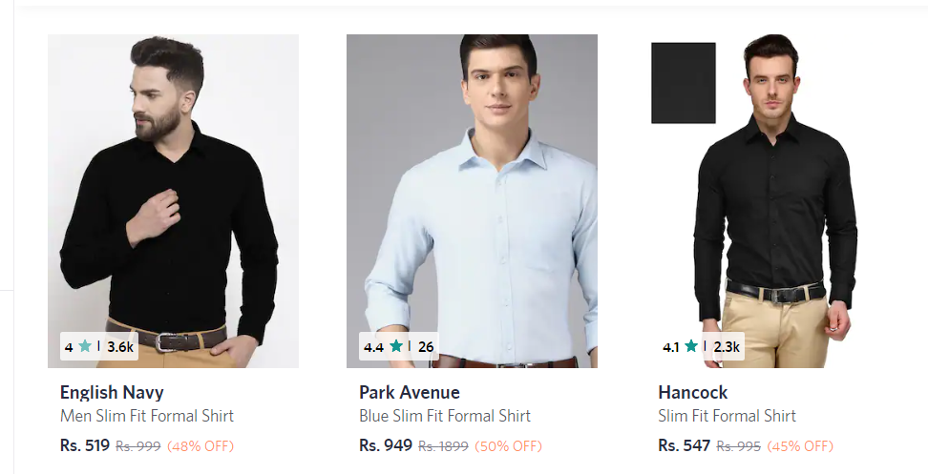

Overview

It’s an e-commerce website for clothing and fashion

Everything from shirts,T Shirts,formals,traditional wear

and footwear is also widely available everything ranging from slippers to shoes are available.

Fashion accessories like bags,bracelets and etc are available.

It is an all in all fashion stop from kids to adults.

1. Home Page  
   # Logo  
   # Navigation bar  
    # sections

#search bar

#profile

#wish list

# Deals of the day

#Footer  
 #contact  
 #Helplines  
 #About Company  
 #Socialmedia

1. Registration Form  
   #Email  
   #Phone no.
2. Listing Page  
   #List of selected section  
    #Filters

#clothes(formals,casuals,traditional,etc.)  
 #shoes  
 #accessories  
 #bags

1. Details Page  
     
    #product Image

#Product Description  
 #Discount if any  
 #Price  
 #Fitting  
 #Delivery Options  
 #Reviews

#similar products

1. Payment Page  
     
   #Address Selection  
   #Payment method