Install Prometheus and Grafana on a Linux EC2 machine, connect Prometheus to Grafana, and create a dashboard to view metrics.

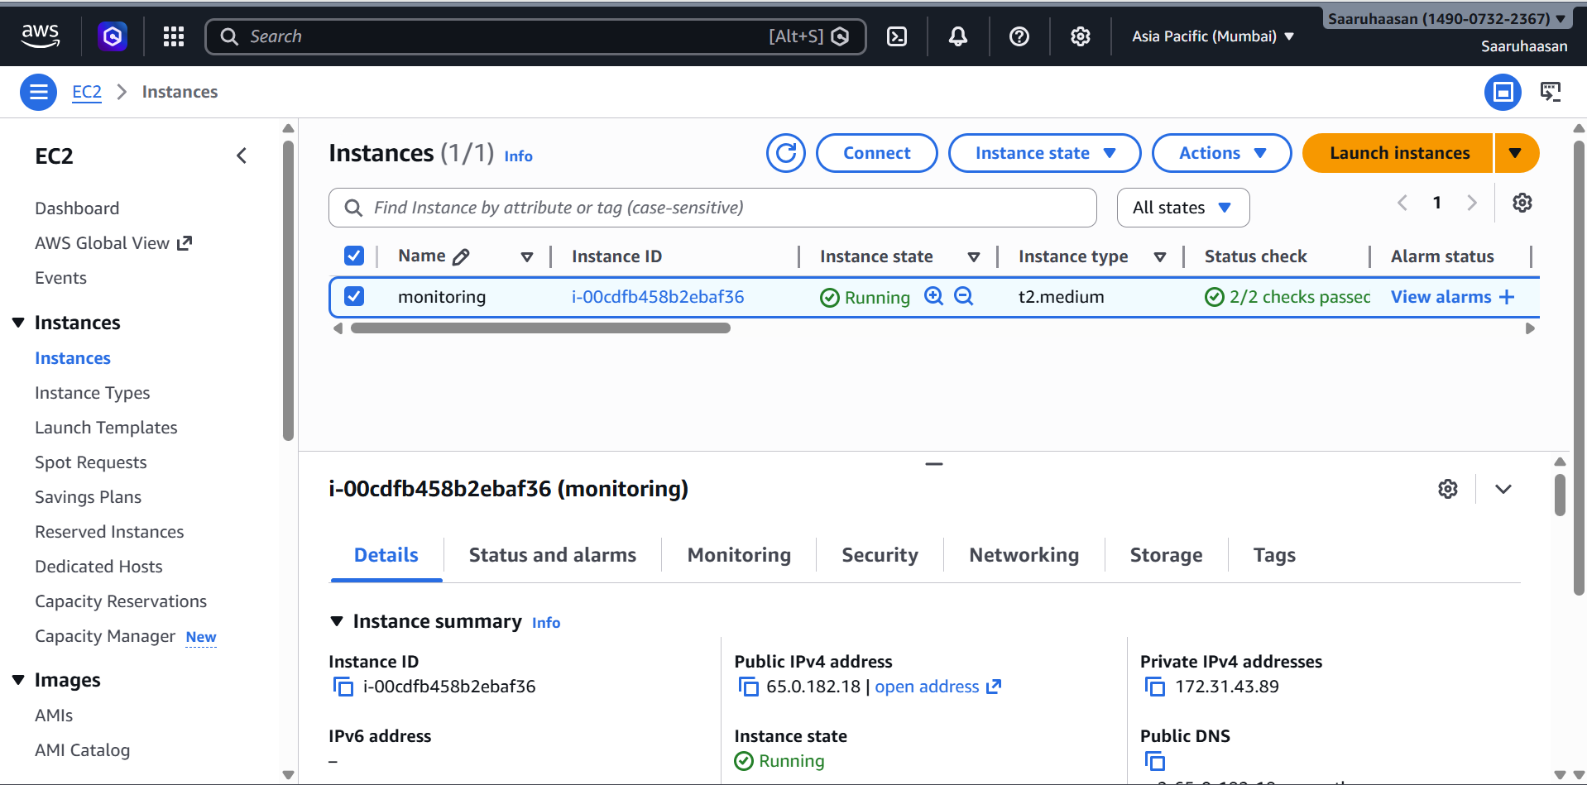

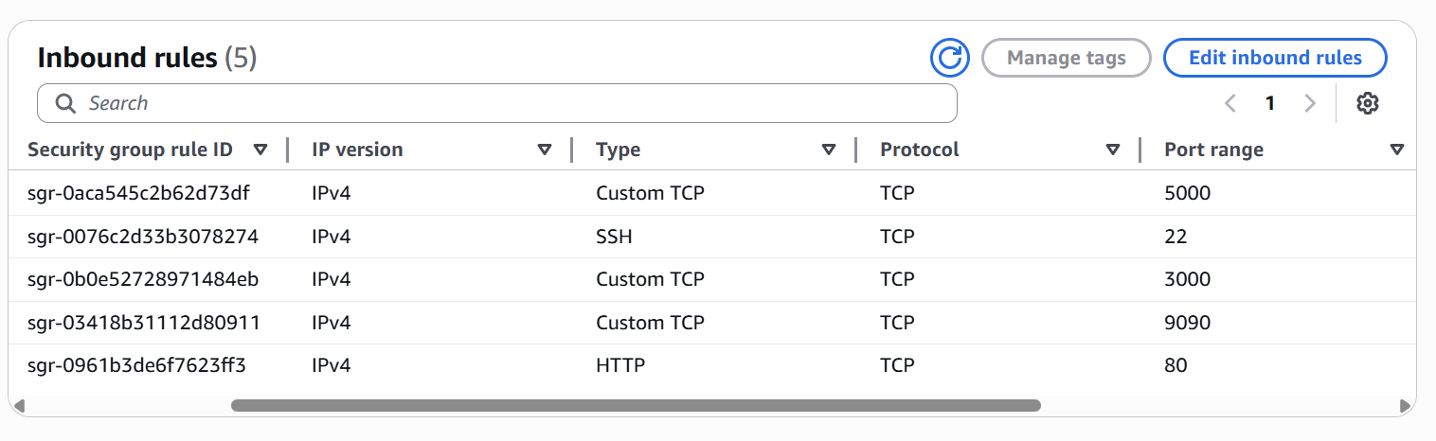
Codes used for monitoring from mentor data - https://github.com/saaruhaasan/Devops-Learning-Material/tree/main/Monitoring/k8s-kind-voting-app-main/k8s-specifications
https://github.com/saaruhaasan/Devops-Learning-Material/tree/main/Monitoring/k8s-kind-voting-app-main/kind-cluster

