Name : Khan Mohd Aaquib Sameer

Roll No : 22co21

Batch : B2

**Experiment 3**

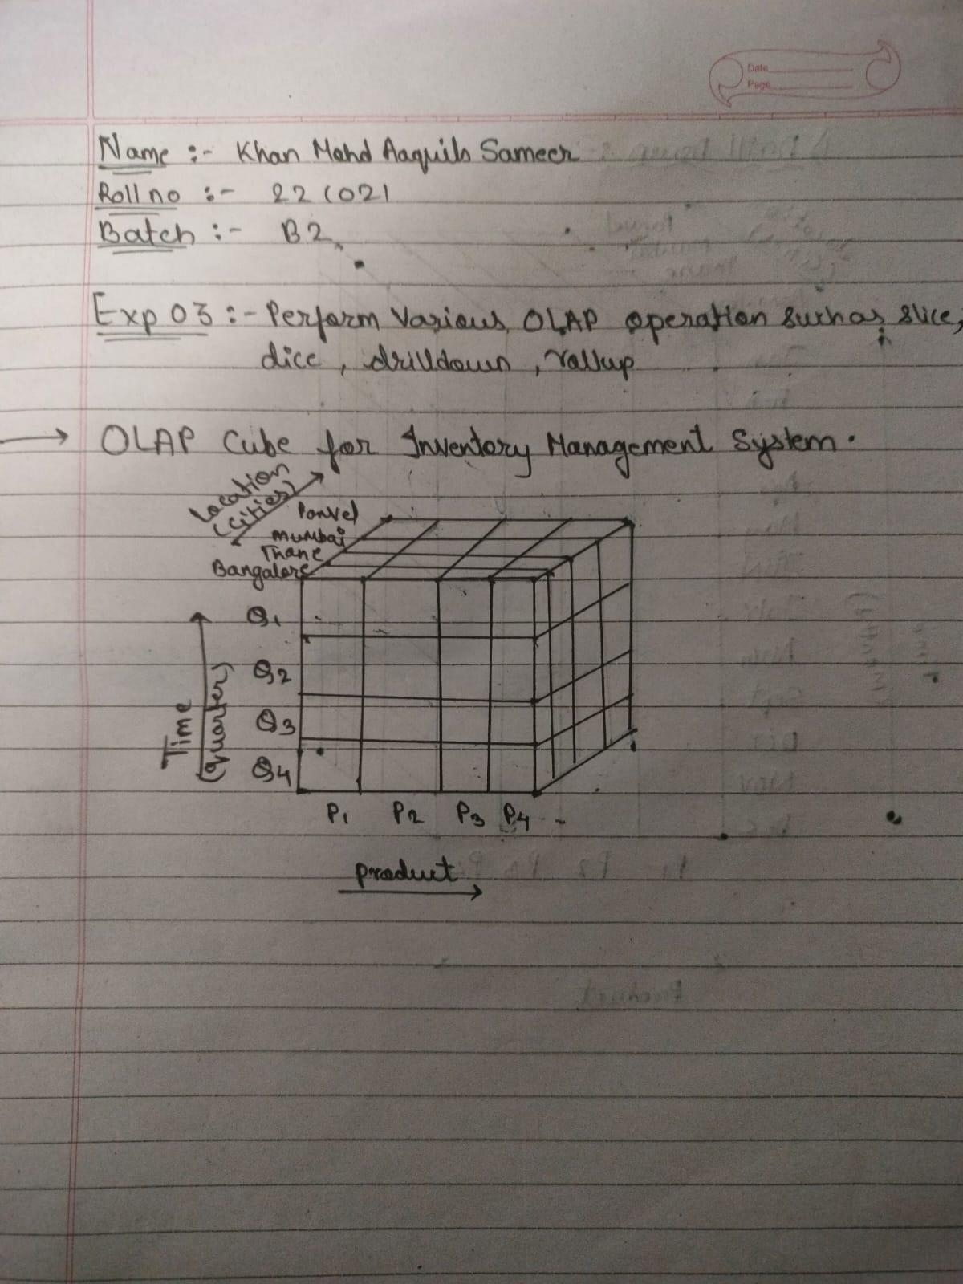

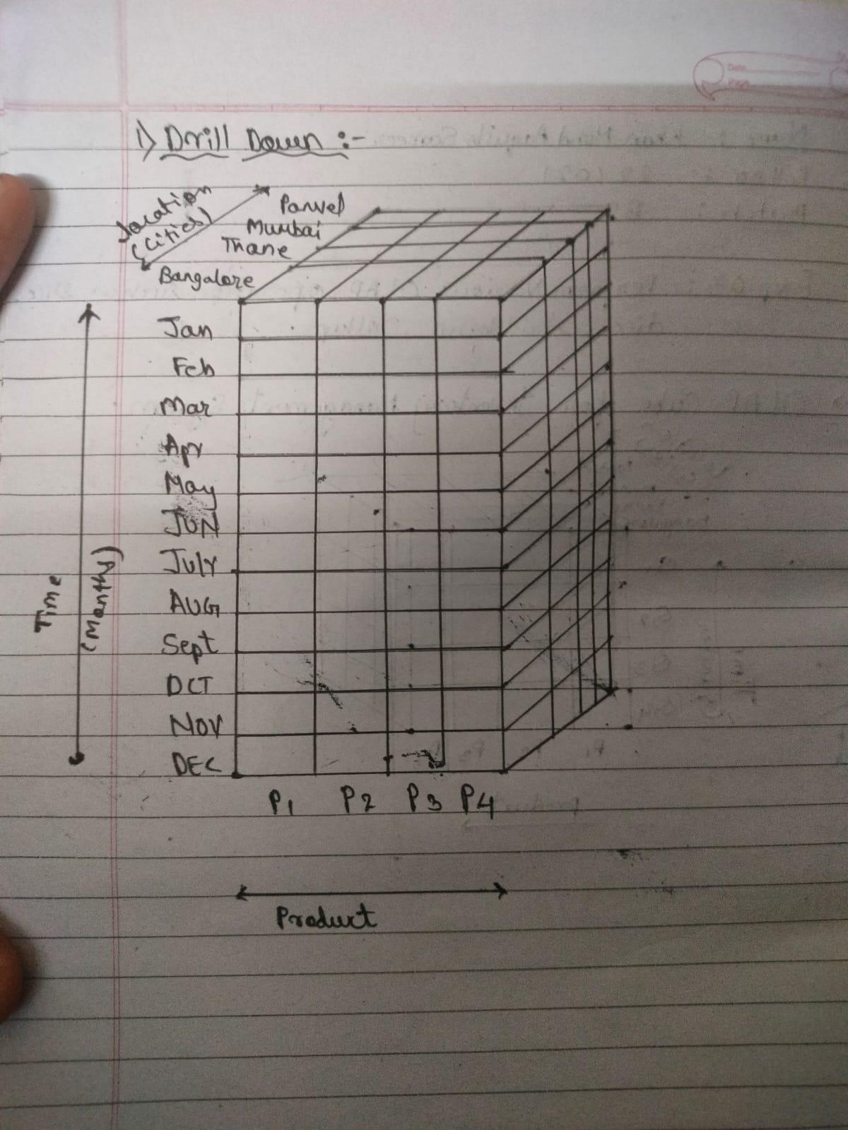

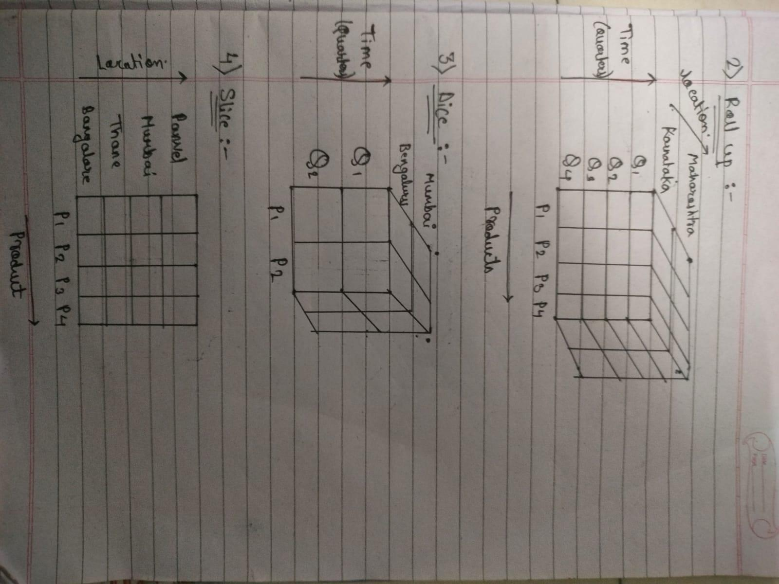

Code :

CREATE TABLE inventory_sales (

id INT PRIMARY KEY AUTO_INCREMENT,

location VARCHAR(50),

product VARCHAR(50),

quarter VARCHAR(10),

sales INT

);

### **1. Slice Operation:**

Slice is used to select a specific slice of the data by restricting one dimension to a specific value.

**Example: Find sales for product P1 across all locations for Q2.**

sql

SELECT location, sales

FROM inventory_sales

WHERE product = 'P1' AND quarter = 'Q2';

### **2. Dice Operation:**

Dice is used to perform selection on multiple dimensions, choosing a subcube of the data.

**Example: Get sales data for products P1 and P2 in Mumbai and Bangalore for Q1 and Q2.**

sql

SELECT location, product, sales

FROM inventory_sales

WHERE product IN ('P1', 'P2')

AND location IN ('Mumbai', 'Bangalore')

AND quarter IN ('Q1', 'Q2');

### **3. Drill Down Operation:**

Drill down provides more details by descending into a finer level of data. For example, if you're currently viewing by quarter, you can drill down into months.

**Example: Assume a more detailed table exists with months. Drill down from Q1 to individual months (M1, M2, M3).**

sql

SELECT location, product, month, sales

FROM inventory_sales_by_month

WHERE quarter = 'Q1';

### **4. Roll Up Operation:**

Roll up aggregates the data to a higher level. For example, you might roll up from quarters to years.

**Example: Aggregate sales for each product across all locations for the entire year.**

sql

SELECT product, SUM(sales) AS total_sales

FROM inventory_sales

GROUP BY product;