Analyzing the website of Chili’s South Indian Cuisine restaurant

About the product

The product I have chosen is the [website](http://chilissouthindianrestaurant.com/home) of a restaurant – the Chili’s South Indian Cuisine located at 4220 University Way NE, Seattle, WA. The website has many problems with its design including its intuitiveness, interactivity and aesthetics

Stakeholder Research

Direct Stakeholders

* Students at the University of Washington
* People who like Indian food
* Local residents

These are the direct stakeholders of the restaurants website since they directly interact with the website. These are the customers of the service which who would potentially go to the restaurant. The website is the first point of contact between the customer and the restaurant that would help the customer assess the food, type, price, services and quality of the restaurant.

I gathered this information by interviewing the people who I have been to the restaurant or are planning on going there. I chose this research method since it would give insight on the customers of the restaurant and what motivated/demotivated them to go there.

The primary goal of most people I interviewed was to get good Indian food close to the University of Washington, that is worth its price. Most people were demotivated to go to restaurant after looking at its website. They also do not think the website is an accurate representation of its food or service. The current design of the website does not encourage customers to try their food, and rather has the opposite effect.

Indirect Stakeholders

* Restaurant owners
* Shareholders/investors
* Employees / potential employees

Indirect stakeholders are those who may not directly interact with the website but are nevertheless affected by it. The restaurant owners have the website as their primary point of contact with the customers which represents the restaurant. If the website demotivates customers, they have less people at their restaurant and therefore lose revenue. Similarly, for investors, they would be demotivated to put their money into a restaurant that has a bad website. Potential employees would also like to work at a place which will do well and can be demotivated by the website.

I gathered this information by talking to the owners of the restaurant and asked them how people get to know about their restaurant and their services to which they answered that it is usually by word of mouth since there is no other medium.

The primary goal of the indirect stakeholders is to get food and service worth their money which may be determined by the representation of the restaurant on the website. Since the quality and potential revenue of the restaurant seems poor from the website the stakeholders will think they won’t get their money’s worth.

Design Critique

There are several striking problems with the design of this website.

**User Interface and Organization**

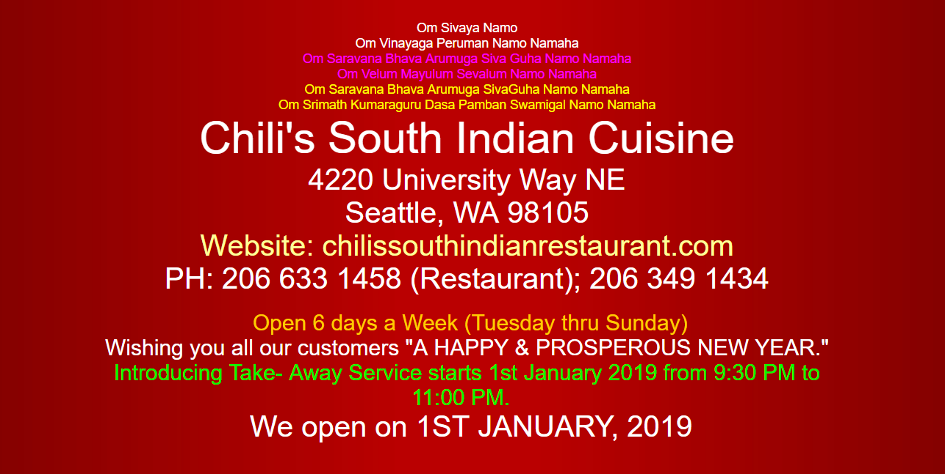

-No clear hierarchy

-Too much clutter

Lacks consistency

Focal point?

The design of a website is a form of communication between the business and the user. In this case, the title must be the focal point on the page. This can be done by using either size, contrast or color. It seems that the designer tried to employ the difference in size to highlight “Chili’s South Indian Cuisine” but since the difference in the text size is not much, it isn’t emphasized.

Color can be used as an organizational tool as well as a personality one. The pink, yellow, orange and green text draw a lot of unnecessary attention away from the title. Additionally, there is no consistency in the text colors used, which confuses the user by taking away familiarity and a sense of control. Using lush and comforting colors makes the user experience better, but using a harsh red tends to get a negative reaction from users.

According to the proximity rule of design: “Objects are located within the same closed region, we perceive them as being grouped together” [4 Gestalt Principles] Therefore, the cluttering of text near the title makes users think of all the text as a whole and doesn’t establish any hierarchy.

**Navigation, Intuitiveness and Aesthetics**

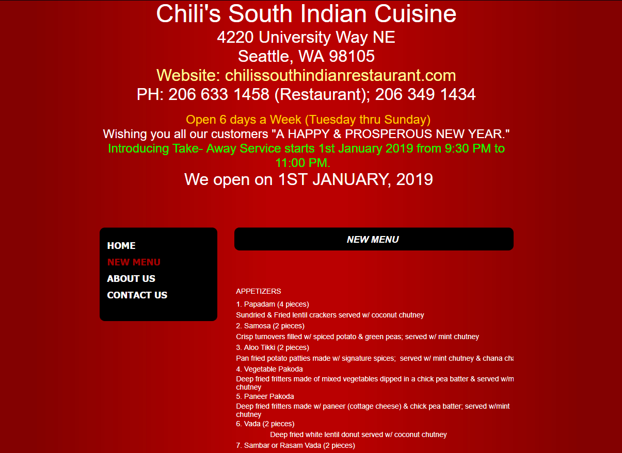



The same contrast techniques are used for the above three elements even though they represent different things. The focal point should have been the navigation menu and less focus should be given to the footer. This is detrimental to the intuitiveness of the website and confuses the user about its navigation.

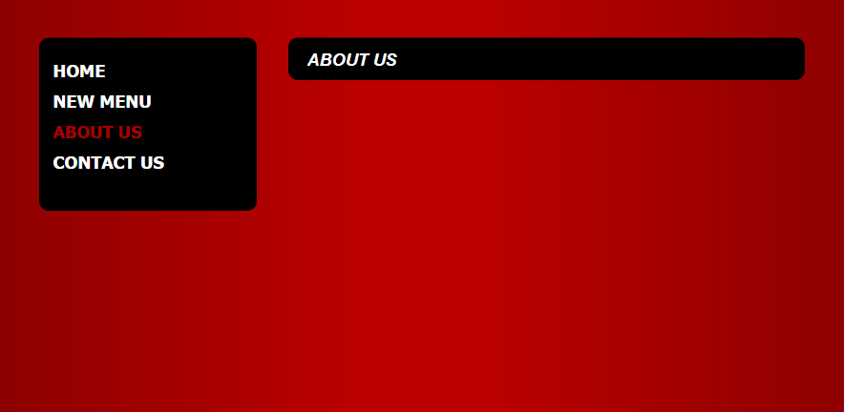

Empty “About Us” tab

On clicking on the “About us” tab there are no results. The lack of this content portrays lack of professionalism and doesn’t allow the stakeholders to reach their goals of getting to know about the restaurant.

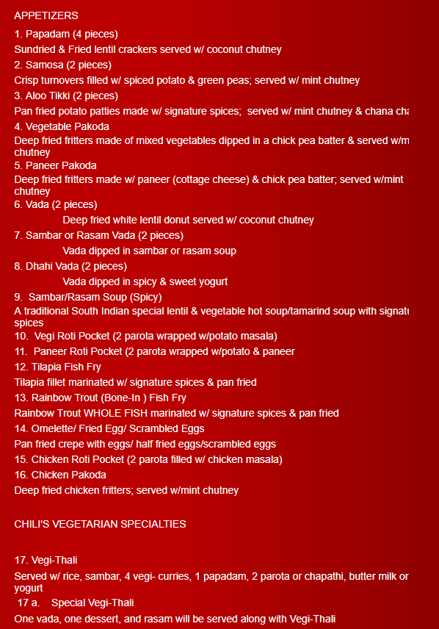

Cannot differentiate between title and description

Not a clear different in emphasis

No prices mentioned

No pictures

The navigation of the menu is daunting since it seems like a lot of text to read with no organization. Lists generally have mental models i.e. expectations users have before they interact with the website with the title highlighted with bigger, bolder text and a smaller description – this increases the readability of text.

Additionally, there are no visual elements in the website. Images bring your products to life, draw attention and trigger emotions.

## Re-Design Proposal

**Intuitive Navigation bar and Organized menu**

I have revised the website to have a clear navigation bar. The colors used is a simple red, black and white scheme which provides clear cues that red is the color that used to highlight text. This consistent color scheme provides clarity to the user and makes the interface intuitive to use.

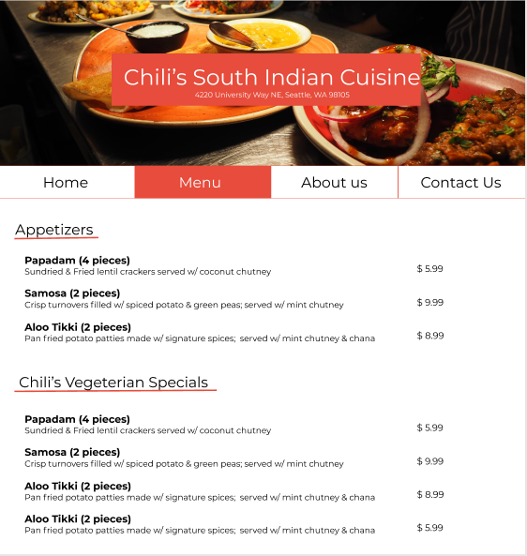

Prices clearly displayed

Clear distinction between title and description

Highlights and differentiates categories

The “About us” page now serves a purpose and displays the necessary information which was otherwise displaced

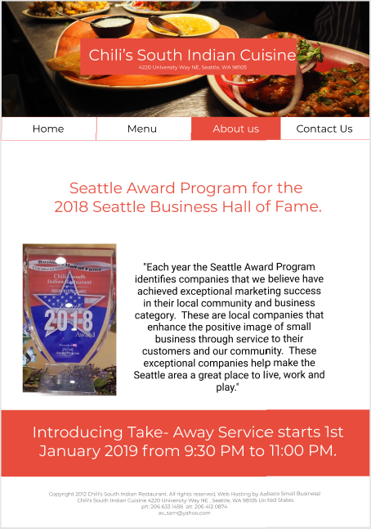

**Employing color schemes and establishing hierarchy**

There is clear hierarchy where the title – “Chili’s South Indian Cuisine” is explicitly emphasized with a subtitle of the address. There is no clutter around the title and uses a background image to induce emotion in the user to lure the user to come to the restaurant. Additionally, I suggest displaying images for each dish on the website on hover, this will motivate the user even more.

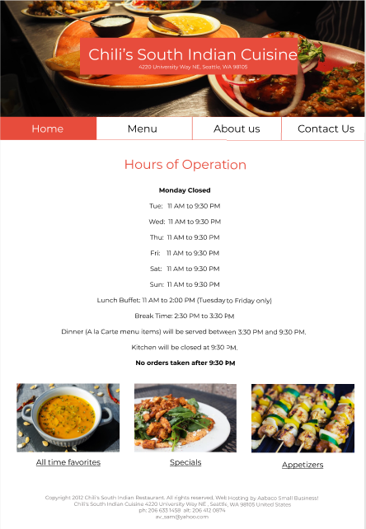

Simple color scheme that establishes emphasis

Emphasized and uncluttered title

Contrast, Color and size techniques have been used to portray focal points across the page. The contrast is also consistent with the color scheme by using familiar colors.

The proximity principal was also employed to group elements together. For example, the fast links to the menu have been established as a separate section and the hours of operation is a separate one. This can also be seen in navigation bar which is grouped in a horizontal tabular way right at the top of page; it makes navigating the page more intuitive.

The proposed design also has its limitations in not leveraging the fact that visual interaction is the strongest way to persuade users. Especially since it’s a website is food based, images can be a strong motivator. Additionally, the menu may be better organized and have better hierarchy but its still daunting to see a lot of text in proximity. These are the limitations that can be addressed in future iterations of the website.

Bibliography

* Riel, & M, R. (2018, March 19). Psychology design: Gestalt principles you can use as design solutions. Retrieved from <https://uxdesign.cc/psychology-design-4-gestalt-principles-to-use-as-your-next-design-solution-fcdec423a6bf>
* Complete Beginner's Guide to Information Architecture | UX Booth. (n.d.). Retrieved from <https://www.uxbooth.com/articles/complete-beginners-guide-to-information-architecture/>

Appendix

* Research for motivation and goals of customers was done using [this survey](https://docs.google.com/forms/d/e/1FAIpQLSdgriUj4zk0tAp_xhZK6XztCn6AaJY6CbrN7mNFoM9l4UgYTw/viewanalytics)
* [Interview notes](https://docs.google.com/document/d/1x0FoYm29Mfj8YwpeP0Zd_4XHgYtBtZKO1fUcgnNJDRA/edit?usp=sharing) with Chili’s owner