**Kevin Saavedra**

USP 587 – Homework 2

1. Develop Cross-Classification Trip Rate Tables for Household

As this assignment involves HBW Trips, it was logical to begin with the number of workers per surveyed household size. While the provided dataset had counts of up to 5 workers per household, I decided to recategorize for 1, 2, or 3 or more workers, as this seems to be more in line with the average household. Initially, allowing a value of 0 for household workers led to a 0-cell issue, so the minimum worker count must be 1. I also opted to recategorize household size to 1, 2, 3, and 4+, again to better represent average household sizes.

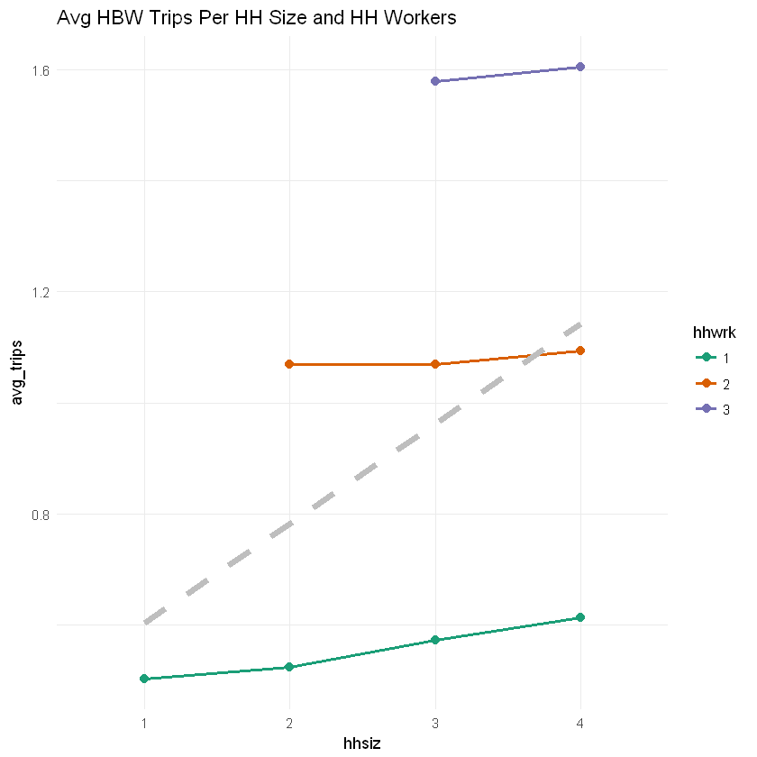*Table 1, Fig 1. CCA, Average HBW Trips by HH Size: HH Workers*

| **HH Size** | **HH Workers** | **Avg HBW Trips** |
| --- | --- | --- |
| 1 | 1 | 0.5025381 |
| 2 | 1 | 0.5240964 |
| 2 | 2 | 1.0689115 |
| 3 | 1 | 0.5731225 |
| 3 | 2 | 1.0696721 |
| 3 | 3 | 1.5786164 |
| 4 | 1 | 0.6123188 |
| 4 | 2 | 1.0927152 |
| 4 | 3 | 1.6047619 |

SSE = 3369.96520922889

SST = 3968.93572744015

R2 = 0.150914642953307

Adj R2 = 0.149818240536903

n = 5430

The relatively low Adjusted R2 value of .1497 led me to try other factors for CCA. First, HH size by presence of non-workers (Table 2, Fig 2). Non-workers are identified with the dummy variable 1 if *n*HHSize > *n*HHWorkers.

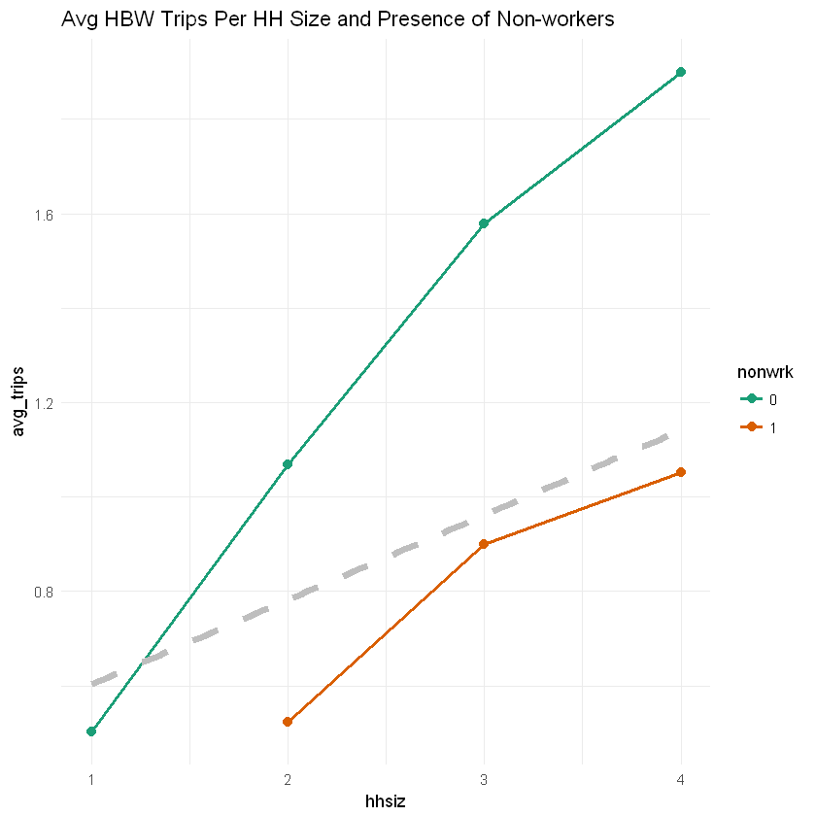*Table 2, Fig 2. CCA, Average HBW Trips by HH Size: Presence of Non-workers*

| **HH Size** | **Non-workers** | **Avg HBW Trips** |
| --- | --- | --- |
| 1 | 0 | 0.5025381 |
| 2 | 0 | 1.0689115 |
| 2 | 1 | 0.5240964 |
| 3 | 0 | 1.5786164 |
| 3 | 1 | 0.9001350 |
| 4 | 0 | 1.9000000 |
| 4 | 1 | 1.0520231 |

SSE = 3508.24607053155

SST = 3968.93572744015

R2 = 0.116073851668474

Adj R2 = 0.115258872737687

n = 5430

The presence of non-workers did not appear to have as good a predictive ability as HH size and number of workers.

For a final attempt, I tried a CCA using the number of workers with the number of vehicles per household (Table 3, Fig 3), under the assumption that the presence of a household vehicle will lead to higher HBW trips. In a first attempt, I compared HH size to the *presence* of a household vehicle (dummy variable 0 or 1). This produced an adjusted R2 value of .1533. Recategorizing for the number of vehicles 0, 1, 2, or 3 or more against household size actually produced a higher R2, .1587, which is reproduced below. The following section will compare the model using the presence of a household vehicle to the model using categorical variables representing the number of household vehicles.

*Table 3, Fig 3: CCA, Average HBW Trips by HH Workers: HH Vehicles*

| **HH Workers** | **HH Vehicles** | **AVG HBW Trips** |
| --- | --- | --- |
| 1 | 0 | 0.2716049 |
| 1 | 1 | 0.5060554 |
| 1 | 2 | 0.5838103 |
| 2 | 0 | 0.7222222 |
| 2 | 1 | 0.8817204 |
| 2 | 2 | 1.1164773 |
| 3 | 0 | 1.0000000 |
| 3 | 1 | 1.3448276 |
| 3 | 2 | 1.6165192 |

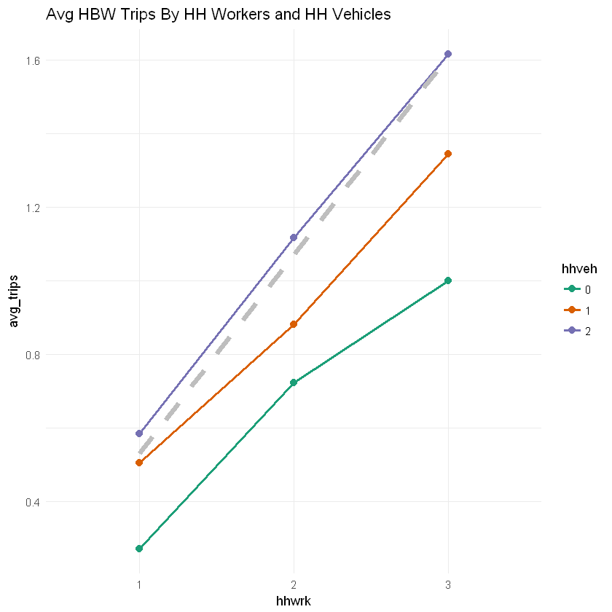SSE = 3334.23016798233

SST = 3968.93572744015

R2 = 0.159918326484764

adj R2 = 0.158678353534926

1. Estimating a Linear Regression Model of Household Trip Generation

This section will compare the best-performing linear regression models using linear regressions calculated in R as well as F-statistics calculated manually.

*Fig x: Final graph based on model comparison and findings.*