Peer-to-Peer Carpooling & Expense Splitter

UML Use-Case Diagram Specification - Lab 1
System Boundary Label: Peer-to-Peer Carpooling & Expense Splitter
Actors:
- Rider Commuter: Primary actor seeking a shared ride along daily commute routes.
- Driver Host: Primary actor offering vehicle seats to split travel costs.
- Map & Route Service: External system supporting actor providing route calculations and detour distance evaluation.

1. Diagram Preview

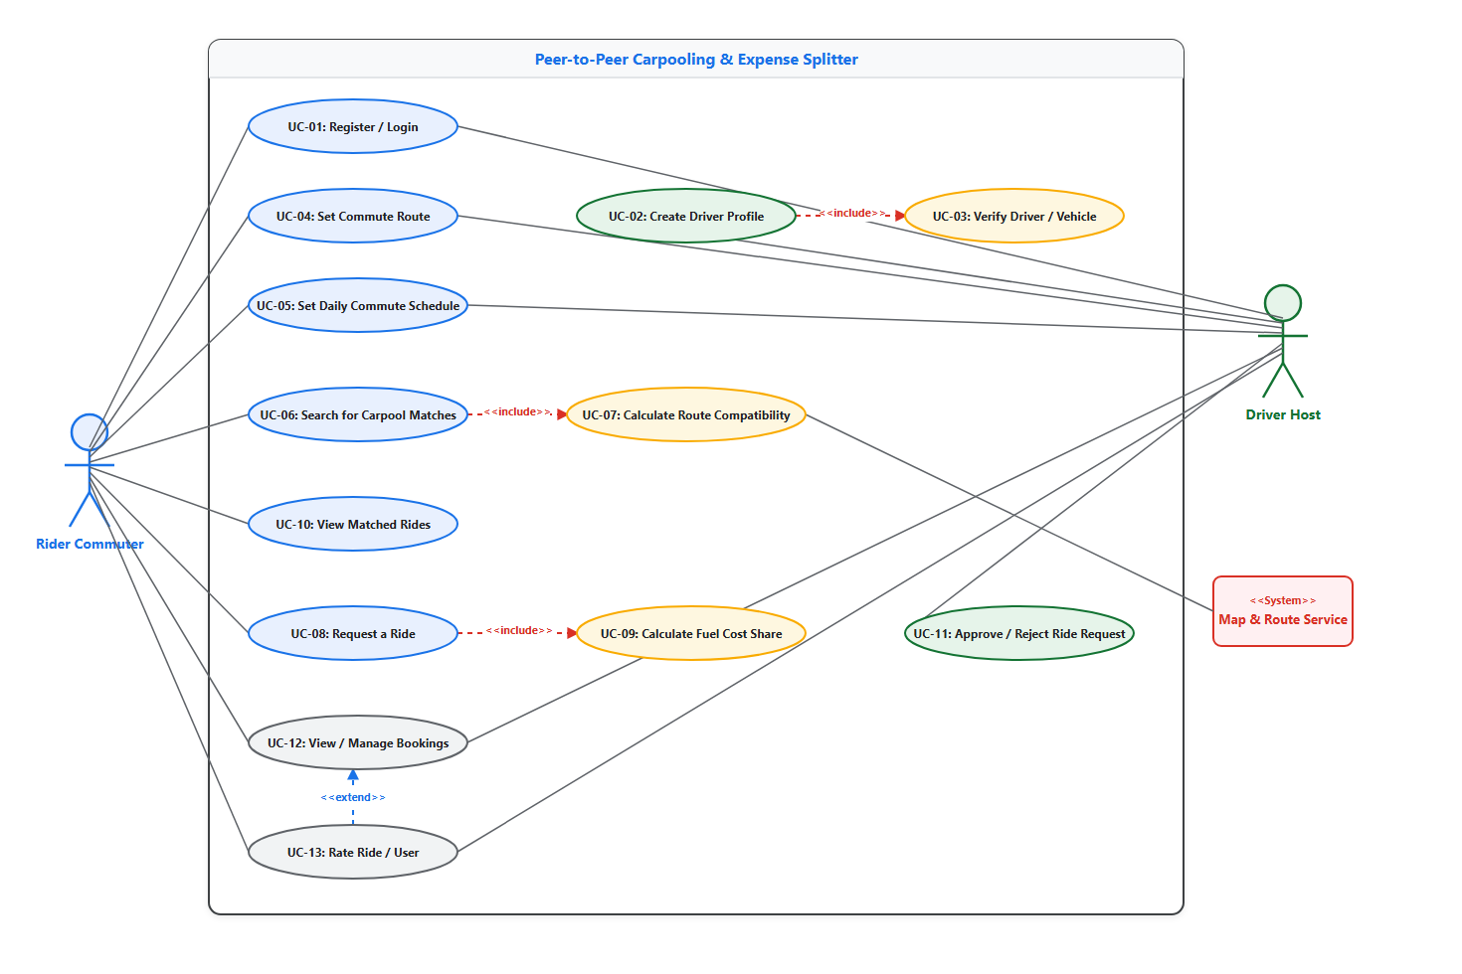

- Editable Diagram Source File: [use-case-diagram.drawio](file:///C:/Users/llath/OneDrive/Desktop/Lab1/use-case-diagram.drawio)
- High-Resolution Submission Image: [use-case-diagram.png](file:///C:/Users/llath/OneDrive/Desktop/Lab1/use-case-diagram.png)
- PDF Submission Document: [use-case-diagram.pdf](file:///C:/Users/llath/OneDrive/Desktop/Lab1/use-case-diagram.pdf)

2. Use Case Inventory
Use Case ID | Use Case Name | Primary Actor(s) | Description
**UC-01** | Register / Login | Rider Commuter, Driver Host | Authenticate users and grant access to portal services.
**UC-02** | Create Driver Profile | Driver Host | Set up vehicle details and host profile settings.
**UC-03** | Verify Driver / Vehicle | System / Driver Host | Verify driving license and vehicle registration documents.
**UC-04** | Set Commute Route | Rider Commuter, Driver Host | Define origin, destination, and key route waypoints.
**UC-05** | Set Daily Schedule | Rider Commuter, Driver Host | Configure recurring daily departure time windows.
**UC-06** | Search Carpool Matches | Rider Commuter | Search for drivers with overlapping commute routes.
**UC-07** | Calc Route Compatibility | Map & Route Service, System | Compute route overlap enforcing the 1.5 km detour threshold.
**UC-08** | Request a Ride | Rider Commuter | Send seat reservation request to a driver host.
**UC-09** | Calc Fuel Cost Share | System | Compute proportional cost share split per passenger.
**UC-10** | View Matched Rides | Rider Commuter | Display sorted list of compatible carpool matches.
**UC-11** | Approve / Reject Request | Driver Host | Review incoming passenger requests and accept/decline.
**UC-12** | View / Manage Bookings | Rider Commuter, Driver Host | Track active, upcoming, and completed ride bookings.
**UC-13** | Rate Ride / User | Rider Commuter, Driver Host | Submit rating and performance feedback post-trip.

3. UML Relationship Specification

Actor-to-Use-Case Association Mapping
- Rider Commuter (Primary Actor): Associated with UC-01, UC-04, UC-05, UC-06, UC-08 (Request a Ride), UC-10 (View Matched Rides), UC-12, UC-13.
- Driver Host (Primary Actor): Associated with UC-01, UC-02, UC-04, UC-05, UC-11 (Approve / Reject Request), UC-12, UC-13. (Note: UC-11 is directly connected to Driver Host for decision authorization; it is NOT connected to Map & Route Service).
- Map & Route Service (External Supporting System Actor): Associated ONLY with UC-07 (Calc Route Compatibility) to evaluate geographical detour distance.

`<<include>>` Relationships (Points FROM Base Use Case TO Included Use Case)
- `UC-02: Create Driver Profile` $\xrightarrow{<<include>>}$ `UC-03: Verify Driver / Vehicle`
- Base Use Case: UC-02: Create Driver Profile
- Included Use Case: UC-03: Verify Driver / Vehicle
- Rationale: Creating a driver profile mandatorily includes identity and vehicle document verification.
- `UC-06: Search Carpool Matches` $\xrightarrow{<<include>>}$ `UC-07: Calc Route Compatibility`
- Base Use Case: UC-06: Search Carpool Matches
- Included Use Case: UC-07: Calc Route Compatibility
- Rationale: Searching for carpool matches automatically triggers the route compatibility calculation.
- `UC-08: Request a Ride` $\xrightarrow{<<include>>}$ `UC-09: Calc Fuel Cost Share`
- Base Use Case: UC-08: Request a Ride
- Included Use Case: UC-09: Calc Fuel Cost Share
- Rationale: Requesting a ride automatically calculates the estimated fuel cost split.

`<<extend>>` Relationship (Points FROM Extending Use Case TO Base Use Case)
- `UC-13: Rate Ride / User` $\xrightarrow{<<extend>>}$ `UC-12: View / Manage Bookings`
- Extending Use Case: UC-13: Rate Ride / User
- Base Use Case: UC-12: View / Manage Bookings
- Rationale: Rating a ride/user optionally extends booking management after a ride is completed.

