Women education

If women are educated, she will know about the rules and regulations and will know the good and bad touch and will be able to easily report to the police.

Some policemen who are not doing their job by being educated she can imbibe knowledge over them.

If her daughter is faced with assault, she can take appropriate actions to get justice and seeing this her daughter will also learn not to sit silent in these situations.

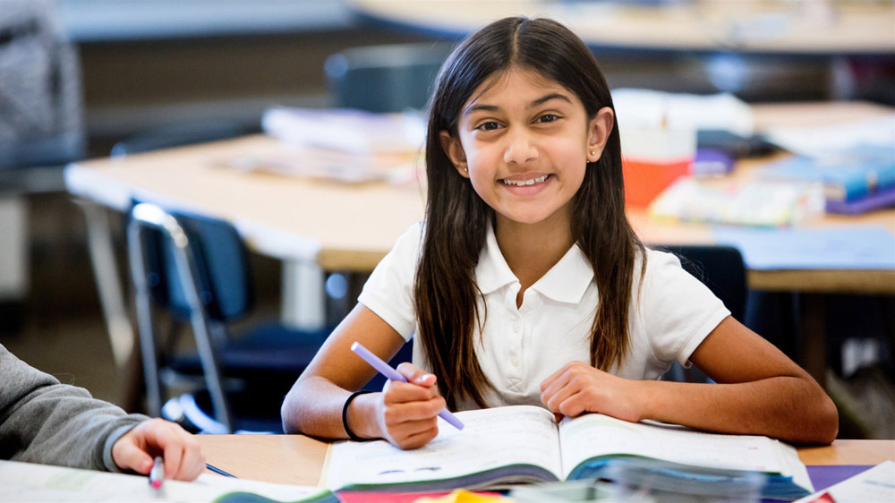

Educating women will make them go for jobs that will make the country proud like being a police officer who can understand other women’s plight and take appropriate action.

Educating women will increase the intellectual power of a country overall.

Educating women will make them ask for equal pay for the same job done by boys so equality is maintained.