[Home](https://www.fnp.com/) [Send Flowers Online](https://www.fnp.com/flowers) Stylish Box Of Red Roses & Chocolates



[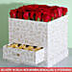](javascript:void(0))

[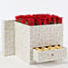](javascript:void(0))

[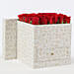](javascript:void(0))

[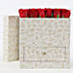](javascript:void(0))

[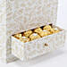](javascript:void(0))

[](javascript:void(0))



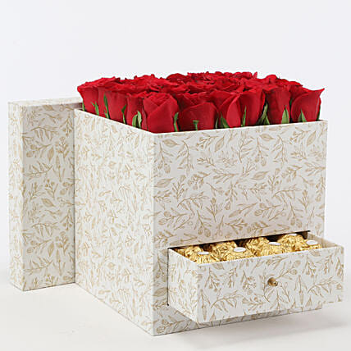

*EXD_FLOWER_MFDL_260*Roll over image to zoom in

* https://i9.fnp.com/assets/images/custom/homepage_target/icons/safe.png 100% Safe and Secure Payments.
* https://i9.fnp.com/assets/images/custom/homepage_target/icons/trust.png 6 Million People Trust Us.

Stylish Box Of Red Roses & Chocolates

5 **☆☆☆☆☆**

8

 Reviews

Top of Form

₹

2,399

Inclusive of all taxes

[View more details](javascript:void(0);)





info_outline Enter correct Pincode for hassle free timely delivery.

Don't know Pincode ?

[Select Delivery Date](javascript:void(0);)

ADD TO CARTBUY NOW

Bottom of Form

 05:17:49 Hrs. left for

tomorrow's

 delivery

Description

**Product Details:**

* 8 Ferrero Rocher Chocolates
* 30 Red Roses
* One Cardboard Box- 7.25 x 7.25 x 7.25 cms

**Flowers Trivia:**

* Did you know that the rose is edible, can live for a very long time, has been mentioned in the bible and is a great source of vitamin C?
* Red Roses are perfect expressions of love and romance since ancient times!

**Please Note:**

* This Arrangement is made using green oasis foam that stores water in it and keeps your arrangement fresh for a longer time.

Delivery Information

* The image displayed is indicative in nature. Actual product may vary in shape or design as per the availability.
* Flowers may be delivered in fully bloomed, semi-bloomed or bud stage.
* The chosen delivery time is an estimate and depends on the availability of the product and the destination to which you want the product to be delivered.
* Since flowers are perishable in nature, we will be able to attempt delivery of your order only once.
* The delivery cannot be redirected to any other address.
* This product is hand delivered and will not be delivered along with courier products.
* Occasionally, substitution of flowers is necessary due to temporary and/or regional unavailability issues.

Care Instructions

* Don’t place the flower arrangement under direct sunlight or near any other source of excessive heat. It should also not be placed under a fan.
* If any petal gets damaged, then remove it from the flower.
* Ensure that the floral foam is always soaked in water.
* All the flowers benefit from a daily mist of water.
* Enjoy your flowers!
* Store your chocolates in the refrigerator. If they are exposed to high temperatures, they may begin to soften, compromising the appearance and flavour.