SAATWIK SINHA
Phone Number: +91 98765 43210 Email Address: saatwik@email.com

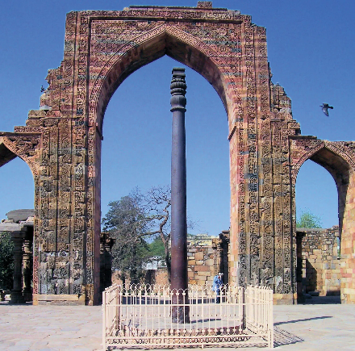
Date of Birth: 12 June 2006
Gender: Male
Blood Group: 0+
Father’s Name: Ajay Kumar Sinha
Mother’s Name: Needhi Sinha
Nationality: Indian
Address: Bandra West, Mumbai, India
Languages Known: English (Fluent) & Hindi (Fluent)

Educational Qualifications
Degree | Institution | Year of Pass | Marks
Higher Secondary School (HSSC) | Mount Carmel College | 2025 | 87%
Secondary School Certificate (SSC) | St. Anne’s High School | 2022 | 91%
- Currently: In Symbiosis Institute of Technology, Maharashtra |B. Tech CSE [2025-2029]
Work Experience
IT INTER Executive
Brightline Technology 2025 – Present
- Coding Department
- Maintained records
Skills
- Proficient in MS Office (Word, Excel, PowerPoint)
- Strong communication and interpersonal skills
- Hand on Experience on HTML, CSS

Declaration: I declare the above information true and complete to the best of my knowledge.

Signature: Saatwik Sinha

