Digital Image Processing – HW1

Submitters:  
Amir Avivi – 305183873  
Sagi Bouzaglo –

1. Theoretical questions
2. Let $f(x)$ be the image that would be formed on the image plane if the camera was still, and $g_{k}\left[n\right]=(f*h_{k})(n)$ be the actual formed digital image of the k-th frame.  
   In the process of taking the actual image we imply 2 actions – Sampling(digitalizing) and translation(due to the handshakes).  
   Mathematically, the convolution kernel describing the above actions would be:

$h_{k}=\int_{t}^{t+1msec}{τ_{o\left(t\right)}}δdt$

1. The Fourier transform of $h_{k}$ is given by:
$$H_{k}[ω] =F{\left(h_{k}\right)}_{ω}= F\left(\int_{k}^{k+1}{τ_{o(t)}}δ\right)=\{Linearty\}\int_{k}^{k+1}{ϕ_{o(t)} dt}$$

2. Let $G_{k}[ω]$ be the spectral decomposition of the real-world image. $f$ 
    – Real-world image (calculated via the pixel’s cumulative sunlight absorption). $h_{k}$ 
    – Photographer’s handshakes. $box(t)$ 
    – Camera shutter exposure time describing function.  
     
   Mathematically:

$$G_{k}\left[ω\right]=F\left(g_{k}\left[n\right]*box(n)\right)=F{\left(f(n)*h_{k}(n)*box(t)\right)}_{n}=F[ω]⋅H_{k}[ω]⋅sinc(ω)$$

The expression for the frequency response of the discrete kernel $P_{k} is H_{k}[ω]$.

$\left|P_{k}\left[ω\right]\right|=\left|\int_{k}^{k+1}{ϕ_{o\left(t\right)} dt}\right|≤\left\{triangle inequalty\right\}\int_{k}^{k+1}{\left|ϕ_{o\left(t\right)}\right|dt} = \int_{k}^{k+1}{\left|e^{-2π{iw}^{T}o\left(t\right)}\right|dt}≤\left\{{Euler}^{'}s identity\right\}≤\int_{k}^{k+1}{1dt}=1$

1. We’ll express $P_{k}\left[ω\right]$ with respect to the given trajectory:

$$P_{k}=\int_{k}^{k+1}{e^{-2π{iw}^{T}\left(τ-k-0.5\right){ve}_{1}}dτ}\overset{→}{define c=-2π{iw}^{T}ve_{1}} \int_{k}^{k+1}{e^{c\left(τ-k-0.5\right)}dτ}= \\ e^{c\left(-k-0.5\right)}\int_{k}^{k+1}{e^{cτ}dτ}=e^{c\left(-k-0.5\right)}\left(\frac{e^{c\left(k+1\right)}}{c}- \frac{e^{ck}}{c}\right)= \\ \frac{e^{0.5c}-e^{-0.5c}}{c} \\ Inserting c: \\ \frac{e^{-π{iw}^{T}ve_{1}}-e^{π{iw}^{T}ve_{1}}}{-2π{iw}^{T}ve_{1}}=\frac{1}{πw^{T}ve_{1}}⋅\frac{e^{-π{iw}^{T}ve_{1}}+e^{π{iw}^{T}vke_{1}}}{2i}=\frac{\sin\left(πw^{T}ve_{1}\right)}{πw^{T}ve_{1}}= \\ sinc(vw^{T}e_{1})$$ This concludes an expected outcome:  
The higher the velocity –> sinc is more narrow This lead to a more concentrated spectrum -> Blurrier images( Which is the main idea of this task 😊 )

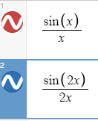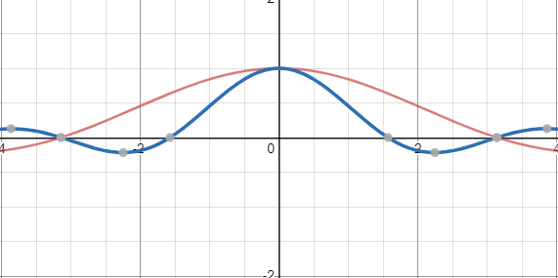

1. We’ll generalize the previous result for $o\left(τ\right)=q+τv$:

$$P_{k}=\int_{k}^{k+1}{e^{-2π{iw}^{T}\left(q+τv\right)}dτ}= \int_{k}^{k+1}{e^{-2π{iw}^{T}\left(\left(τ-k-0.5\right)v +\left(k+0.5\right)v+q\right)}dτ}= \\ \left\{decomposing for integral and consts+using previous result\right\} \\ =sinc\left(w^{T}v\right)⋅e^{-2π{iw}^{T}\left(\left(k+0.5\right)v+q\right)} \\ \left\{Translating v for its e1 and e2 general cordinates-based on the assupmtions that the handshakes are parller to the image plane\right\}$$ We can see that now the sinc’s directions are based on the velocity directions + higher velocity will result a more concentrated spectrum, just like before.  
The added function, results the same effect of concentrating the spectrum the higher the velocity gets.