Report

CS 736 – Medical Image Computing

Assignment 3 - Reconstruction

Instructor: Dr. Suyash Awate

By,

|  |  |
| --- | --- |
| Aditya Modi | 18305R007 |
| Saavi Yadav | 170020003 |

Submission Date: 03/04/2020

# Notes

1. The code is written in Python 3.6. The following libraries are used and hence are necessary for the code to work seamlessly:
   1. matplotlib
   2. numpy
   3. os
   4. skimage
   5. cv2
2. The range of image intensities is .
3. The results (images) are saved in “results” folder, in case, the images in the report aren’t up to the desired resolution.
4. The formula used for Fourier and Inverse Fourier Transform is in terms of frequency and not where , i.e

and

1. We use a polar system instead of Cartesian system where a point in Cartesian grid is represented by where

and

where,

# Part A

To execute part A, uncomment #359. Angles of projection are used are . The image used is “SheppLogan256.png”.

## Sub-Part A

To execute part A - sub-part A, uncomment line #205. The following is done:

1. Forward Projection/Radon Transform
2. Back Projection without any frequency filtering

The image is saved under the name “Question 1a1.png”.

## Sub-Part B

To execute part A - sub-part B, uncomment line #206. The following is done:

1. Implemented various frequency filters. The implementation of these filters is in the file “Functions.py” under the function “myFilter(len)”.
2. For , we visualize how the filtering is done in the frequency by corresponding filter-type. We plot
   1. The unfiltered FFT of , in blue
   2. The filtering function in red
   3. The filtered frequencies in green
3. The sinogram after filtering.
4. The reconstruction of the original image after filtering and the absolute of difference from the original image.

### Ram-Lak Filter

#### Bandlimit

1. Reconstruction RRMSE = 0.347.
2. The sinogram, filtering in frequency domain and the filtered sinogram image is saved under with the name “Question 1a2 (ram-lak) (full) (filtering).png”.

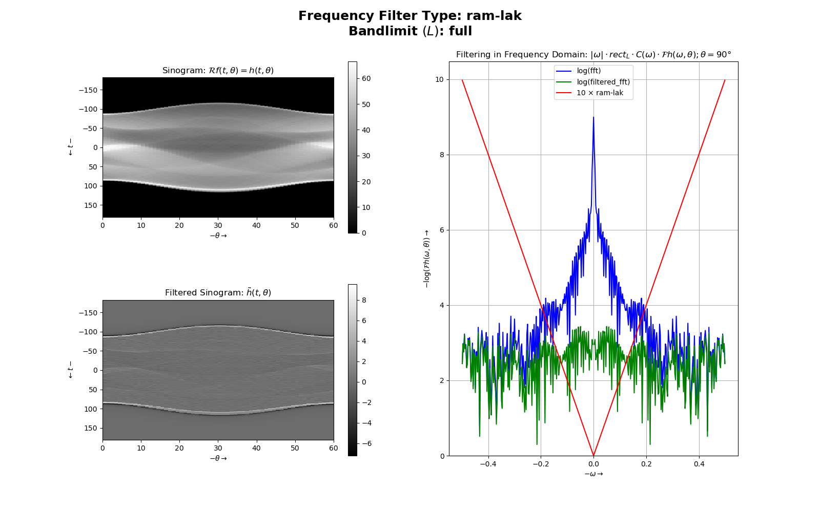

1. The original image, reconstructed image and the absolute of difference is saved under the name “Question 1a2 (ram-lak) (full) (reconstructing).png”.

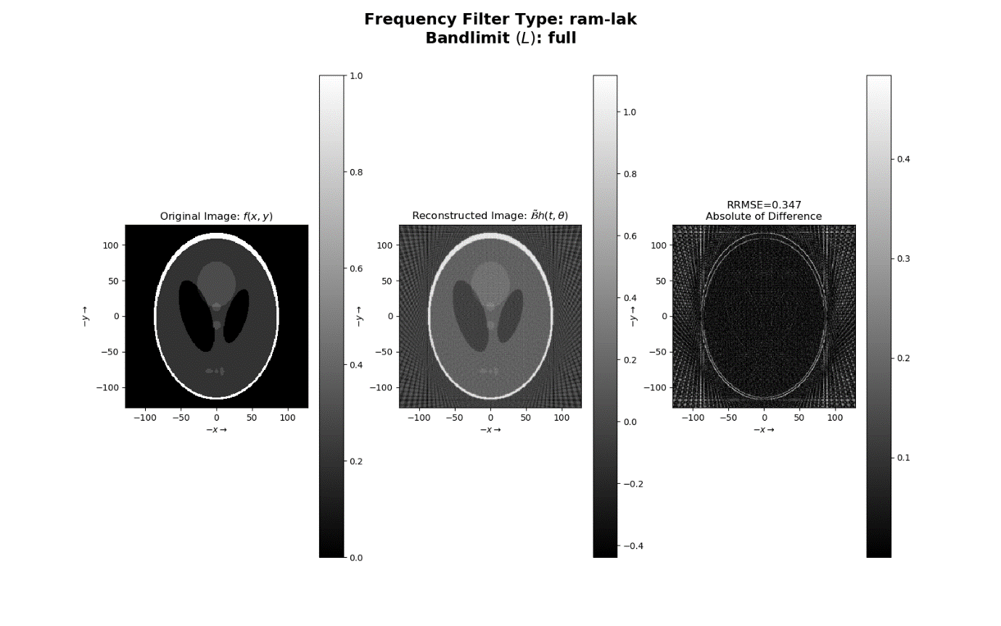

#### Bandlimit

1. Reconstruction RRMSE = 0.339.
2. The sinogram, filtering in frequency domain and the filtered sinogram image is saved under the name “Question 1a2 (ram-lak) (half) (filtering).png”.

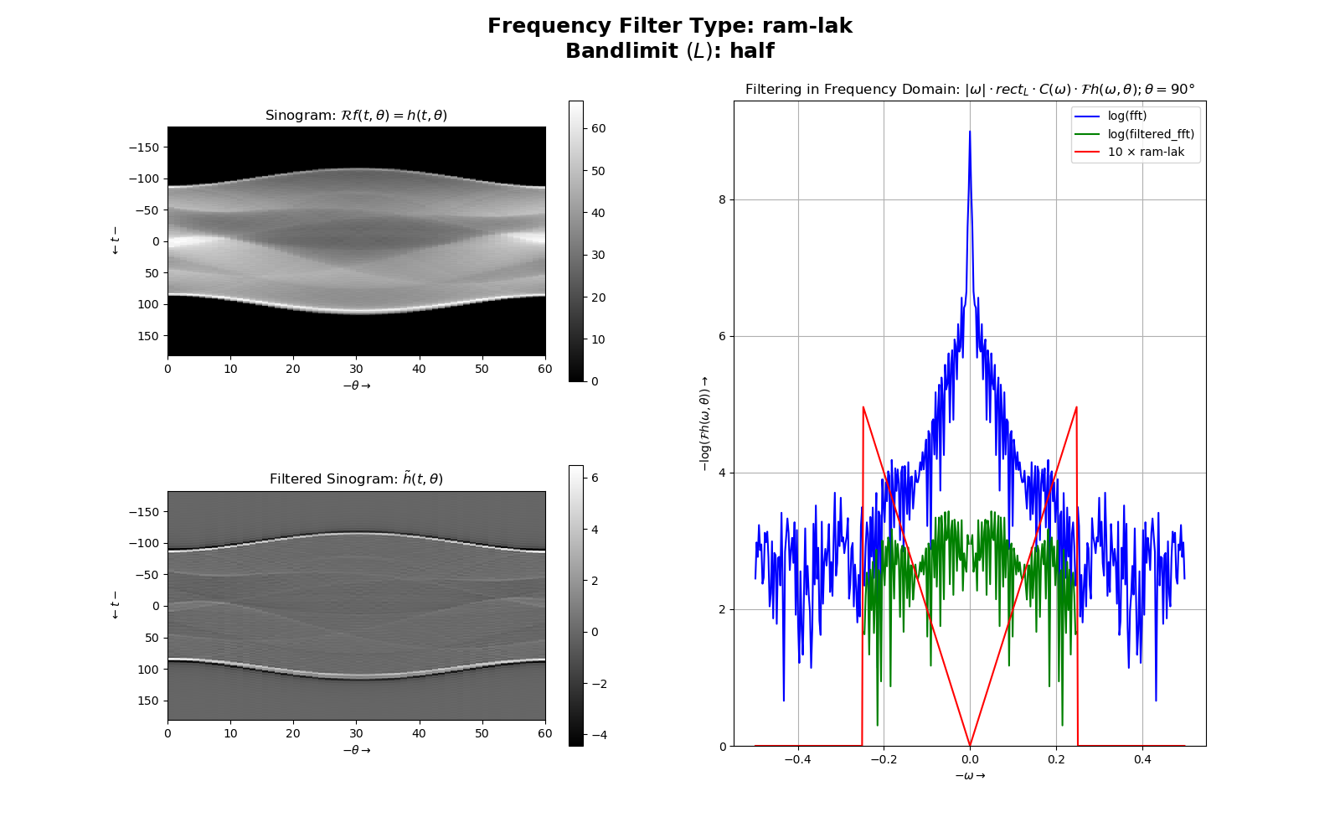

1. The original image, reconstructed image and the absolute of difference is saved under the name “Question 1a2 (ram-lak) (half) (reconstructing).png”.

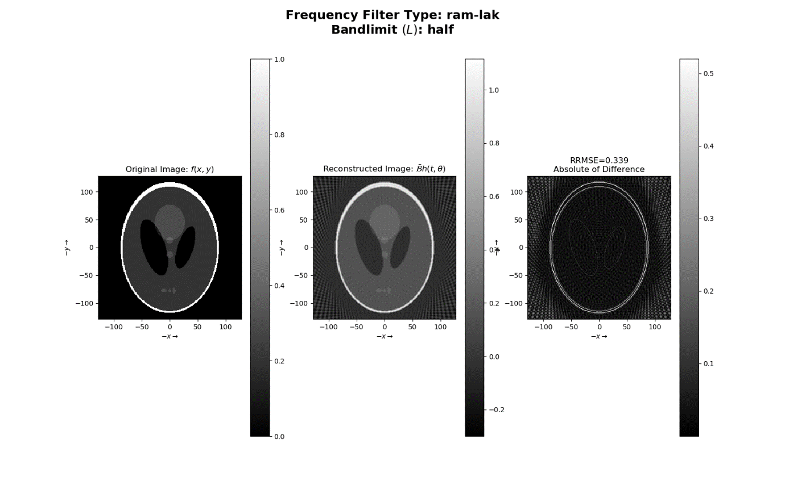

### Shepp-Logan Filter

#### Bandlimit

1. Reconstruction RRMSE = 0.331.
2. The sinogram, filtering in frequency domain and the filtered sinogram image is saved under the name “Question 1a2 (shepp-logan) (full) (filtering).png”.

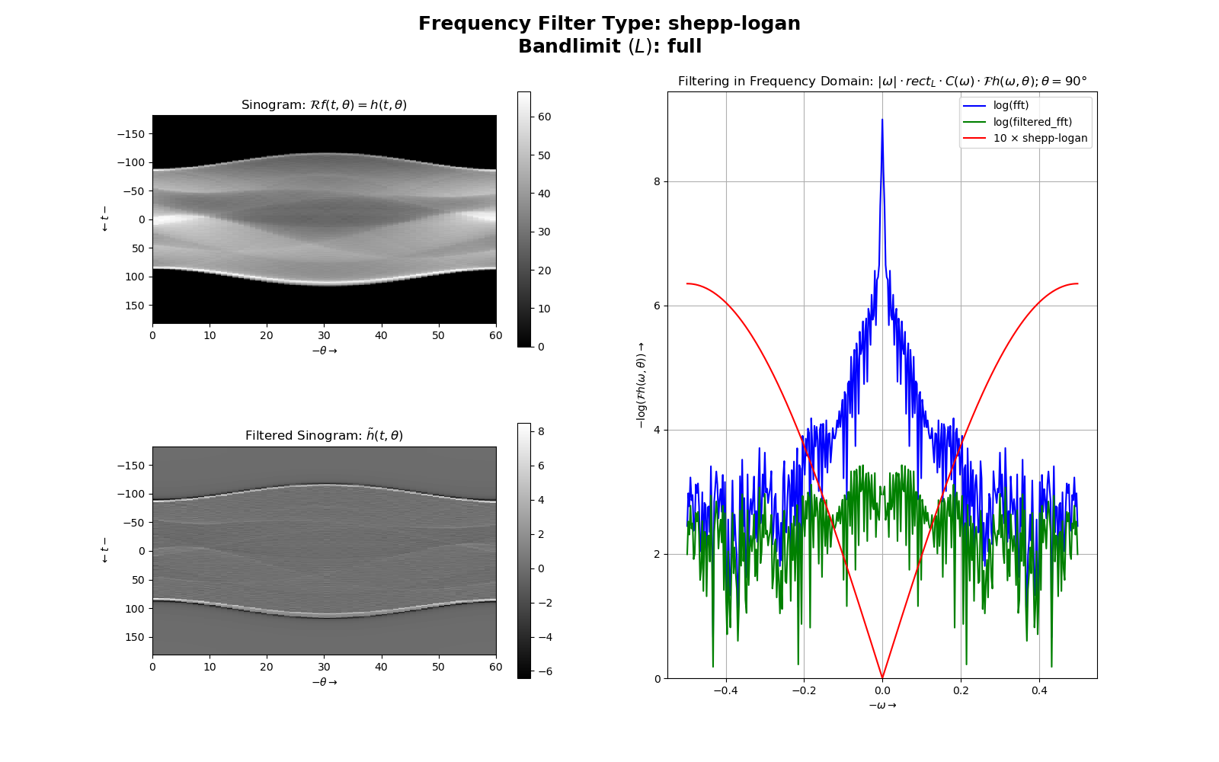

1. The original image, reconstructed image and the absolute of difference is saved under the name “Question 1a2 (shepp-logan) (full) (reconstructing).png”.

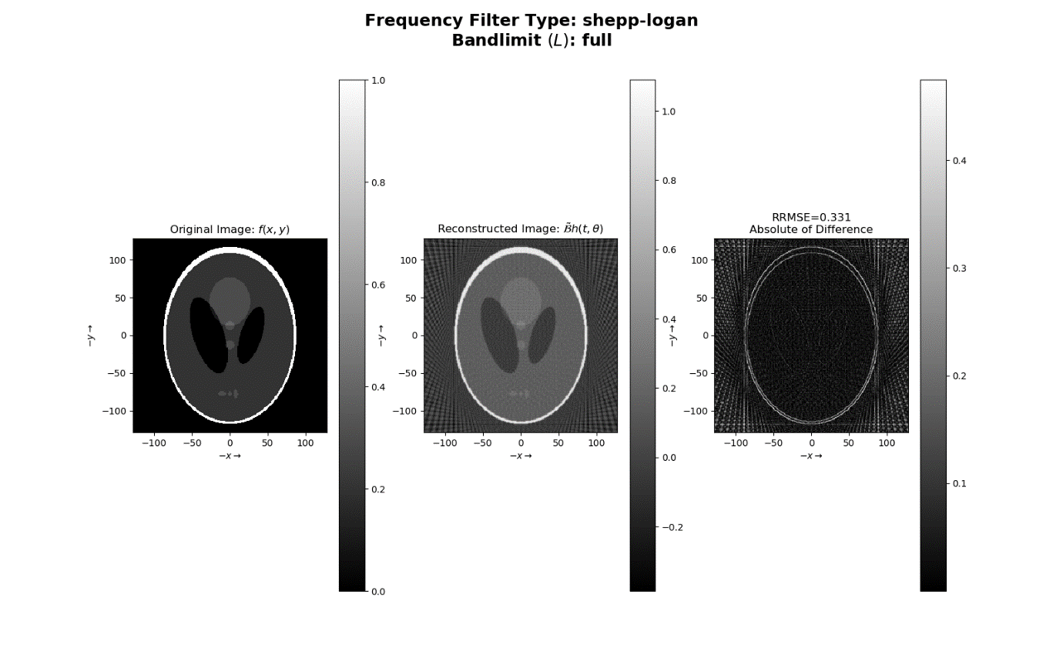

#### Bandlimit

1. Reconstruction RRMSE = 0.328.
2. The sinogram, filtering in frequency domain and the filtered sinogram image is saved under the name “Question 1a2 (shepp-logan) (half) (filtering).png”.

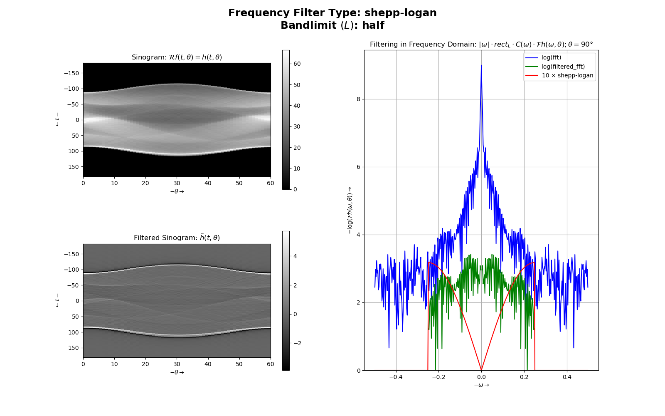

1. The original image, reconstructed image and the absolute of difference is saved under the name “Question 1a2 (shepp-logan) (half) (reconstructing).png”.

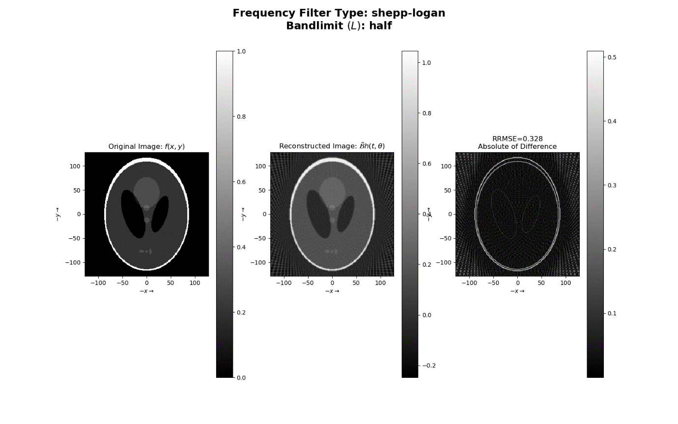

### Cosine Filter

#### Bandlimit

1. Reconstruction RRMSE = 0.319.
2. The sinogram, filtering in frequency domain and the filtered sinogram image is saved under the name “Question 1a2 (cosine) (full) (filtering).png”.

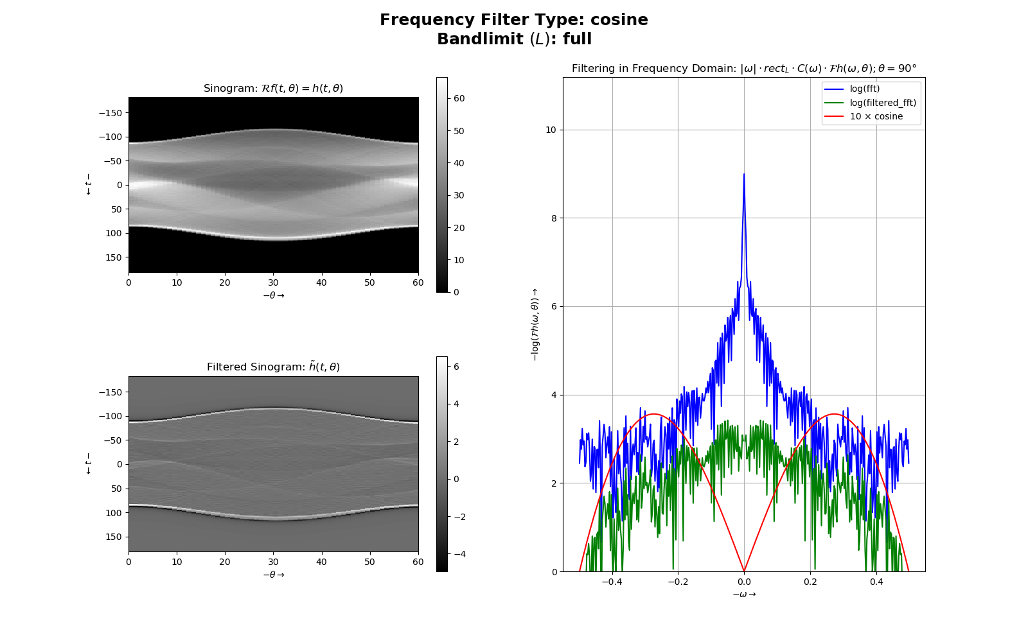

1. The original image, reconstructed image and the absolute of difference is saved under the name “Question 1a2 (cosine) (full) (reconstructing).png”.

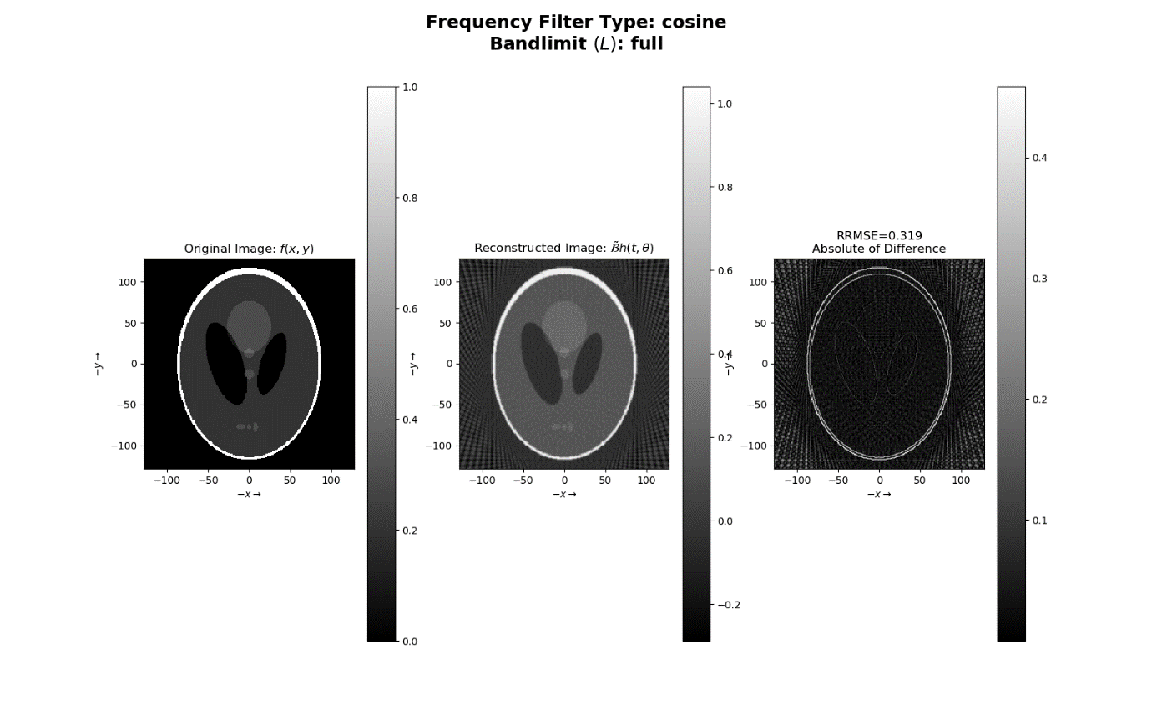

#### Bandlimit

1. Reconstruction RRMSE = 0.338.
2. The sinogram, filtering in frequency domain and the filtered sinogram image is saved under the name “Question 1a2 (cosine) (half) (filtering).png”.

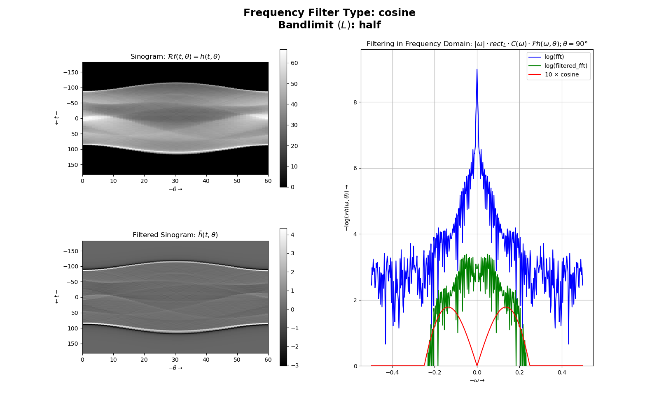

1. The original image, reconstructed image and the absolute of difference is saved under the name “Question 1a2 (cosine) (half) (reconstructing).png”.

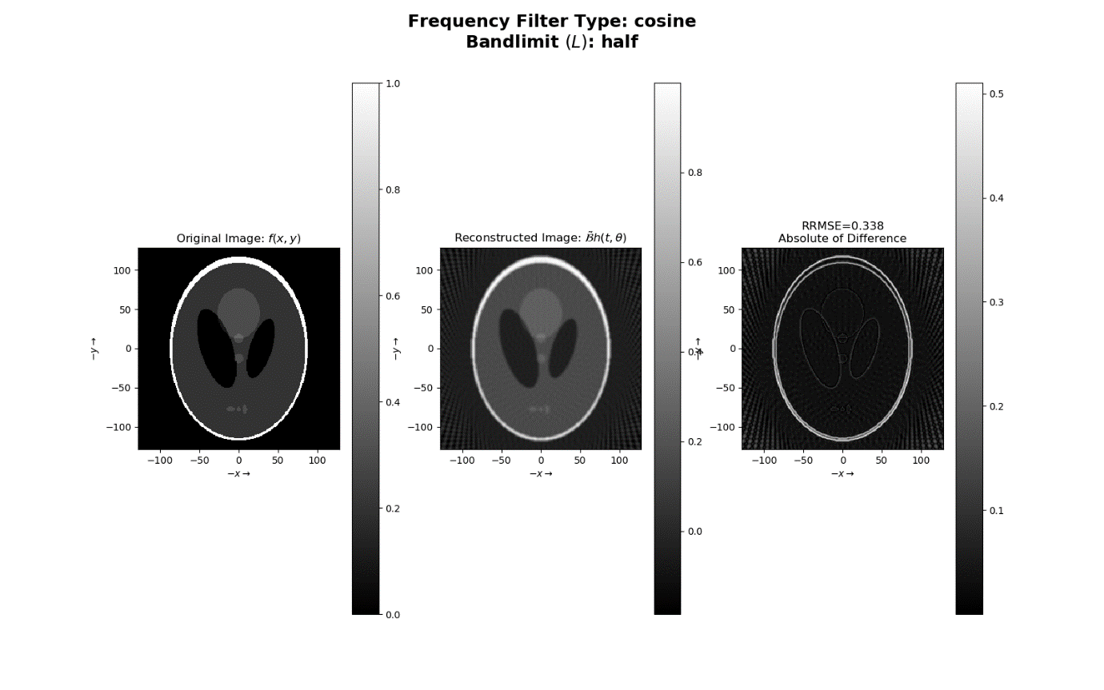

## Part B

To execute part B, uncomment #360. Angles of projection are used are . The image used is “SheppLogan256.png”. Frequency filter used is “ram-lak” filter. Bandlimit For this question, we have 3 images as follows

1. The original image:
2. The original image Gaussian blurred with :
3. The original image Gaussian blurred with :
4. The image is saved under the name “Question 1b (Blurred with σ=0).png”
5. Reconstruction RRMSE = 0.347

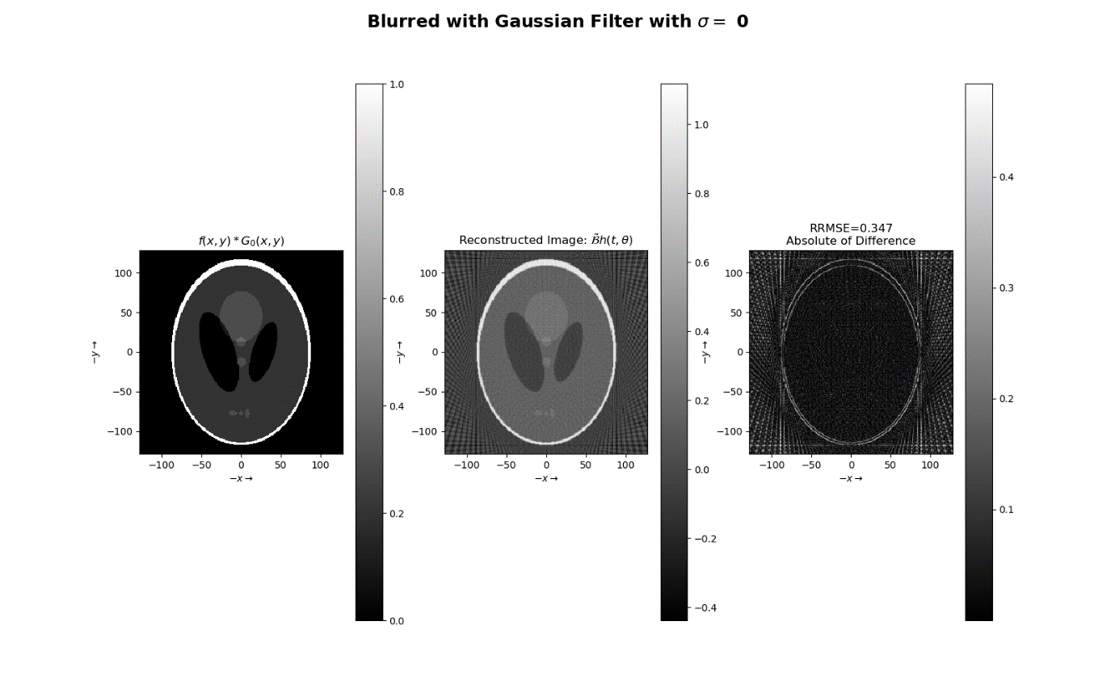

1. The image is saved under the name “Question 1b (Blurred with σ=1).png”
2. Reconstruction RRMSE = 0.213

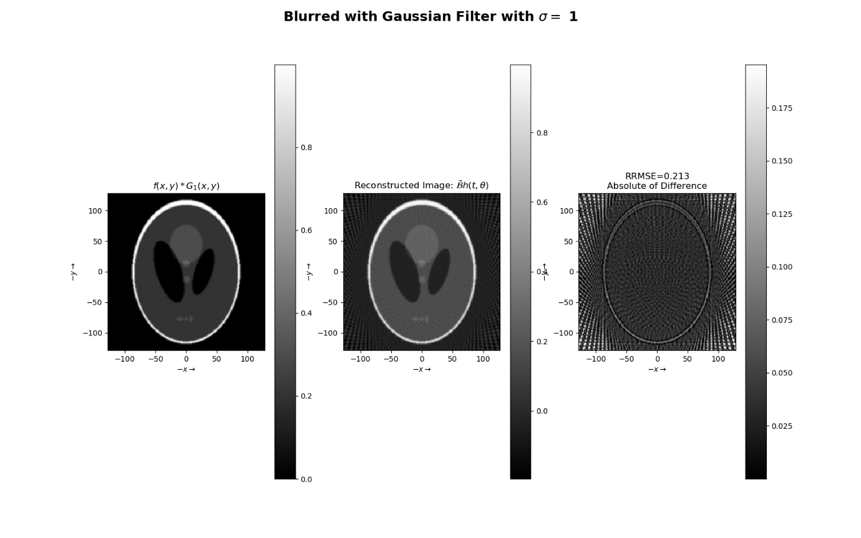

1. The image is saved under the name “Question 1b (Blurred with σ=5).png”
2. Reconstruction RRMSE = 0.191

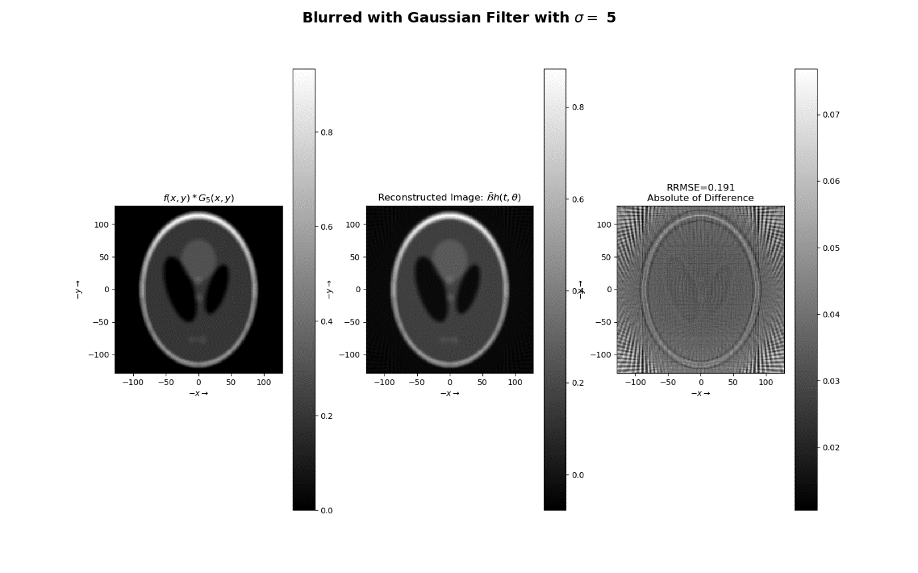

# Part C

To execute part C, uncomment #361. Angles of projection are used are . The image used is “SheppLogan256.png”. Frequency filter used is “ram-lak” filter. Bandlimit where .For this question, we have 3 images as follows

1. The original image:
2. The original image Gaussian blurred with :
3. The original image Gaussian blurred with :

