Report

CS 736 – Medical Image Computing

Assignment 3 - Reconstruction

Instructor: Dr. Suyash Awate

By,

|  |  |
| --- | --- |
| Aditya Modi | 18305R007 |
| Saavi Yadav | 170020003 |

Submission Date: 03/04/2020

# Notes

1. The code is written in Python 3.6. The following libraries are used and hence are necessary for the code to work seamlessly:
   1. matplotlib
   2. numpy
   3. os
   4. skimage
   5. cv2
2. The range of image intensities is $[0, 1]$.
3. The results (images) are saved in “results” folder, in case, the images in the report aren’t up to the desired resolution.
4. We use a polar system $(t, θ)$ instead of Cartesian system where a point $(x, y)$ in Cartesian grid is represented by $(x\left(s\right), y(s))$ where

$$x\left(s\right)=t⋅\cos\left(θ\right)-s⋅\sin\left(θ\right)$$

and

$$y\left(s\right)=t⋅\sin\left(θ\right)+s⋅cos⁡(θ)$$

where, $s∈\left[-∞,∞\right], t∈\left[-∞,∞\right], θ∈[0, 2π]$

# Part A

To execute part A, uncomment #193. The images used are “ChestCT.png” and “SheppLogan256.png”. We use a pseudo brute-force approach to find the optimal angle $θ^{*}$, for which reconstruction RRMSE is the minimum.

$θ^{*}∈Θ_{start}$

1. $Θ_{start}=[θ_{0},θ_{0.5},θ_{1.5},⋯, θ_{179.5}]$.
2. $θ_{i}=[i, i+1, i+2, ⋯, i+150]$.

## ChestCT

1. Minimum RRMSE = 0.272
2. Corresponding $θ=52.5°$

## SheppLogan256

1. Minimum RRMSE = 0.332
2. Corresponding $θ=105.5°$

The images are saved under the name “Question 3a.png”.

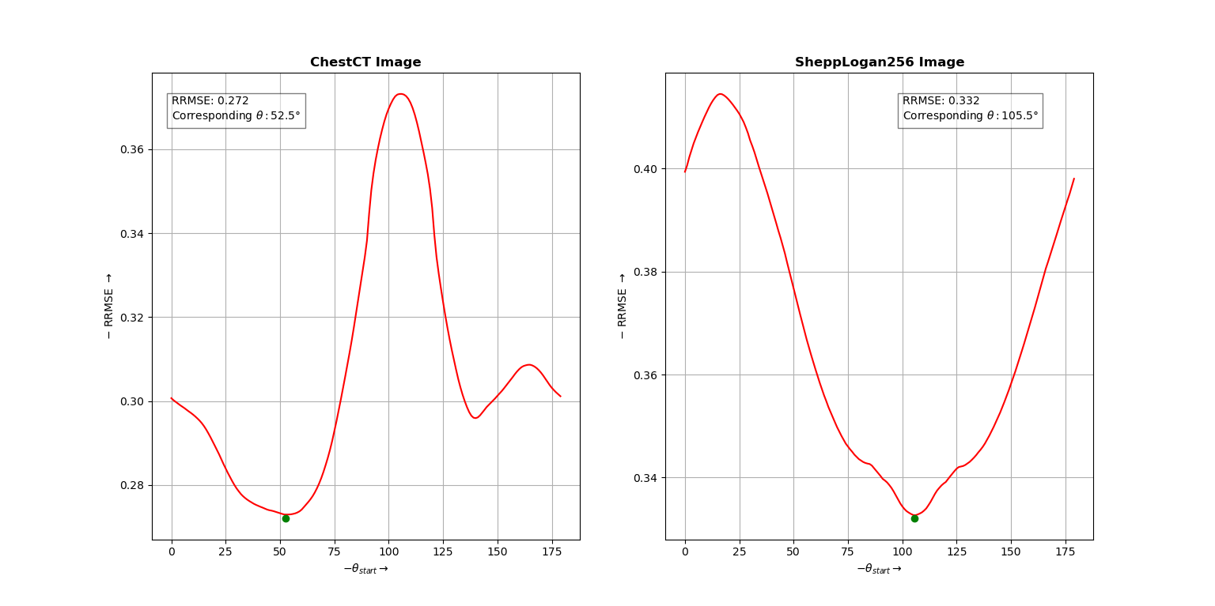

# Part B

## ChestCT

The image is saved under the name “Question 3b (ChestCT)”.

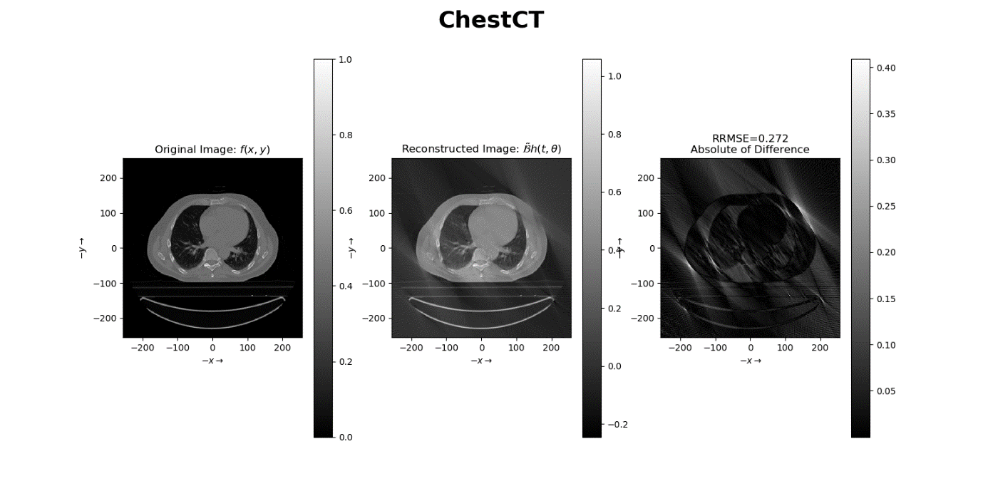

## SheppLogan256

The image is saved under the name “Question 3b (SheppLoagn256)”.

