Beneficiary Analytics Lambda - Small Workflow
Purpose: Count beneficiaries over time and rank beneficiaries by country for standard and custom date ranges.
Workflow
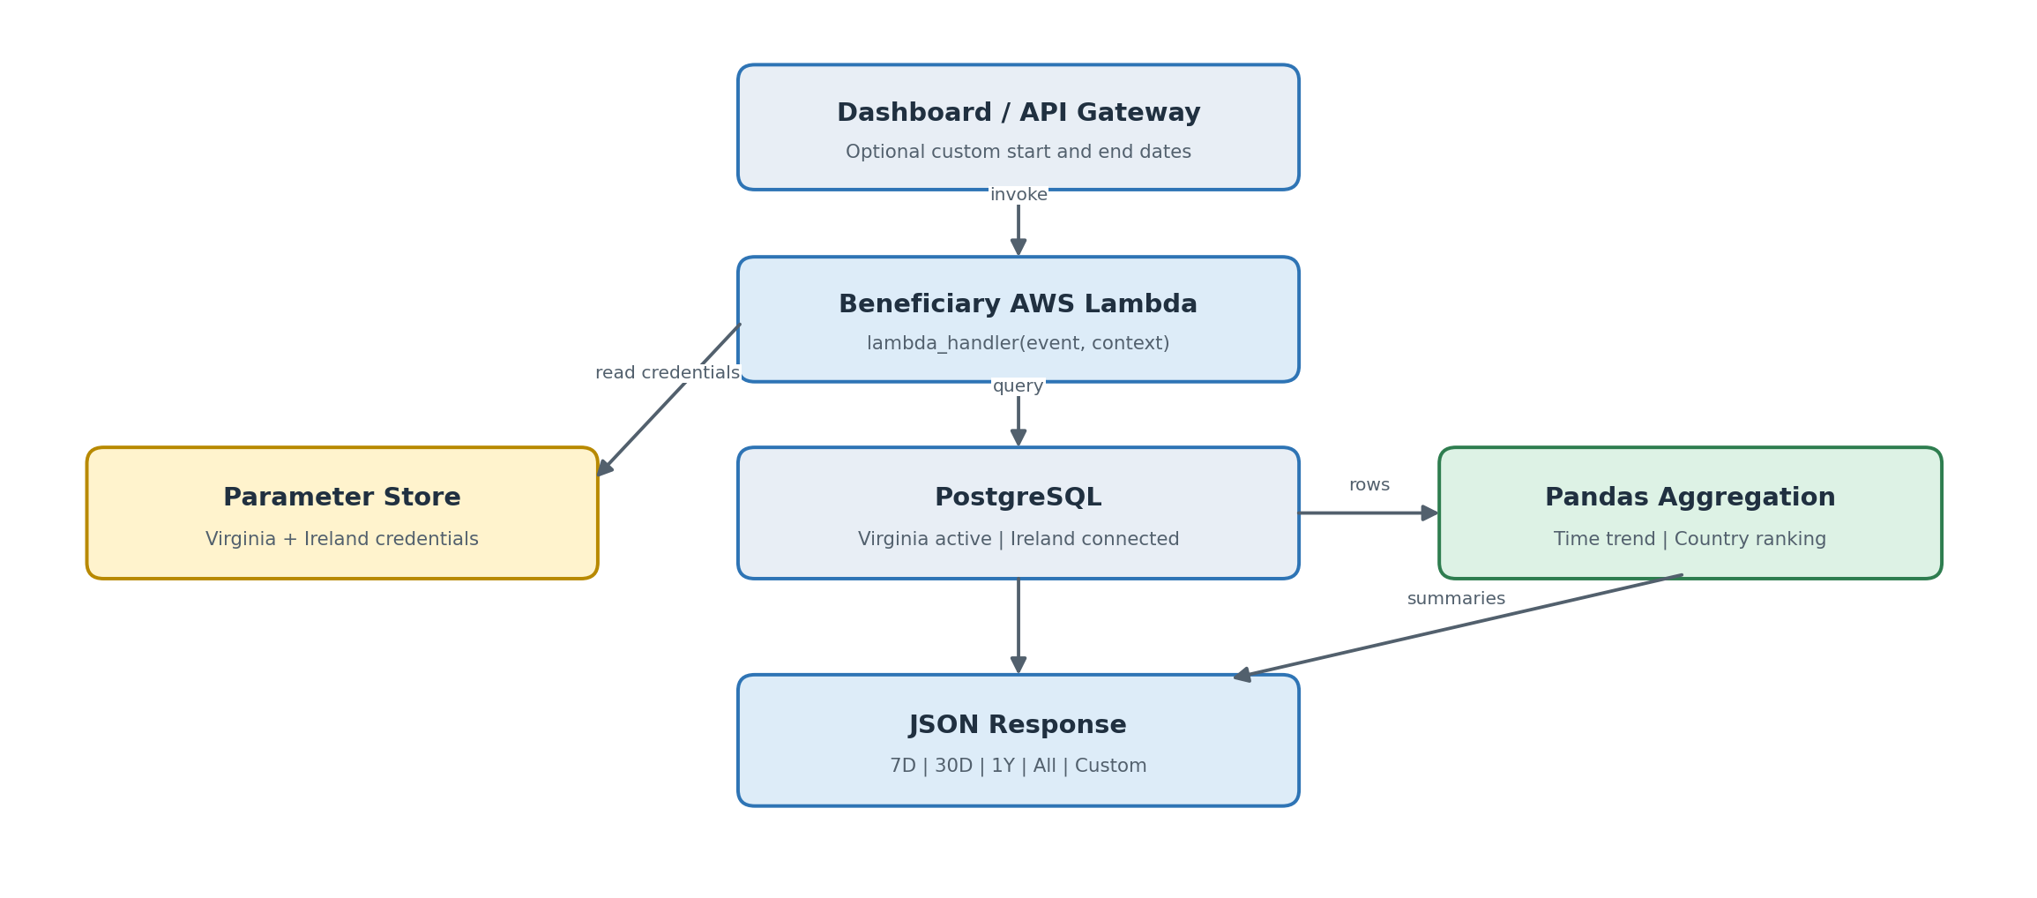
Active tables used
requests | users | countries
beneficiary_id and last_updated_at | Matches beneficiary to user | Provides country_code
Beneficiary dashboard output
Growth Trend  Beneficiary count by date | By Country  Ranked count by country | Date Windows  7D | 30D | 1Y | All | Custom
Grouping: 7D, 30D, and 1Y are grouped by day; All is grouped by month. Custom ranges use day when 365 days or less and month when longer.
Current scope: The Lambda opens both Virginia and Ireland connections, but only Virginia records are included because the Ireland aggregation calls are commented out.

