KPI Analytics Lambda - Small Workflow
Purpose: Calculate request KPIs for standard and custom periods, then return dashboard-ready JSON with SLA reference values.
Workflow
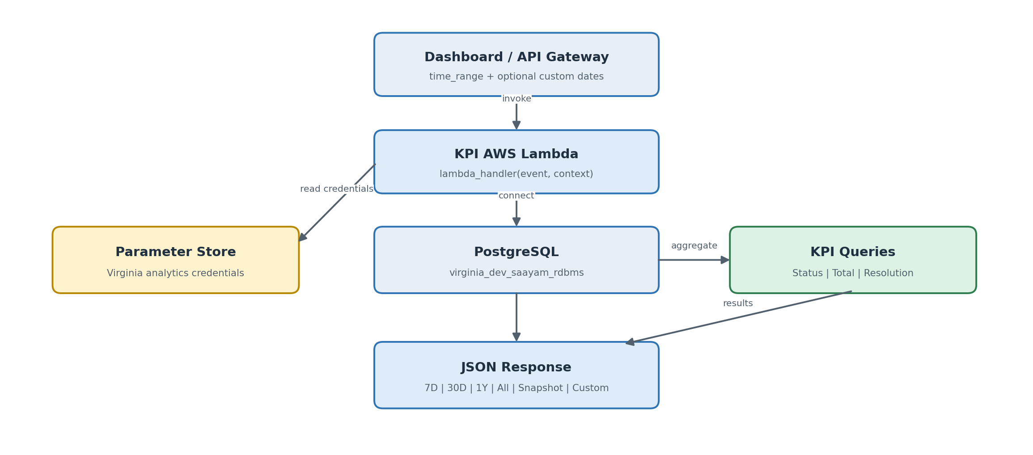
Tables used
requests | request_statuses | help_categories
Dates, status, category, serviced time | Readable request status | Readable category name
KPI dashboard output
Status Distribution  Count by status and period | Total Requests  Count by period | Avg. Resolution  Hours by category | SLA Reference  Target 240h | Warning 200h
Time ranges: 7D and 30D group by day; 1Y and All group by month; Snapshot returns current totals without time buckets; Custom uses the supplied dates. In this code, All is limited to the last 2 years.
Simple explanation: The requests table is the main KPI source. Status and category lookup tables provide readable labels, SQL performs the aggregation, and Lambda returns all KPI datasets to the dashboard.

