Request Analytics Lambda - Small Workflow
Purpose: Receive dashboard filters, query Virginia PostgreSQL, calculate request analytics, and return JSON datasets to the UI.
Workflow
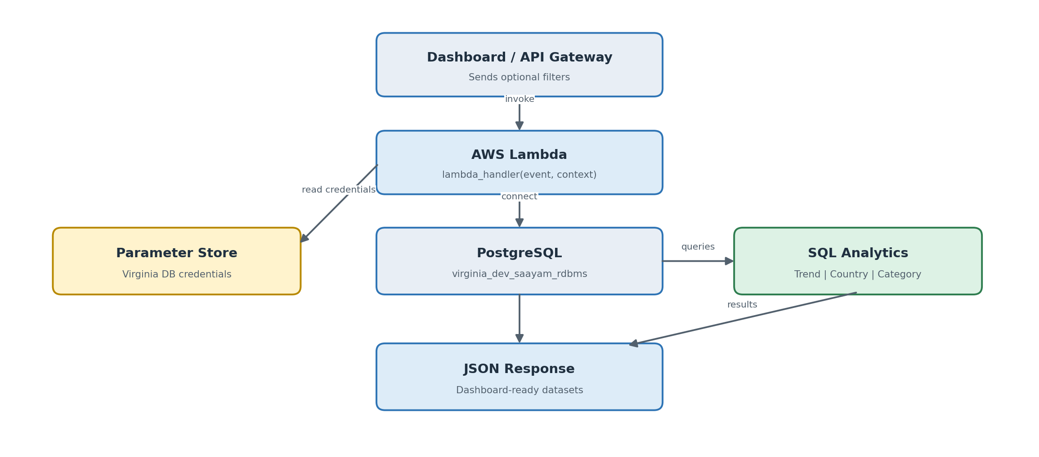
Tables used
requests | users | countries | help_categories
Main request records | Creator and country link | Country code | Category name
Dashboard output
Request Volume Trend  7D | 30D | 1Y | Custom | Top 5 Countries  7D | 30D | 1Y | Category + Region  Filters + standard/custom ranges
Simple explanation: The requests table is the main source. Users and countries provide location, help_categories provides category, SQL performs the aggregation, and Lambda sends the summarized response to the dashboard.

