Volunteer Analytics Lambda - Small Workflow
Purpose: Combine Virginia and Ireland data to show volunteer activity trends and volunteer distribution by location.
Workflow
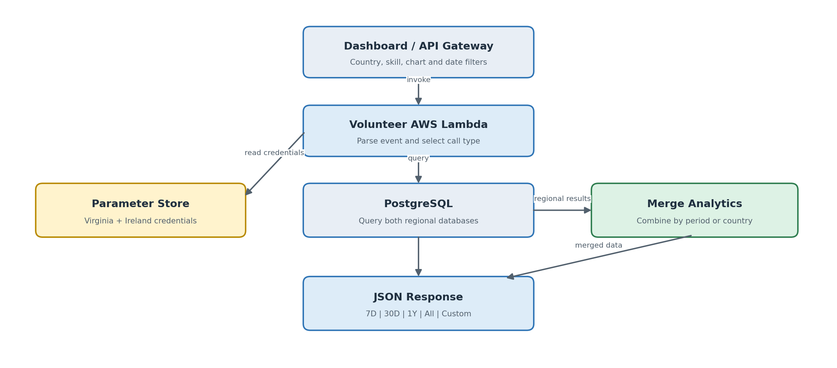
Active tables used in both regions
users | volunteer_details | countries | user_skills | help_categories
User and status | Created date | Country code | Skill-category link | Skill name
Volunteer dashboard output
Active Volunteers  Distinct active users by period | Total Volunteers  Cumulative volunteers by period | By Location  Volunteer count by country
Filters: Country, skill, chart_type, activity dates, and separate location dates. The skill filter joins user_skills to help_categories.
Time ranges: 7D and 30D group by day; 1Y and All group by month; Custom groups by day. Regional results are merged by period or country before being returned.

