Test Case Scenarios (Issue #111)
Feature: Emergency Contacts button on Beneficiary Dashboard (and Request Details page) GitHub Issue: saayam-for-all/prod #111

1. Overview
The Emergency Contacts feature adds a button on the Beneficiary Dashboard, placed alongside the Create Help Request and Become a Volunteer buttons. It lets users quickly access emergency contact information relevant to their detected location, without extra navigation. The same feature also shows up on the Request Details page.
When you click the "Emergency Contacts" button, it opens a page titled "Emergency Contacts" that displays an "Area Detected" line (e.g., "San Jose, California (US)") and lists contacts grouped into categories — Safety & Security and Medical. Each contact shows a name and number, such as Police — 911 and Mental Health Crisis Line — 988. The page states that you can click a number to call directly from the device.

2. Test Summary
Total test scenarios documented: 22
Passed (verified in Staging): 12
Not tested (require specific test data / mobile / network simulation): 10

3. Test Case Scenarios
Legend: P = Positive · N = Negative · E = Edge case
TC-0  1 | P | Button visible on  dashboard | Log in as beneficiary; open Beneficiary Dashboard. | An "Emergency Contacts" button is displayed on the dashboard. | Pass
TC-0  2 | P | Button placement | View the dashboard. | Button appears next to "Create Help Request" and "Become a Volunteer". | Pass
TC-0  3 | P | Button labeling & styling | Inspect the button. | Labeled "Emergency Contacts", has icon, distinct red/coral color, readable. | Pass
TC-0  4 | P | Responsive  display | Open on mobile / resize  window. | Button remains visible and usable; layout does not break. | Not  tested
TC-0  5 | P | Button opens  contacts page | Click "Emergency Contacts". | Page titled "Emergency Contacts" opens with instructional text. | Pass
TC-0  6 | P | Return to  dashboard | Open the page, then  navigate back. | User returns to dashboard without errors. | Pass
TC-0  7 | P | Location detected & shown | Open the page with location available. | "Area Detected" line shown (e.g., San Jose, California (US)). | Pass
TC-0  8 | P | Content matches location | Compare contacts to  detected area. | Numbers appropriate for region (911 / 988 for US). | Pass

ID | Typ  e | Scenario | Steps | Expected Result | Result
TC-0  9 | P | Contacts grouped by category | Review page layout. | Contacts grouped under headers (Safety & Security, Medical); each shows name + number. | Pass
TC-1  0 | N | Location  permission denied | Deny location access; open page. | Handled gracefully — clear message / fallback / prompt; no blank or broken page. | Not  tested
TC-1  1 | E | Location  unavailable | Simulate location not  resolvable; open page. | Sensible fallback or message; no error/blank screen. | Not  tested
TC-1  2 | E | Location change | Change region; reopen page. | "Area Detected" and contacts update to the new location. | Not  tested
TC-1  3 | P | Click-to-call  (mobile) | On mobile, tap a contact (e.g., Police — 911). | Device dialer opens pre-filled with the number. | Not  tested
TC-1  4 | E | Click a contact on desktop | On desktop, click a contact number. | Handled gracefully; no error or broken state. | Not  tested
TC-1  5 | P | Feature on  Request Details  page | Open an existing request's details page. | "Emergency Contacts" button  available (with Organizations / More Information). | Pass
TC-1  6 | P | Consistent  behavior on  Request Details | Launch feature from Request Details. | Same page, categories and entries as on the dashboard. | Pass
TC-1  7 | P | Uses other  person's location | Open a request on behalf of another person whose  location differs; open feature. | "Area Detected" and contacts reflect the other person's location, not the user's. | Not  tested
TC-1  8 | E | Other person's  location missing | Open on-behalf request with no location data; open  feature. | Graceful handling; does not silently default to user's location without indication. | Not  tested
TC-1  9 | N | Self vs. other not confused | Compare self-request vs on-behalf request. | Self shows user's contacts; on-behalf shows other person's. Not mixed up. | Not  tested
TC-2  0 | N | Not logged in | Access dashboard/feature while logged out. | Handled per app rules  (redirect/restriction); no broken state. | Not  tested
TC-2  1 | E | Loading state | Open the page (esp. on slow network). | Loading indicator shown (observed: "Fetching emergency numbers..."); then loads. | Pass
TC-2  2 | P | Keyboard  accessibility | Tab to button and entries via keyboard. | Elements keyboard-focusable with readable labels. | Not  tested

4. Notes & Open Questions
- Test cases marked Pass were verified hands-on in the Staging environment (evidence below). Cases marked Not tested require specific conditions, such as mobile device, throttled network, denied permissions, or on-behalf-of test data, which are all not available during this round.
- Open question: expected fallback when location cannot be determined or permission is denied (TC-10, TC-11, TC-18).
- Open question: intended desktop behavior for click-to-call (TC-14).
- Open question: defined data source for location-based emergency numbers (TC-08, TC-12).

5. Test Evidence (Screenshots)
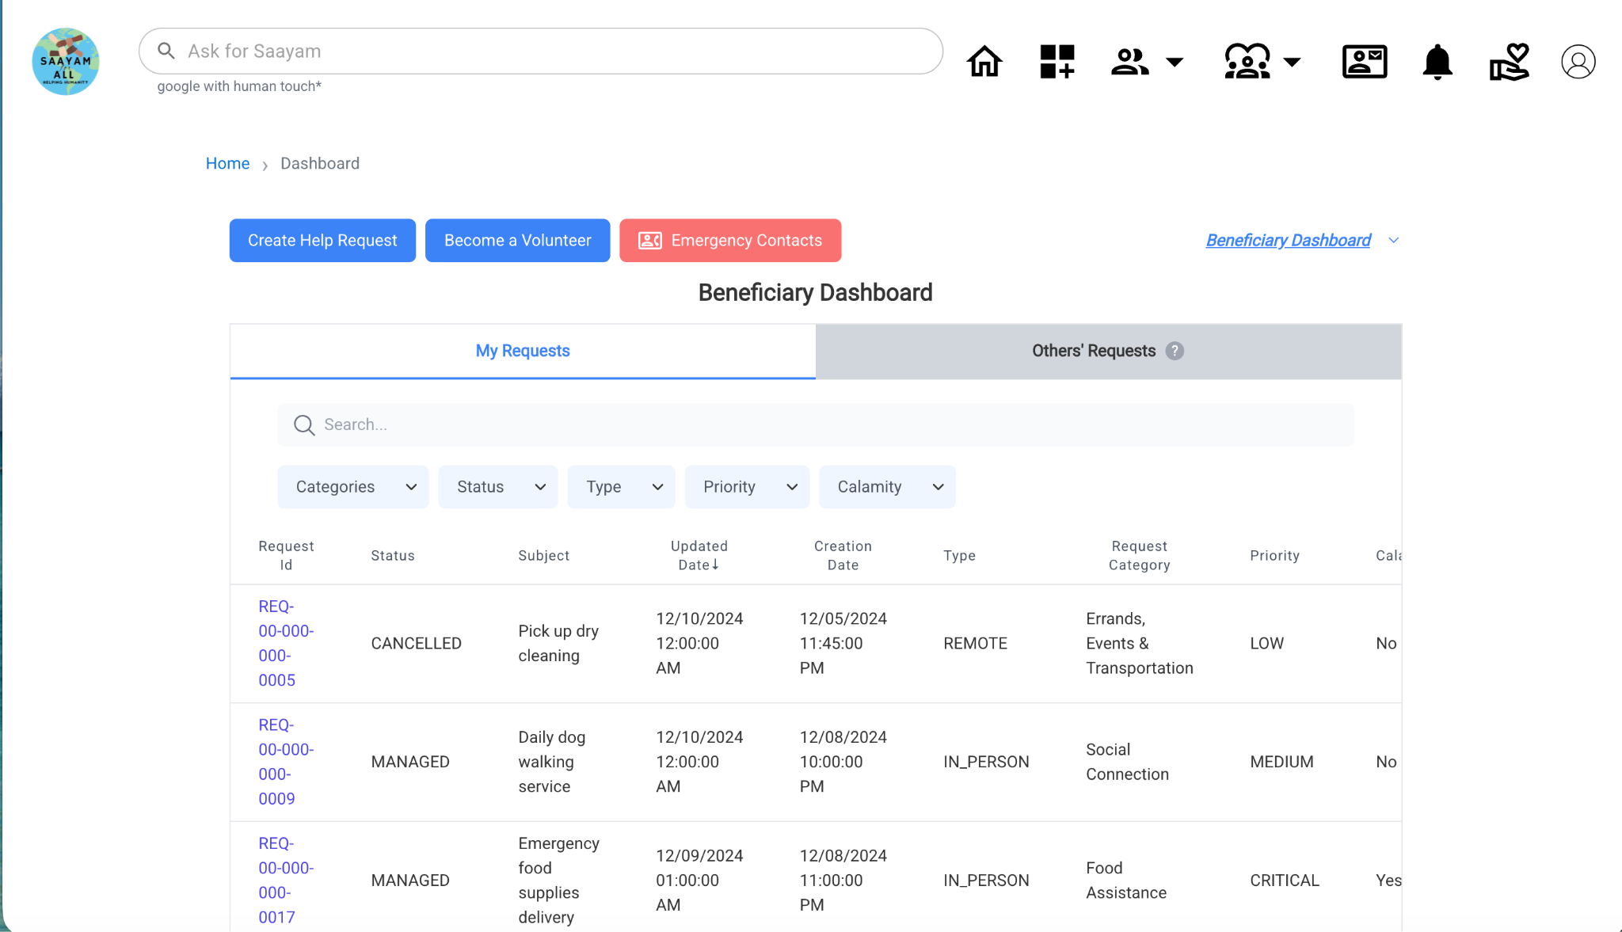Figure 1: This is the “Beneficiary Dashboard: Emergency Contacts” button next to Create Help Request and Become a Volunteer (TC-01, TC-02, TC-03).
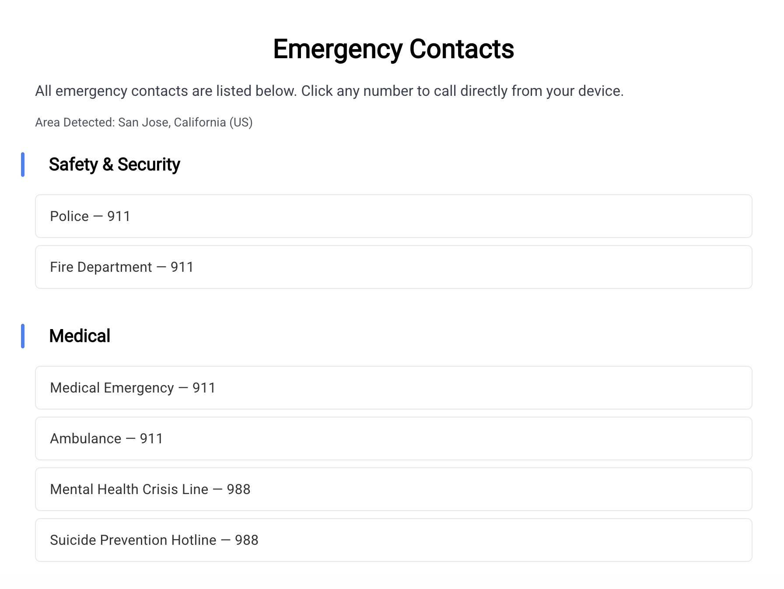
Figure 2: This is the Emergency Contacts page from the dashboard: "Area Detected: San Jose, California (US)", categorized contacts (TC-05, TC-07, TC-08, TC-09).
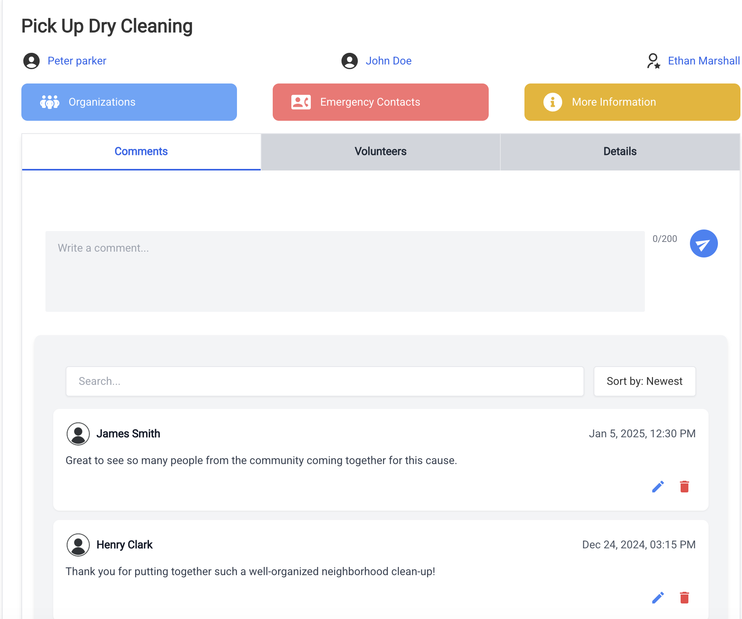Figure 3: This is the Request Details page showing the "Emergency Contacts" button (TC-15).
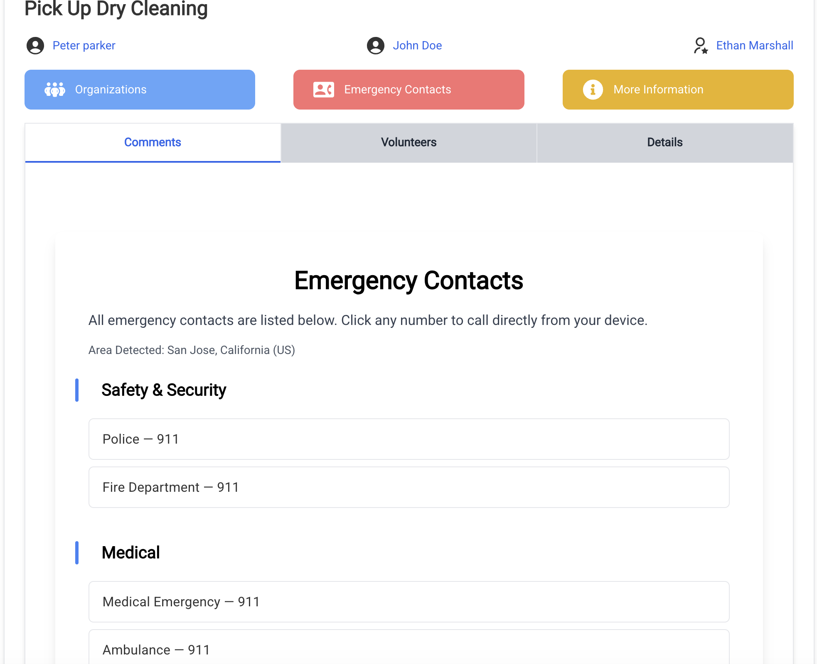Figure 4: This is the Emergency Contacts opened from the Request Details page. It’s the same layout and content as the dashboard (TC-16).

