**Assignment**

1. **create two files - student.txt and employee.txt and add them to staging area**

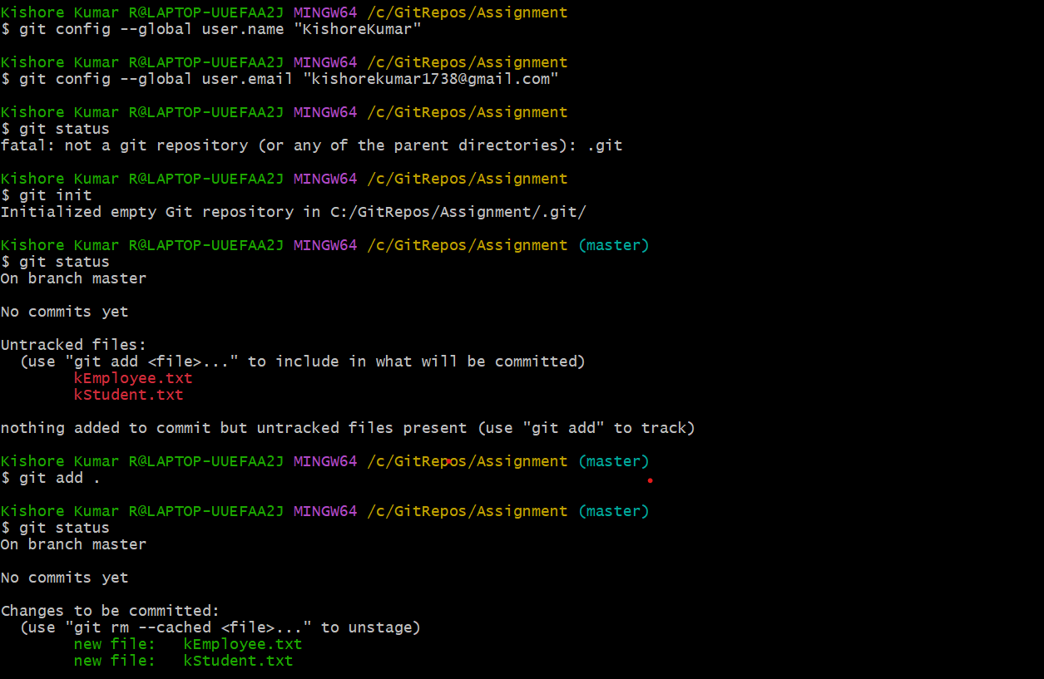

1. **add one more file - dept.txt into staging area but at same time restore the employee.txt and modify some changes inside the student.txt**

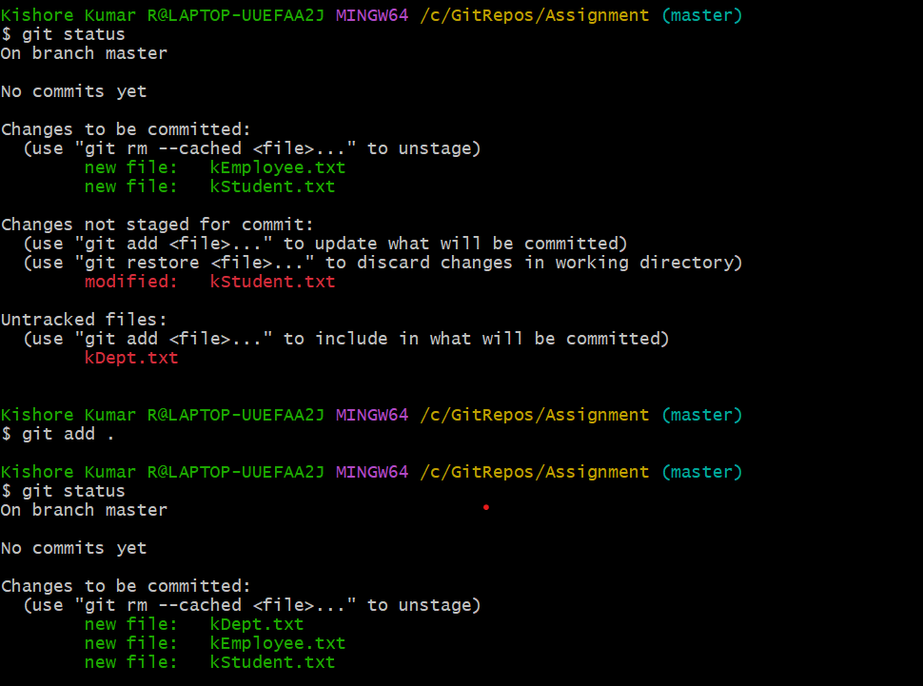

1. **push dept.txt, student.txt and employee.txt to the remote repos**

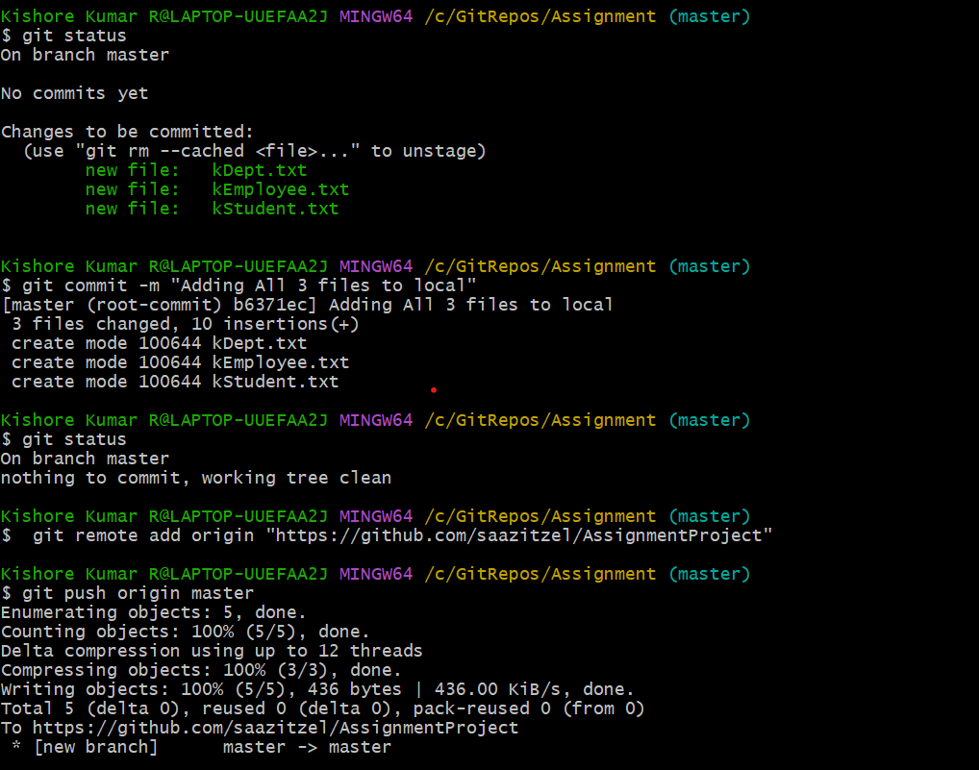

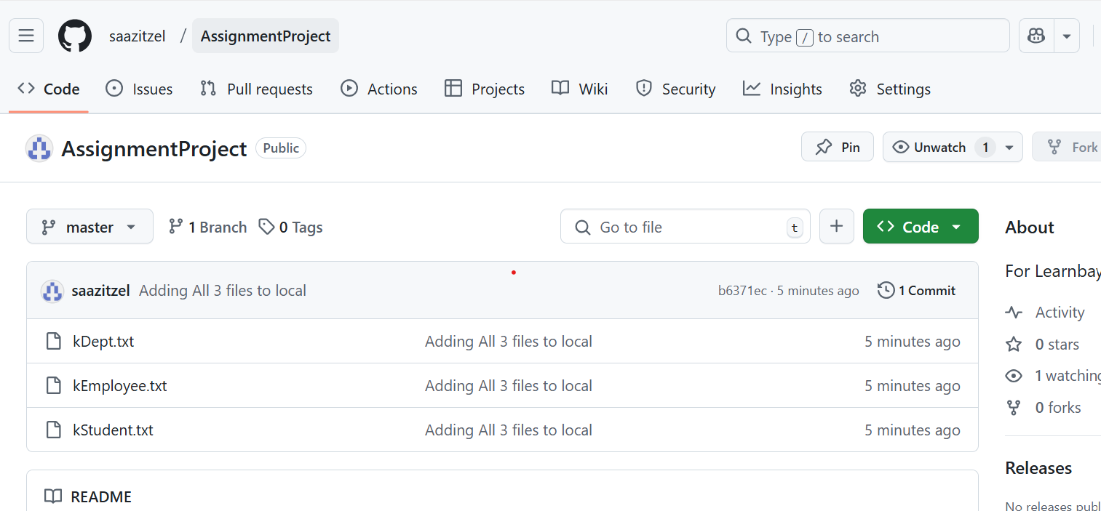

1. **create a new file - hello.txt in remote repos directly and bring to the working directory**

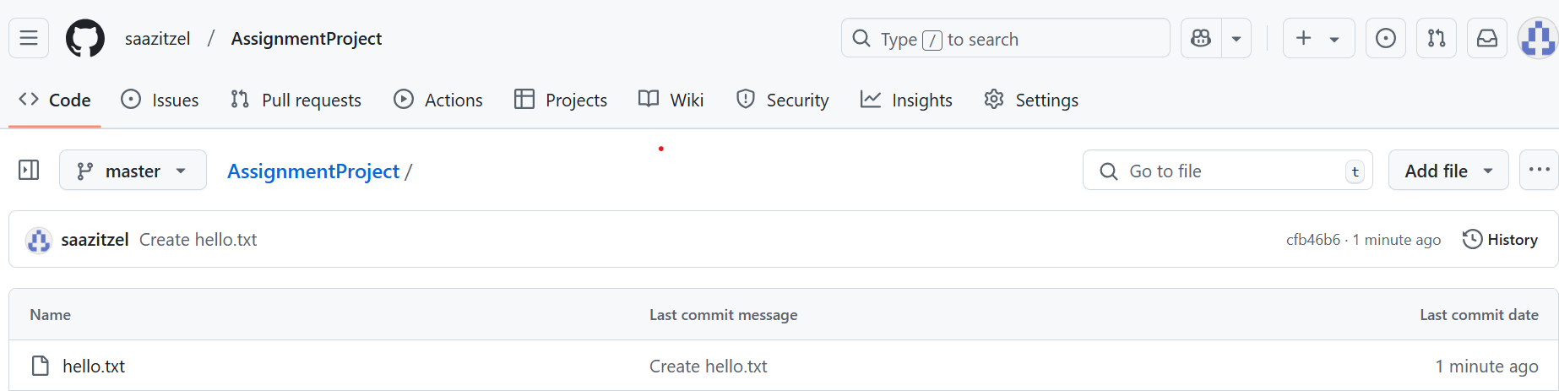

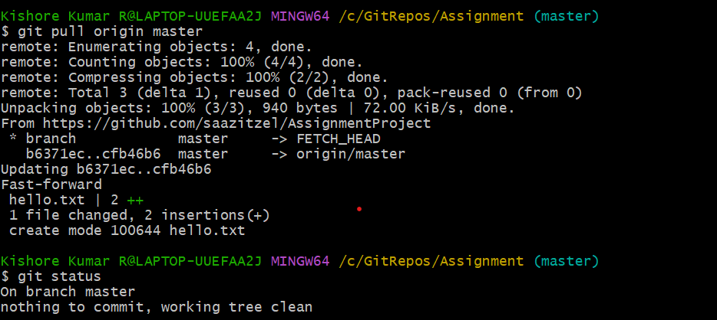

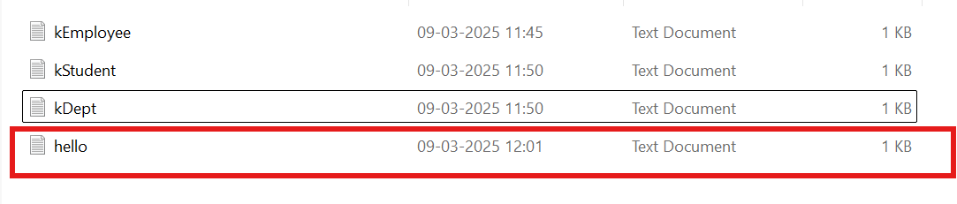

1. **send all files from working directory to remote repos**

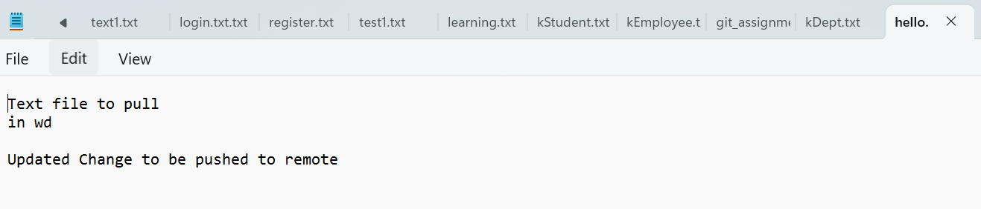

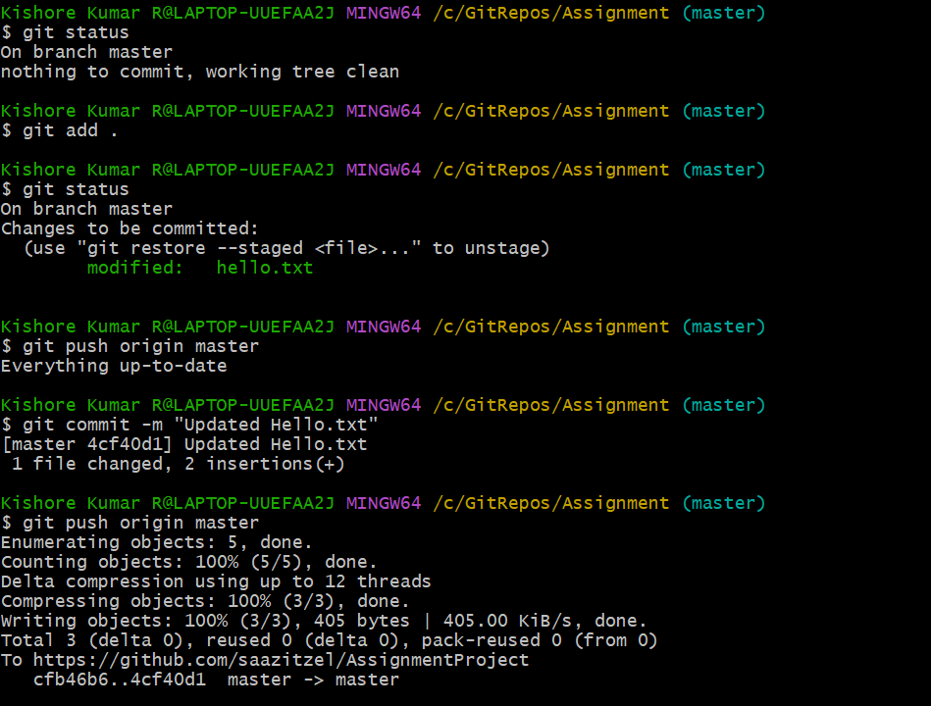

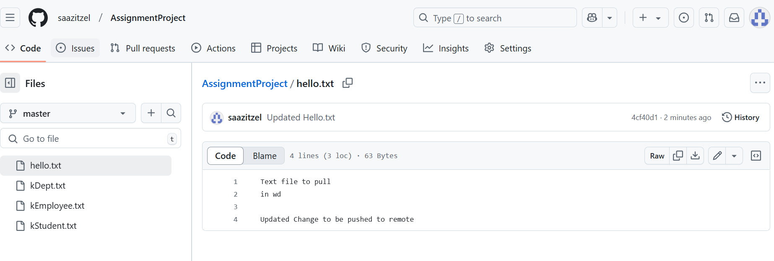

1. **remove a file from the remote repos and sync the changes into your working directory**

**Deleted hello.txt**

