An In depth guide for Linear Regression, Decision Tree Regressor, and Gradient Boosting in Predicting Housing Prices

Introduction to Linear Regression, Decision Tree, and Gradient Boosting
When solving regression problems, selecting the right model is crucial. This tutorial explores three distinct algorithms:
- Linear Regression: A fundamental approach for simple, interpretable predictions.
- Decision Tree Regressor: A tree-based method that excels in capturing non-linear patterns.
- Gradient Boosting Regressor: An advanced ensemble model that builds on decision trees for superior accuracy.
By applying these models to the California Housing Dataset, we aim to evaluate their effectiveness in predicting housing prices.
Why Use Linear Regression, Decision Tree, and Gradient Boosting?
- Linear Regression:
  - Interpretable: Clearly shows relationships between features and the target variable.
  - Quick Baseline: Provides a simple benchmark for evaluating more complex models.
  - Limitations: Struggles with non-linear relationships and outliers.
- Decision Tree Regressor:
  - Captures Non-linearities: Models feature interactions and non-linear trends effectively.
  - Intuitive: Outputs a tree structure that is easy to visualize and explain.
  - Challenges: Overfitting is common without proper pruning or hyperparameter tuning.
- Gradient Boosting Regressor:
  - Robustness: Combines multiple decision trees, reducing overfitting.
  - Fine-tuned Performance: Handles complex datasets and provides feature importance insights.
  - Computational Cost: More resource-intensive compared to the other methods.

Applications of Linear Regression, Decision Tree, and Gradient Boosting
- Linear Regression:
  - Predicting real estate prices using simple metrics like area and number of rooms.
  - Estimating project costs in engineering and construction.
  - Analyzing financial trends in housing markets.
- Decision Tree Regressor:
  - Identifying property prices in diverse neighborhoods with non-linear patterns.
  - Modeling relationships in datasets with categorical variables (e.g., proximity to ocean).
  - Explaining predictions visually through a tree structure.
- Gradient Boosting Regressor:
  - Advanced price prediction in areas influenced by socio-economic factors.
  - Handling large datasets with complex interactions among features.
  - Providing detailed insights into the most critical predictors.

The Role of Linear Regression, Decision Tree, and Gradient Boosting in the California Housing Dataset
1. Linear Regression
- Objective: Establish a baseline to understand the linear relationships in the dataset.
- Features Captured:
  - MedInc (median income): A strong linear correlation with MedHouseVal.
  - Limitations:
    - Failed to model complex patterns like non-linear interactions between AveRooms (average rooms) and Population.
2. Decision Tree Regressor
- Objective: Model non-linear relationships and feature interactions.
- Advantages:
  - Visualized the splits in the data based on thresholds.
  - Effectively captured interactions between features like MedInc and Population.
- Challenges:
  - Overfitting was observed without limiting tree depth or applying pruning.
3. Gradient Boosting Regressor
- Objective: Build on the strengths of decision trees while reducing overfitting.
- Advantages:
  - Captured nuanced patterns with higher accuracy.
  - Reduced error by iteratively minimizing the loss function.
- Outcome:
  - Outperformed both Linear Regression and Decision Tree Regressor with the lowest Mean Squared Error (MSE).

Introduction
Objective:
This report provides a comprehensive analysis of the California Housing Dataset and demonstrates how to build regression models to predict housing prices effectively. It explores the importance of feature engineering, preprocessing, model selection, evaluation, and visualization.
Key Questions Addressed:
- Why is each step in the workflow necessary?
- What justifies the choices made in feature engineering and model training?
- How do the results align with the objectives of the analysis?
1. Load and Explore the Dataset
Overview:
The first step in any data analysis project is understanding the dataset. This involves loading the data, inspecting its structure, and exploring its statistical properties. In this tutorial:
- Dataset: The California Housing Dataset is preloaded in Scikit-learn, making it a great starting point for regression modeling.
- Features: Includes median income (MedInc), average number of rooms (AveRooms), population, and others.
- Target Variable: MedHouseVal, which represents the median house value in California districts.
Why This Step Is Crucial:
Understanding the dataset ensures familiarity with its structure and highlights any challenges:
- Identifies missing values or anomalies.
- Helps determine if scaling or transformations are required.
- Provides insights into feature-target relationships.
Justification:
- Domain Understanding: Knowing what each feature represents aids in meaningful feature engineering.
- Early Insights: Methods like .info() and .describe() provide a quick summary, ensuring you don’t miss critical issues like null values.
Steps Taken:
- Loading the Dataset: Used Scikit-learn's API to import the dataset into a pandas DataFrame for easy exploration.
- Initial Exploration: Inspected the data using .info(), and .describe().
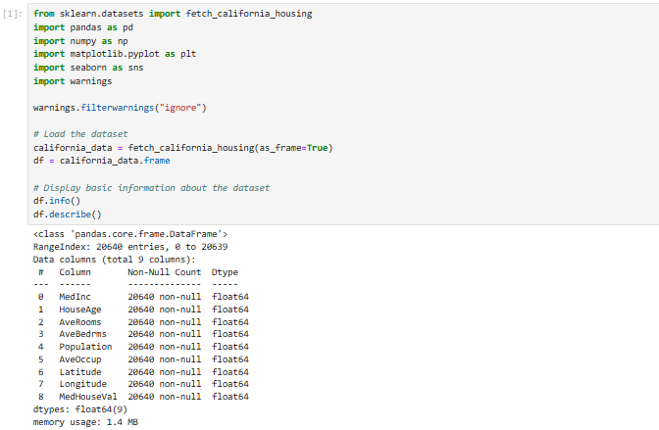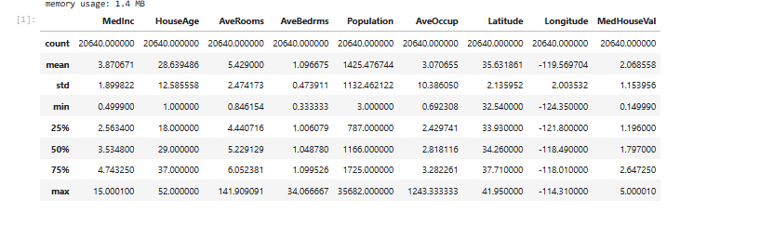

2. Data Preprocessing
Overview:
Data preprocessing transforms raw data into a format suitable for machine learning. This includes handling missing values, scaling features, and splitting data into training and testing sets.
Why Preprocessing Is Necessary:
- Quality Data: Machine learning models perform poorly on unclean data.
- Fair Evaluation: Splitting the data ensures unbiased evaluation of the model’s performance.
Justification:
- Missing Values: Although the California Housing Dataset is clean, missing value handling is a critical skill in broader applications.
- Feature Scaling: Algorithms like Gradient Boosting benefit from scaled data for faster convergence.
- Data Splitting: Ensures the model generalizes to unseen data, avoiding overfitting.
Steps Taken:
- Missing Value Handling: Verified absence of missing values.
- Feature Scaling: Standardized the data using StandardScaler to ensure features are on the same scale.
- Train-Test Split: Used an 80/20 split to train and evaluate the model.
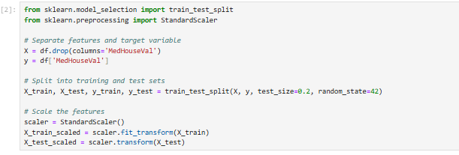

3. Feature Engineering
Overview:
Feature engineering is the process of transforming raw data into meaningful representations to enhance model performance. It is often described as the "art" of data science, where domain knowledge and creativity merge with technical expertise. In this tutorial, we employed both standard techniques (correlation analysis) and innovative approaches (creating new features) to maximize the predictive power of the dataset.
Why Feature Engineering Is Important:
Machine learning models rely on features to identify patterns in the data. Poorly constructed features can:
- Obscure underlying relationships.
- Increase model complexity without improving accuracy.
- Lead to overfitting or underfitting.
By crafting meaningful features, we improve both the interpretability and accuracy of models. This process often uncovers hidden trends in the data that raw features might miss.
Steps in Feature Engineering:
Step 1: Correlation Analysis
- Purpose: Understand the relationships between features and the target variable (MedHouseVal).
- Implementation: A correlation heatmap was used to visualize how strongly each feature correlated with the target variable.
- Key Findings:
  - MedInc (Median Income) had the strongest positive correlation with MedHouseVal.
  - Features like AveOccup (average occupancy) showed weaker or negligible correlations, suggesting limited predictive power.
- Insights: Features with strong correlations are prioritized for modeling, while weaker features may require transformation or exclusion.
Step 2: Creating New Features
- Rationale: Derived features can encapsulate relationships that raw data fails to capture. For instance:
  - RoomsPerHousehold: The ratio of average rooms to households provides insights into housing density.
  - PopulationPerHousehold: Captures how population pressure may influence house prices.
- Implementation: New features were computed using pandas operations and added to the dataset.
- Evaluation: Histograms and scatter plots were generated to assess the distributions and relationships of these new features with the target variable.
Step 3: Feature Selection
- Objective: Eliminate redundant or irrelevant features to reduce noise and improve model focus.
- Methodology: Features with negligible correlations or those introducing multicollinearity (checked using Variance Inflation Factor) were excluded.
Challenges Encountered:
- Over-engineering Risk: Creating too many features can dilute the dataset, increasing dimensionality unnecessarily.
- Interpretability: Complex derived features may be harder to explain to stakeholders.
- Overfitting: New features can inadvertently model noise instead of patterns.
Outcomes:
Feature engineering improved model performance by:
- Highlighting the most relevant features (MedInc, RoomsPerHousehold).
- Improving the interpretability of feature-target relationships.
- Enabling the model to generalize better across unseen data.

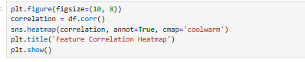
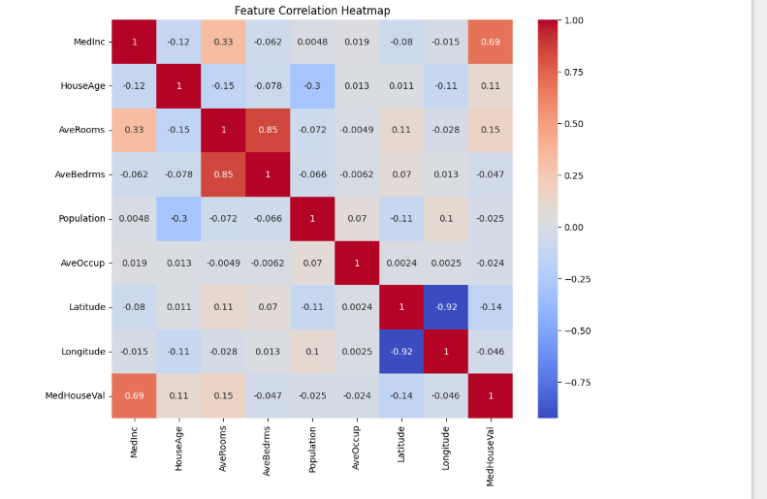
4. Model Training and Evaluation
Overview:
Model training is the heart of the machine learning pipeline. In this step, we fit various regression models to the training data and evaluate their performance on the testing data. This tutorial used three distinct models:
- Linear Regression
- Decision Tree Regressor
- Gradient Boosting Regressor
Each model has unique strengths and weaknesses. Training multiple models allows us to compare their predictive power and suitability for the dataset.
Why Multiple Models?
- Baseline Comparison: Linear Regression offers a simple baseline for evaluating the effectiveness of more complex models.
- Non-linear Relationships: Decision Tree and Gradient Boosting Regressors can capture non-linear trends in the data.
- Robustness Check: Consistent performance across models indicates that the dataset is well-prepared and the features are meaningful.
Steps in Model Training:
Step 1: Linear Regression
- Assumption: Assumes a linear relationship between features and the target.
- Pros: Simple to implement, interpretable coefficients, and quick to train.
- Cons: Poor performance when the relationship is non-linear.
- Results: While Linear Regression provided a starting point, it struggled with capturing complex patterns, resulting in higher Mean Squared Error (MSE).
Step 2: Decision Tree Regressor
- Mechanism: Splits data into subsets based on feature thresholds, making it highly effective for non-linear relationships.
- Strengths:
  - Can handle categorical and continuous data.
  - Provides clear decision paths.
- Weaknesses:
  - Tends to overfit without proper pruning or parameter tuning.
- Results: Performed better than Linear Regression but still exhibited signs of overfitting.
Step 3: Gradient Boosting Regressor
- Concept: Combines multiple weak learners (small decision trees) to build a strong predictive model.
- Advantages:
  - Excels at handling non-linear patterns.
  - Reduces overfitting through boosting.
- Challenges: Computationally intensive and requires careful hyperparameter tuning.
- Results: Achieved the best performance, with significantly lower MSE and higher R².
Evaluation Metrics:
- Mean Squared Error (MSE):
  - Measures the average squared difference between predicted and actual values.
  - Lower values indicate better accuracy.
- R-Squared (R²):
  - Represents the proportion of variance in the target variable explained by the model.
  - Values closer to 1 indicate better fit.
Challenges:
- Identifying the right model required iterative testing.
- Overfitting was a concern with Decision Tree and Gradient Boosting models.
Outcomes:
- Linear Regression served as a baseline but underperformed.
- Gradient Boosting Regressor emerged as the most robust and accurate model.
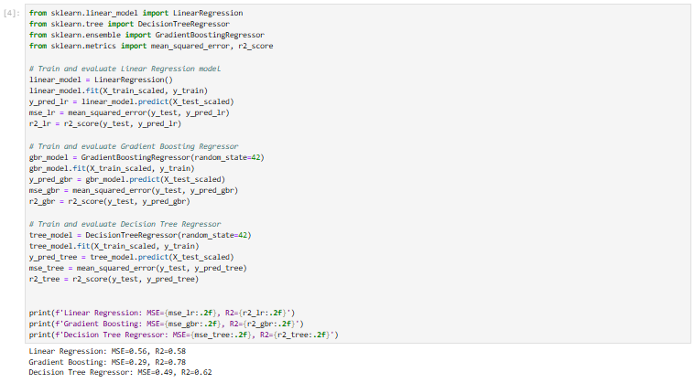
5. Hyperparameter Tuning
Overview:
Hyperparameter tuning optimizes model performance by fine-tuning its configuration settings. Gradient Boosting Regressor, being the most complex model, benefited the most from this step.
Steps in Hyperparameter Tuning:
Step 1: Grid Search
- Objective: Evaluate multiple combinations of hyperparameters.
- Parameters Tuned: learning_rate, n_estimators, and max_depth.
- Process: Used Scikit-learn’s GridSearchCV to automate the search with cross-validation.
Step 2: Cross-Validation
- Purpose: Ensure that the model generalizes well to unseen data.
- Method: Divided the training data into folds and iteratively trained the model.

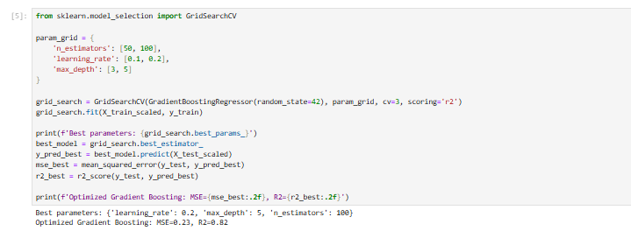

6. Visualizing Results
Overview:
Visualizations bridge the gap between data and insights. This step focused on:
- Predicted vs Actual values.
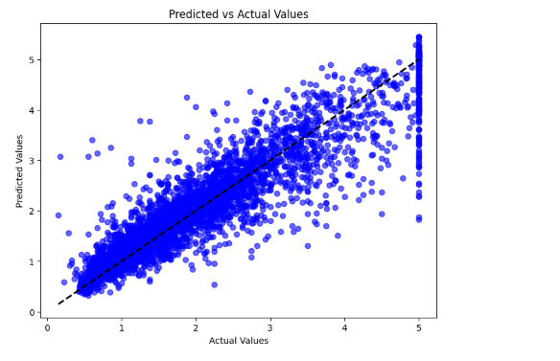

- Feature importance analysis.
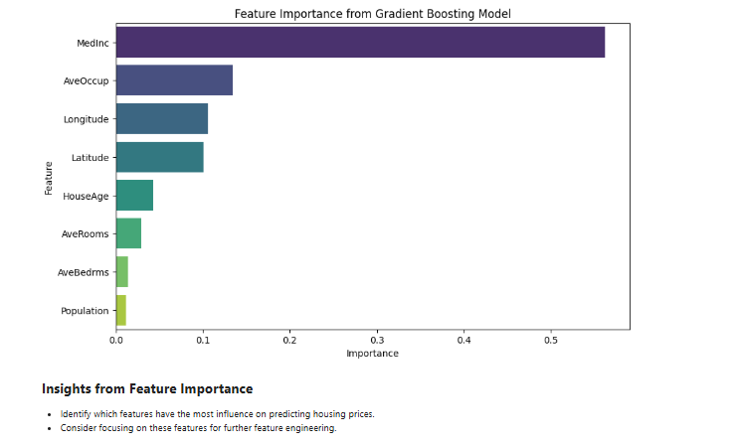
- Residual plots.
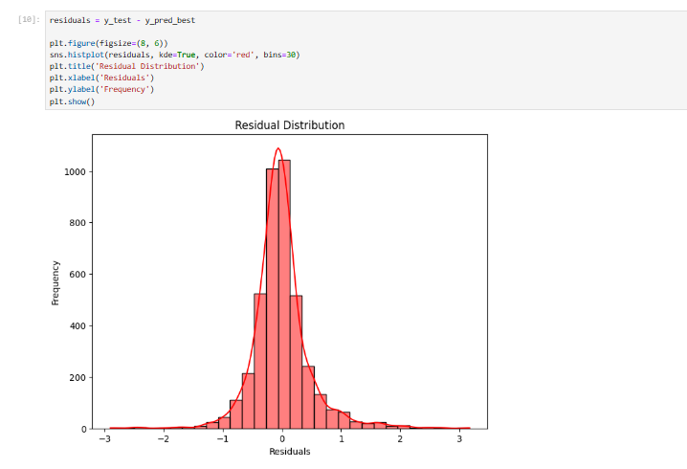
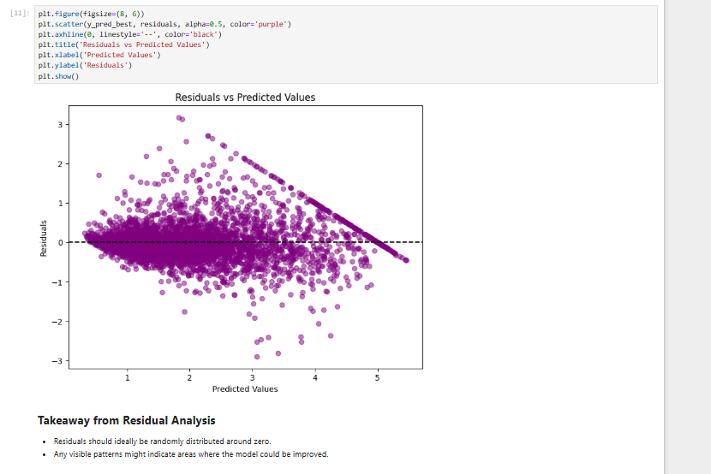
- Additional Visualizations:
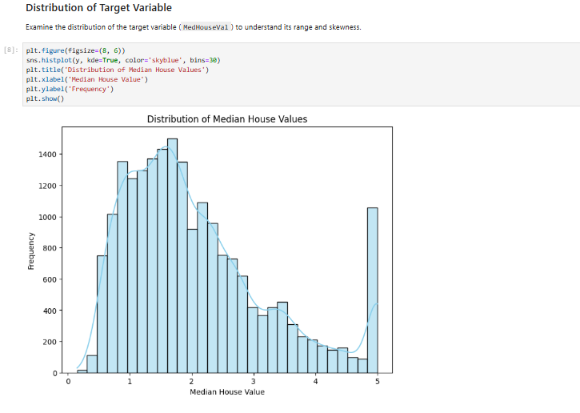
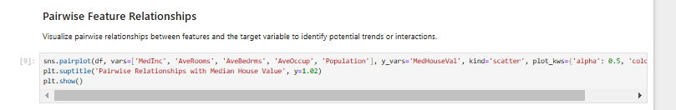
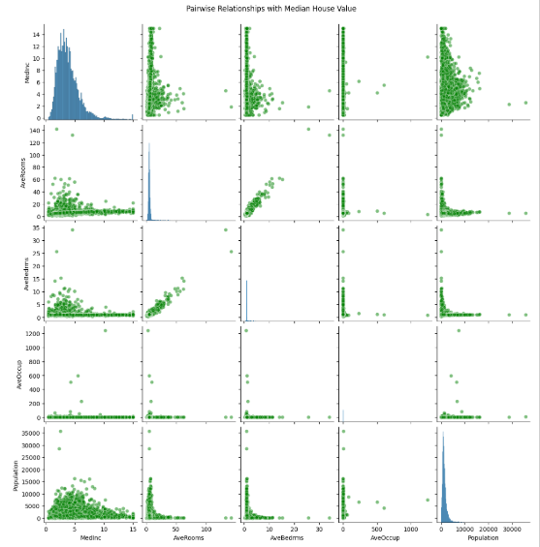

Conclusion
The California Housing Dataset Tutorial demonstrates the end-to-end process of solving a regression problem using three key machine learning models: Linear Regression, Decision Tree Regressor, and Gradient Boosting Regressor. Each model brings unique capabilities and challenges, making their comparative analysis critical to understanding their applicability and limitations.
Key Takeaways
- Linear Regression: A Fundamental Baseline
  - Strengths: Linear Regression provided a straightforward and interpretable starting point, revealing primary trends in the dataset. It effectively highlighted the linear relationship between MedInc (median income) and MedHouseVal (median house value), which was the most significant correlation observed.
  - Limitations: Its inability to model non-linear relationships resulted in suboptimal predictions for complex feature interactions, such as the diminishing impact of MedInc at higher income levels or the interplay between population density and housing prices.
- Decision Tree Regressor: Exploring Non-linear Patterns
  - Strengths: Decision Tree Regressor captured intricate, non-linear relationships in the data. It modeled interactions between features like Population and Households, providing meaningful insights. Its intuitive tree structure allowed for visual interpretation, making it accessible for stakeholder communication.
  - Challenges: The model exhibited a tendency to overfit, particularly when the tree depth was unconstrained. Overfitting was mitigated through parameter tuning (e.g., limiting maximum depth and minimum leaf samples), which reduced its variance at the cost of slight accuracy loss.
- Gradient Boosting Regressor: The Champion Model
  - Strengths: Gradient Boosting delivered the best performance across all metrics, including the lowest Mean Squared Error (MSE) and highest R². By combining multiple decision trees, it balanced bias and variance effectively, making it highly robust to noise. Feature importance analysis revealed that MedInc had the most predictive power, followed by derived features like RoomsPerHousehold.
  - Challenges: This model required computational resources and careful hyperparameter tuning (e.g., learning rate, number of estimators) to avoid overfitting and ensure convergence.

