

**BAHRIA UNIVERSITY (KARACHI CAMPUS**)

FINAL EXAMINATION –SPRING SEMESTER – 2020

**(Entrepreneurship& Leadership: CSC-307)**

Class: **BS (CS) – 7(A)**  **(Morning)**

Course Instructor: **Awais Rao** Time Allowed: **8 Hrs.(8:00am-4:00pm)** Date: **3rd July 2020; Session: I** Max Marks: **50**

**Student Name: SABA_ DILDAR_ Enrolment #02-134171-126__**

**Note:** All questions carry equal marks.

In addition to upload the solution on LMS, please also email it to course instructor.

In order to avoid any run time electricity and internet unavailability situation, it is suggested that keep your

laptop charged. Also activate 3G/4G connection as an alternative of Wifi/internet option to upload your

solution.

**QUESTION: 1 (5+5=10 Marks)**

Steve Jobs and his friend Steve Wozniak were self-taught engineers who created one of the most popular, revolutionary, technology brand, “Apple”. Steve Jobs was not the first person to have an idea to create a user-friendly computer, and he was not the first person to come up with an idea about music players or smartphones, but he was the first person to implement them. He covered potential ideas and then implemented them in ways that no one had ever dreamed of before. Apple products, whether they be a computer, laptop, iPod, iPhone, iTunes, or otherwise, are featured everywhere. Not only Apple products are of high quality technological items, but the company also has superior branding and a strong company image making them, one of the most popular and easily recognizable brands in the world.

a) From this example, identify and explain any four traits/characteristics of Steve Jobs that helped him to be successful in his business.

b) What are the factors/reasons that support the success of Apple Company?

**Steve Jobs**



**INTRODUCTION**

[Steve Jobs](https://www.cnbc.com/id/10000257) is an entrepreneurial legend. He famously started [Apple](https://www.cnbc.com/quotes/?symbol=AAPL) in a garage with co-founder Steve Wozniak in 1976 after dropping out of college. The tech company has[a market capitalization of $870 billion](https://finance.yahoo.com/quote/AAPL?p=AAPL).

Jobs, who [died of pancreatic cancer in 2011 when he was 56 years old](http://www.nytimes.com/2011/10/06/business/steve-jobs-of-apple-dies-at-56.html), was revered for his vision in making computer technology elegant and consumer friendly. His legacy includes the Mac computer, the iPod, iPhone and iPad. He was also infamously caustic and was forced out of the company he founded when he clashed with the management. He returned to the company in 1997 to once again lead the business he birthed.

According to Jobs, two things are required to build a successful company: passion and people. Jobs said so in an interview he did with Microsoft Chairman Bill Gates[in 2007](http://allthingsd.com/20070531/d5-gates-jobs-transcript/).

**“People say you have to have a lot of passion for what you’re doing and it’s totally true,” the Apple CEO said. “**

And the reason is because [building something of value is] so hard that if you don’t, any rational person would give up.

Jobs said.

**“It’s really hard. And you have to do it over a sustained period of time. So if you don’t love it, if you’re not having fun doing it ... you’re going to give up. And that’s what happens to most people, actually,”**

It’s one of the greatest sources of motivation, he said.

**If you don’t love it, if you’re not having fun doing it, you don’t really love it, you’re going to give up.**

For Jobs, the other component to building a successful business is your ability to attract and retain the best team members.

**It takes “a lot of hard work,” said Jobs, so if you don’t love what you’re doing, “you’re going to fail. So you’ve got to ... have passion.”**

The name is so incredibly inspiring and intimidating at the same time.

The man who created Apple.

The man who turned black turtlenecks into a uniform of power.

The man who changed technology forever.

His legacy is one-of-a-kind. The tech titan's impact on the world remains unparalleled.

The namesake duo went on to redefine computers and subsequently, the larger picture of technology.

One day, they would be the co-founders of the world’s largest IT Company.

They started with the ‘blue box’; a digital device that could be used to make long distance calls for free. Its success became their motivation to take on big companies with their inventions.

This led to the birth of the first-ever Apple machine.

Jobs and Wozniak paid for the ambitious project by selling off their gadgets. They labored relentlessly in Jobs’ garage to finish it. Jobs spent the maximum time working and often greeted clients in his underwear, and barefoot.

The man was still very much a hippie, just not when it came to business



**Four traits/characteristics of Steve Jobs**

If you make a list of famous leaders in tech, the list cannot be complete without Steve Jobs. He happens to be an inspiration for many people who want to make their mark in the tech world. If you are among those people, then this is the right article for you.

Steve Job’s leadership skills contributed to turning Apple into one of the biggest tech giants.

If you are aiming to kick off your start up, then following the path of Steve Jobs may help you turn your start up into a brand.

Below are six noteworthy lessons you can learn from Steve Jobs:

* **Have A Vision**

Without a strong vision, Apple would not be where it is today. It would be hard to become a [successful leader](https://aboutleaders.com/leaders-never-say/) without a clear vision for your company or organization. Simply being able to kick off your startup is not enough. You must be able to consistently plan for the long term.

* **Develop the Passion**

Steve Jobs had both passion and self-confidence to turn his dream into a reality. You need to love what you’re doing. Developing a strong [passion](https://aboutleaders.com/leadership-skills-2-great-leaders-ignite-passion/) for your work helps you on the road to success in business.

* **Challenge the Limits of Your Employees**

Another great leadership lesson from Jobs is to find the actual capabilities of your employees. Leadership is not about ordering people around or micro managing. You need to encourage employees to challenge themselves for innovation and increased productivity.

This approach by Steve Jobs enabled his employees to explore their full potential.

* **Follow Excellence, Not Money**

Steve Jobs did not confine his efforts into making huge dollars from his ideas. He was very much focused on coming up with exciting and unique [innovations](https://aboutleaders.com/facing-opposition-innovator/).

Rather than simply focusing on making money, you should focus on providing quality services and products. This is essential to help turn your start up into a well-known brand.

* **Don’t Aim Below Perfection**

Steve Jobs never compromised on perfection. Before the launch of the iPod, Jobs went to get the headphone jacks entirely replaced. This is a clear example that he would not settle for less.

* **Take Risks**

As noted, Jobs’ necessity for perfection also made him a risk taker often. He trusted his judgment and understood what people needed.

Keep in mind and remember these leadership lessons from Steve Jobs before jumping into the business world.

They will help keep you on a progressive path and enable you to deal with challenges effectively to help you create a successful brand.

### **What Can You Learn from Steve Jobs?**

* Love what you do. ...
* Cut out or avoid the bozos. ...
* Surround yourself with culture to be more creative. ...
* Don't be afraid to take risks. ...
* Qualifications are not everything. ...
* Keep it simple. ...
* Money need not dictate your projects. ...
* Learn to be bold.

**B-PART**

**Reasons Apple Is So Successful**

One of the more interesting questions I get asked about as an industry analyst who’s followed Apple since 1981 is why Apple is so successful. It’s an honest question because to those unfamiliar with Apple, the company’s rise and current dominance in non-PC devices is somewhat puzzling.



Most people have a working understanding of the fact that Apple lost the PC wars to Microsoft, and only nominally understand that when Apple created the iPod and then the iPhone, the company started to go in a new direction. And anyone who’s gone into an Apple store knows full well that Apple’s customer service and stores represent the gold standard for selling and supporting tech gadgets. But beyond that, the reasons why Apple is really successful are still a mystery to many.

* **Vision**

The key secret behind the success of any business is its Vision and Apple has the vision to deliver the best quality product to its consumers. Apple makes some of the best products in the market available today. The main idea is to create products for the who make them.

The engineers who are creating Apple products actually make them for themselves. And Jobs was the chief “user” of Apple products when he was alive. With the guidance of Steve, Apple became more confident in their products and hence that energy and vibes are ultimately delivered to the consumers.

* **Easy to use**
* The products of apple are so easy to use even that a 6-year-old kid can use it. Jobs were very concerned about this point. He really wanted to make products which are easy to use. According to him if it is not easy to use, it is considered worthless to the consumer.
* This is what drove the company towards its own software and hardware for the products such as iPad, iPhone, iMac and MacBook Pro to ensure full control over the devices. Apple always believed in perfection, not abundance.
* **Less issues**
* As both hardware and software are made by Apple they ensure full security and control over their devices. Apple test each product thousands of times before launching it in the market.
* They also control all software and hardware related issues. Apple constantly works on new updates so that users can experience the best possible efficiency in products.
* They are also very strict regarding the apps on App Store and ensure full safety of user data. Their products are much away from common issues like frequent app crashes, slow processing, malware attacks etc.
* **Years ahead of the competition**
* We all know that apple works in advance from its competitors. They are working on a product now which has to be launched two years after. Which is a nightmare for their competition as they can’t match their advance policy.
* Another reason is that they offer great customer and after sales service which keeps them ahead from other brands.
* You can yourself experience this by visiting their stores. The best part is if your iPhone or iPad or whatever product you use have any issue they might replace it with the new device rather repairing it.
* **Improvements and Branding**
* Apple doesn’t release products just for the sake of releasing them. With every new Apple product, there is some technological advancement that was not seen in the previous model of that product. This is one of the reasons why people flock to Apple stores and stay in line for hours just to buy the new iPhone when it releases.
* Every update to its operating systems, every new camera feature, every new color introduced has incited excitement in its customers, in part thanks to the excellent presentations conducted by Jobs and his successors that have branded Apple as a dynamic force you can’t afford to miss. It is not unlikely that the minute a new product has been launched, their next one is already in the stages of development.
* **Quality Products**
* Jobs’ and by extension, Apple’s, main objective for their products was beauty in simplicity. Aside from their elegant, sleek trademark design, it was paramount for them that their products should be easy to use for all age groups and audiences, which is plain to see in the amount of toddlers you may see running around playing Subway Surfer on their parents’ iPad. Apple’s obsession with perfection makes it so that its issues are virtually non-existent. Each product is tested by experts hundreds of times before it is finally approved for mass production and launching.
* Apple users will hardly ever complain of typical issues such as app crashing, malware attacks, or frequent annoying pop-ups, because Apple’s design and programming is near flawless. Each product is a take on current existing technology on the market that they improve on ten times over, taking into account common issues customers experience in their products and working to eliminate it altogether.
* **Customer Experience and Retail Experience**
* Seeing as Apple’s entire brand is based on fulfilling and catering to the needs of all audiences, it comes as no surprise that their customer service is near unparalleled. The reason for Apple’s huge success in sales over the years is in no small part to the loyalty they incite in their customers, a fact they are well aware of.
* In order to keep their customers feeling happy, Apple has opened over 460 retail stores worldwide by 2015 in order to have better, direct access to their audience. This has not only opened up millions of jobs for people all around the world, but has also reached an inordinate amount of people.
* **Range of Products**
* Apple has been consistently releasing a wide variety of products over the years ranging from phones, laptops, watches, and more that are steadily expanding. Word on the street is speaking of potential production of Apple Cameras and even an Apple car. Though Apple holds no technology not already existing in the market, their customers still eagerly await the launch of their newest products simply because Apple just does it better.
* Considering Apple’s objective is reinvention toward perfection, there is still an entire market of products they can still aim to improve in their future products that keep their audience and competition eagerly keeping tabs on what new experiment they may embark on.
* Looking at all these reasons, it seems Apple’s role in the industry is undefeatable. Yet if Apple has taught us anything since its inception, it is that perfection is never wholly reached, and that there is always room for improvement. Keeping this in mind, it seems that Apple won’t be going anywhere in the foreseeable future and neither will their loyal customers.

**QUESTION: 2**

From the information we have regarding Awang, we know he possesses certain entrepreneurial characteristics which are as follows.

**INTRODUCTION**

**Background**. Azizulhasni was born in Dungun, Terengganu, Malaysia. ... He received his primary education at Sekolah Kebangsaan Batu 48 and continued his secondary studies at the Sekolah Menengah Kebangsaan Sultan Omar in Dungun, before transferring to National Sport School in Bukit Jalil.

**Event:**Olympic Games Rio 2016, Malaysian S...

**Sport:**Cycling

**Nationality:**Malaysia

**Place of birth:**Dungun

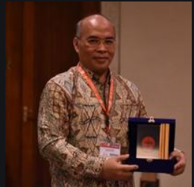

Following are the characteristics does Awang have that may be important to his success?

* **Passionate**

The work of Awang was really good and qualitative, so Daud wiiling to sell his business to Awang and not to anyone else. Awang only possessed this qualitative work because of his love for machining, which revealed the true craftsman in Awang.

* **Leadership**

Awang was not only a professional worker but a successful leader as well. Among the employees he was a respected person and this could help him lead the company with minimal conflicts between the employees.

* **Optimistic**

Awang had been hopeful about the future and optimistic. Remaining optimistic in a company is one of the most important features, since the company is still unpredictable and uncertain.

* **Talented**

Awang had a natural machining skill or aptitude that will help him thrive in his future.

* **Urge to learn**

Awang wanted to continue learning and to add to its perfection. This is yet another important Awang quality that Daud admired.

* **Self-Motivation**

Self-motivation is one of the most significant characteristics of entrepreneurs. You need to be able to drive yourself, if you want to succeed.

Being an entrepreneur, you are not responsible to someone else, so that also means it's hard to travel without someone having you. ] You need to be committed to the mission to start going forward even though you don't get an immediate paycheck.

* **Understand What You Offer**

As a businessman, you need to know what you are offering, and how it fits into the market. You need to know where you fit in, whether it's a product or a service.

That means you need to know when it's time for a bit of tweaking. It also involves understanding whether you're high-end, middle-of-the-road or contract.

Being able to position yourself and then adjust as needed is an important part of entrepreneurship.

* **Flexibility**

You need to be flexible as an entrepreneur, to a certain extent. Be willing to adjust whenever needed. Stay on top of your industry and be prepared to embrace process and product changes as needed.

You need versatility in your thought too sometimes. That's an integral part of solving problems. You want to be able to search for new and efficient approaches to problems.

**B-PART**

**Characteristics could lead to Awang’s failure**

Whether the loss is major or low, there is plenty to learn from it. Failure is often considered the other word "F" in the startup and business sector, but it shouldn't be so.

Entrepreneurs always aren't the only ones to fail. In the first three years they 're open, forty per cent of all companies will fail.

Entrepreneurs are also not the only ones to fail. In the first three years they 're open, forty per cent of all companies will fail. There is a lot of companies that are struggling.

The danger is much greater for the businessmen. Intentionally, the entrepreneurs launch their companies to disrupt an industry. This increases the chance of falling onto their faces.

* **Lack of business knowledge**

Awang was a talented manufacturer in the field of machining and he was really good technically. But he had never been into the company's business phase. That could lead to Awang making wrong decisions.

* **Lack of support**

Awang is poor in business decisions and would have no support whatsoever from anyone in decision taking. Daud can no longer engage in business activities and Awang 's wife has no business experience at all.

* **He will be more like a sole proprietor**

Awang had only had to concentrate on production before the purchase and Daud maintained the company. Yet now both the role of output and the role of business are Awang 's duty and he must struggle therein.

**Keep an eye on cash flow and financial trends.**

Was there ample money to pay the bills on time and you still have any left over to take home? If not, it's time to search for ways to raise revenue , reduce expenditures, or find investment or loan financing. Looking at a variation of the above also is a good idea.

* **Has advertising been cut because money is getting tight?**

Without advertising it will be difficult to reach new customers, so look for alternative marketing strategies. Find out how customers are finding your business and focus marketing efforts in those mediums

* **Lack of management control**

Another big explanation why companies find themselves in difficulties is lack of management power. All companies need a strategic strategy to ensure they compete in the best markets with reasonable margins and sufficient financial capital. Far too often, management spends too much time coping with day-to-day problems and thereby fails to tackle these fundamental concerns.Lack of management control may result from:

* Failure to develop a business plan
* Failure to understand costs, markets and key customers
* Failure to submit returns, resulting in penalties and possible investigations allowing customers unnecessary discounts
* Wasting time fending off creditors
* Wasted promotional expenditure
* **Inadequate or inappropriate financing**

Inadequate or inappropriate financing is the fourth major cause of company difficulties.

* Use of short term overdrafts for long term capital acquisitions
* Failure to use factoring facilities when sales are substantially increasing
* Inadequate shareholder capital all contribute to cash flow problems
* These problems will become more pronounced when a substantial difficulty such as a major bad debt, loss of a principal customer or business interruption occurs.

**QUESTION: 3 (5+5=10 Marks)**

Franchising is appropriate when a firm has a strong or a potentially strong trademark, a well-designed business method, and a desire to grow. Cell phone companies are an example, because it possesses all three of these qualities.

a) When do franchisors select entrepreneurial franchisees? Explain in an organizational identity perspective.

b) “Innovative ideas are always high in entrepreneurship”. Briefly explain any three methods to generate new ideas for business?

**Understanding Franchisees**

The franchisor is the person who acquires the right to market the franchisor's products or services under the current business model and trademark in the original company

**Franchise and franchisee in business?**

A franchise (or franchise) is a method of distributing products or services involving a franchisor establishing the trademark or trade name of the brand and a business system, and a franchisee paying a royalty and often an initial fee for the right to do business under the name and system of the franchisor.



**Are franchisees entrepreneurs?**

[Yes, a Franchisee is also an Entrepreneur!](https://www.krbrokers.com/are-you-an-entrepreneur-when-you-own-a-franchise/)

[You share with the franchisor knowledge of your specific territory. You see a business opportunity and act on it – by buying a franchise. You take a risk by buying into a franchise system although your chances of success are higher.](https://www.krbrokers.com/are-you-an-entrepreneur-when-you-own-a-franchise/)

**Who owns the franchise?**

A franchise business is a business in which the owners, or "franchisors", sell the rights to their business logo, name, and model to third party retail outlets, owned by independent, third party operators, called "franchisees".

 Franchises are an extremely common way of doing business.

**Executive Summary**

**Context and rationale**

identities of the franchisor and franchisee some franchisors might desire entrepreneurial franchisees, but there is no real consensus in the literature with regards to the extent to which entrepreneurial franchisees are desired within the organizational form of franchising, or the organizational antecedent factors that would influence this desire.

The central argument in this study is that franchisors will desire to select entrepreneurial franchisees when the franchise organization has entrepreneurial values which form part of its organizational identity. Further it is argued, that franchise system performance will be affected by the degree of congruence (match) between the identities of the franchisor and franchisee.

**Methodology**

A cross-sectional research design, involving a mail questionnaire survey of UK franchise systems, was employed for data collection

**Findings and implications**

The franchise systems that select entrepreneurial franchisees are those which have entrepreneurial values as part of their organizational identity. Additionally, we find that the extent of the alignment (congruence) of franchisor management support for entrepreneurial values and entrepreneurial franchisee selection has a significant positive influence on franchise system performance.

Franchisors should seek to recruit franchisees who will be able to identify with the organization. This would suggest franchisors should be careful that their promotional material and interaction with franchisees during the recruitment process truly reflects the organizational identity of the franchise system.

**When do franchisors select entrepreneurial franchisees? An organizational identity perspective**

Generally, franchising is typically designed around standardization, with the

Franchisor desiring a uniform replication of his/her standardized business format across the entire franchise system. Standardization involves minimizing variance in operations via the development of work patterns that are constantly applied.

provision of a standardized product or service across all locations is crucial to the success of the franchise system and the franchisor exercises control over the franchisee in order to minimize risk of opportunism, ensure adherence to the

Franchise contract, and to protect the brand name (Pizanti and Lerner, 2003).

Keeping with the desire for standardization, franchisors need to select franchisees that can ensure the system-wide adoption of a consistent brand image in order to achieve standardization and efficiencies.

It seems that the last thing

**Entrepreneurial franchisees**

Many franchisors want is entrepreneurial franchisees. It has been stressed that franchisees with high entrepreneurial dispositions may be risky for a franchise system as they may exhibit considerable entrepreneurial autonomy in their operations, which may depart from the Franchisor’s proven methods.

Franchisees may display opportunistic behaviors to the detriment of the

Franchisor, by deliberately ignoring the franchisor’s goals as well as deviating from the franchisor’s proven procedures, in pursuit of their own entrepreneurial interests hence, it has been

Argued that franchisors

**“Prefer to select a manager rather than an entrepreneur as a**

**Franchisee to protect their business system from unauthorized change”**

**SUGGESTION**

These studies

Suggest that perhaps, some franchisors would desire entrepreneurial franchisees, but, given it

opposes the requirement for standardization, there is no real consensus in the literature with regards to the extent to which entrepreneurial franchisees are desired within the organizational form of franchising, or the organizational antecedent factors that would influence this desire. By drawing on organizational identity theory, the present paper aims to develop and test a theory that explains the franchisor’s desire for ‘entrepreneurial franchisee selection’.

**Entrepreneurial franchisee selection**

Entrepreneurial franchisee selection is defined as the extent to which franchisors select franchisees on the basis of their potential for entrepreneurial behavior (e.g. opportunity seeking, risk-taking, innovativeness, independence and reactiveness).

The central argument in this study is that franchisors would desire to select entrepreneurial franchisees when the franchise organization has entrepreneurial values which form part of its organizational identity (as reflected in the franchisor support systems to willingly endorse and facilitate franchisee entrepreneurial behaviors.

Entrepreneurial values of the franchise organizations

that distinguish them from the typical franchise organization and influence their desires to select entrepreneurial franchisees to fit with their organizational identity

**Challenge franchisee selection**

This challenge largely coexists with the difficulties of integrating franchisors

Entrepreneurial practices with the need for standardisation of the franchisor. This study provides insights into the various forms of support systems that franchisors use to willingly promote franchisee entrepreneurial behaviors within the standardized franchise context

Installation program.

**Developing identification.**

Although there are a number of potential dimensions to organizational identity, this paper focuses on the entrepreneurial values of the organization.

Franchisors seek to maintain consistency of the franchise network in

Order to promote their brand image, and as a means of protecting their systems against franchisee free riding.

**Evidence that franchisees**

Evidence that franchisees are often a source of new products, services or processes. It would seem therefore, that different franchise systems have different entrepreneurial values, yet the impact this has on their

Recruitment strategy is not known

**Franchisors should seek to recruit franchisees**

Franchise organizations seek franchisees with entrepreneurial attributes

Little is known about if/how these preferences differ between different

Types of franchise systems. Given the importance of organizational identification though, it would seem logical that those systems with entrepreneurial values will seek franchisees with

Entrepreneurial traits.

**Management support and organizational identity**

Management support is believed to be an indicator of

The entrepreneurial identity of the franchise organization. Within the franchise context, we argue that the franchisor’s management support for an entrepreneurial identity can be categorized into three main types:

* franchisor managerial support,
* franchisor structural support
* Franchisor institutionalized support.

Franchisor managerial support reflects the extent to which entrepreneurial autonomy is encouraged within the franchise system. This includes the degree of freedom fostered in the system with regards to franchisee entrepreneurial activity.

**Organizational Identity/Congruence**

Organizational identity theory would suggest that this relationship may not

Hold across all systems. Rather, it is the level of congruence between the franchisor and franchisee identity which is important.

This would seem logical a highly entrepreneurial franchisee who joins a highly standardized system is likely to become frustrated. Indeed found evidence that dissatisfaction and conflict within the franchise

System derive.

**B-PART**

**“Innovative ideas are always high in entrepreneurship**”

Starting entrepreneurs are very careful about sharing their ideas with anyone. They are afraid that someone will steal it and start executing it right now.

And there is a reason for that.

On the one hand, any idea remains just an idea.

An interesting business idea can become a good start for building a great product.

And no wonder why among frequently asked questions on [Quora](https://www.quora.com/) you can meet the ones about where to find successful business ideas or what are some useful techniques for generating ideas for startups.



Becoming aware will not take too much time but can help you to know a lot about different industries and innovations

* **Focus on problems**

Successful business ideas solve real problems.

Learn about the problems people face in daily life. Talk with family and friends about their problems at work, in sport, with clothing, food, etc. Think about your own problems and difficulties.

Is everything perfect in your life? Probably there are things you would love to improve or change. Think about it.

* **Become inquisitive**

Start being interested and involved in what is going on around the world. Find 30 minutes a day to read popular blogs, news portals or watch hot news.

Learn about startups that are launched and start growing.

* **Explore**

Web surfing can be a great way to have fun and get some cool ideas. Visit popular entertaining websites, question and answer platforms, popular forums and learn [social media trends](https://istarthub.net/make-money-on-instagram-the-most-powerful-secrets-from-popular-bloggers/) and what people are talking about. What are some hot topics of discussions and popular shared posts on social networks? It can be a good source of ideas.

* **Travel more**

Travelling is one of the most excited and effective ways to get inspired and generate ideas for business. Visit different countries, meet new people, learn cultures and spend time sightseeing. It is like a breath of fresh air in daily life

Make traveling be a part of your regular lifestyle. Set a plan, for example, to visit one new city or country every month. You will see how much creativity it will evoke in you.

* **Build your network**

Building a good network will give you an opportunity to switch from working hard to working smart. Connecting with professionals in the sphere of your business niche can bring not only an understanding of the highest customers’ needs but can help you to get tons of smart advice from influencers and top leaders.

According to Keith Ferrazzi, the author of the book “Never Eat Alone”, connecting with the right people is a true art that can help to reach great business goals.

* **Stay relaxed, but focused**

When you feel that you need to come up with a good business idea as soon as possible and start putting all your efforts into this process, you can hardly create something really successful.

#### **If you need an idea, you will find it!**

Just try to relax, have more rest and sleep well. But always be attentive to what is happening around you.

* **Analyze old ideas**

Analyze more deeply the ideas that have already been implemented. Think about the opportunities to change and improve them.

But remember – you cannot just copy someone’s idea. In this case, it can hardly become successful.

Make research and learn customers’ feedback about the existing product or service. Try to find out what is missing there and how to transform this product into something better.

* **Read more books**

Continuing to talk about the role of books, I should stress that good books are #1 source for inspiration and getting knowledge.

Reading can show you where to start!

Books can help you to learn many lessons, give new business ideas and understanding how to implement them.

If you are a starting entrepreneur, here is the list of books I would recommend you to take into account

* **Get new experience**

When a person gets in unusual conditions, new feelings and emotions received evoke creativity.

Switch your mind from everyday routine to something new you always wanted to try.

The new atmosphere will make your mind think about all pluses and minuses, find problems that need to be solved.

* **Focus on making life easier**

There is a huge number of cool products that appeared as a result of our attempts to make life easier, cheaper, and more convenient. And this is really a great approach to creating new products.

People love everything that simplifies everyday staff.

* **Use the Cut-up technique**

Though this technique was widely used in music and poetry, it can be used as [a perfect tool](https://istarthub.net/rank-1-on-google-with-these-free-seo-and-content-improvement-resources/) to generate business ideas.

* Write down any business idea and describe what problem it can solve, why it can be useful for people. It can be any idea, even the most stupid one, you’ve just thought about. Do not focus on the idea itself too deeply, generate as many as possible;
* Do the same with all the ideas you have;
* Cut up ideas and their description, and rearrange them.
* See what happened.

**QUESTION: 4 (5+5=10 Marks**)

A business model is a firm's plan or recipe for how it creates, delivers, and captures value for its stakeholders. A firm's business model also describes how the core aspects of what it does fit together and complement one another. Business models are fundamental to a firm's ability to succeed both in the short and long term. Dropbox, for example, has what's referred to as a freemium business model. It offers customers a free account with a set amount of storage space, and makes money by selling premium accounts with more capacity. Dropbox could charge all of its users a monthly fee based on the amount of storage that they use, but that's not its business model. Its business model is based on the belief that by introducing users to its service through a free account, it will ultimately sign up more paid users. a) Discuss in details the value proposition of Dropbox by using the Business Canvas Model. b) How did Dropbox use the Lean Launchpad Method (Using the steps of Customer Development and Agile Product Development)?

**DROP BOX**

Dropbox is a place where the content of the whole team falls together. Wherever you can use the instruments that you love. Where we help you cut through the noise, and what matters most is to surface. This is the world's first intelligent workspace



**HOW DROP BOX WORKS?**

The Dropbox app allows users to drop any file into a specified directory. The file is then automatically transferred to the cloud-based service of Dropbox and made available to any other computers and devices of the user that also have the Dropbox app installed, keeping the file current on all platforms.

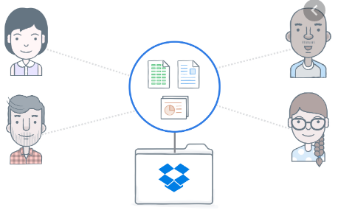

**BUSINESS CANVAS MODEL OF DROP BOX**

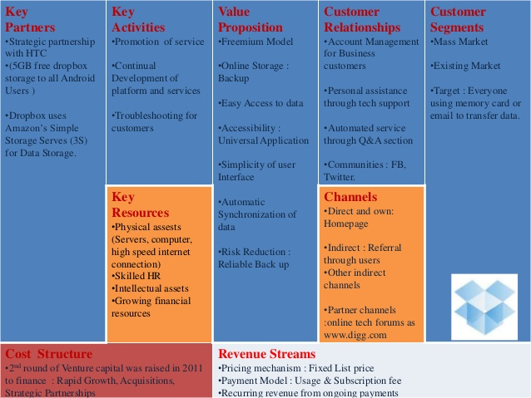

**Key Activities**

Dropbox is a company specialized in software technology. It mainly provides solutions for cloud storage and file sharing for individual customers, small businesses and large businesses.

Business and business solutions securely protect their users' work and allow team members to access files from any computer, phone or tablet, either through the company's website or through one of its many desktop and mobile applications



**Key Partners**

Dropbox collaborates in the development and deployment of its software with a number of companies. Participants include:

Channel Partners, including a number of technology companies, software providers, consulting firms, websites and independent reseller product vendors, helping the company's in-house teams to grow sales and marketing scope



**Key Resources**

The key resources of Dropbox are its technologies and intellectual properties, its online and mobile platforms, its IT and communications infrastructure, its channel of sales and distribution, its partnerships – especially its leading technology partners and its staff.

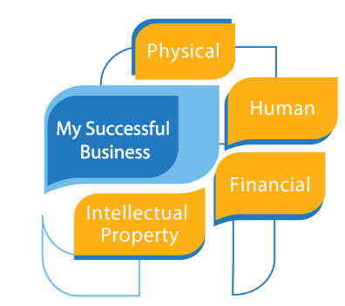

**Customer Relationships**

In a self-service basis, Dropbox's cloud storage and file-sharing applications are open to customers. Customers can register user accounts, access free trials, download software, and manage subscriptions through the website of the Company without interacting with sales team members. When signed in,customers can access the full functionality of the Company’s platform autonomously through its various mobile and desktop applications.



**Customer Segments**

Dropbox provides cloud storage and file sharing options to a wide variety of customers from general users and companies. The Company's solutions are primarily targeted at three client segments:

Individuals, including general users, students and professionals, who can back up personal files such as cloud photographs;;



**Value Propositions**

Dropbox gives its clients value in the following ways:

Its credibility and industry status, with the Company founded as a reliable provider of cloud solutions and file sharing services, serving a range of leading customers such as Yahoo, National Geographic and Hewlett Packard Enterprise;

The efficiency and reliability of its products, with the company providing dedicated cloud storage and file sharing products of high quality;

Its security and privacy controls, with the Company using state-of-the-art security tests and file encryption to keep its customers' files private;

Its specialized technical staff, employing highly trained technical staff throughout its departments of development , support and integration; and the accessibility and flexibility of its solutions, providing solutions across a wide range of operating systems, both on mobile devices and desktop computers, and offering flexible , customizable solutions to its enterprise customers

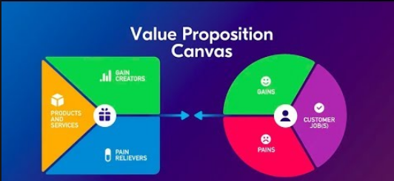

**Cost Structure**

Dropbox costs in developing its software solutions and digital platforms, maintaining its communications and IT infrastructure, operating its sales and distribution channels, implementing marketing schemes, managing its partnerships and retaining its staff.

Much of the Company’ costs relate to the payment of salaries and benefits to its workforce, as well as occupancy and utility costs accrued across its international network of offices.



**Revenue Streams**

Dropbox provides three premium subscription plans: Technical, priced at $8.25 per month paid annually or $9.99 per month paid monthly; Business, priced at $12.50 per month paid annually or $15 per month paid monthly; and Company, of which custom fees apply.

While Dropbox has been advertised for a public listing, the Company remains private and does not publish its financials on its website as such. Nonetheless, sources say the Company is heading towards profitability, with the Company's 2015 annual rate of revenue running at about $400 million..

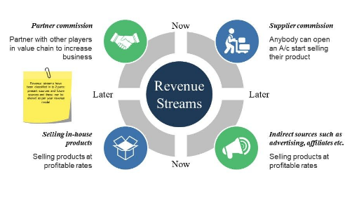

**B-PART**

**Customer Development:**

What Dropbox learned was that when they were ready it was more important to start, rather than as early as possible. Upon entering Y Combinatory, Dropbox 's founders promised to have a fully functional product available for launch in just eight weeks. In fact, it's not been 18 months since the launch.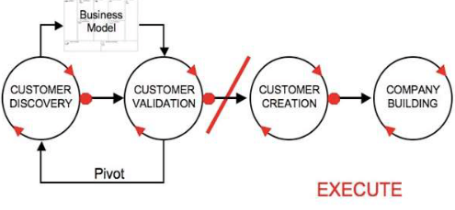

The code that they sent out was far from the finished product. However, this basic product presentation allowed Dropbox to confirm that the problem it was trying to solve for its customers was very real. Dropbox learned through the reviews it received from early adopters that it was on its way to a real solution

**Customer validation at Dropbox:**

Dropbox had already decided they had to know early. We soon learned, too, that studying was not a one-time experience. We realized that if they really wanted their customers to understand, they had to learn early and learn often.

For their early adopters they produced a private beta-launch video. Since they knew where their clients were and how to connect with them, the video resulted in a waiting list rising to 75,000 people in just one day..

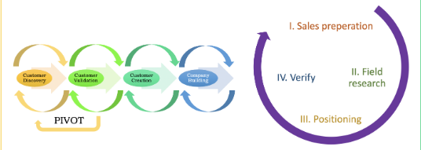

Since the team at Dropbox were themselves early adopters, they knew where they could find the other early adopters. As a result, Dropbox wanted to step out of the workplace so they knew where they could go and test their conclusions when they did.It showed the inherent value of the full product but did not include all of the bells and whistles yet. They sent this minimum viable product out to Hacker News, where their early adopters lived. The feedback they got was of very high quality. More importantly, the feedback they got validated their learning.

**Customer Creation at Dropbox:**

Dropbox was getting excited about its offering by its early adopters. The business will need to start building its mainstream consumer base to adhere to the Consumer Growth model. To get started, Dropbox created a landing page, designed to capture interest before the product was officially released..

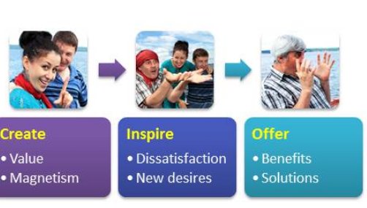

**Agile Development:**

For many companies and executives the Agile approach has been revolutionary in terms of the way they work and the performance they see. Since the 2000s it has been a driving force in software development processes and aspects of it have permeated the work environment. Whether you are planning to sit for a team scrum tomorrow morning or just stick to emails, it seems the Agile methodology is here to stay.

**Dropbox use the Lean Launchpad Method**

* Lean start-up is a three-step methodology designed to help entrepreneurs strengthen their decision-making to enter a wider audience.
* This approach will help you to evaluate if your company has a viable product from the design or concept phase to the learning phase.
* Lean methodology offers a wide range of advantages which ultimately lead to a competitive advantage for businesses.
* Dropbox signed on 5,000 subscribers before the product was even available. The cloud-based file storage and sharing services company created sign-ups from a 90-second video explaining their services and why they should be paid for by people..

**BENEFITS OF LEAN METHODOLOGY:**

**BETTER PRODUCTIVITY:**

Using lean methods involves removing activities that do not add consumer value.

**BETTER FLEXIBILITY AND RESPONSIVENESS:**

O Your business can better meet customer demands once the production process is streamlined. The company should be in a place where consumers should clearly come to your company to get the product they want and/or need and when the product is available when they need it.

**NO DEFECTS**

A product defect means more effort, which means waste of money and energy, and the possibility that the finished product will not be delivered on time. The premise behind lean methodology is to eliminate defects, so that the first time your products are made correctly.

**QUESTION: 5 (5+5=10 Marks)**

A copyright is a form of intellectual property protection that grants to the owner of a work of authorship the legal right to determine how the work is used and to obtain the economic benefits from the work. The work must be in tangible form, such as a book, operating manual, or magazine article. If something is not in a tangible form, such as a speech that has never been recorded or saved as a computer file, copyright law does not protect it.

a) How safe is it for users to download online copyright content?

b) Explain the importance of acquiring a registered copyright for any site’s content and how to copyright it.

**Is it illegal to download copyrighted material?**

It is not illegal or immoral to download copyrighted material as long as you have the consent of the author.

Some copyrighted material on the Internet may be pirated or made available for download without the author's consent, and this can lead to legal liability.

* Google, as with most web sites/services, has a Terms of Services agreement.
* You agree to abide by that ToS whenever you utilize their services/access their sites.
* Google’s ToS forbids the breaking of ANY relevant law.
* Therefore, uploading any material which violates a law is a direct violation with your agreement with Google from that point forward.
* While Google has no standing to file suit against you in court; they can, and WILL ban you from use of their services for violating the ToS.
* What does that mean? Well, Google may not be able to file suit against you. But, you are most definitely at risk of waking up one morning to find out your Google accounts have been erased; along with everything saved therein.
* Instead of using Google drive; drop $8 at Walmart for a zip drive and save your copyrighted study material there; and try to avoid violating agreements with web sites/services that control your data and/or access to it.

**Is it always safe to download information music videos and other content?**

Downloading content over the internet is a great way to enjoy music, video, games and other entertainment.

Vigilance, combined with up-to-date internet security software, will help you download safely. Don't download copyright-protected material – it can result in serious penalties.

**Why do you need to be careful about what you download on the Internet?**

A virus is a type of computer program that you may get if you download from untrusted websites. It can do bad things to your computer, including preventing you from accessing your files.

**How do I know if a download is safe?**

If you right click on the file once downloaded, there should be an option to scan the file using your anti-virus software. If the file is genuine and safe, the scan will come up clear. If it isn't, remove the file and scan your computer with your anti-virus software to have it remove any malware

**Steps to safe is it for users to download online copyright content?**

* **Assess what you're downloading.**

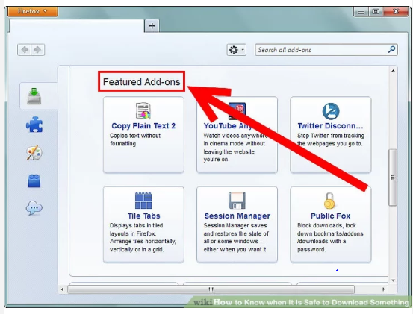

* **Look over the site.**

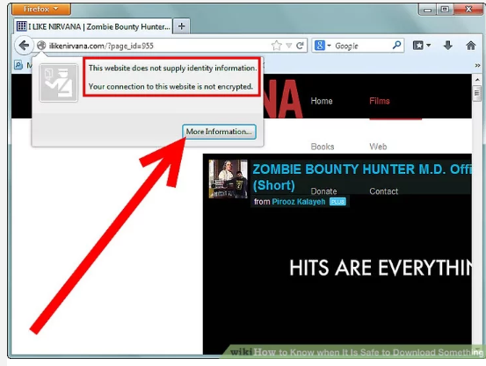

* **Consider who you are downloading the file from**

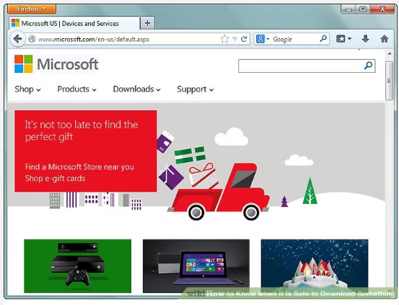

* **Are there other people that have downloaded the file?**

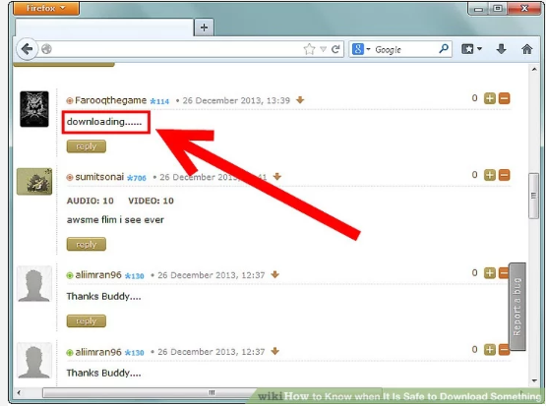

* **Look at the size of the file.**

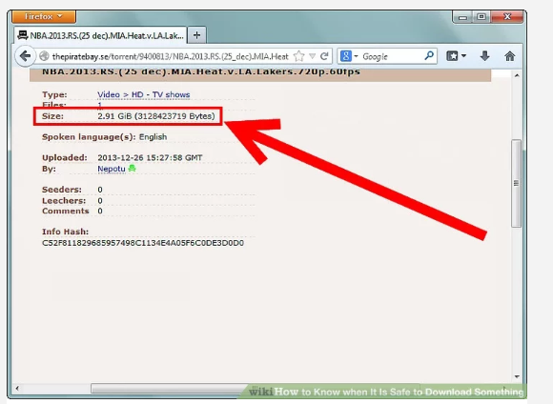

* **Watch out for executable files, such as '.exe', '.bat', '.pif', and '.scr'.**



* **Is the file signed?**



**B-PART**

**The Benefits of Copyrighting Your Website’s Content**

A copyright is a type of intellectual property protection. In short, it limits who can copy and redistribute your content. This is the type of legal protection commonly used for books, movies, and other media, but it applies to your website as well.

A registered copyright can be invaluable in certain types of legal situations. It provides proof of ownership, and makes it easier to pursue legal action against someone if they copy and redistribute your site’s content without your consent.

If your content generates income – through ads on your blog posts, for example – this kind of theft could negatively impact your finances. Duplicate content doesn’t rank well within search engines, which means that even your original content will be less likely to attract organic traffic. Plus, there’s a risk that interested potential visitors will end up visiting the thief’s page instead of yours.

To be safe, you might want to consider periodically checking to see if any of your content has been stolen. There are several tools you can use to search for duplicate content on other sites, such as Copyscape. If you find anything amiss, you can contact the other site owner and ask them to remove it.

The safest course of action, however, is to make sure your content is legally protected. Clearly displaying a copyright symbol on your site is a good start, and can deter many would-be content thieves. Registering an official copyright is an even better strategy, however, and provides the best defense for your content.

**How to Copyright Your Website’s Content (In 4 Steps)**

Technically, under U.S. law your content is copyrighted as soon as you publish it. You can add the symbol to your site any time, although it isn’t strictly necessary. However, if you don’t register your copyright, it can be difficult and time-consuming to prove ownership if your content is stolen. That’s why we recommend following these four steps.

* **Step 1: Add a Copyright Symbol to Your Site**

As we mentioned earlier, adding a copyright symbol to your site can make people think twice about stealing your content. While it isn’t part of the registration process, taking this step can help to protect your site while your application is being processed:

An example of a copyright symbol from the Elegant Themes Home page.

There are a few methods for adding a copyright symbol to your site. Some services, including Copyscape and the Digital Millennium Copyright Act (DMCA), offer free banners for websites. You can also simply add the symbol to your website’s footer by hand**.**

* **Step 2: Gather the Materials You Wish to Copyright**

You probably want to protect your website as a whole. However, for full protection you’ll also need to register individual blog posts, images, and any other media. The Copyright Office considers these to each be separate entities, so a copyright for your site may not fully protect posts or media files.

Fortunately, you can register collections of content, so you won’t have to file an application for each individual post and image on your site (that would be incredibly time-consuming). Still, you may want to go through your site and compile a detailed list of content to register.

Before you can fill out any forms, you’ll also need to generate hard copies of each piece of content you want to copyright. Even if you file your application electronically, it’s required that you also mail in a hard copy of your content to the Copyright Office.

The regulations also state that the hard copy should be the “best edition” of your work. So when printing your site’s pages, make sure the copies are of high-quality and accurately reflect what your site looks like. This will help ensure that your application is approved as quickly as possible.

* **Step 3: Complete the Copyright Registration Application**

You can submit the copyright registration application online or by mail. To register by mail, find the correct form for your content, fill it out on your computer or by hand, and then print and mail it with your hard copies and a filing fee of $85.

If you register online, you’ll benefit from a lower filing fee of $35–$55, faster processing times, and the ability to track your application’s status. To access the online application, you’ll need to create an account with the electronic Copyright Office:

The electronic Copyright Office's account registration form.

Then find and select the correct form for your content, and provide all the required information. You can submit your hard copies by mail, and still receive the benefits of online registration.

Once you’ve submitted your application, you’ll want to keep an eye on its status. On average, copyright applications take seven months to process. So in the meantime, make sure you have a copyright symbol on your site and are checking periodically for stolen copies of your content online.

* **Step 4: Create a Schedule to Copyright New Material on a Regular Basis**

After your application has been approved, you’ll never have to renew your registration. However, new content that you add to your site is not automatically protected by your registered copyright.

Gathering new material you’ve produced once or twice a year and submitting a new registration application will help keep your protection up-to-date. This strategy is most cost-effective if you wait until you have a collection of new work to submit. That way, you don’t have to pay the full filing fee for each piece.

Setting up a schedule for submitting new work can help ensure that none of your posts or other content slips through the cracks. Therefore, you’ll want to consider adding dates for registration updates to your calendar, or setting recurring reminders.

**Conclusion**

While copyrighting your website’s content can be a long process, it requires relatively little work and provides important benefits to your site. Taking the time to register your online content can ensure that both your site and your income are protected.

**References**

* file:///C:/Users/sabad/Downloads/When_do_franchisors_select_entrepreneuri.pdf
* <https://www.dummies.com/business/start-a-business/business-plans/how-to-generate-a-successful-business-idea/>
* <https://neilpatel.com/blog/entrepreneurs-fail/#:~:text=Whether%20that%20failure%20is%20large,but%20it%20shouldn't%20be.&text=Entrepreneurs%20aren't%20the%20only,three%20years%20they're%20open.>
* <https://www.homeworklib.com/questions/1249349/1-discuss-entrepreneurial-characteristics-does>