Design:
These are the main modules:
- Client: this the main module in the client-side which takes input as args explained in manual. It parses the input to make call for client_local Or client_remote.
- client_local: this module dose the local implementation for the cloudkon framework. It setup request and response queue.
- client_put : a thread running at client side called by client_local. It put requests into the request queue reading task form file and checks for response size to stop worker when finished.
- Worker: implements thread at worker called by client_local. Retrieves sleep tasks form request queue execute them to puts result in response queue.
- client_remote: implement the client in the instance machine, creates SQS request and response queue, & DynamoDB table too. It create workers using AWS AMI. This AMI is has src code & java pre-installed.
- client_response: thread is executed on client machine to read work_file and put task in the request SQS queue.
- client_response: thread is executed on the client machine to retrieve task from response SQS. It also keeps track for num_of task executed to terminate worker when finished.
- create_worker: class used to create user specified worker form worker AMI.
- Worker _remote: class to be executed in the remote worker (manual start-up) in each worker. Configures the requests & response queue along with DynamoDB.
- worker_thread: thread running on each remote worker retrieves task form request SQS, checks for duplicates with DynamoDB, skips duplicate task and executes new once to put the result back to response SQS.
- Q: implements SQS queue (generic) on the name passed by user. Implement several important methods like create-to create a queue, insert-inserts task,remove-removes task, delete-deletes queue,purge-clears the queue.
- Table: implements DynamoDB table with key message_id. Implements methods such as create-to create table,add-adds entry in to table,scan-search for given entry,delete-deletes the table.
Note: user has to excute Client.java at client mahince creates workers. But each worker has to initialized later by the user.

Manual:
Needs:
- Ami: need an ami reference with java installed, AWS SDK installed & all the source code in it. This is used for creating remote workers. The AMI must also have credential file in it with read permissions at location /home/user/.aws/credentials.
How to execute?
User can enter following cammonds :
java Client LOCAL OR REMOTE] [num_threads or blank] [path to workfile]
is the generic cammond.
Example:
java Client LOCAL 8 /path/work_file –----------for local implementation.
Java Client REMOTE /path/work_file------------for remote worker implementation
For Remote setup follow the on screen instructions(it will later ask fo SQS queue names-request & reponse, DynamoDB table name -table & also for num_of worker). We setpu the client on the machine which this code is run. Workers are setup using AMI but they have to initialized to configure & run threads. For each worker worker_remote is to be executed:
java worker_remote
it asks for num_threads to execute at worker.

Performance Evaluation:
Two type of programs are performed one for through-put & other for Efficiency over LOCAL&REMOTE implementation;

LOCAL:

# of worker threads | Through-put (10k) | Through-put (100k)
1 | 27247 | 26666
2 | 28328 | 28642
4 | 30959 | 30135
8 | 30769 | 30817
16 | 32154 | 32209

throughput of the local worker increases with the increase in number of worker threads.

Workers | 10sec task per worker (time taken) | Efficiency=ideal/real | 1sec task per worker(time taken) | Efficiency=ideal/real
1 | 104.16 | 96 | 112.35 | 89
2 | 111.11 | 90 | 117.64 | 85
4 | 114.9 | 87 | 125 | 80
8 | 121.9 | 82 | 126.58 | 79
16 | 125 | 80 | 129.87 | 77
Workers | 10millisec task per worker(time taken) | Efficiency=ideal/real
1 | 142.8 | 70
2 | 156.25 | 64
4 | 200 | 50
8 | 232.55 | 43
16 | 250 | 40

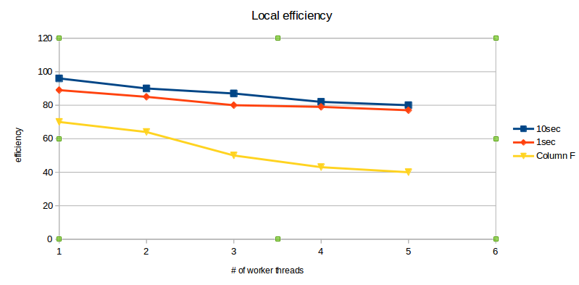
Efficiency decreases with decreases in num of threads.

REMOTE:
# of worker threads | Through-put (10k)
1 | 157
2 | 172
4 | 195
8 | 207
16 | 243

The throughput of the local worker increases with the increase in number of worker

Workers | 10sec task per worker (time taken) | Efficiency=ideal/real | 1sec task per worker(time taken) | Efficiency=ideal/real
1 | 107.52 | 93 | 119 | 84
2 | 119.04 | 84 | 131.5 | 76
4 | 129 | 77 | 147 | 68
8 | 138.8 | 72 | 158.7 | 63
16 | 147.05 | 68 | 166.6 | 60
Workers | 10millisec task per worker(time taken) | Efficiency=ideal/real
1 | 185.1 | 54
2 | 217.3 | 46
4 | 270.2 | 37
8 | 303 | 33
16 | 344 | 29

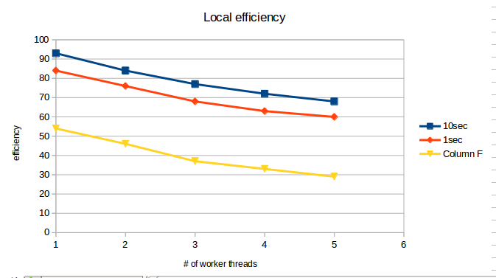
Efficiency decreases with decreasesin num of workers.

