Solidarity Questions correlations

WP27 | If you were in trouble, do you have relatives or friends you can count on for help? [yes/no] | Solidarity | Inward Solidarity
WP110 | In the past month, have you helped a stranger or someone you didn’t know who needed help? [yes/no] | Solidarity | Outward Solidarity
WP108 | In the past month, haye you donated money to a charity? [yes/no] | Solidarity | Outward Solidarity
WP109 | In the past month, have you volunteered your time to an organization? [yes/no] | Solidarity | Outward Solidarity
WP103 | Is the city or area where you live a good place or not a good place to live for racial and ethnic minorities? [yes/no] | Solidarity | Outward Solidarity
WP105 | Is the city or area where you live a good place or not a good place to live for gay or lesbian people? [yes/no] | Solidarity | Outward Solidarity
WP106 | Is the city or area where you live a good place or not a good place to live for immigrants from other countries? [yes/no] | Solidarity | Outward Solidarity
WP61 | Were you treated with respect all day yesterday? [yes/no] | Solidarity | Outward Solidarity
WP129 | Do you believe that children in (Country) are treated with respect and dignity, or not? [yes/no] | Solidarity | Outward Solidarity

WP106 is highly correlated with WP103 and WP105– immigrants, ethnic minority, gay/lesbians.
But, apart from Turkey and Russia, other countries have the same number of NAs for these questions.

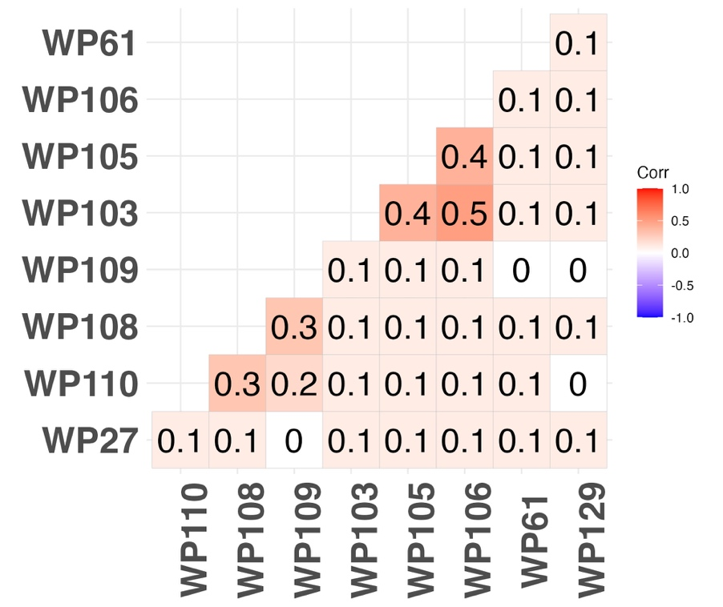

WP138 | In this country, do you have confidence in each of the following, or not? How about judicial system and courts? [yes/no] | Agency | Institutional Trust
WP139 | In this country, do you have confidence in each of the following, or not? How about national government? [yes/no] | Agency | Institutional Trust
WP146 | Is corruption widespread throughout the government in this country, or not? [yes/no] | Agency | Institutional Trust
WP134 | In this country, are you satisfied or dissatisfied with your freedom to choose what you do with your life? [satisfied/dissatisfied] | Agency | Personal Agency
WP93 | In the city or area where you live, are you satisfied or dissatisfied with the educational system or the schools? [satisfied/dissatisfied] | Agency | Public Services and Infraestructure
WP97 | In the city or area where you live, are you satisfied or dissatisfied with the availability of quality healthcare? [satisfied/dissatisfied] | Agency | Public Services and Infraestructure
WP98 | In your city or area where you live, are you satisfied or dissatisfied with the availability of good, affordable housing? [satisfied/dissatisfied] | Agency | Public Services and Infraestructure
WP92 | In the city or area where you live, are you satisfied or dissatisfied with the roads and highways? [satisfied/dissatisfied] | Agency | Public Services and Infraestructure
WP91 | In the city or area where you live, are you satisfied or dissatisfied with the public transportation systems? [satisfied/dissatisfied] | Agency | Public Services and Infraestructure

WP138 and WP139 are highly correlated (national government and judicial system trust). They might be good proxies for each other since not NAs are the same.

