**Admin**

**Supervisor**

* **Current Assignments: hindi nag update meaning hindi sya dynamic.. puro pending lang meaning hindji mo sya pwde ma update into new as supervisor, (the bug is not responsive and dynamic)**

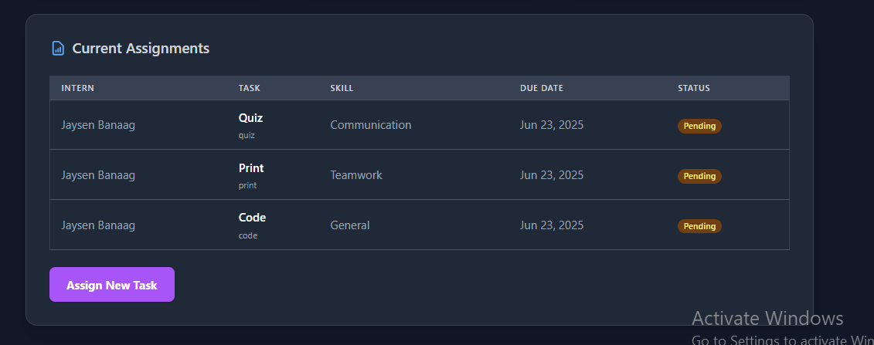

* **Kailangan pag pinindot mo ung button dapat mag uupdate sya at mag didisplay ng assign new task same with skills, (the bug is after mo ma assign ng new task, then hindi na nag didisplay ung description or information ng task na inassign mo.. dapat makikita un mismo sa loob ng evaluate interns, at hindi lang dapat nakikita sa dashboard)**

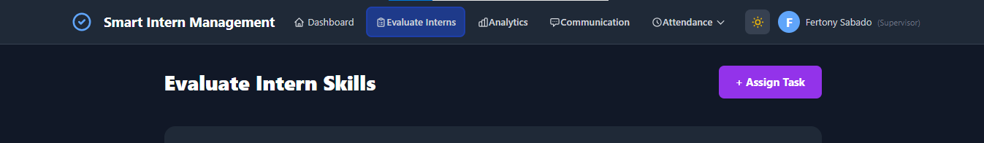

* **Howevering it should be atleast at ease not with duration or timer, earase the duration of time effect it should be at ease effect, meaning dapat howering effect lng walng timer**



**Intern**