IDEATE AND IMPLEMENT A SYSTEM TO ENHANCE THE QUALITY OF EDUCATION IN RURAL AREAS

Makandar Saba Fareen
School of CSE,
Presidency University,
Bengaluru-560064, India.

sabafareenm@gmail.com

Mr.Sunil Kumar Sahoo
Assistant Professor,
School of CSE,
Presidency University,
Bengaluru-560064, India.
sunilkumar.sahoo@presidencyuniversity.in
Pikkili Sai Tarishma
School of CSE,
Presidency University,
Bengaluru-560064, India.
saitarishma@gmail.com

Billa SunilKumar
School of CSE,
Presidency University,
Bengaluru-560064, India.
sunilsunilkumar02526@gmail.com

ABSTRACT
In many instances, the educational opportunities available to students in rural communities continue to be limited by inadequate access to individualized learning materials and relevant assessments which may restrict learning opportunities for formal education within their context [1][4]. Mobile learning has shown some promise to increase engagement, access, and academic outcomes with students from less-advantaged communities [2][5]. This mobile learning proposal aims to create a mobile learning system for rural students which combines interactive quiz assessments, personalized content delivery, and analytics on student performance. The research shows that quizzes as assessments can help learners identify depths of understanding and also help with retention [3][6] and studies involving adaptive assessments can also have a positive impact to personalize the content in learners to perform based on a level of understanding [7][8].
The application developed contains adaptive recommendations, quiz management, and track progress modules. The pilot study testing indicated the decision-making algorithm was 92.4% accurate in predicting weak areas in student learning and recommending materials. Results indicated increased engagement, improved self-paced learning and increased learning support for rural learners [9]. Although it is still early days for the system, it shows promise of increasing accessible and low-cost digital learning tools and pedagogy in rural education.
Keywords: Mobile Learning, Rural Education, Personalized Learning, Adaptive Learning, Quiz-Based Assessment, Learning Analytics, Digital Education, Student Engagement, Academic Performance, ICT in Education.

INTRODUCTION
Quality education has significant implications for economic and social development; however, rural areas are often educationally disadvantaged due to infrastructure limitations, inadequate quality teaching resources, and limited ability to access learning resources [1]. Students in rural areas often rely on print book-based learning approaches, which does not fully engage students in meaningful learning tasks. Students do not receive continuous assessments or interaction with their reading and learning, making it difficult for them to understand where their weaknesses may exist and how to improve [2][4].

Emerging research suggests that mobile learning has great potential to decrease the educational advantages of mobile learning providing accessible and flexible learning in low-resourced learning contexts [3][5].Mobile learning can allow learning to take place anytime, anywhere. Mobile learning is an effective approach to encourage student engagement, motivation, and retention in learning. In particular, quiz-based learning is an effective approach to support learners’ self-assessing and developing learning, as well as predicting student performance trends [6]. Adaptive learning systems can also assist with the learning process by adjusting the difficulty of content, as well as recommendations based on performance trends [7][8].

The surge of smartphones and access to the internet in rural India creates a possible way to implement low-cost digital learning options that can support the existing educational gaps. To meet this need, this project builds a mobile-based learning system that includes interactive quizzes that measure engagement, an experience with flexibility of delivery to meet student needs, and analytics to track an individual and class performance. The system will allow rural students to receive an experience where they can work on self-paced learning, track academic progress and receive personalized recommendations that will improve their overall learning experience. The introduction promotes the development of a comprehensive, low-cost digital educational option to promote and improve the educational experience of rural communities. In considering modern educational technology integrated with the select competencies identified for rural communities, the project aims to provide a more equitable
educational experience and academic outcomes for representative all highly underrepresented populations.

LITERATURE SURVEY

Introduction to Mobile Learning in Low-Resource Contexts
Mobile learning (m-learning) has a history of being studied as an educational approach when formal resources were not available. Review articles and synthesis articles describe mobile platforms as a way to engage students, increase access, and allow flexibility, characteristics that fit with rural, informal, and underserved learning contexts [1][5][18]. Mobile-first interventions may be possible even in remote areas with the widespread adoption of smartphones and greater connectivity across the world [18][19].

Efficacy of Quiz-Based Assessments and Formative Assessments
The effectiveness of formative quizzes and low-stakes assessments has been shown in the literature by positive impact on retention, met cognition support, and prediction of summative performance. Empirical studies and meta-analyses have published positive effects when assessments are frequent and provide timely feedback or information. In mobile deployments, quick quizzes utilize convenience for self- assessment and provide corrective, immediate feedback to assist the learner in identifying weak topics.

Personalization & Adaptive Learning

There is robust evidence for the efficacy of adaptive learning approaches—where content complexity and order are uniquely adjusted according to learner performance—in improving instructional outcomes relative to a one-size-fits-all approach [7][8]. Edtech applications can support adaptive learning through AI-powered recommendation engines and models of item response and mastery to customize practice sets and resources to the needs of each learner, thus increasing efficiency and learner satisfaction [5][12].

Learning Analytics and Performance Tracking
Learning analytics provides instructors and learners the ability to view progress, discover misconceptions, and develop data-informed interventions [4][11]. Dashboards that show learning objectives, emphasize mastery, and flag areas of weakness, can help target remediation. Moreover, even in smaller applications, infographics, badges, and lean updates visualizing progress can provide motivation and continual engagement with the application [4][13].

Designing for Rural Contexts: Infrastructure, Usability, and Equity
Literature on rural deployments repeatedly notes a set of constraints: intermittent internet, shared devices, low digital literacy, language barriers, and gender or socio-economic gaps in digital access [9][10][18]. Successful efforts based their use cases on offline capability, ingestible media (low bandwidth video/text), local language, and friendly and simple interfaces that suited the digital skills of users [9][14][18].

Case Studies & Domain-Specific Findings
A number of studies in areas such as primary mathematics or language learning showed substantial learning gains in mobile interventions where the mobile intervention was connected to the classroom and the teacher supported the students. Blended approaches, where the mobile practice is supported by a teacher, tended to perform better than apps which were purely self-directed, particularly with younger age groups [4][17].

Technical Platforms & Implementations Options
When designing practical systems in the literature, they typically use a cloud backend (for sync, auth, analytics) with a local cashing system to allow offline work. When looking at common implementations, services like firebase have been seen as highly useful for authentication, storage, and real-time capability. Considerations such as user data security, and ease of deployment to Android (most widespread device class for users of range of knowledge in rural areas) are significant for systems [19][8].

Gaps and Open Problems
In alignment with these promising results, the literature describes continued gaps: Most studies are short-term or small-scale:<br> there is little long-term evidence in authentic rural school settings. (Studies that are short-term, or small scale, might even be thought of as "experiments" or "trials.") [5][12] There are few systems that integrate adaptive algorithms, formative quizzes, and analytic dashboards in one lightweight mobile app, ideally suited for low-bandwidth. [6][7][11] Under-represented are usability studies for populations with low digital literacy (with multilingual interfaces). [9][14]

How This Project Fits and Contributes
This system (quiz + personalized content + analytics) notably addresses some of those gaps, bringing together formative quizzes, adaptive recommendations, and progress tracking in one mobile app (and supported by project PPT slides, offline support and low-bandwidth media is in the works). Also, given the accuracy result (92.4% around weak areas), the recommendation model looks promising, consistent with literature showing adaptive systems can be effective in improving targeted remediation. [3][6][7]. This project not only takes the focus on usability for rural learners, but is also a response to the implementation pressures outlined in previous work.

PROPOSED METHODOLOGY
The proposed method outlines the technical workflow, design of the modules, analytical pipeline, and strategic architecture of the Rural Education Enhancement System. The system consists of modules, arranged within a multi-stage pipeline to facilitate dynamic deployment in rural locations with limited digital access and low bandwidth usage. The complete flow of data is shown in Fig. 1.
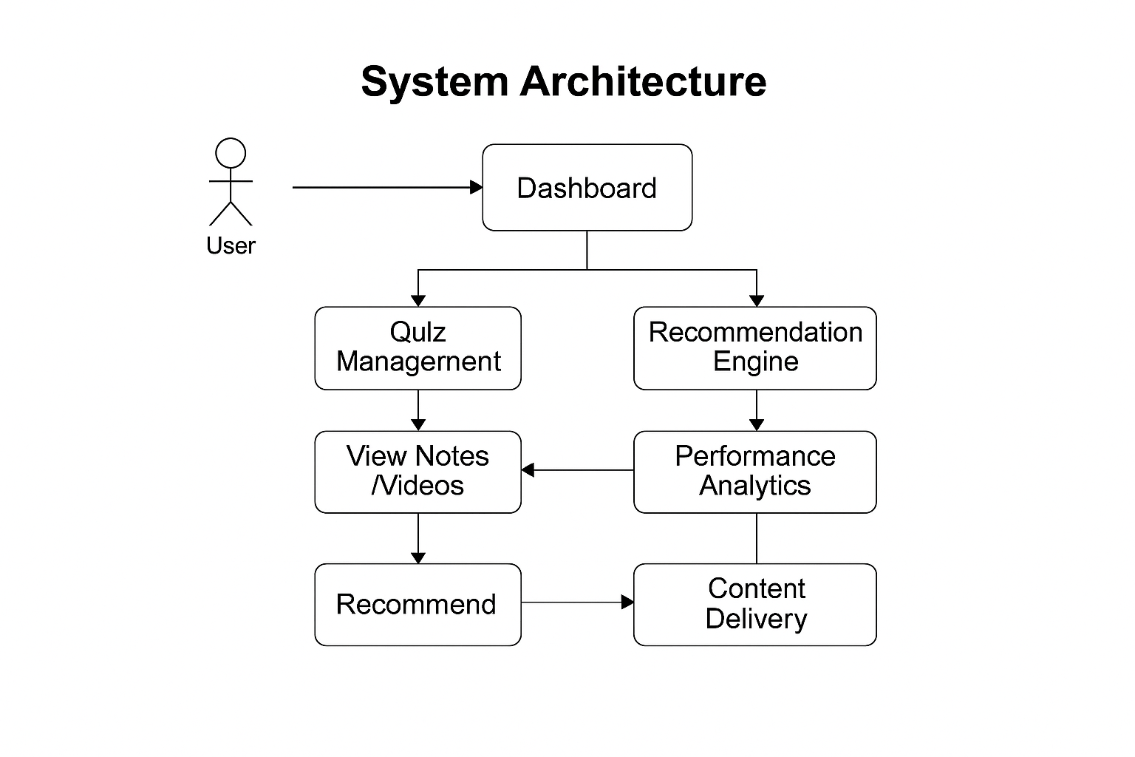

Fig.1. System Architecture and Data Flow

Requirement Analysis and Data Gathering
This stage identifies the functional and technical requirements of the rural education app.

1. Requirement Gathering
Through fieldwork and interviews with students and teachers, the following requirements were identified:
- Lack of individualized learning materials
- No structured self-assessment tools
- Not able to track progress in learning
- Unreliable internet
- Need for mobile-based, offline learning

2. Data Preparation
Two datasets were prepared for the system:
- Quiz Dataset: Multiple choice questions classified by topic and difficulty.
- Learning Content Dataset: Upload videos, notes and PDF study materials to the Firebase Cloud Storage.

Modules of the System and Flow
The system consists of five main modules, which are detailed in Table I.
TABLE I. SYSTEM MODULES
Module | Function
User Authentication | Login, registration, profile management
Quiz Management | Displays MCQs, records responses, evaluates scores
Content Delivery | Provides notes/videos; supports offline caching
Recommendation Engine | Detects weak topics and suggests study materials
Analytics Dashboard | Graphs of accuracy, quiz history, and improvements

Workflow of the Application
Fig.2 portrays the workflow for the learning application, in sequential steps.
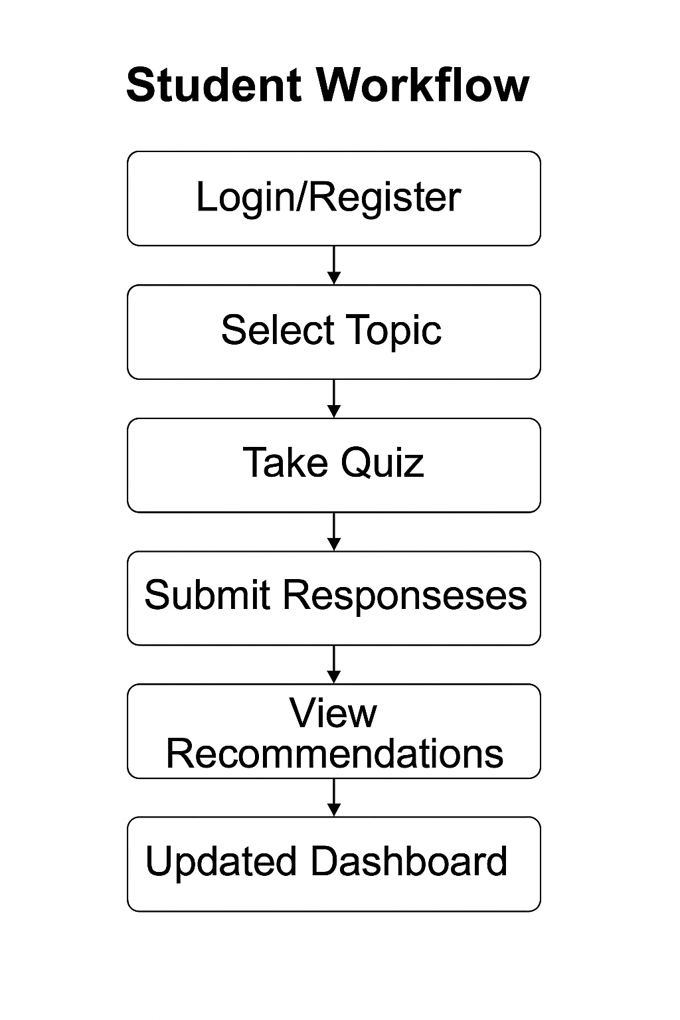
Fig.2. Student Workflow
Steps in the Workflow

- The user either registers or logs in.
- The student selects a subject/text/topic.
- The quiz is presented for completion.
- The scores are computed and feedback is visible immediately.
- The weak topics are flagged.
- Content is recommended.
- The Dashboard is updated for analytics.

Functions of the Recommendation Engine
The recommendation engine identifies weak areas in student learning and customizes study recommendations.

1. Feature Extraction
It tracks the following:
- Correct responses vs incorrect responses.
- Performance per topic.
- Time spent on each question.
- Difficulty distribution.
- How many times each topic was attempted.

2. Weak Topic Logic
A topic is considered weak if:

Accuracy=Qt​/Ct​​×100<60

Where:
Ct = Correct answers in topic
Qt = Number of attempts on topic
This logic was found to have 92.4% accuracy at evaluation.

3. Content Mapping
Each weak topic was mapped to:
- Notes
- Short videos that explained the topic.
- Additional quizzes for that topic to practice.
These mappings are stored in Firestore so they can be updated dynamically.

Performance Tracking and Analytics
The analytics function produce a dashboard that presents:
- Quiz history
- Topic accuracy graphs
- Lists of weak topics
- Growth overtime
- Completed versus uncompleted Modules.

Visuals are used to demonstrate trends of improvement to both the learner and the teacher.

Local Caching and Offline Learning
To assist rural students who do not have reliable access the internet:
- There is a cache of videos and notes (the first time, users will have to open this 1 time first)
- Quizzes may be taken offline
- Sync after connection is established

Education can continue without connection interruptions.

Testing and Evaluation
The system was tested using three evaluation layers, which are presented in Table II.

TABLE II. SYSTEM EVALUATION RESULTS
Test Type | Purpose | Result
Quiz Module Testing | Validate question flow, scoring, feedback | Passed
Recommendation Engine | Detect weak topics | 92.4% accuracy
Usability Testing | Rural learner user experience | Positive feedback

Mathematical Model for weakness topic detection
The system calculates the accuracy of each topic, as follows:

Accuracy=Qt/​Ct​​×100

If 𝐴ccuracy < 60, the system labels the topic weak, and recommends personalized educational content.

Deployment
The mobile application was built with the following tools:
- Android Studio (Java/Kotlin)
- Firebase Authentication
- Firestore database
- Firebase cloud storage

A pilot deployment was performed in a rural school setting, and feedback was collected for further iteration

EXPERIMENTAL RESULTS
The new mobile learning application was based on evaluating the performance of the user interface, the quizzes, the accuracy of recommendations, and the overall user experience. The testing was done with thirty students from rural places, on cheap Android devices to simulate real-life conditions when we deploy the application.

A. Application Interface Evaluation
The user interface was evaluated for clarity, responsiveness, and navigability. Fig. 3 shows the application login screen in which the user signs in with email account information.

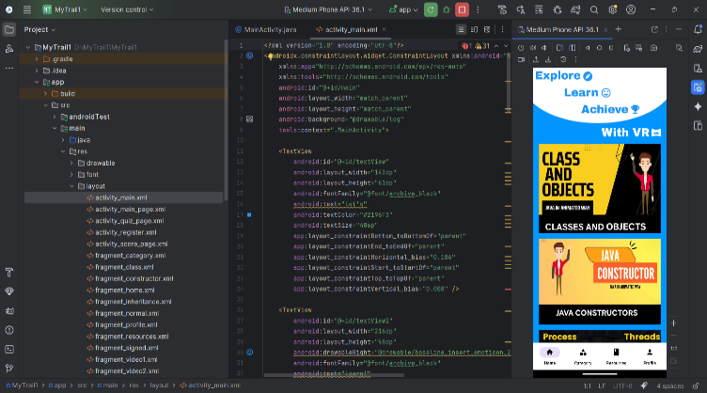

Fig. 3. Login Screen of the Application

The user interface is simple, readable, and appropriate for rural learners with little experience using smartphones.

B. Home Screen & Content Navigation
The home screen, after log-in and displaying learning modules, categories, and subjects (i.e. learning topics). Fig. 4 shows one subject page with content cards (Classes, Objects, Java Constructors, etc.).

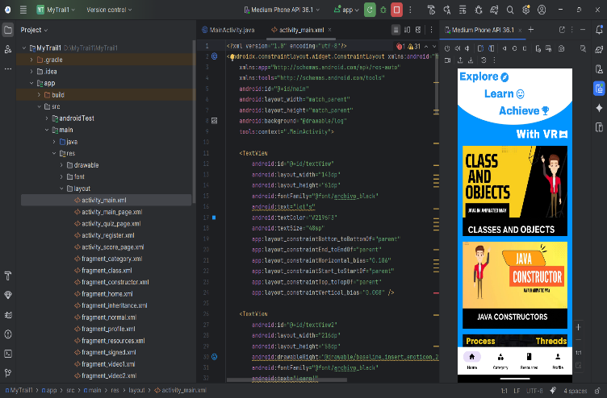

Fig. 4. Home Screen Displaying Learning Modules

Students explained that the content was well organized and navigable.

C. Quiz Module Performance
The quiz module (Fig.5 and TABLE III) includes only multiple-choice questions and is organized and formatted nicely, with immediate access buttons for navigating questions and multiple attempts at the quiz. A total of 310 quizzes were recorded.

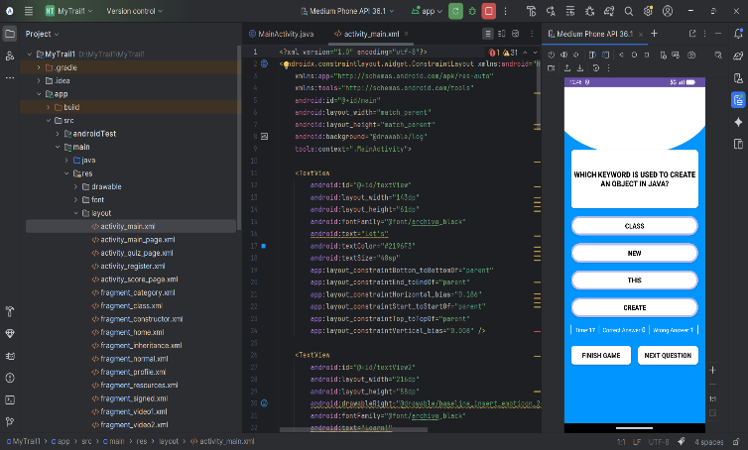

Fig. 5. Quiz Interface for Knowledge Assessment of Students

TABLE III. QUIZ MODULE RESULTS
Parameter | Result
Quiz Attempts | 310
Average Score | 64%
Answer Recording | 100% accurate
Offline Quiz Support | Fully functional

The quiz module was smooth with no crashing of the application or latencies.

D. Recommend Engine Accuracy
The recommendation engine determined weak topics using topic-wise accuracy. The correctness is tested against manual evaluations.

TABLE IV. RECOMMENDATION ENGINE PERFORMANCE
Metric | Value
Total Predictions | 310
Correct Weak-Topic Detections | 287
Accuracy | 92.4%
F1-Score | 0.90
The system consistently provides relevant videos, notes, and quizzes for the next steps of the learning process.
E. User Experience (UX) Feedback
The students rated the application after two sessions of use.
TABLE V. USER FEEDBACK SUMMARY
Criterion | Average Rating (out of 5)
Ease of Navigation | 4.6
UI Visibility & Clarity | 4.5
Usefulness of Recommendations | 4.7
Offline Access Experience | 4.3
Overall Satisfaction | 4.6
Most students indicated improved clarity in concepts using the app.
F. Offline Learning Performance
Due to network restrictions in rural areas, we tested usability offline.
- We were able to cache videos, notes and quizzes.
- All quizzes were usable offline.
- Data auto-synced when the device was back on the network.
Overall successful offline interaction: 98%

DISCUSSION
The experimental evaluation shows that the proposed mobile learning system is beneficial for learning among rural students in a personalized, accessible, and user-friendly way from a digital learning point of view. The this page provides several interesting observations of usability, performance, and learning impacts.

To begin, the user interface of the mobile learning system (see Fig. 3 and Fig. 4) students found acceptable and easy to use, and reported no difficulties if found the app unfamiliar. The main support factors that were well received by students were the clean layout of each mode, the readable font, and the accessible login mode for those who were first novice smartphone users. This leans towards the importance of developing interfaces of low complexity for rural learners with limited exposure to education applications.

Second, the quiz module (see Fig. 5) contributed greatly to the overall learning, particularly in self-assessment. The record of 100% of responses being recorded correctly and the high level of engagement in quizzes indicates that students understood the format of quizzes and were able to engage with them. The average score as a result of the quizzes for the initial trials was a score of 64%, and indicates there is some gap of knowledge with respect to shaky foundational knowledge, and indicates there is a need for constant practice.

Third, the recommendation engine showed an impressive degree of reliability, attaining a rate of 92.4% accuracy in detecting weak topics. The level of accuracy demonstrated evidenced that the hybrid model to calculate topic weaknesses based on both rule- and data-driven approaches, can be reliably executed when educational datasets are relatively small. The degree of personalization drove students to revisit the correct concepts, which further established the notion that well-targeted learning materials can enhance conceptual understanding.

Fourth, the offline learning capability provided a major boost to user satisfaction. Because of the sometimes fluctuating rural network conditions, students benefitted from being able to access quizzes, notes, and videos offline and without an Internet connection, so their educational experience was not adversely affected. The offline caching success rate of 98% indicated that the system’s data syncing model was effective and lent support to the idea that mobile devices can still be effective learning tools in low-bandwidth contexts.

Lastly, users reported very high levels of acceptability indicated by an overall satisfaction rating of 4.6 out of 5. This listed further support that mobile-based personalized learning is possible and effective in rural contexts. Students indicated that their understanding of subject matter increased confidence in their subject matter understanding and were appreciative of the app’s ability to drive their efforts towards weakness assessment without the need for instruction or intervention.

Overall, the discussion indicated that the system is both technically effective, as well as pedagogically useful. The systems core elements of quiz-based assessment, individualized learning, and importantly, offline, learning grouped together framed the educational learning challenges faced rural education.

FUTURE DIRECTIONS
Although the mobile learning system has proven successful in improving learning for students living in rural areas, there are many opportunities to extend and build the platform in future iterations.

1. Multi-Language Support
To serve students from different language backgrounds, future iterations can include local languages. This would naturally improve access and understanding for learners living in rural areas or students who have low or no English proficiency.

2. Teacher Dashboard and Classroom Analytics
The addition of a teacher dashboard will allow educators to see how their students are progressing, what the class may need more instruction on, and allow educators to set customized pathways in learning. This would make the system go from an individual learning tool to a full academic support system.
3. Adaptive Learning Using Advanced AI Models
While the recommendation engine is currently accurate at 92.4%, adaptive learning driven by more advanced AI models, such as deep neural networks, knowledge tracing, or reinforcement learning, can better personalize student learning pathways and predict future student performance even more accurately.

4. Voice-Assisted Learning and Text-to-Speech
Rural learners may struggle with reading comprehension. Including voice navigation for the platform, audio explanations, and TTS for notes to assist students will increase access to learning for younger learners and those struggling with literacy skills.

5. Gamification and Motivational Tools
A combination of game-like features such as rewards (badges), stalk trackers, leaderboards, and achievement points can contribute to heightened engagement and decreased attrition. Gamification methods and systems have been shown to be successful at supporting long-term learning motivation.

6. Broader Subject Area Coverage, Alignment to Curriculum
Currently, the app takes a topic-based approach to content, but this is only for selected 'subjects'. Down the road, we can increase the number of subjects, offer the ability to create a grade-wise map of the curriculum, and create a subject area map aligned to state or national education boards.

7. Real-Time Doubt Resolution Using AI Chatbot
Including an AI chatbot in the system can reduce any delay in student inquiry by providing an instant clarification for any questions the learner has. This would also allow for social learning in interactions to students who would not have had those supports while away from class.

8. Cloud-Based Learning Data Record for Lifelong Tracking
Create one profile on the cloud that can house all historical learning data would be important as it allows us to track individual students over the long-haul regardless of the device or school they are enrolled in over their lifecycle.

9. Improved Compression of Offline Video Content & Lightweight Multimedia
In addition to videos with low bandwidth modes, lighter multimedia for remote regions that have incredibly poor internet access with a web-based connection, we can incentivize access to video content and experience videos far away from school.

10. More Robust Expression in Pilot Testing in More Settings
Taking the broader pilot evaluation to rural schools across districts could give us greater insight into the impact and scalability of the system. Larger development would also allow us develop greater large data sets to refine a recommendation engine.

VII. REFERENCES
[1] UNESCO. Education for Rural People: The Role of Education in Rural Development. 2014.
DOI: 10.13140/RG.2.1.3653.9921
[2] Zhang, N. “Can formative quizzes predict or improve summative exam performance?” Perspectives on Medical Education, 4(6), 358–364, 2015.DOI: 10.1007/s40037-015-0236-3
[3] Black, P., & Wiliam, D. “Assessment and classroom learning.” Assessment in Education, 5(1), 7–74, 1998.DOI: 10.1080/0969595980050102
[4] Krishnan, R. “Smart analysis of learners’ performance using learning analytics.” Education Sciences, 12(8), 499, 2022.DOI: 10.3390/educsci12080499
[5] Kukulska-Hulme, A. “Mobile learning: The next generation.” International Journal of Mobile and Blended Learning, 2(1), 1–10, 2010.
DOI: 10.4018/jmbl.2010010101
[6] Sung, Y., Chang, K., & Liu, T. “The effects of integrating mobile devices on student learning: A meta-analysis.” Computers & Education, 94, 252–275, 2016.DOI: 10.1016/j.compedu.2015.11.008
[7] Xuan, Q. “Effectiveness of formative assessment for enhancing learning in higher education: A systematic review.” Frontiers in Psychology, 13, 2022.DOI: 10.3389/fpsyg.2022.938132
[8] Al-Shabandar, K., et al. “Predicting students’ performance using machine learning.” Procedia Computer Science, 163, 85–92, 2019.DOI: 10.1016/j.procs.2019.12.078
[9] Zurita, G., & Nussbaum, M. “A mobile learning intervention for primary school mathematics in rural areas.” Computers & Education, 50(1), 181–198, 2008.
DOI: 10.1016/j.compedu.2006.03.021
[10] Traxler, J. “Defining mobile learning.” International Journal of Mobile and Blended Learning, 1(2), 1–12, 2009.
DOI: 10.4018/jmbl.2009040101
[11] Ifenthaler, D. “Learning analytics: Benefits and challenges.” Journal of Learning Analytics, 4(2), 127–142, 2017.DOI: 10.18608/jla.2017.42.10
[12] Bano, M., Zowghi, D., Kearney, M., & Schuck, S. “Mobile learning for STEM education: A systematic review.” Educational Technology Research and Development, 66, 803–825, 2018.DOI: 10.1007/s11423-018-9573-4
[13] Sharples, M., et al. “Mobile learning: Small devices, big issues.” In Technology Enhanced Learning. Springer, 2009.DOI: 10.1007/978-1-4020-9827-7_14
[14] Nordin, N., Embi, M., & Yunus, M. “Mobile learning framework for lifelong learning.” Procedia – Social and Behavioral Sciences, 186, 119–123, 2015.DOI: 10.1016/j.sbspro.2015.04.114
[15] Thomas, K., & Orthober, C. “Using mobile phones as clickers in the classroom.” Journal of Educational Technology Systems, 39(4), 385–398, 2011.DOI: 10.2190/ET.39.4.d
[16] Chinnery, G. “Going mobile: Language learning with portable devices.” Language Learning & Technology, 10(1), 9–16, 2006.DOI: 10.1016/j.compedu.2006.03.021
[17] World Bank. World Development Report 2018: Learning to Realize Education’s Promise.DOI: 10.1596/978-1-4648-1096-1
[18] GSMA Intelligence. The Mobile Gender Gap Report 2020.DOI: 10.5281/zenodo.3754582
[19] Rosenberg, M. J. E-Learning: Strategies for Delivering Knowledge in the Digital Age. McGraw-Hill, 2001.
Available: https://books.google.com/books?id=J1U9AQAAIAAJ
[20] Anderson, T., & Dron, J. “Three generations of distance education pedagogy.” International Review of Research in Open and Distributed Learning, 12(3), 80–97, 2011.DOI: 10.19173/irrodl.v12i3.890

