ChIP-Seq Workflow

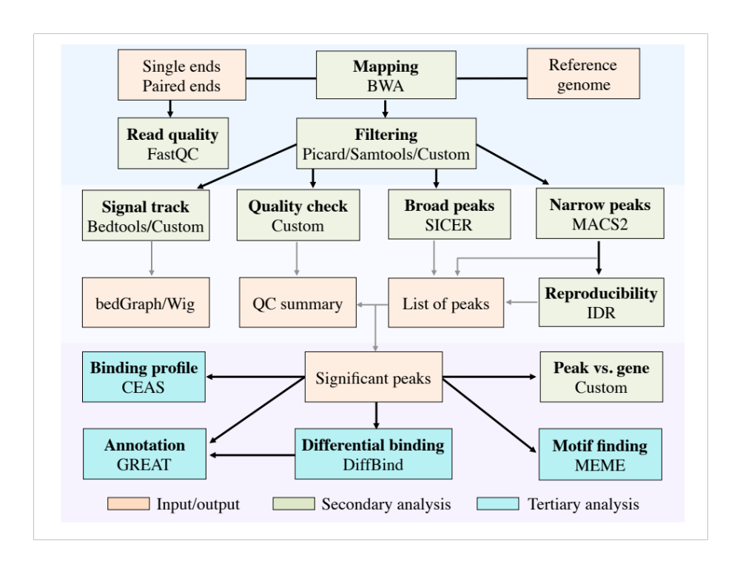

1. Output files from mapping, filtering and quality check

1.1). *.bam.size.txt file
Column 1 is the estimated fragment size, and column 2 is the corresponding number of mapped pairs. This file is available only for paired-end reads.

1.2). MainDocument.html – Mapping Summary Table
For paired-end reads, this table includes the number of pairs for the following cases:
- Both ends uniquely mapped
- One of the ends uniquely mapped
- Both ends mapped to multiple locations
- Both ends not mapped
- One of the ends not mapped
- Un-properly mapped pairs
- Total pairs

For single-end reads, this file includes:
- Number of uniquely mapped reads
- Number of multi-reads
- Number of unmapped reads
- Total reads

1.3). MainDocument.html – Library Complexity Table
This file summarizes library complexity, the optimal library complexity value should be ~ 0.8 at a sequencing depth of 10M uniquely mapped reads.
Column 1: file name
Column 2: the number of genomic positions with a single uniquely mapped read (or pair of reads for paired-ends)
Column 3: the number of genomic positions with one or more uniquely mapped reads (or pair of reads)
Column 4: total number of uniquely mapped reads (or pair of reads)
Column 5: the ratio of column 3 over column 4
Column 6: the ratio of column 2 over column 3

2. Output files from SICER peak finding
These output files are available only when SICER is used for peak calling

2.1). *-islands-summary file
This file contains the candidate peaks, from left to right are: chr, start, end, read count from peak region in IP, read count from the corresponding region in control, raw p value, fold change and FDR.

2.2). *-islands-summary_FDR* file
This file contains a subset of peaks from *-islands-summary file that meets the FDR cutoff.

3. Output files from MACS peak finding
These output files are available only when MACS is used for peak calling

3.1). *_macs2_peaks.encodePeak
This file contains a list of peaks, from left to right are: chr, start, end, peak ID, integer score for display, fold-change, -log₁₀pvalue, -log₁₀qvalue and peak summit position relative to peak start. If you want to extract top peaks with high confidence, you can sort this file based on the 8th column (-log₁₀pvalue) in descending order.

3.2). *_macs2_peaks.bed
This file contains basic information about peaks: chr, start, end, peak ID and -log₁₀pvalue. It contains columns 1-4 and 8 from the file in 3.1.
This file can be loaded directly to a genome browser for visualization.

3.3). *_macs2_summits.bed
This file contains the genomic position with the highest tag density (peak summit) for each peak. The 5th column is -log₁₀pvalue. This file can be loaded directly to a genome browser for visualization.

3.4). *_macs2_peaks.xls
This file contains a list of peaks, plus additional information about MACS parameters.

3.5). *_macs2_model.r
An R script that can be used to produce a PDF file showing the shift model, only available for single-end reads.

4. Output files from MACS peak finding and IDR analysis
These output files are available only when MACS is used for peak calling and IDR analysis is done to MACS peaks. Please see above for the format of MACS output files listed in 4.1 and 4.2.

4.1). MACS output files from each IP versus pooled input from biological replicates
*_r1pr0_macs2_peaks.encodePeak
*_r1pr0_macs2_peaks.bed
*_r1pr0_macs2_summits.bed
*_r1pr0_macs2_peaks.xls

4.2). MACS output files from pooled IP versus pooled input from biological replicates
*_r0pr0_macs2_peaks.encodePeak
*_r0pr0_macs2_peaks.bed
*_r0pr0_macs2_summits.bed
*_r0pr0_macs2_peaks.xls

4.3). Output files from IDR analysis
*-overlapped-peaks.txt
This file contains the full set of overlapping peaks.
Columns 2-5: chr, start, end, and -log₁₀pvalue of MACS peaks from replicate 1
Columns 6-9: chr, start, end, and -log₁₀pvalue of MACS peaks from replicate 2
Columns 10-11: local and global IDR values

*-uri.sav and *_idr-plot.pdf
This *-uri.sav file is used to generate *_idr-plot.pdf. The pdf file shows the number of consistent peaks at different idr cutoff

*_top*_macs2_peaks.encodePeak
These files contain the reliable peaks identified from pooled IP versus pooled input. They represent top peaks from file *_r0pr0_macs2_peaks.encodePeak (first sorted by the 8th column).

*_macs2_idr_peaks.encodePeak
This file contains the idr value for each peak in the 4th column. Otherwise, it is the same as file *_r1pr0_macs2_peaks.encodePeak. If you would like to get a list of reproducible peaks for further analysis, you can sort the file by the 4th column and extract a subset of peaks whose idr value is equal to or less than the cutoff you specify (default: 0.01).

*_idr_summary.txt
See the comment lines within this file for details

*_idr_combined.txt
See the comment lines within this file for details

5. Association of peaks with the nearby genes (*_peak_vs_gene.xls)
This file lists genes whose TSS or TTS are less than a pre-define distance (default: 10,000 bp) away from peaks.

6. Additional information
6.1). Files listed above are from a standard (secondary) analysis. Currently, tertiary analysis is not part of the standard analysis, therefore output files from tertiary analysis are not listed here.

6.2). Please visit the website at http://bsiweb.mayo.edu/chipseq for additional information about this pipeline.

6.3). Useful links
MACS paper: http://genomebiology.com/content/pdf/gb-2008-9-9-r137.pdf
MACS website: https://github.com/taoliu/MACS/
SICER paper: http://bioinformatics.oxfordjournals.org/content/25/15/1952.full.pdf
MACS website: http://home.gwu.edu/~wpeng/Software.htm
IDR paper: http://www.stat.berkeley.edu/tech-reports/790.pdf
IDR website: https://sites.google.com/site/anshulkundaje/projects/idr

