Lab 04
Simple Python Database Connections
Name: Saba Gull
Registration No: 2023-BSCS-074
Course Code: CS-649 (Cloud DevOps)
Section: A
GitHub Username: sabagu003-ui
Ubuntu Identity: sabagu003-ui@ubuntu

Repository Links
Databases fork: https://github.com/sabagu003-ui/Databases
Submission repository: https://github.com/sabagu003-ui/DevOps
Lab 4 directory: https://github.com/sabagu003-ui/DevOps/tree/main/Labs/Lab04

Task 1: Fork and Clone the Databases Repository
Step 1: Forked the instructor's Databases repository to my account, keeping the name Databases. The page shows sabagu003-ui/Databases and "forked from WaqasSaleem97/Databases".
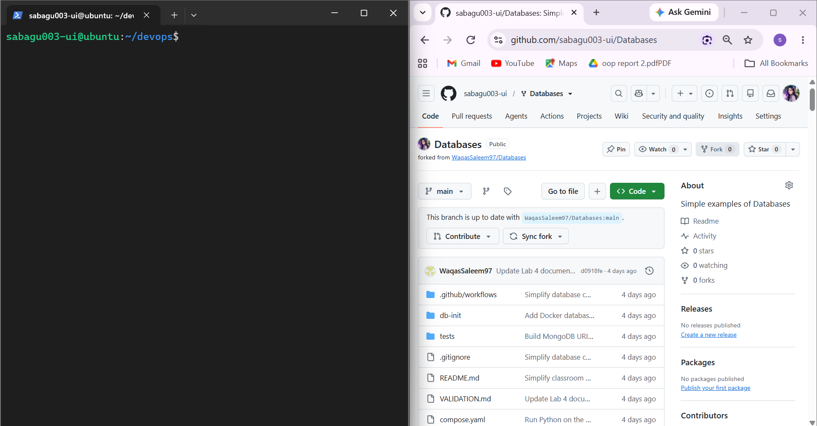
Figure 1.1 (databases_fork.png)
Step 2: Cloned my own fork over SSH into ~/Databases. The folder contains db_connect.py, compose.yaml, requirements.txt, credentials.ini.example and db-init.
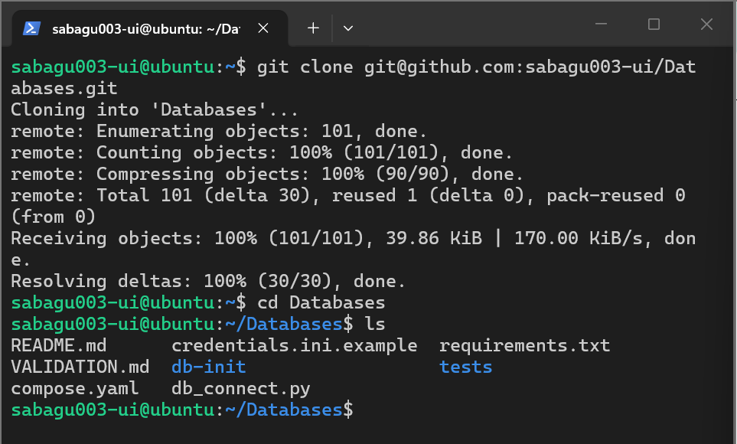
Figure 1.2 (databases_clone.png)

Task 2: Install Docker, Docker Compose, and Python on Ubuntu
Step 1: Installed docker.io and the Docker Compose plug-in, added my user to the docker group and reconnected. Git 2.53.0, Docker 29.1.3 and Docker Compose v5.6.1 are installed. Python 3, a virtual environment (.venv) and the packages from requirements.txt were installed for the lab.
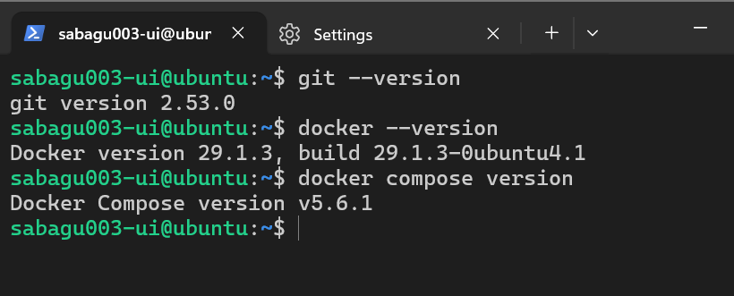
Figure 2.1 (docker_installation.png)

Task 3: Start the Database Services
Step 1: Started MySQL and three MongoDB databases (dev, test, prod) with docker compose up -d --wait. docker compose ps shows all four services healthy.
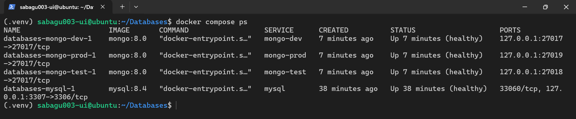
Figure 3.1 (database_services.png)
Step 2: docker compose port shows the host endpoints: MySQL 127.0.0.1:3307, MongoDB dev 127.0.0.1:27017, MongoDB test 127.0.0.1:27018 and MongoDB prod 127.0.0.1:27019.
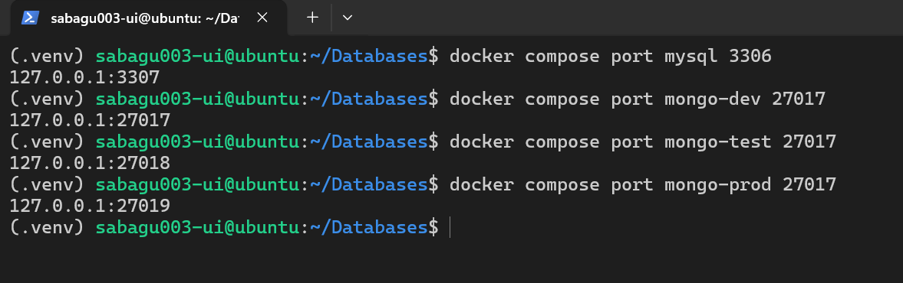
Figure 3.2 (database_ports.png)

Task 4: MySQL with Values in the Code
Step 1: db_connect.py connects to MySQL using the host, port, user, password and database written directly in the code. Result: Connected to MySQL: school_mysql, server 127.0.0.1 3307, Environment: dev.
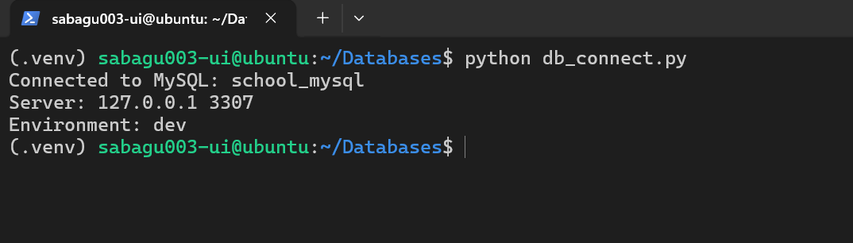
Figure 4.1 (mysql_hardcoded_connection.png)

Task 5: MongoDB with Values in the Code
Step 1: The same file now connects to MongoDB. The username, password, endpoint and database name are kept in separate variables and joined into the URI. database.command("ping") sends a real request. Result: school_dev, port 27017, Environment: dev.
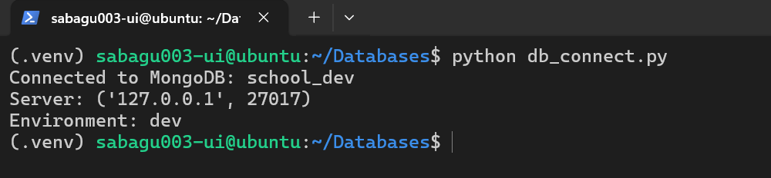
Figure 5.1 (mongo_hardcoded_connection.png)

Task 6: MongoDB with os.getenv()
Step 1: The four settings are read with os.getenv() from exported variables (MONGO_USERNAME, MONGO_PASSWORD, MONGO_ENDPOINT, MONGO_DATABASE). Dev values: school_dev, port 27017, Environment: dev.
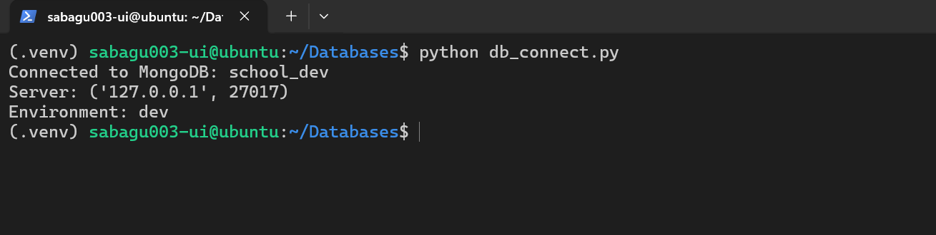
Figure 6.1 (mongo_env_dev.png)
Step 2: Only the exported values were changed to the test set; the program is unchanged. Result: school_test, port 27018, Environment: test.
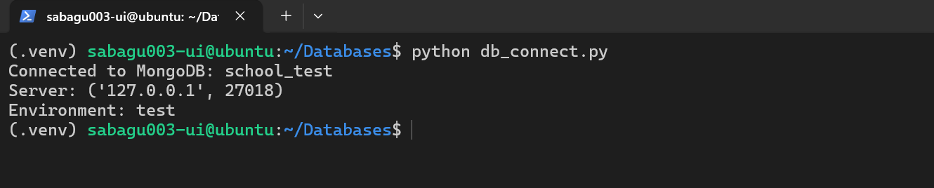
Figure 6.2 (mongo_env_test.png)
Step 3: Simulated prod values exported. Result: school_prod, port 27019, Environment: prod.
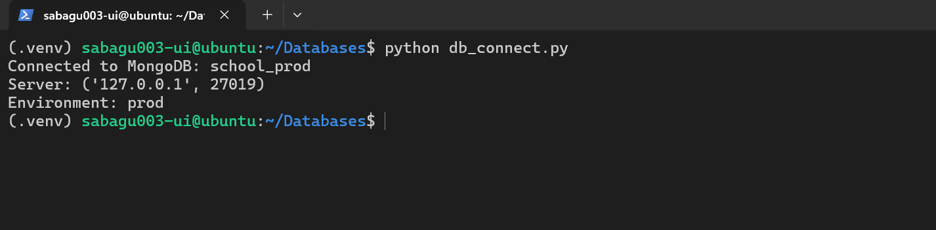
Figure 6.3 (mongo_env_prod.png)

Task 7: MongoDB with a Credentials File
Step 1: Created the local credentials.ini from credentials.ini.example (the file is ignored by Git).
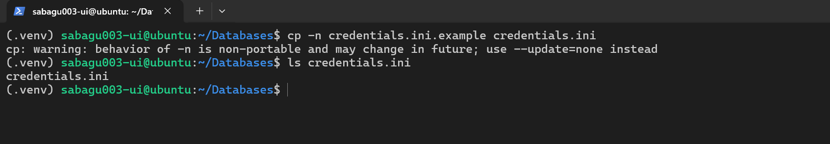
Figure 7.1 (credential_files_created.png)
Step 2: Restricted the file to my account with chmod 600. stat shows 600 credentials.ini.
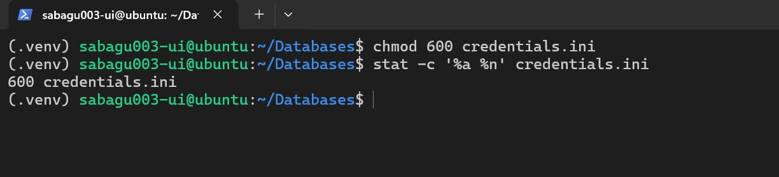
Figure 7.2 (credential_file_permissions.png)
Step 3: configparser reads the [dev] section (APP_ENV=dev). Result: school_dev, port 27017, Environment: dev.
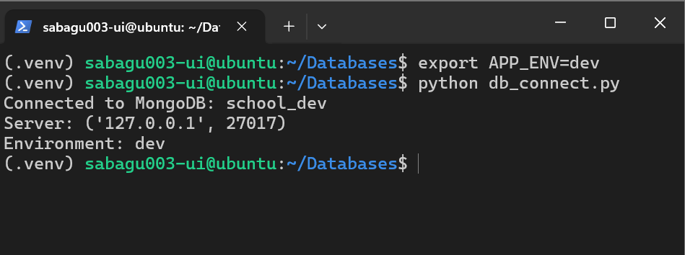
Figure 7.3 (mongo_file_dev.png)
Step 4: APP_ENV=test selects the [test] section. Result: school_test, port 27018, Environment: test.
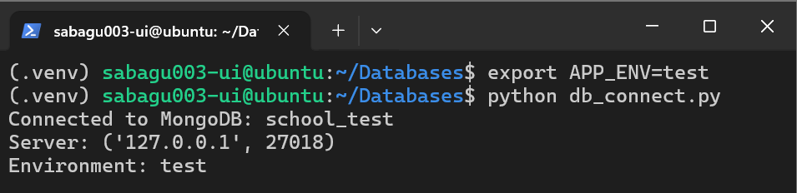
Figure 7.4 (mongo_file_test.png)
Step 5: APP_ENV=prod selects the [prod] section. Result: school_prod, port 27019, Environment: prod.
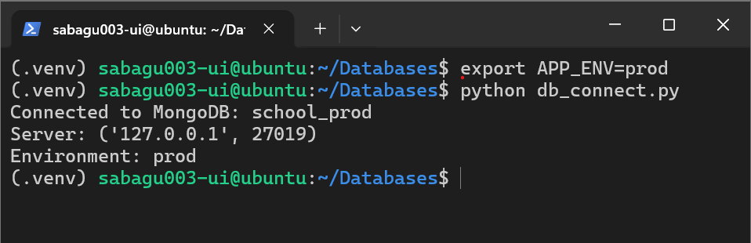
Figure 7.5 (mongo_file_prod.png)

Exam Evaluation Questions :
1. A Missing Environment Variable
When MONGO_DATABASE is unset, os.getenv("MONGO_DATABASE") returns None, so database_name is empty. The condition "not username or not password or not endpoint or not database_name" becomes true because of that one missing value, so the program stops with the message "Set all four MongoDB environment variables first." before it builds the URI or connects. After export MONGO_DATABASE=school_prod is restored, all four values exist and the program connects again.
2. Which Source Does the File Version Read?
The credentials-file version does not read MONGO_USERNAME, MONGO_PASSWORD, MONGO_ENDPOINT or MONGO_DATABASE at all. It reads only APP_ENV to choose a section of credentials.ini. When APP_ENV is unset, os.getenv("APP_ENV", "dev") returns its default value "dev", so the [dev] section is used and the program connects to dev even though the shell still holds the prod settings. Setting APP_ENV=test selects the [test] section.
3. A Wrong Password in the File
The endpoint and database name only decide which server and database the program talks to. The username and password are checked by that server against its stored user. If the password in the selected section is wrong, MongoDB rejects the login with an authentication error even though the endpoint is correct. Restoring the supplied dummy password makes the connection succeed again.
______________________________

