
Lab 01
GitHub Identity, Student Portal Registration, and Ubuntu Server Installation

Name: Saba Gull
Registration No: 2023-BSCS-074
Course Code: CS-649 (Cloud DevOps)
Section: A
GitHub Username: sabagu003-ui



Task 1: Create and Configure Your GitHub Account
Step 1: Created my GitHub account with the username sabagu003-ui and opened my profile page.

Figure 1.1: GitHub profile showing my profile name and GitHub username.
Step 2: Opened GitHub > Settings > Public profile and entered my name in the Name field.
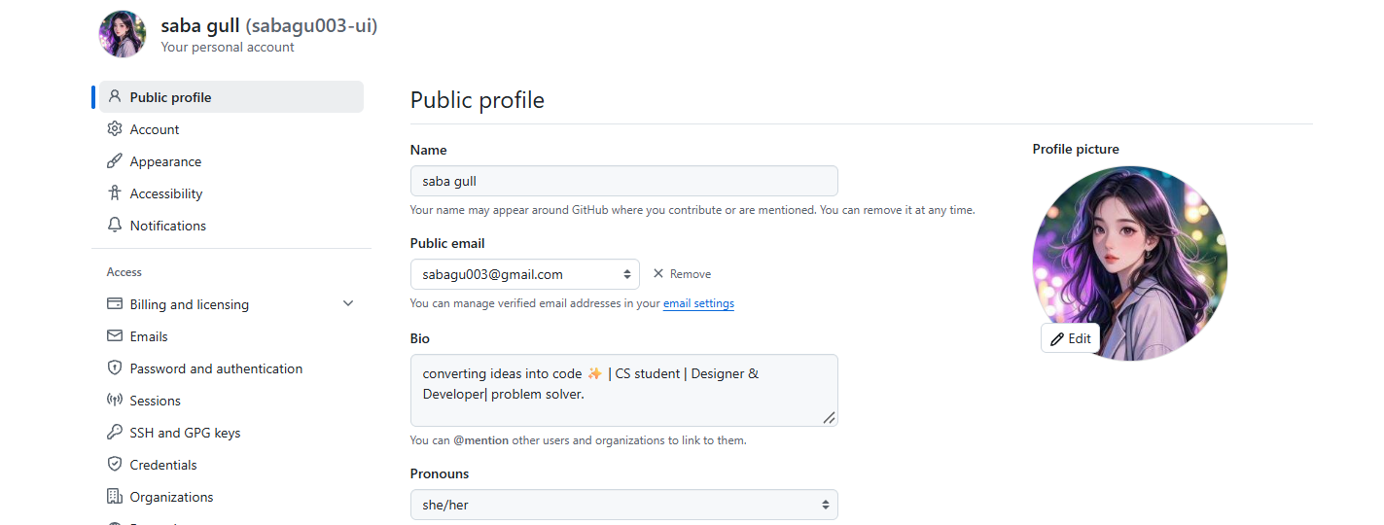
Figure 1.2: GitHub Public profile settings showing my name in the Name field.

Task 2: Register in the Student Marks Portal
Step 1: Opened the Student Marks Portal login page.
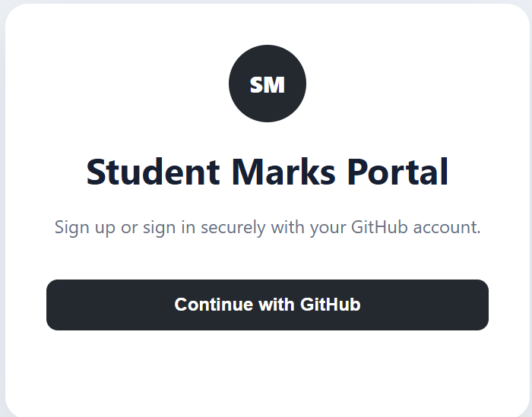
Figure 2.1: Student Marks Portal login page with the Continue with GitHub button.
Step 2: Selected Continue with GitHub and authorized the portal with my GitHub account.
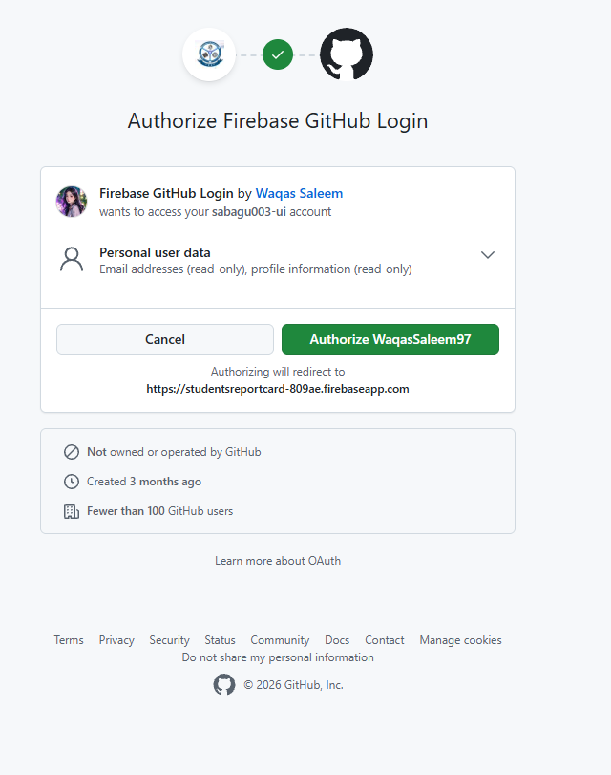
Figure 2.2: GitHub authorization screen for the Student Marks Portal.
Step 3: Entered my registration number, selected the course and section, and submitted the enrollment.
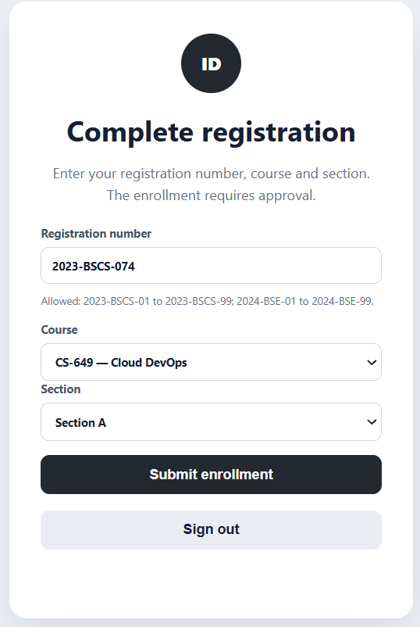
Figure 2.3: Complete registration form with registration number, course CS-649 and Section A.
Step 4: Checked the portal after submission to confirm my profile and enrollment status.
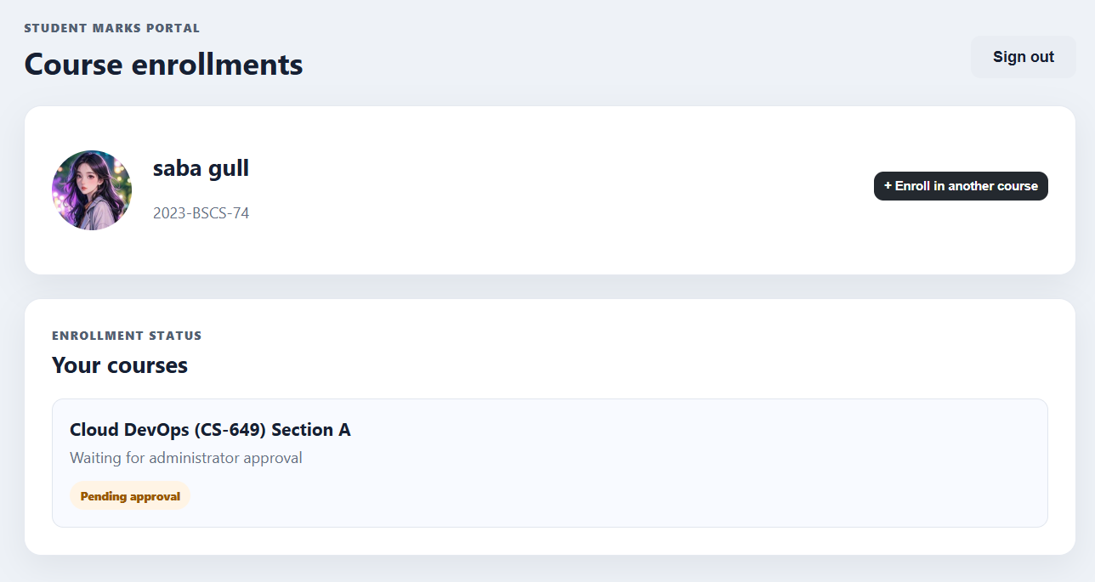
Figure 2.4: My GitHub profile information and the pending enrollment in the portal.

Task 3: Download VMware Workstation Pro and Ubuntu Server
Step 1: Downloaded and installed VMware Workstation Pro on my Windows computer.
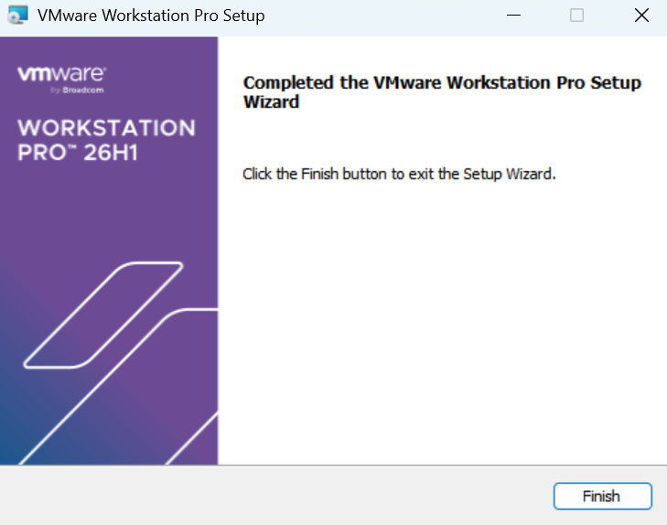
Figure 3.1: VMware Workstation Pro setup completed successfully.
Step 2: Downloaded the latest Ubuntu Server LTS ISO from the Ubuntu website.
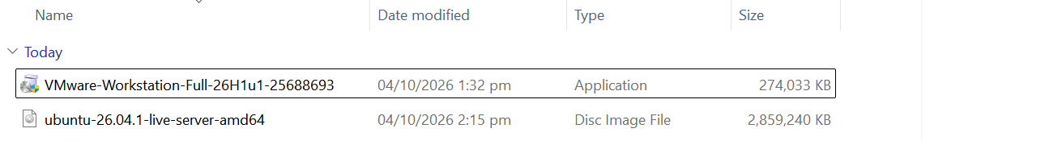
Figure 3.2: Downloads folder showing the Ubuntu Server ISO file and the VMware installer.
Step 3: Checked that Drive C: has more than 20 GB of free storage.
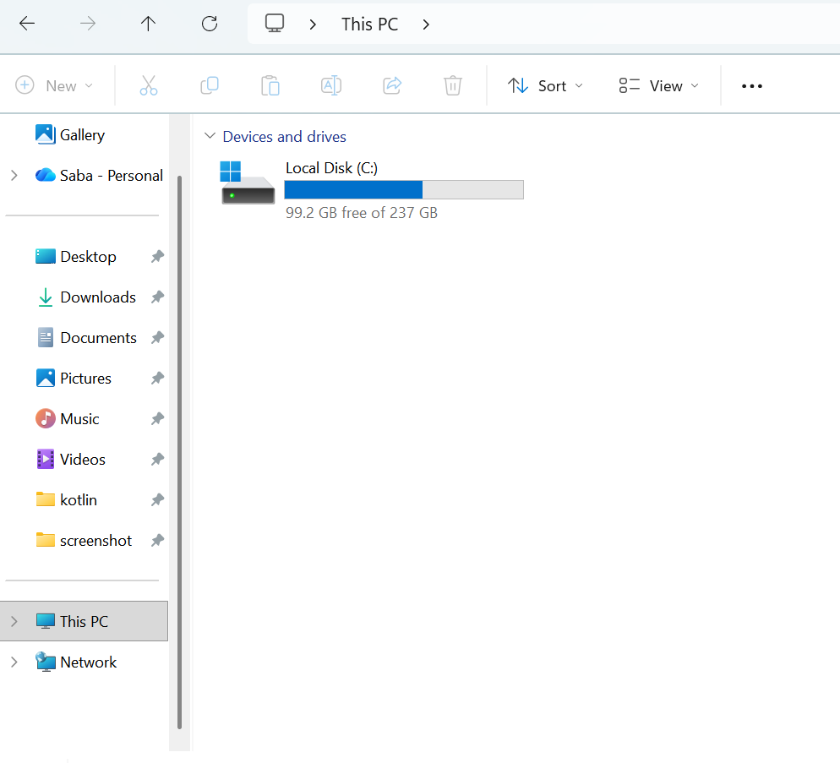
Figure 3.3: This PC showing 99.2 GB free on Local Disk (C:).

Task 4: Create the Ubuntu Server Virtual Machine
Step 1: Opened VMware Workstation Pro and selected Create a New Virtual Machine.
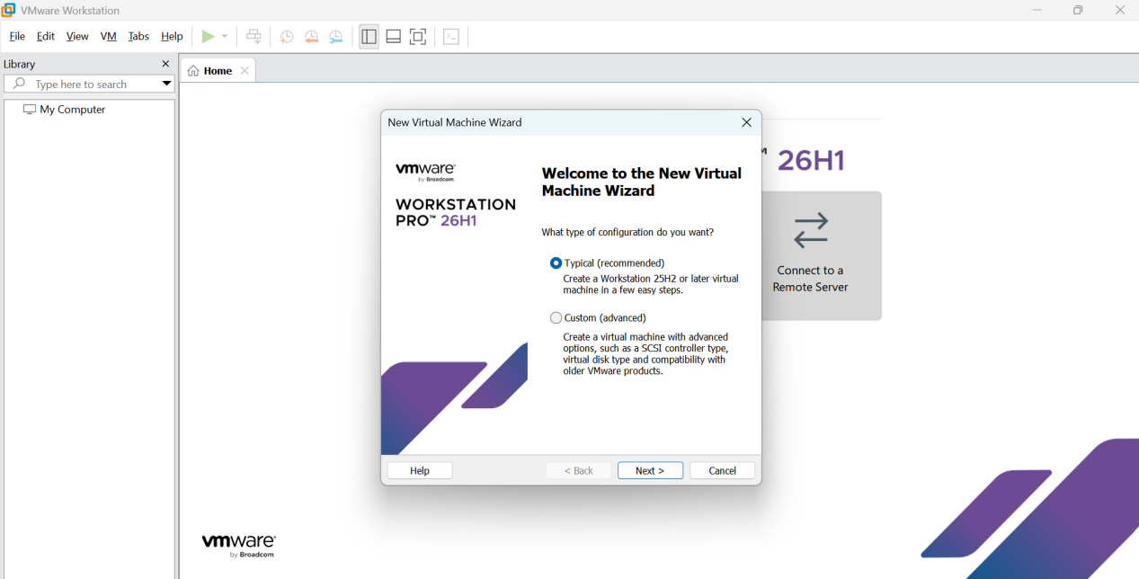
Figure 4.1: New Virtual Machine Wizard opened in VMware Workstation Pro.
Step 2: Selected the Typical (recommended) configuration.
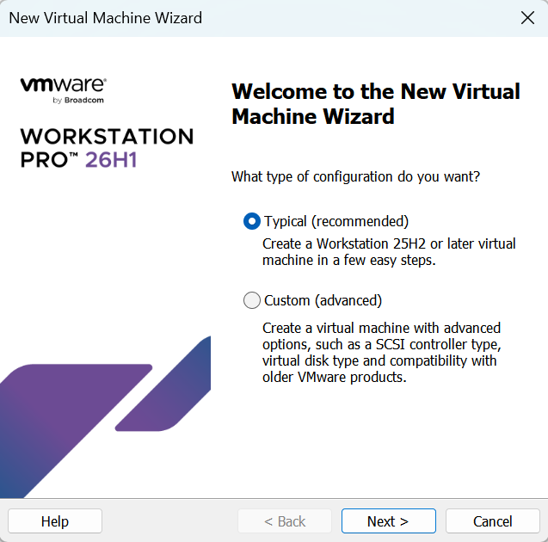
Figure 4.2: Typical (recommended) configuration selected.
Step 3: Selected Installer disc image file (ISO) and browsed to the Ubuntu Server ISO.
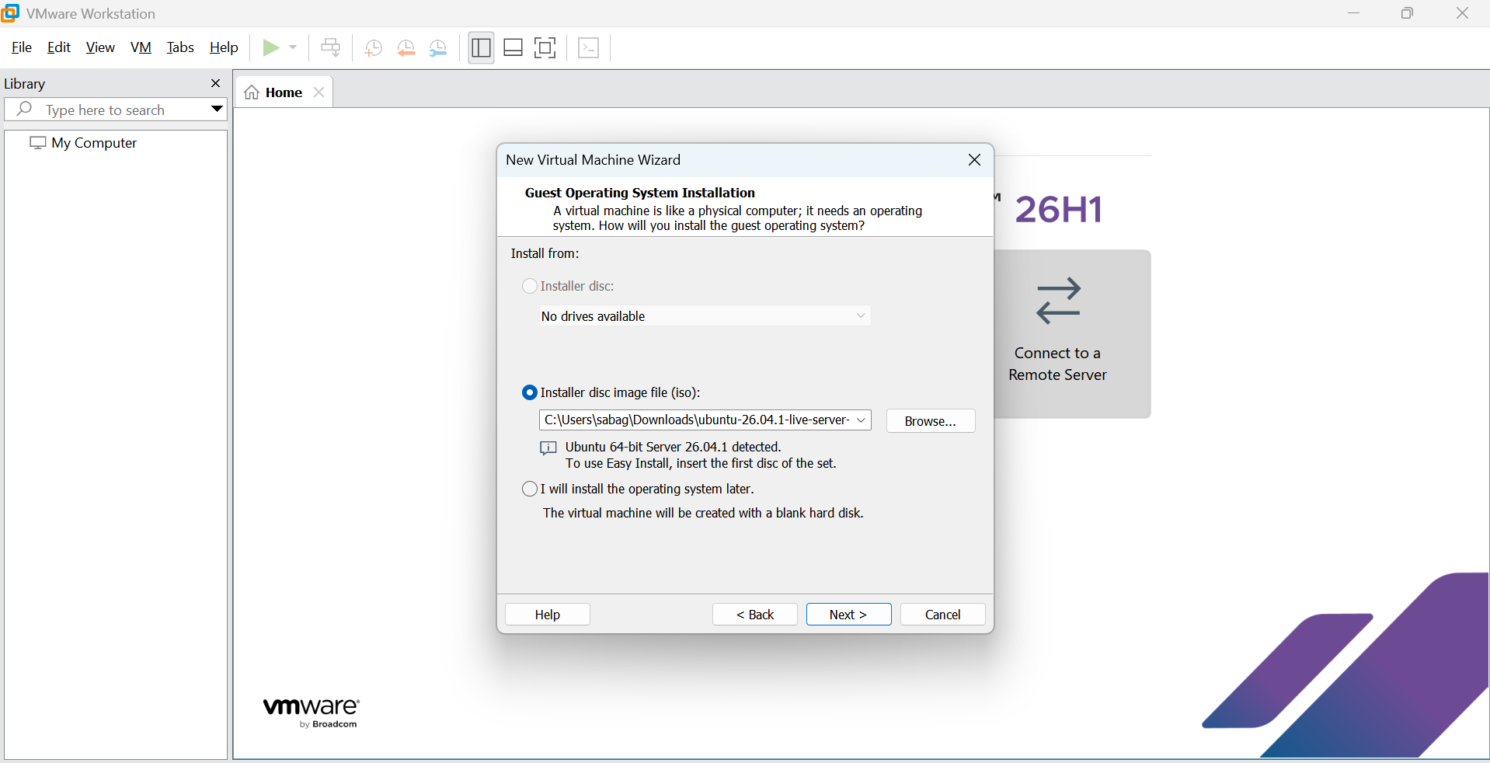
Figure 4.3: Ubuntu Server ISO selected and detected by the wizard.
Step 4: Allocated 25 GB of virtual disk space and stored it as a single file.
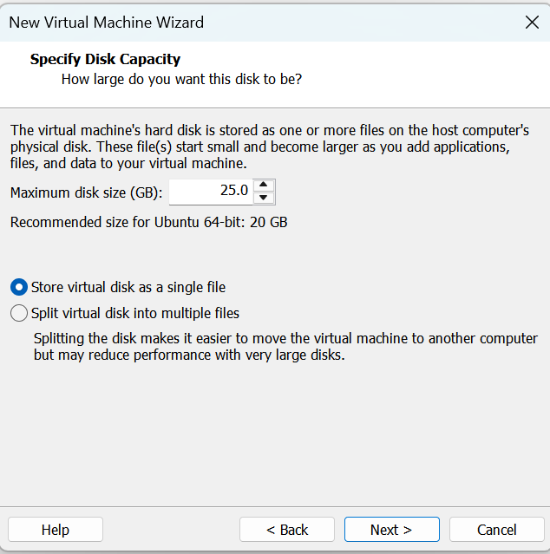
Figure 4.4: Maximum disk size set to 25 GB.

Task 5: Choose the Installation Language
Step 1: Used the arrow keys to select English as the installation language.
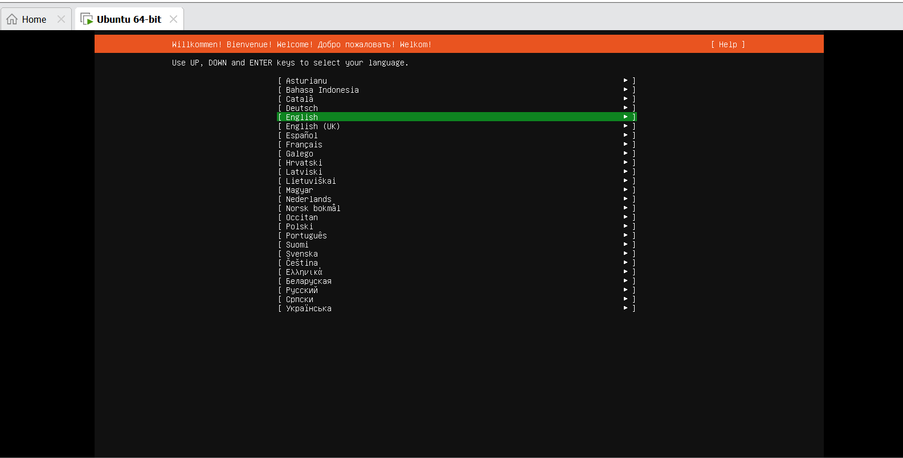
Figure 5.1: English selected on the language screen.

Task 6: Configure the Keyboard Layout
Step 1: Selected the English (US) keyboard layout and variant, then continued with Done.
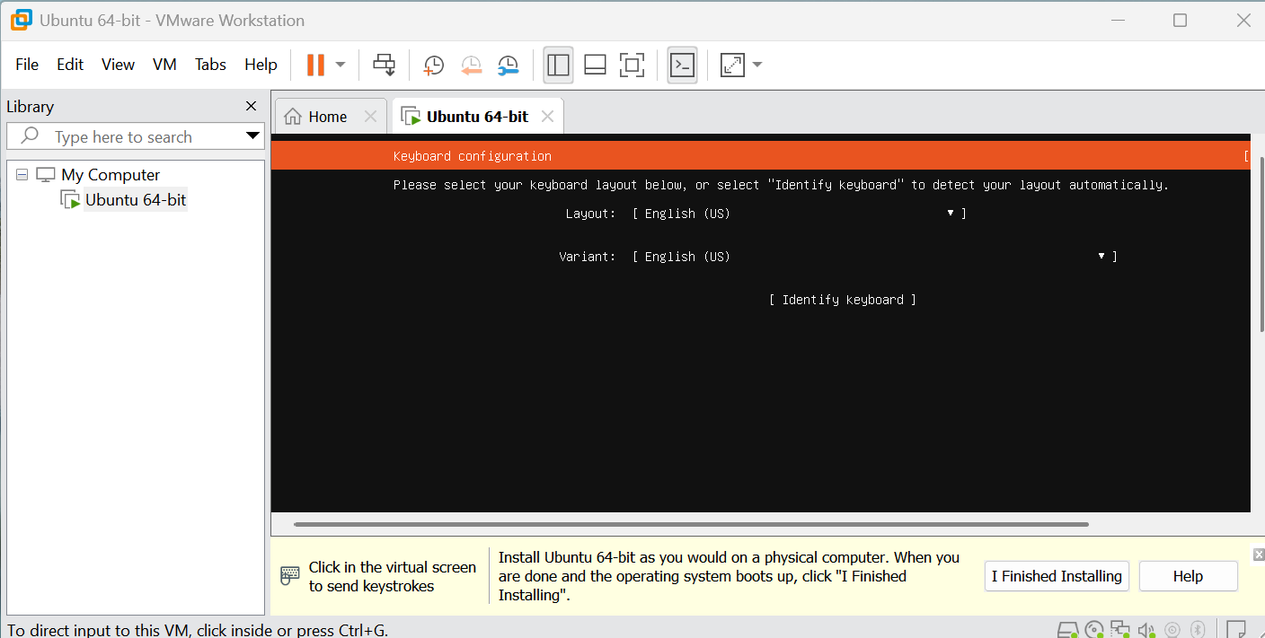
Figure 6.1: Keyboard layout and variant both set to English (US).

Task 7: Choose the Ubuntu Server Installation Type
Selected the normal Ubuntu Server installation option (not MAAS) and continued.

Task 8: Configure the Network
Step 1: Reviewed the detected network interface and confirmed it received an address through DHCP.
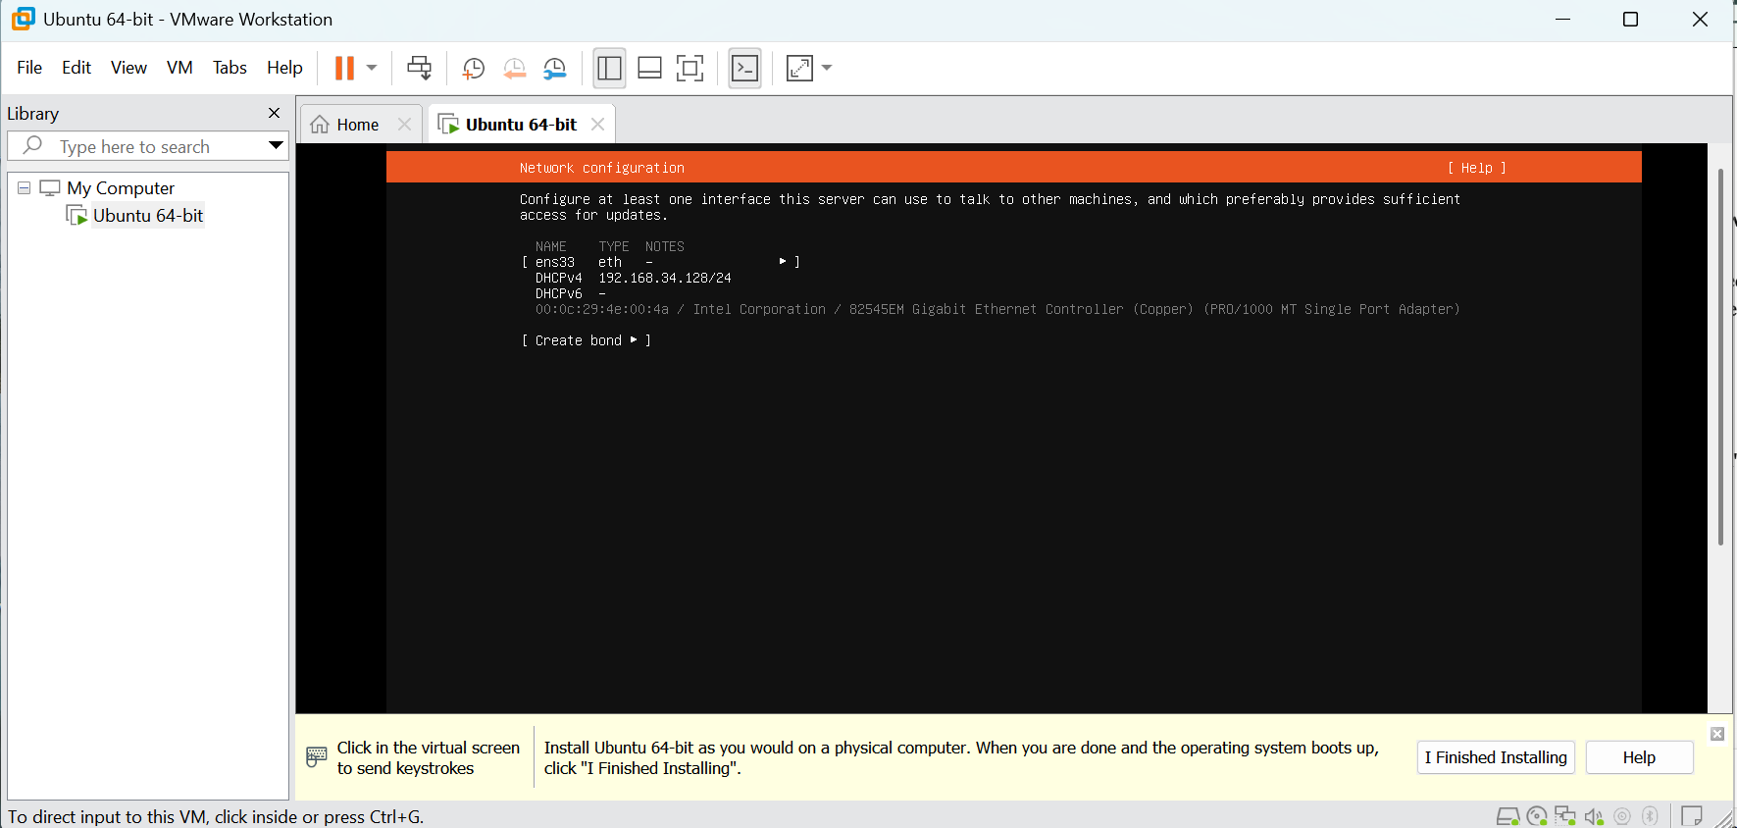
Figure 8.1: Network interface ens33 with an IPv4 address assigned by DHCP.
Step 2: Left the proxy address empty and continued.
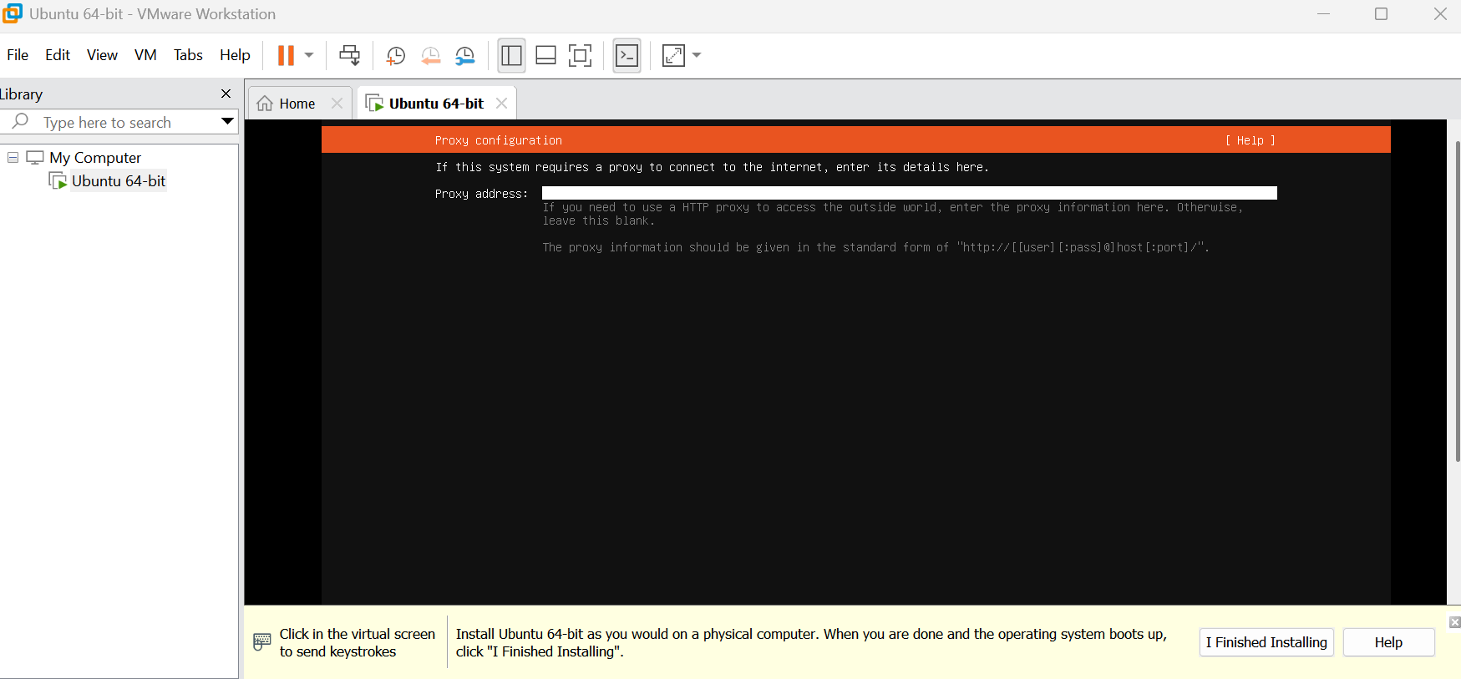
Figure 8.2: Proxy configuration screen left empty.
Step 3: Accepted the default Ubuntu archive mirror after it passed the tests.
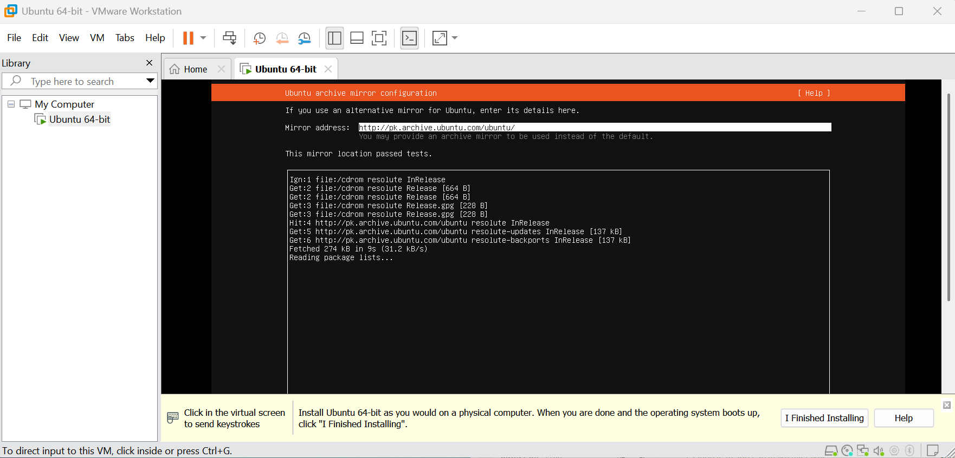
Figure 8.3: Ubuntu archive mirror configuration passed tests.

Task 9: Configure Storage
Step 1: Selected the guided storage option Use an entire disk on the VMware virtual disk.
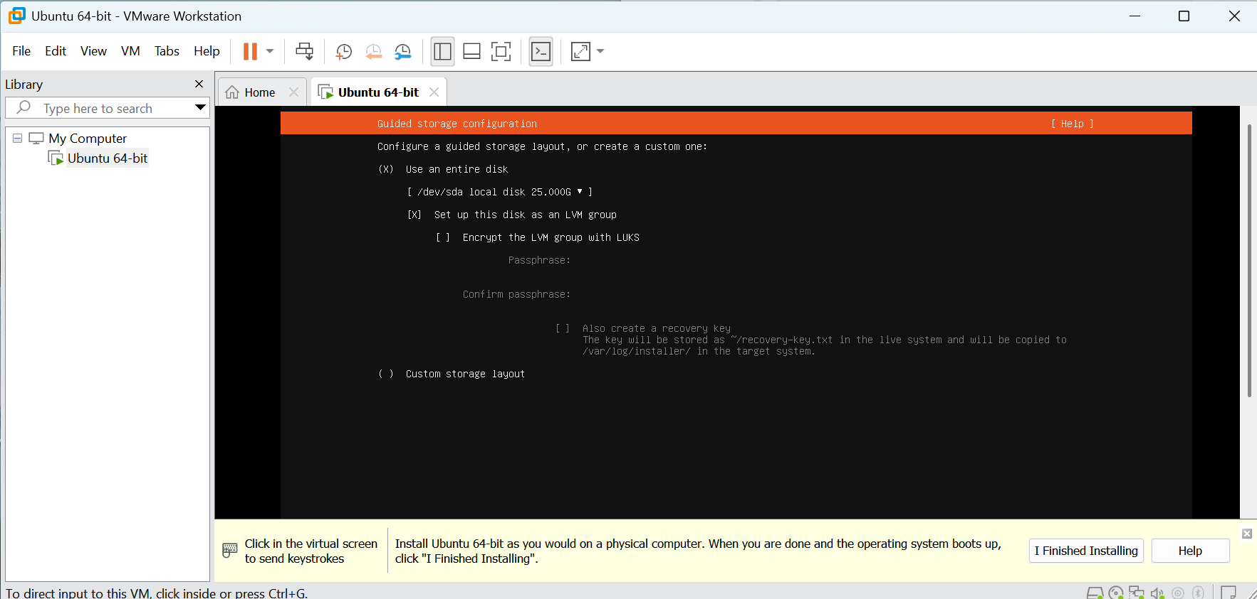
Figure 9.1: Guided storage configuration with Use an entire disk selected.

Task 10: Select the Installation Disk
Step 1: Confirmed the selected disk is the 25 GB VMware virtual disk (/dev/sda).
Figure 10.1: Selected disk /dev/sda local disk 25.000G.

Task 11: Review the Partitions
Step 1: Reviewed the proposed partition layout on the VMware virtual disk.
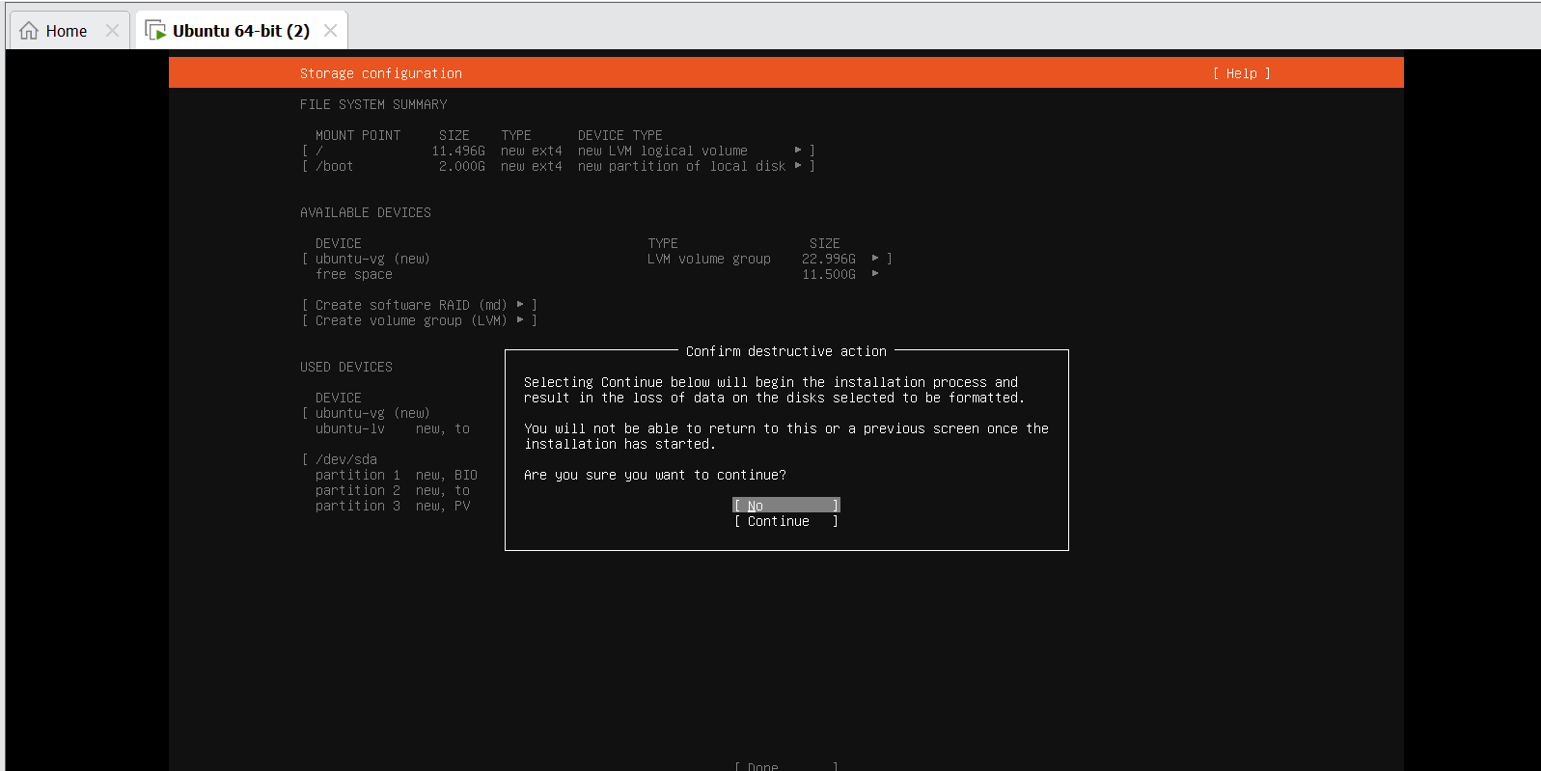
Figure 11.1: Proposed partitions and file system summary on the virtual disk.

Task 12: Confirm the Storage Changes
Step 1: Read the destructive-action warning and selected Continue after confirming the VMware virtual disk.
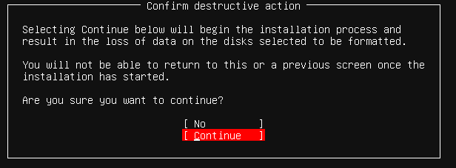
Figure 12.1: Confirm destructive action warning with Continue selected.

Task 13: Configure the Ubuntu Profile
Step 1: Filled in my name, the server name ubuntu, my username and a password on the profile screen.
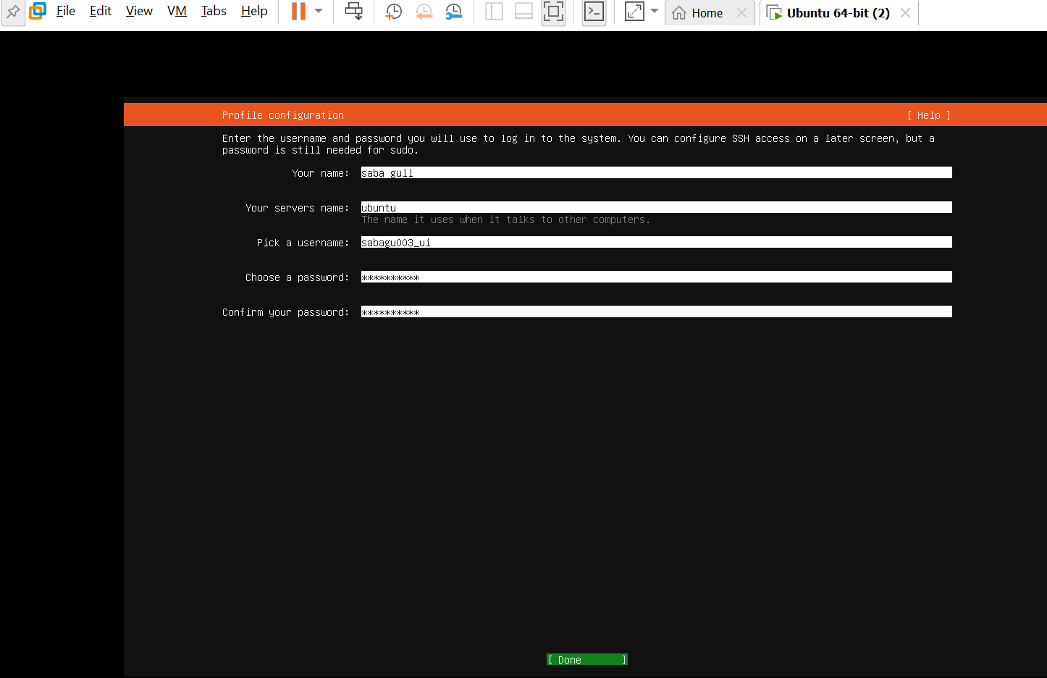
Figure 13.1: Completed Ubuntu profile configuration (password hidden).

Task 14: Complete the Software Installation
Step 1: Waited while Ubuntu Server installed the required software.
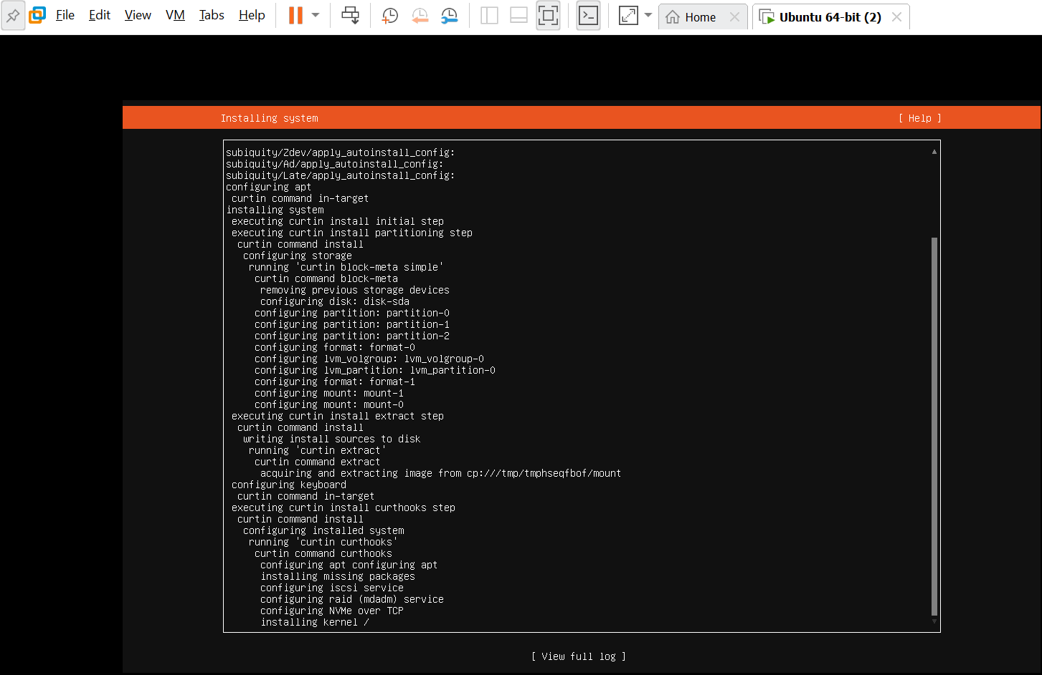
Figure 14.1: Ubuntu Server installation in progress.

Task 15: Reboot and Verify the Ubuntu Identity
Step 1: Waited for the installer to finish and selected Reboot Now.
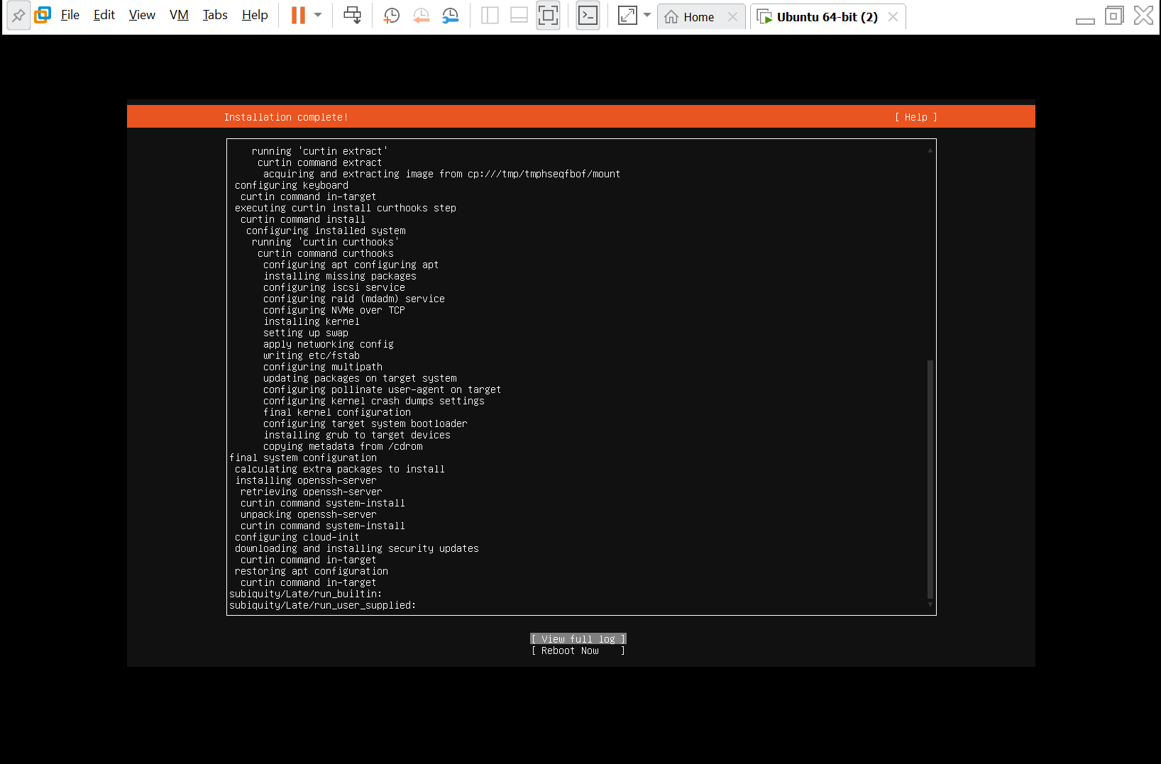
Figure 15.1: Installation complete screen with Reboot Now option.
Step 2: Rebooted, signed in with my Ubuntu username and password.
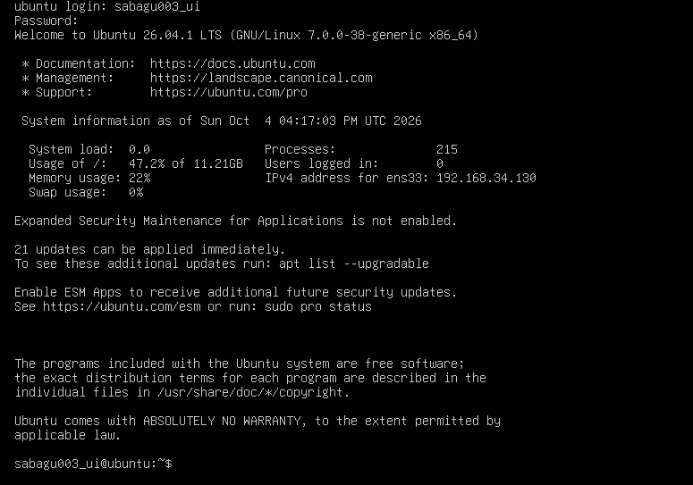
Figure 15.2: Successful terminal login after the reboot.
Step 3: Verified the terminal prompt follows the required format.
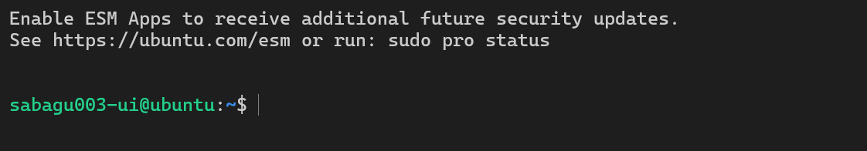
Figure 15.3: Terminal prompt showing sabagu003-ui@ubuntu:~$.

Task 16: Find the Ubuntu Server IP Address
Step 1: Ran the ip addr command and found the IPv4 address of the active interface ens33.
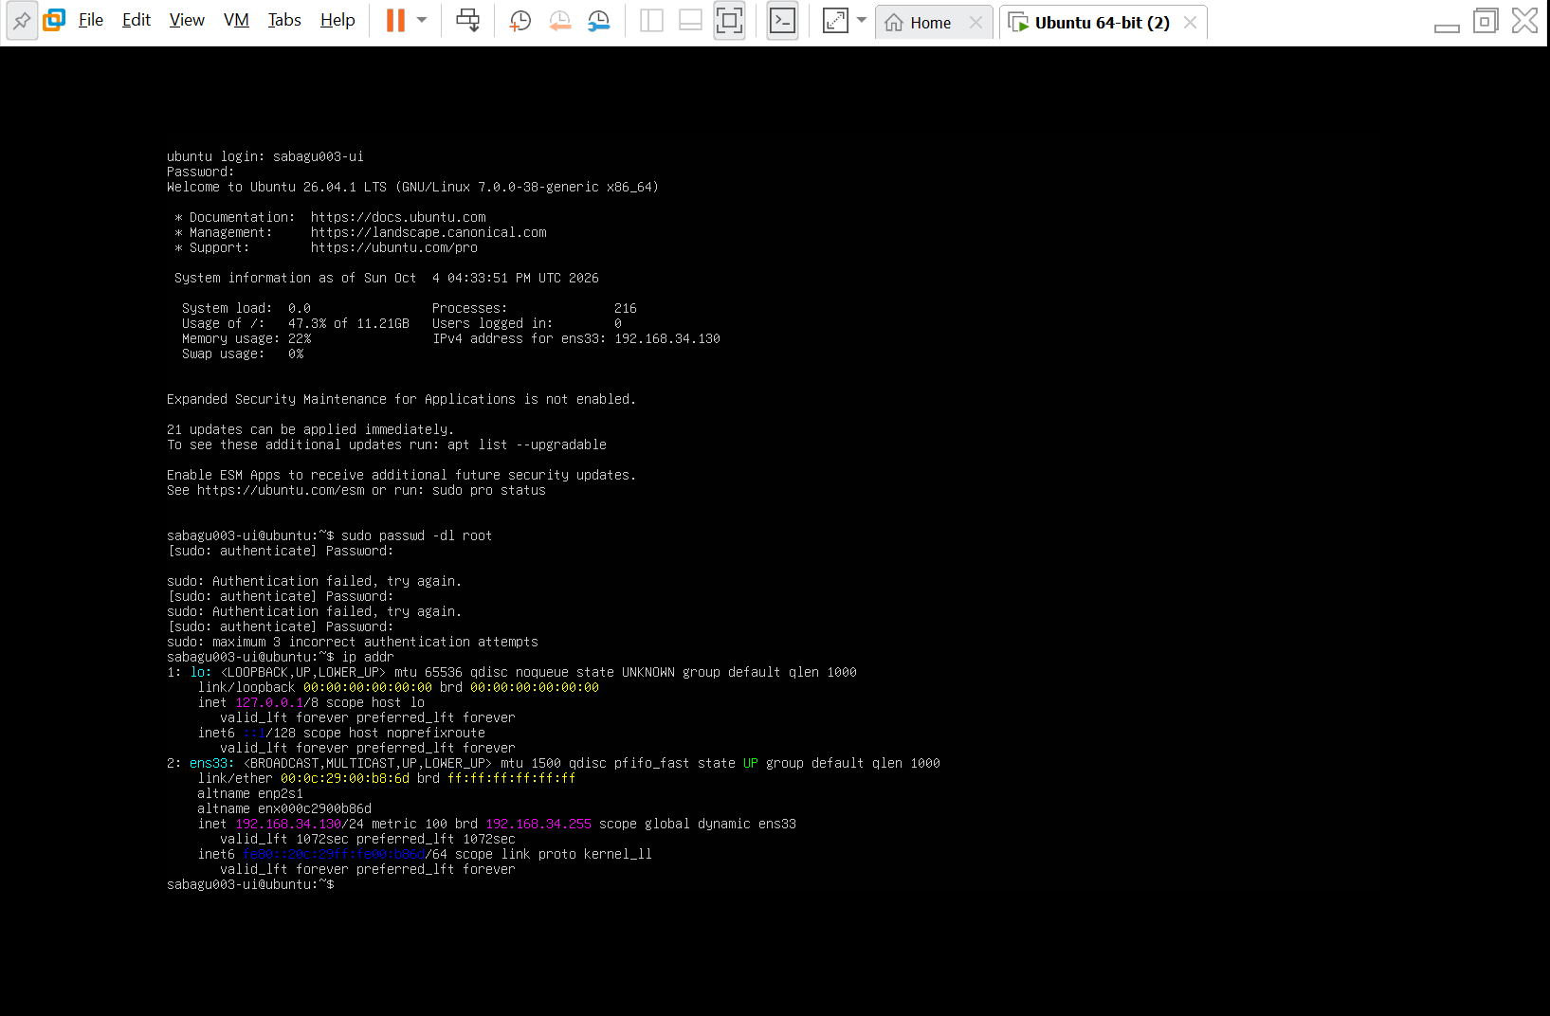
Figure 16.1: ip addr output showing the IPv4 address 192.168.34.130 for ens33.

Task 17: Connect to Ubuntu Server from Windows
Step 1: Ran ssh sabagu003-ui@192.168.34.130 in PowerShell and typed yes to accept the fingerprint.
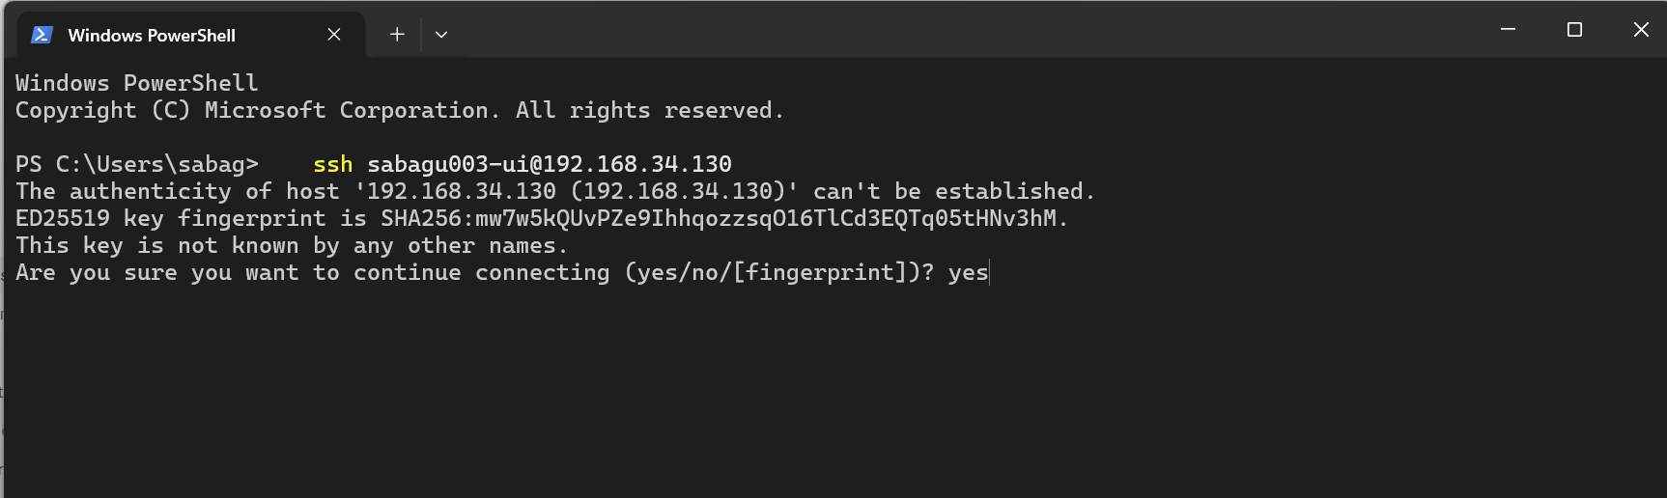
Figure 17.1: SSH command and server fingerprint accepted in PowerShell.
Step 2: Entered the Ubuntu password and logged in to the server remotely.
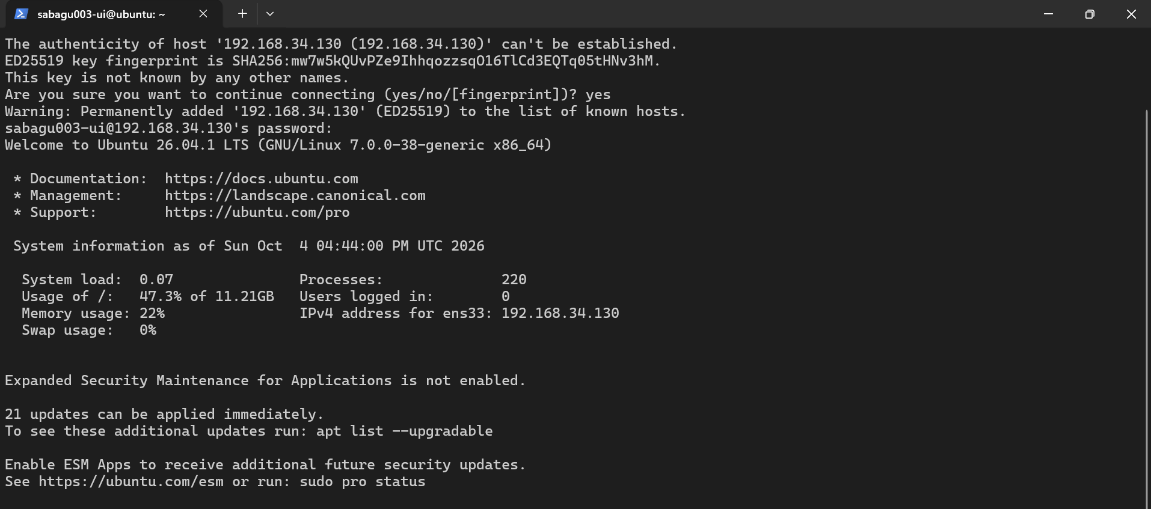
Figure 17.2: Successful SSH session on the Ubuntu Server.

________________________________

