

SCHOOL OF QUANTITATIVE SCIENCES (SQS)

SEMESTER 1 SESSION 2019/2020 (A191)

**SQIT1013**

**PROGRAMMING IN BUSINESS APPLICATIONS**

**GROUP PROJECT:**

**DATABASE**

|  |  |  |
| --- | --- | --- |
| **NO.** | **NAME** | **MATRIC NUMBER** |
| 1. | MUHAMMAD BIN ABD HADI | 273554 |
| 2. | AMIRUL HAKIMI BIN ZAHARI | 273057 |
| 3. | AIMAN HAKIMI BIN SAMSUDIN | 272903 |
| 4. | DHIINESH A/L RAVINDRAN | 272918 |

DATE OF SUBMISSION:

30 DECEMBER 2019

SUBMIT TO:

DR. MOHD FAIZAL BIN OMAR

**INTRODUCTION**

What is vehicle? Vehicle is a thing used for transporting people or goods, especially on land, such as a car, lorry, taxi, motorcycle, bus and others. In this fast-paced world, managing your personal and professional lives can be really hectic. If you don’t have your own personal mode of transportation, life can become even more hectic. To make your life easier, you should always find an easier and reliable mode of transportation. One of the main reasons why vehicle like cars have become more prevalent and important is because it is an easy mode of transportation. Getting from point A to B has never been more convenient and easier than before.

Based on collection of data for the “Total motor vehicle by type and state in 2016”so we can conclude that motorcycle recorded the highest use is at Johor (1,786,021) and the lowest use is Perlis (78,263). Next for motorcar is W.P Kuala Lumpur recorded the highest use which is (3,720,213) and for the lowest use is also Perlis which is (26,868). For bus, W.P Kuala Lumpur still recorded the highest use which is (19,002) and the lowest is Perlis which is (176). Next for taxi, W.P Kuala Lumpur recorded the highest use which is (55,371) and the lowest use is Perlis which is (126). Next, hire & drive car also W.P Kuala Lumpur recorded the highest use which is (46,331) and Perlis also recorded the lowest use which is (79). For goods vehicle, W.P Kuala Lumpur recorded the highest use which is (268,007) and Perlis recorded the lowest use which is (1,998). Lastly is others, W.P Kuala Lumpur recorded the highest use which is (238,654) and Perlis recorded the lowest use which is (2,281). So based on the summary of the data collection, we can see that W.P Kuala Lumpur dominate all vehicle use because the state is the capital of Malaysia and has a large population while Perlis recorded the lowest of all the data because s the smallest state in Malaysia so the use of the vehicle is not excessive than W.P Kuala Lumpur.

**PROBLEM STATEMENT**

Before we proceed to the next level on this project, firstly we observe the raw data given and we have found a few problems in analysing that data which is;

i. Have problem in converting data from Microsoft Excel to Microsoft Access.

ii. Have problem in importing our database to Microsoft Visual Studio.

iii. Have problem in coding the button.

**OBJECTIVE**

For this project, we set the objectives based on the problem statement that had given earlier, which is;

i. Identify the coding for the button in order to make a collection of data for the total motor vehicles by type and state in 2016. This is including the button of “edit”, “save”, “delete”, “close”, “previous”, “next”,”continue” .

ii. Identify the coding for the button to delete the unwanted data for any vehicles in the collection of data. This is including the “delete” button where we can delete the data from the collection of data.

iii. Identify the coding for the button in order to save new data if there any changing data. This includes the button of “save” where it can save after we edit it.

iv. Visualizing the graph of the motor vehicles by type that have been inserted into the data collection. This can be done by clicking the button of “Load Graph” where graph will be displayed.

**CONTRIBUTION OF THE PROJECT**

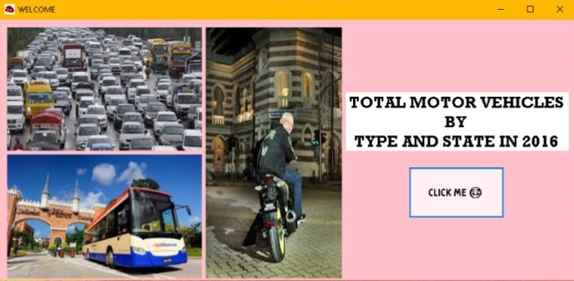

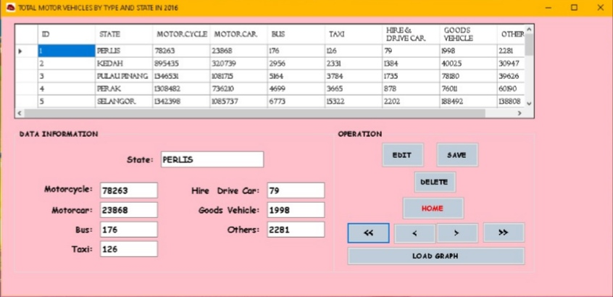

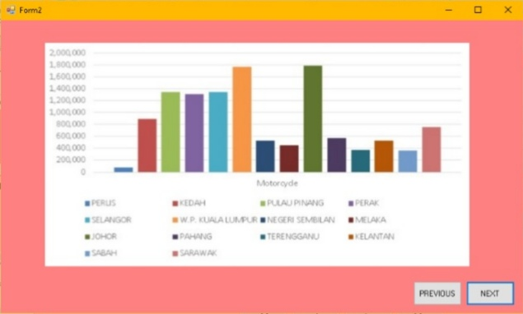

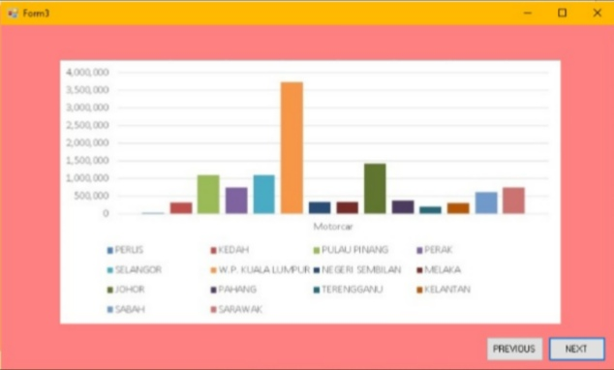

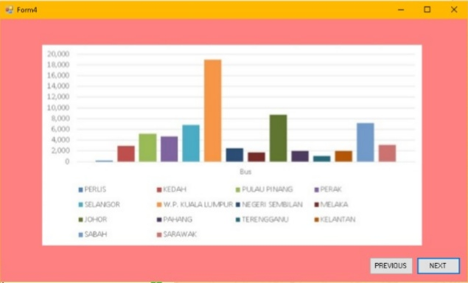

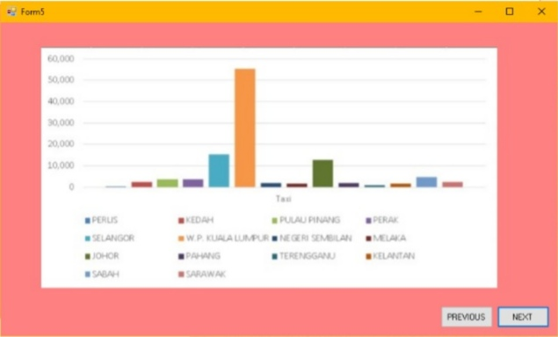

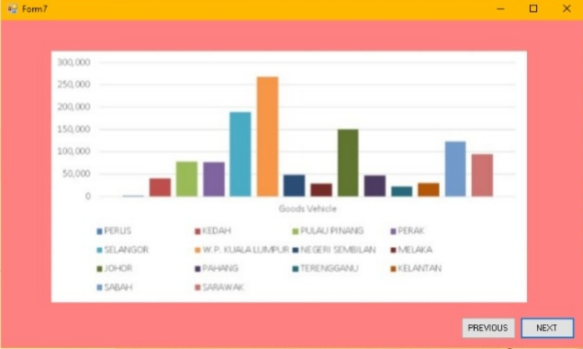

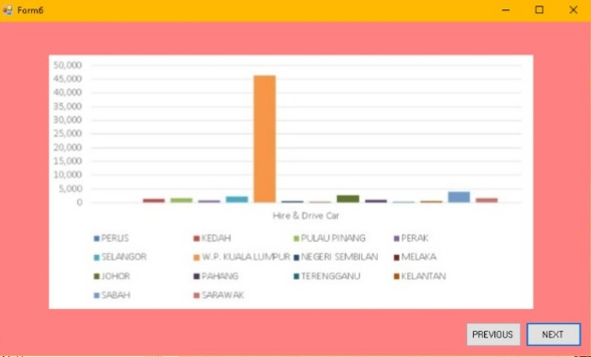

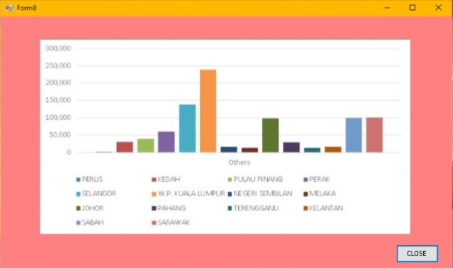

**IMPLEMENTATION**

**CODE**

Public Class Form9

Private Sub Button1_Click(sender As Object, e As EventArgs) Handles Button1.Click

Form1.Show()

End Sub

End Class

Public Class Form1

Private Sub Form1_Load(sender As Object, e As EventArgs) Handles MyBase.Load

'TODO: This line of code loads data into the 'Database_2_hmDataSet.Sheet1' table. You can move, or remove it, as needed.

Me.Sheet1TableAdapter.Fill(Me.Database_2_hmDataSet.Sheet1)

End Sub

Private Sub btnFirst_Click(sender As Object, e As EventArgs) Handles btnFirst.Click

Sheet1BindingSource.MoveFirst()

End Sub

Private Sub btnPrevious_Click(sender As Object, e As EventArgs) Handles btnPrevious.Click

Sheet1BindingSource.MovePrevious()

End Sub

Private Sub btnNext_Click(sender As Object, e As EventArgs) Handles btnNext.Click

Sheet1BindingSource.MoveNext()

End Sub

Private Sub btnLast_Click(sender As Object, e As EventArgs) Handles btnLast.Click

Sheet1BindingSource.MoveLast()

End Sub

Private Sub btnEdit_Click(sender As Object, e As EventArgs) Handles btnEdit.Click

Sheet1BindingSource.EndEdit()

End Sub

Private Sub btnSave_Click(sender As Object, e As EventArgs) Handles btnSave.Click

Try

Sheet1BindingSource.EndEdit()

TableAdapterManager.UpdateAll(Database_2_hmDataSet)

MessageBox.Show("Data have been recorded")

Catch ex As Exception

MessageBox.Show("An error occured! Please try again.")

End Try

End Sub

Private Sub btnDelete_Click(sender As Object, e As EventArgs) Handles btnDelete.Click

Sheet1BindingSource.RemoveCurrent()

End Sub

Private Sub btnClose_Click(sender As Object, e As EventArgs) Handles btnClose.Click

If MsgBox("Are you sure?", vbOKCancel, ".:: Data Information ::.") = vbOK Then

Me.Close()

Else

End If

End Sub

Private Sub btnContinue_Click(sender As Object, e As EventArgs) Handles

btnContinue.Click

Form2.Show()

End Sub

End Class

Public Class Form2

Private Sub Button1_Click(sender As Object, e As EventArgs) Handles Button1.Click

Form3.Show()

End Sub

Private Sub Button2_Click(sender As Object, e As EventArgs) Handles Button2.Click

Me.Close()

End Sub

End Class

Public Class Form3

Private Sub Button1_Click(sender As Object, e As EventArgs) Handles Button1.Click

Form4.Show()

End Sub

Private Sub Button2_Click(sender As Object, e As EventArgs) Handles Button2.Click

Me.Close()

End Sub

End Class

Public Class Form4

Private Sub Button1_Click(sender As Object, e As EventArgs) Handles Button1.Click

Form5.Show()

End Sub

Private Sub Button2_Click(sender As Object, e As EventArgs) Handles Button2.Click

Me.Close()

End Sub

End Class

Public Class Form5

Private Sub Button1_Click(sender As Object, e As EventArgs) Handles Button1.Click

Form6.Show()

End Sub

Private Sub Button2_Click(sender As Object, e As EventArgs) Handles Button2.Click

Me.Close()

End Sub

End Class

Public Class Form6

Private Sub Button1_Click(sender As Object, e As EventArgs) Handles Button1.Click

Form7.Show()

End Sub

Private Sub Button2_Click(sender As Object, e As EventArgs) Handles Button2.Click

Me.Close()

End Sub

End Class

Public Class Form7

Private Sub Button1_Click(sender As Object, e As EventArgs) Handles Button1.Click

Form8.Show()

End Sub

Private Sub Button2_Click(sender As Object, e As EventArgs) Handles Button2.Click

Me.Close()

End Sub

End Class

Public Class Form8

Private Sub Button2_Click(sender As Object, e As EventArgs) Handles Button2.Click

If MsgBox("END SESSION?", vbOKCancel, ".:: tq sir faizal ::.") = vbOK Then

Me.Close()

Else

End If

Dim NewForm As Form

NewForm = New Form1

NewForm.Show()

NewForm = Nothing

Me.Close()

Form1.Close()

Form2.Close()

Form3.Close()

Form4.Close()

Form5.Close()

Form6.Close()

Form7.Close()

Form9.Close()

End Sub

End Class

**ANALYSIS**

**PROBLEM ANALYSIS**

1. **Input : Number of vehicles and state**
2. **Process : Classify number of vehicle according to states**
3. **Output : Display number of vehicle according to states**

**FLOWCHART ILLUSTRATION**

Display the ‘’NUMBER OF VEHICLE’’ according States and visualise the data.

Calssifying data according to ‘’NUMBER OF VEHICLE’’ and ‘’STATES’’

Get the “NUMBER OF VEHICLE” and “ STATES”.

**CONCLUSION**