Prompt | Reference Image | User Image | Resultant
The person is wearing a black leather jacket, a plaid skirt, and black tights. They are also wearing black boots. | 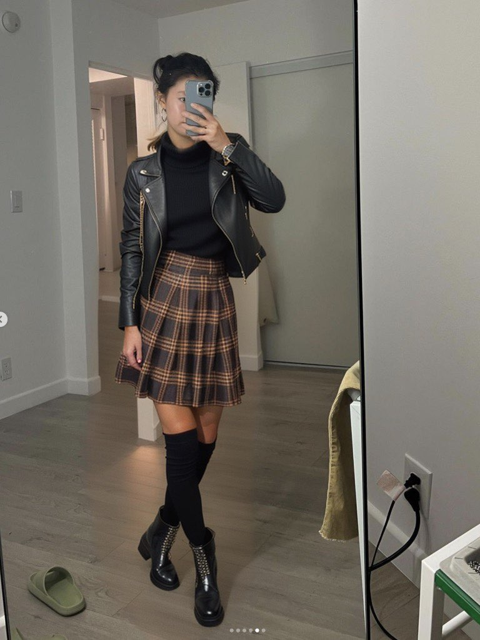 | 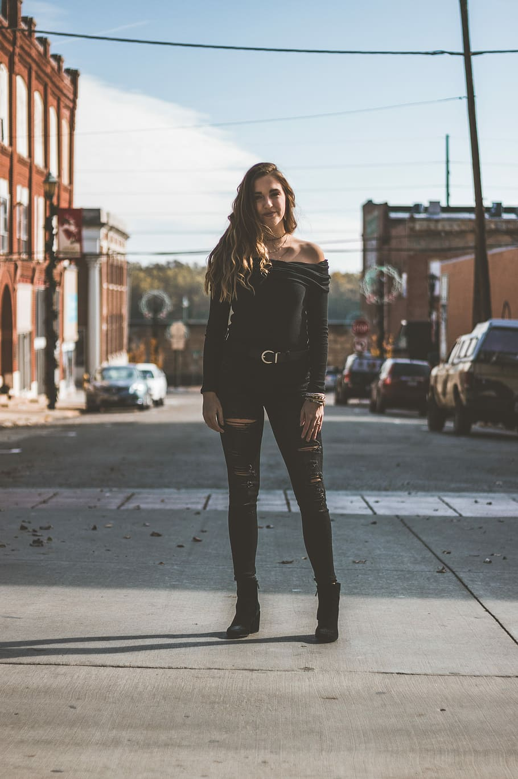 | 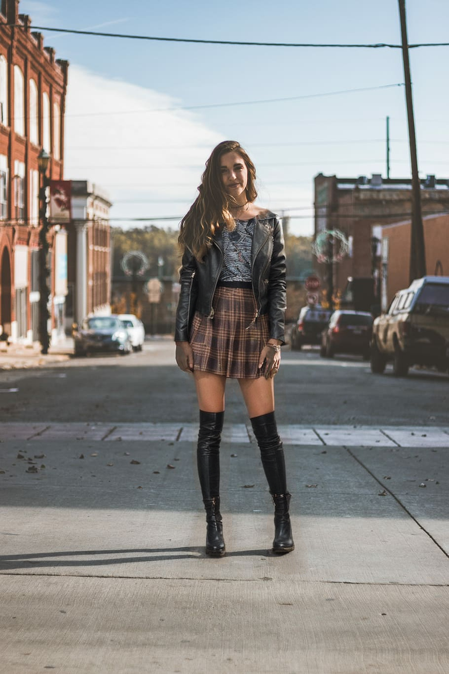
The man is wearing a grey suit with a white shirt. The suit is a two-piece, with the jacket and pants coordinating in color and style. The shirt is white and tucked into the pants, creating a polished and professional appearance. The man is also wearing a pair of sunglasses, which adds a touch of style to his outfit. The shoes he is wearing are white, complementing the overall look of his attire. | 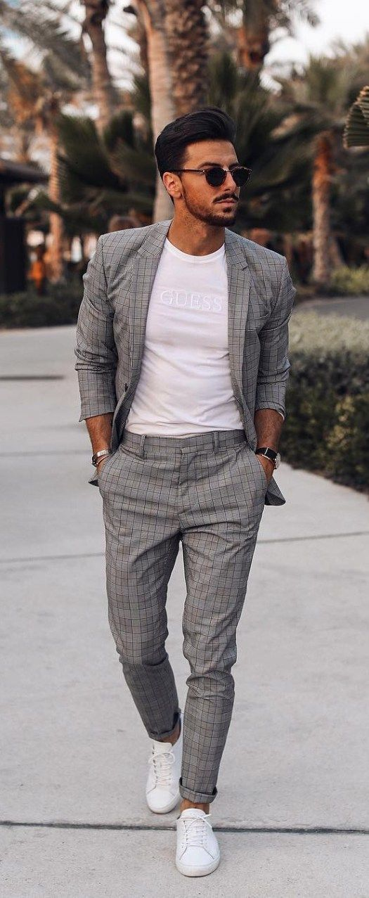 | 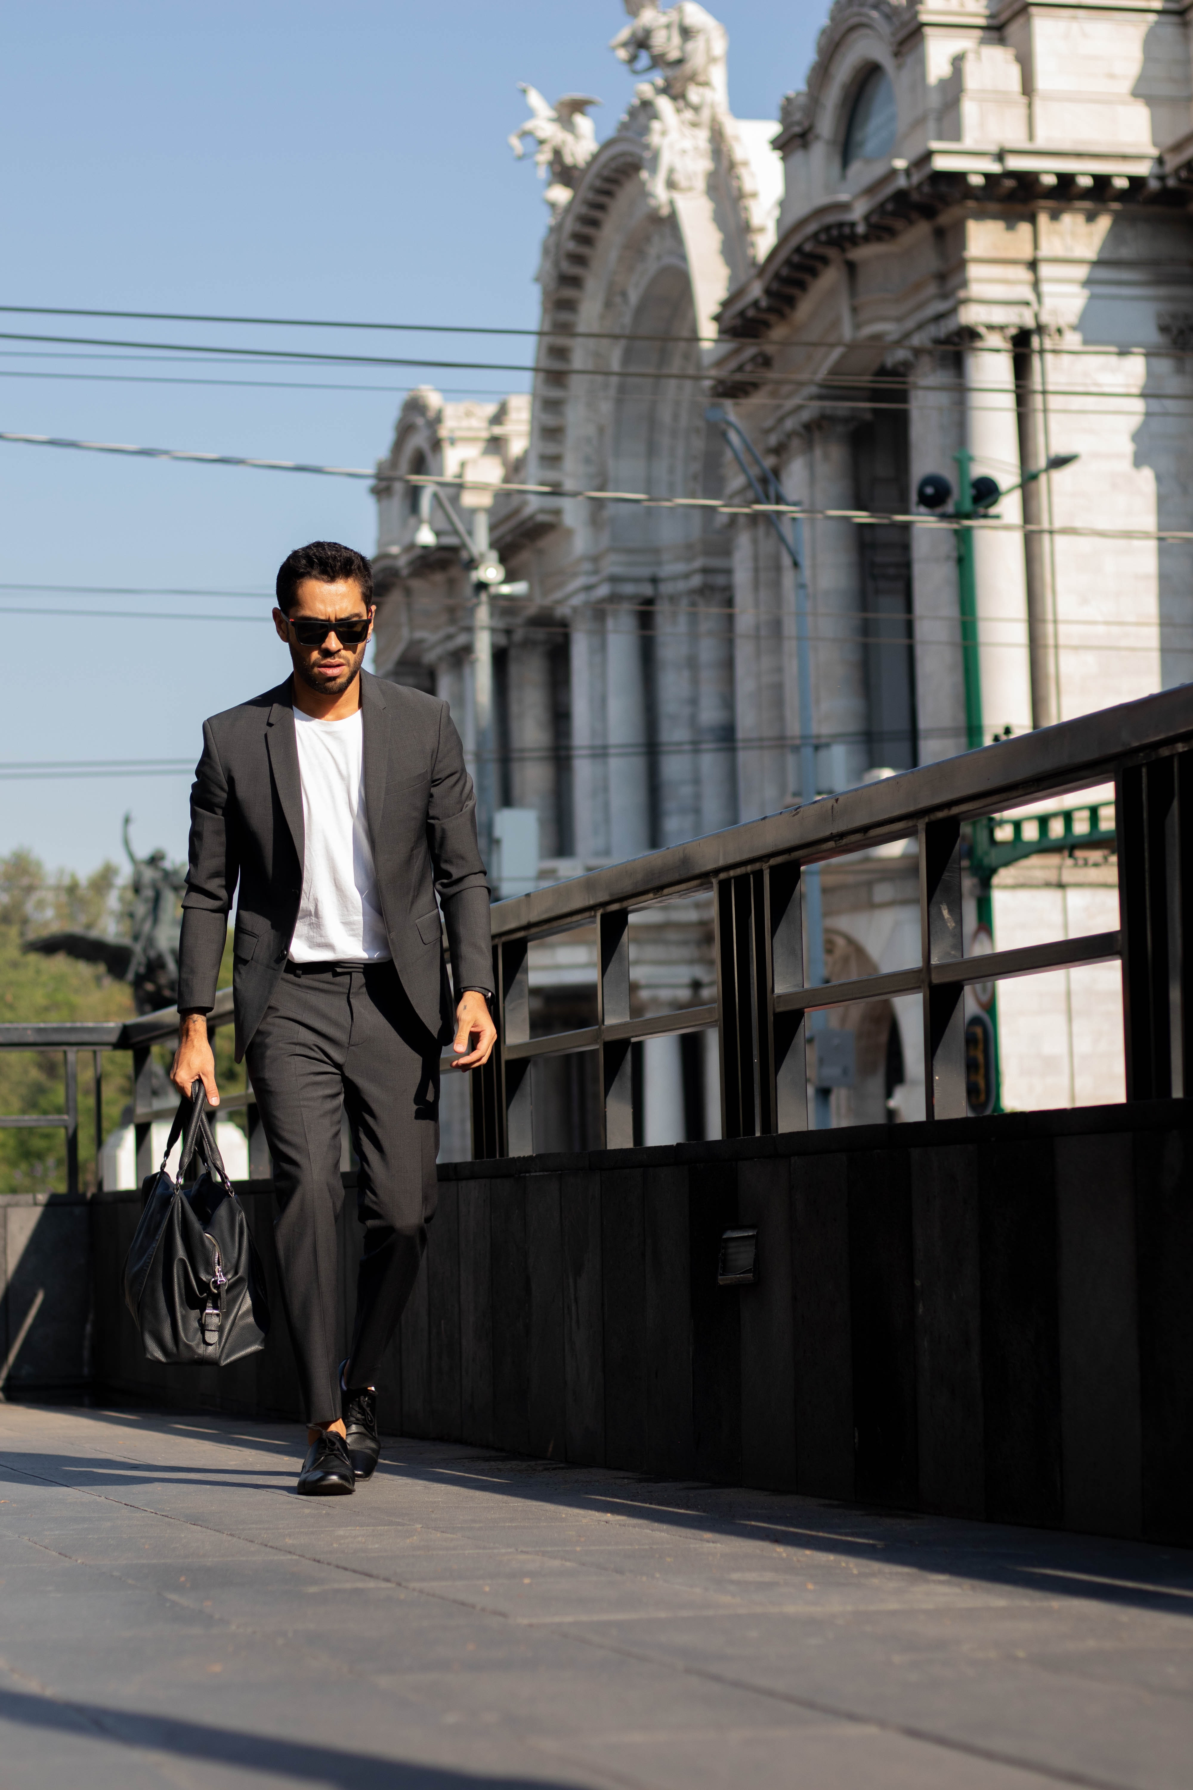 | 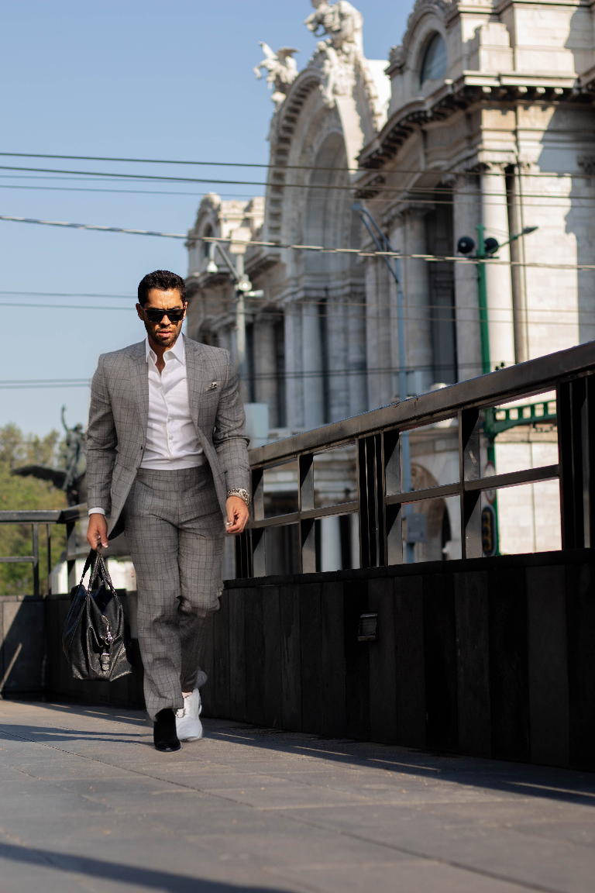
The man is wearing a black suit, which includes a black jacket and black pants. He is also wearing a black bow tie, a white shirt, and black dress shoes. The suit appears to be well-fitted and stylish, giving the impression of a formal or semi-formal occasion. | 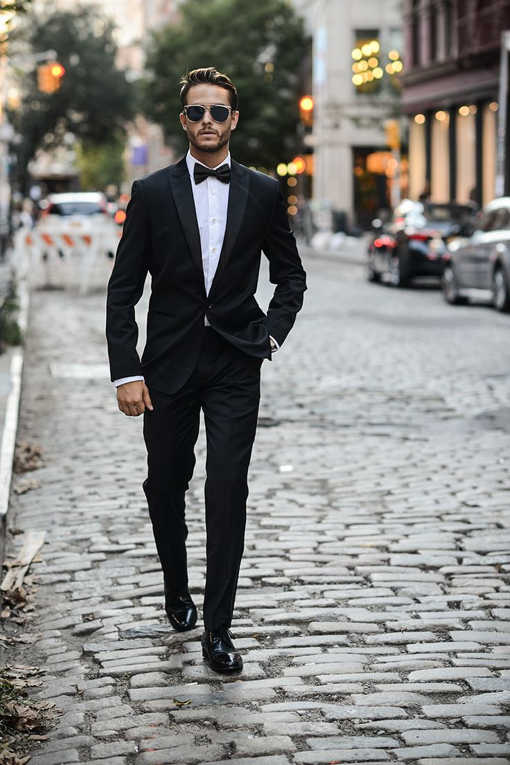 |  | 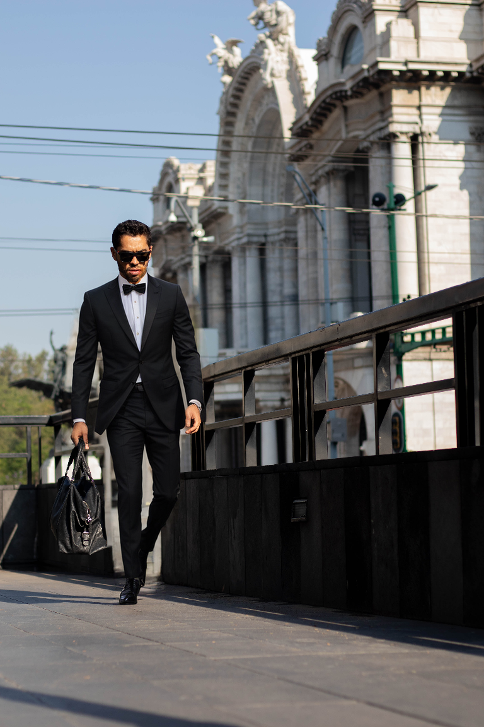
The person is wearing a white shirt and black pants. They are also wearing black shoes. | 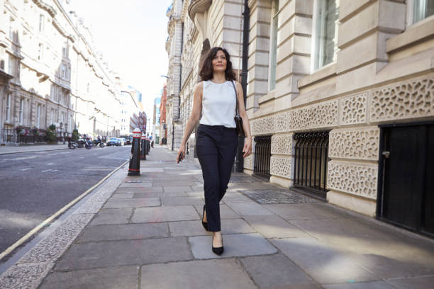 | 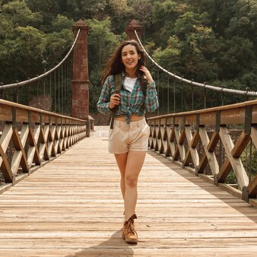 | 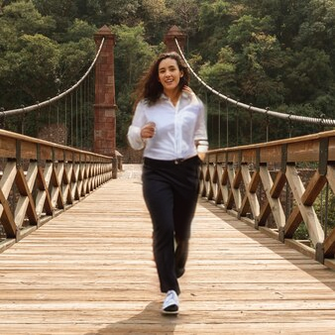
The woman is wearing a gray suit, which consists of a gray jacket and gray pants. She is also wearing a gray shirt underneath her jacket. Her footwear is a pair of red heels. | 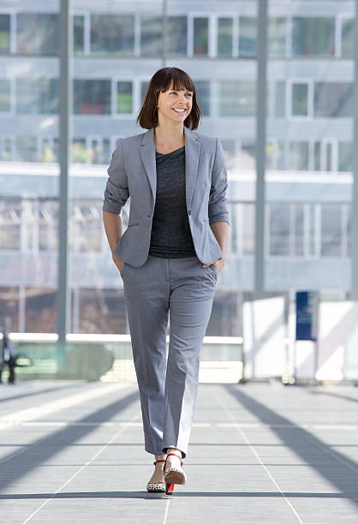 |  | 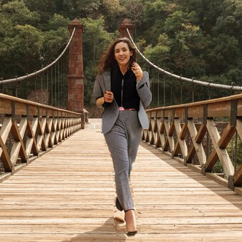

Describe what this person wearing in great detail of minimum 50 words. Unless it's not visible in the image, include a description of the style/type and color of top clothing, bottom clothing, and footwear only if shoes are visible. The following is very important: Do not include any description of accessories. Do not include any description of the environment or background. Do not include any description of hair color. Do not add any description about persons pose and activity.

