**H Enhanching Digital Government & Economy (EDGE) Project**

**Bangladesh Computer Council (BCC) Information and Communication**

**Technology Division Ministry of Posts, Telecommunications, and**

**Information Technology Government of the People’s Republic of**

**Bangladesh**

**And**

**Center for Digital Transformation (CDT)**

**Begum Rokeya University, Rangpur**

**Rangpur-5404, Bangladesh**

**Project Title:**

**“Internet of Things (IoT) & Smart Cities in Bangladesh”**

Name : Md. Sabbir Ahmed-Al Sabah Naeem

Department : Economics

Year : Master

Semester : 2nd

Batch No : B-17

Serial No : 29

Index

|  |  |  |
| --- | --- | --- |
| SL NO. | Contents | Page |
| 01 | Introduction | 3-4 |
| 02 | The Need for Smart Cities in Bangladesh | 5-6 |
| 03 | IoT Applications in Smart Cities | 6-7 |
| 04 | IoT and Smart City Initiatives in Bangladesh | 07 |
| 05 | Benefits of IoT for Bangladesh’s Smart Cities | 7-8 |
| 06 | Challenges of IoT Implementation in Bangladesh | 08 |
| 08 | Case Study: Dhaka’s Smart Traffic Management System | 8-9 |
| 09 | Future Prospects of IoT in Bangladesh | 9-10 |
| 10 | Impact on Citizens | 10-13 |
| 11 | Technological Challenges for IoT in Bangladesh | 13-16 |
| 12 | Conclusion | 17 |
| 13 | Reference | 17 |

**Introduction:**

* **What is IoT?**
* The Internet of Things (IoT) refers to the network of interconnected devices that communicate and share data to optimize systems and processes.

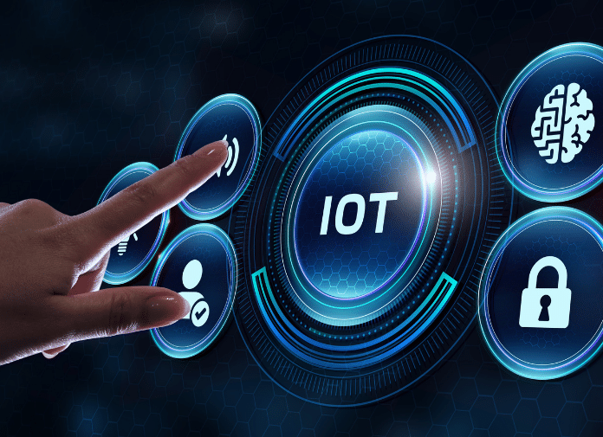

**Why Bangladesh?**

* Present the context of urbanization and population growth in Bangladesh, especially in cities like Dhaka, Chittagong, and Sylhet.
* The need for smart city solutions to address challenges like traffic congestion, pollution, waste management, and inadequate infrastructure.

**Internet of Things (IoT) and Smart Cities in Bangladesh** is a fascinating topic, especially given Bangladesh's rapid urbanization and its growing interest in technology to address urban challenges.

**What are Smart Cities?**

* A smart city uses IoT technologies to enhance the quality of life for citizens, improve sustainability, and streamline urban management.
* Smart cities use data and technology to create efficiencies, improve sustainability, create economic development, and enhance quality of life factors for people living and working in the city. A variety of different datasets may need to be integrated to create a smart energy infrastructure.
* Smart cities use data and technology to create efficiencies, improve sustainability, create economic development, and enhance quality of life factors for people living and working in the city. A variety of different datasets may need to be integrated to create a smart.

energy infrastructure.



**The Need for Smart Cities in Bangladesh:**

* **Urbanization in Bangladesh**:
  + Bangladesh has one of the fastest-growing urban populations in the world.
  + Cities like Dhaka are facing challenges like traffic congestion, waste management, and pollution.
* **Challenges**:
  + Traffic jams

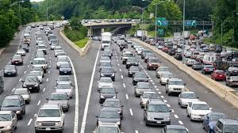

**Air pollution** is contamination of the indoor or outdoor environment by any chemical, physical or biological agent that modifies the natural characteristics of the atmosphere.

Household combustion devices, motor vehicles, industrial facilities and forest fires are common sources of air pollution.

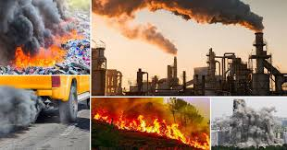

**Inadequate public service:**

Most public institutions are inefficient, highly centralized and politicized, making provision of effective services challenging.



**Inadequate public service**

In the context of **smart cities in Bangladesh**, inadequate public services are a significant challenge that can be addressed through the implementation of IoT and other modern technologies. Dhaka and other major cities in Bangladesh face severe traffic congestion, leading to long travel times, increased air pollution, and economic losses.

**IoT Applications in Smart Cities:**

* **Smart Infrastructure**:
  + IoT sensors monitor building health, bridge integrity, and road conditions.
* **Smart Traffic Management**:
  + Sensors and AI-powered systems help in real-time traffic monitoring, reducing congestion, and optimizing public transport routes.
* **Energy Management**:
  + Smart meters, street lights, and energy-efficient devices to reduce power consumption and ensure sustainable energy use.
* **Environmental Monitoring**:
  + Air quality and water monitoring to track pollution levels and manage resources effectively.
* **Smart Waste Management**:
  + IoT sensors in waste bins to optimize waste collection routes and reduce overflow.

**IoT and Smart City Initiatives in Bangladesh:**

* **Dhaka Smart City Project**:
  + In collaboration with various global tech companies, Dhaka is working on projects to enhance traffic management, waste management, and smart energy solutions.
* **Bangladesh’s Digital Bangladesh Vision**:
  + The government’s push for digitalization and smart solutions in urban areas, especially under the “Digital Bangladesh” initiative.
* **Example of IoT Deployment**:
  + The implementation of smart street lights in Dhaka and other pilot projects.

**Benefits of IoT for Bangladesh’s Smart Cities:**

* **Improved Efficiency**:
  + Real-time data from IoT devices help manage resources more effectively (e.g., reducing energy consumption or traffic delays).
* **Cost Savings**:
  + Optimized use of infrastructure (smart grids, energy management systems) leads to reduced operational costs.
* **Better Public Services**:
  + IoT enables better waste management, emergency services, healthcare monitoring, and citizen engagement.
* **Sustainability**:
  + IoT helps reduce carbon emissions and waste, promoting environmental sustainability in urban areas.

**Challenges of IoT Implementation in Bangladesh:**

* **Infrastructure Limitations**:
  + Limited access to high-speed internet and reliable electricity in certain regions.
* **High Initial Costs**:
  + The initial investment for IoT devices and smart city infrastructure can be expensive.
* **Data Security and Privacy**:
  + Concerns about data privacy and security as vast amounts of personal and public data will be generated and transmitted by IoT devices.
* **Lack of Skilled Workforce**:
  + There is a shortage of skilled professionals trained in IoT technologies and data analytics.

**Case Study: Dhaka’s Smart Traffic Management System:**

* **Overview**:
  + The Dhaka Transport Coordination Authority (DTCA) is working on implementing IoT-enabled smart traffic systems.
* **IoT Sensors**:
  + Real-time traffic data is collected using sensors and cameras, providing information to control traffic lights and reduce congestion.
* **Outcome**:
  + Reduced traffic congestion, improved flow of public transport, and enhanced citizen satisfaction.

**Future Prospects of IoT in Bangladesh:**

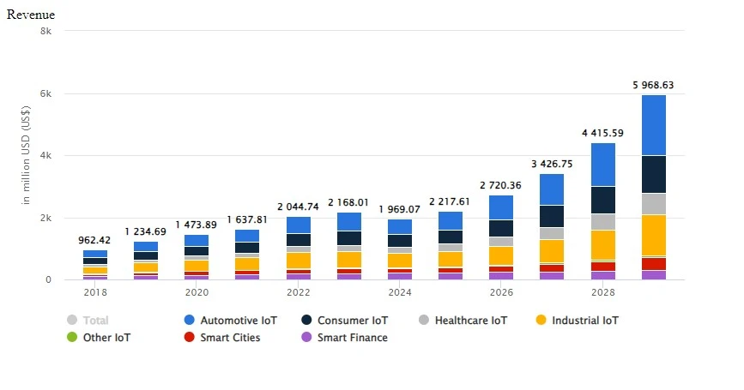

* **Government Support**:
  + The Bangladesh government is actively investing in smart city projects and infrastructure development to foster the adoption of IoT.
* **Expansion in Other Cities**:
  + Cities like Chittagong and Sylhet are exploring similar IoT-based solutions for urban management.
* **Collaboration with Global Tech Giants**:
  + Bangladesh is collaborating with companies like IBM, Huawei, and Siemens to bring innovative smart city solutions to its urban centers.

**Impact on Citizens:**

* **Improved Quality of Life**: A well-implemented smart city can offer residents better services, reduce the burden of traffic and pollution, and provide a safer environment.
* **Economic Opportunities**: The adoption of IoT technology could open new job markets and entrepreneurship opportunities in Bangladesh, particularly in the tech and startup sectors.

The following sections walk through five of the best benefits that come from implementing IoT business technology:

1. [Reduced costs](https://www.impactmybiz.com/blog/blog-5-benefits-of-the-internet-of-things-for-smbs/#reduced-costs)
2. [Higher efficiency and productivity](https://www.impactmybiz.com/blog/blog-5-benefits-of-the-internet-of-things-for-smbs/#higher-efficiency-productivity)
3. [More business opportunities](https://www.impactmybiz.com/blog/blog-5-benefits-of-the-internet-of-things-for-smbs/#more-business-opportunity)
4. [Improved customer experience](https://www.impactmybiz.com/blog/blog-5-benefits-of-the-internet-of-things-for-smbs/#improve-customer-experience)
5. [Increased mobility and agility](https://www.impactmybiz.com/blog/blog-5-benefits-of-the-internet-of-things-for-smbs/#increase-mobility-agility)

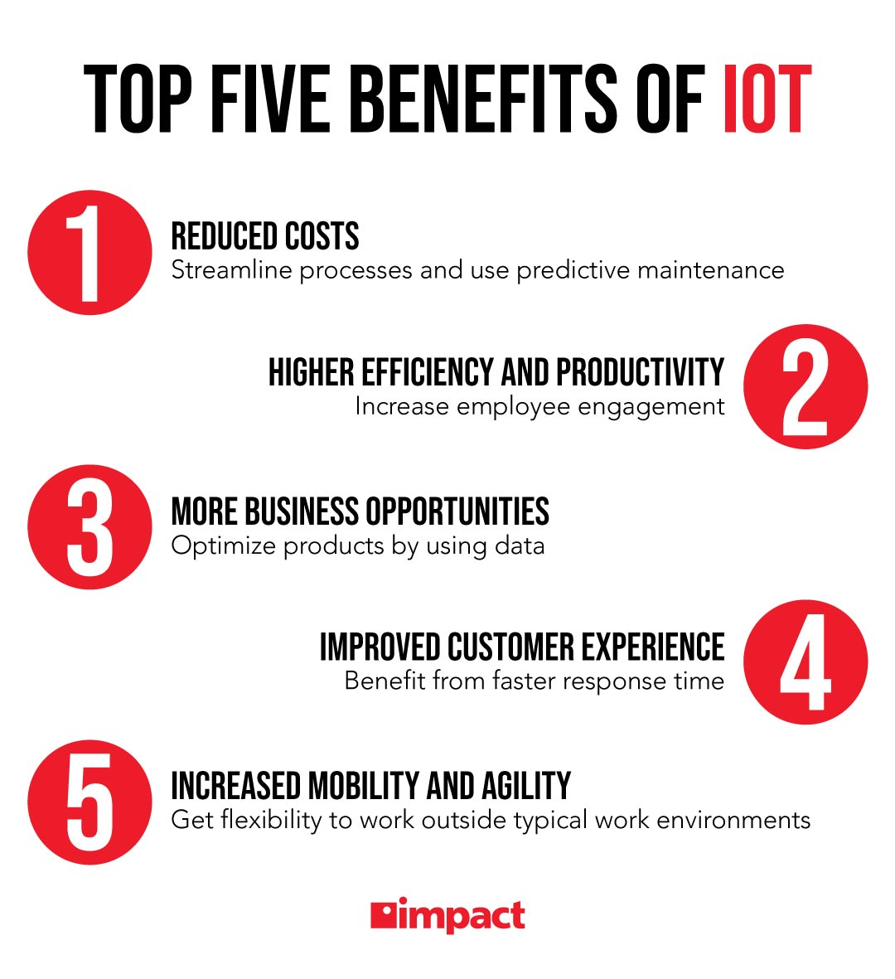

**Potential Collaborations and Examples**

* **Public-Private Partnerships (PPP)**: Collaborations between the government and private tech companies can accelerate the adoption of IoT technologies.
* **International Examples**: Looking at other cities like Singapore, Barcelona, or even nearby cities like Dhaka's implementation of IoT could provide insights into how Bangladesh can implement similar systems.

1. **Proposed Solutions or Use Cases**

* A pilot project in a smaller city like Sylhet or Chittagong could be a
* starting point for testing IoT applications before scaling them to larger cities.
* You could suggest partnerships with local startups or tech companies to develop IoT solutions that cater to Bangladesh’s unique challenges.

**IoT Applications for Bangladesh’s Urban Issues**

Bangladesh faces several urban challenges, especially in Dhaka and Chittagong. Here’s how IoT can be a game-changer:

**Traffic Management**

* **Problem**: Dhaka, the capital, faces severe traffic congestion, leading to air pollution, loss of productivity, and health issues.
* **IoT Solution**:
  + Smart traffic lights that adjust based on real-time traffic data.
  + Sensor-based monitoring of traffic flow and congestion, providing data to control traffic and reroute vehicles.
  + Parking sensors in crowded areas to inform drivers about available spaces, reducing time spent searching for parking.

**Waste Management**

* **Problem**: Waste collection and disposal are often inefficient in urban areas, leading to garbage piling up and environmental pollution.
* **IoT Solution**:
  + Smart bins with sensors that detect when they are full, notifying the waste collection system to optimize routes.
  + Automated waste sorting systems using IoT to separate recyclables, hazardous materials, and organic waste, improving waste management efficiency.

**Water and Energy Management**

* **Problem**: Water scarcity and energy inefficiency are significant concerns.
* **IoT Solution**:
  + IoT sensors to detect leaks in water pipelines and prevent water wastage.
  + Smart meters to monitor energy consumption in real-time, allowing for better distribution and energy savings.
  + Solar-powered smart streetlights equipped with sensors to adjust lighting based on ambient light levels, conserving energy.

**Public Health and Safety**

* **Problem**: Pollution, water contamination, and public health issues.
* **IoT Solution**:
  + Air quality monitoring systems that can send alerts when pollution levels reach unsafe levels.
  + Real-time water quality sensors to ensure safe drinking water and avoid contamination.
  + Smart public surveillance systems that can assist in monitoring crime and improve public safety.

**Environmental Monitoring**

* **Problem**: Bangladesh faces severe environmental challenges, such as floods, deforestation, and pollution.
* **IoT Solution**:
  + IoT-enabled environmental monitoring systems that track air and water quality, waste levels, and even soil health.
  + Flood monitoring systems with IoT sensors that detect water levels and provide alerts, helping with early flood warning systems, especially in flood-prone areas.

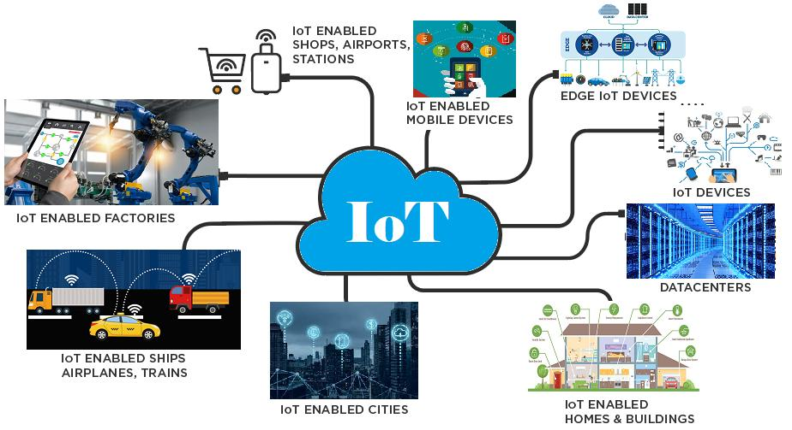

**Technological Challenges for IoT in Bangladesh:**

Despite its promise, there are several challenges to implementing IoT and smart cities in Bangladesh:

**A. Infrastructure**

* **Challenge**: Bangladesh’s digital infrastructure, particularly in rural areas, needs improvement. Limited internet connectivity and unreliable power supply could hinder IoT deployment.
* **Solution**: Expanding 4G/5G networks and internet infrastructure is essential. Public-private partnerships can help improve rural connectivity.

**B. Cost and Accessibility**

* **Challenge**: IoT solutions can be expensive, which might make them unaffordable for local municipalities or businesses, especially in less affluent areas.
* **Solution**: Offering subsidized or low-cost solutions and ensuring access to affordable technology through government or private sector initiatives.

**C. Data Privacy and Security**

* **Challenge**: Collecting data via IoT raises significant concerns about data privacy, particularly in countries with weaker regulations.
* **Solution**: Developing strong data protection laws, implementing cybersecurity protocols, and ensuring transparency in how data is used.

**D. Skilled Workforce**

* **Challenge**: Bangladesh may lack a sufficiently skilled workforce to manage and develop IoT systems.
* **Solution**: Developing local talent through educational programs and training to build expertise in IoT, big data, and smart technologies.

**4. Government and Policy Support**

For a smart city initiative to be successful, government involvement is crucial. Here are some recommendations for Bangladesh:

* **Smart City Vision**: The Bangladesh government should create a roadmap for implementing smart city initiatives, focusing on priority sectors like transportation, waste management, healthcare, and education.
* **Public-Private Partnerships**: Collaborations with private tech companies (like Ericsson, IBM, or local startups) to develop and deploy IoT technologies.
* **Incentives for Innovation**: Offering tax breaks or grants to companies working on smart city technologies could encourage innovation.
* **Regulatory Framework**: Establishing regulations that ensure safe, efficient, and ethical use of IoT data. This could include clear guidelines on data privacy, security, and technology standards.

**5. Examples of Smart City Projects Globally**

Learning from other cities that have successfully implemented smart city technologies can offer useful insights:

**A. Singapore**

* **Smart Traffic**: Singapore uses real-time traffic monitoring systems to control congestion, offering a model for Bangladesh’s traffic management.
* **Waste Management**: Smart waste bins that alert the waste collection services when they need to be emptied.

**B. Barcelona, Spain**

* **Smart Lighting**: Barcelona’s streetlights adjust based on time of day and activity, saving energy.
* **Urban Farming**: IoT systems are used to monitor urban farms, improving food security and sustainability.

**C. Dhaka's Smart City Initiatives**

* **Smart Bus Systems**: Dhaka has started introducing smart buses with GPS tracking and mobile apps that help citizens track routes and timings.
* **Traffic Management**: The city has experimented with intelligent traffic signal systems to reduce congestion.

1. **Potential Pilot Projects for Bangladesh**

You could propose starting with pilot projects in specific areas to showcase the effectiveness of IoT technologies in improving urban life:

* **Chittagong**: A smart traffic management and waste management system could be implemented to test how IoT could improve the city’s efficiency.
* **Sylhet**: A pilot water management IoT project could track water consumption and identify leaks in the city's water distribution system.
* **Khulna**: A smart public health monitoring system could be introduced, leveraging IoT devices to monitor air quality and provide health alerts.

**Global Smart City Examples**

* **Singapore**: Known for its smart traffic systems, waste management solutions, and citizen engagement platforms.
* **Barcelona**: Integrates IoT for smart lighting, smart waste bins, and environmental monitoring.
* **New York City**: Uses IoT for smart water meters, traffic management, and emergency response systems.

**Conclusion:**

* **Summary**:
  + IoT has significant potential to improve urban living in Bangladesh by addressing its growing urbanization challenges.
  + While there are hurdles to overcome, such as infrastructure limitations and data security, IoT presents a path forward for more sustainable, efficient, and smart urban environments.
* **Call to Action**:
  + Continued investment in IoT infrastructure, policy development, and skills training will be key to realizing the vision of smart cities in Bangladesh.

**Reference:**

1. **Sharma, S., & Ghosh,** " IoT and Smart Cities: A Global Perspective
2. **Hossain, M., & Ahmed***, " A Case Study of Bangladesh." P. 49*
3. **Arshdeep Bahga, Vijay Madisetti,** *"IoT in Smart Cities" , P.220-250*
4. **R. S. K. Bhatia & R. G. Ranjan,** (2017*),"IoT in Healthcare Systems", P.85-105*
5. **Zaigham Mahmood, Albert Y. Zomaya**, *"Analytics and IoT for Smart City Development" (2018), P.70-100*
6. <https://en.wikipedia.org/wiki/Smart_city>
7. <https://pridesys.com/iot-in-bangladesh-evolution-applications-future/>
8. <https://www.scirp.org/journal/paperinformation?paperid=124756\>