Define the IT Product management model by means of fuzzy logic analysis
(How can a product/project team define the appropriate development model using fuzzy logic modelling)

Dr. Danil Dintsis
Professor
Global Business School
Barcelona, Madris, Spain
consult@dintsis.org

Abstract—The article deals with the implementing fuzzy logic to build an expert model and define the appropriate project type: predictive, increment, iterative or agile.
Keywords—project management; fuzzy logic; project model definition; predictive; incremental; iterative; agile

Introduction
Rapid development of various management models for IT and other “on-the-edge” product, services and projects lead to various myths and misunderstandings. In the current article the author tries to combine his vast experience as a manager and system analyst to define formal approaches for a product/project management model selection. The basic level for determining the management model is defined by Stacey diagram (fig. 1) [1]

Background Review and research methodology

Methodology overview
1. Meta-analysis of research publications, standards, and frameworks
2. Analysis of feedbacks and questionnaires.
The Stacey model analyses the level of Definity (or chaos) for business requirements (Y-axis), and technical readiness (X-axis). The predictive models are preferred for bottom-left quadrant (low variability of business requirements and technical methods). High level of business requirements changes in a pre-defined technical environment leads to increment (or rolling wave) models. Agile (or incremental/iterative) models stands for high level of chaos, while Kanban is for the extra chaos level (fig. 1).
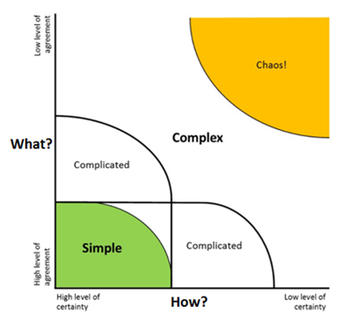
Fig. 1. Stacey model
Meanwhile this model is highly simplified. In [1] several combined models are represented, but without any formal recommendations for their implementation. In [2] the respected author offers the extended approach based on Cynefin Decision making framework and fuzzy logic analysis of basic product/project indicators.
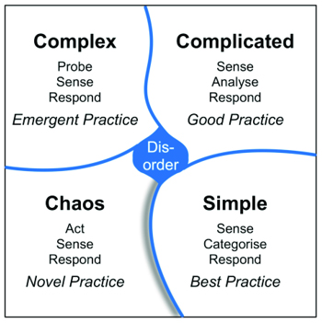
Fig. 2. Cynefin framework
Both models are based on attempts to define level of chaos/uncertainty or, on the contrary, level of understanding of subject matter area, technical requirements and existing features. In practical tasks so called hybrid models become more and more popular now. The term “hybrid model” means a combination of predictive (or linear, or “waterfall”) models with iterative-incremental (agile, Kanban, and many others) models.
The challenge is that all estimates for uncertainty levels, characteristics of hybrid are given expert-based and without any agreed features, indicators, and metrics.
In this article the author presents an approach to introduce indicators for product and project framework, based on fuzzy logic. Product or project development model can be chosen based on metrics for those fuzzy based indicators.

Criticism
The Stacey model seems rationale and applicable at high level of abstraction. Practical implementation demands more detailed procedures or decomposing of the high-level model. Thus, a development process can contain agile and linear blocks of work. Those blocks can be combined in various ways. In the article the author introduces extended methods and attributes, which formalize the process of defining a product/project management model. In this article the author analyzes the experience of a product/project development and offers a decision tree model which reflects practical approach to this choice. The article deals with the combined models of product development process. According to the system of fuzzy model proceeding [3], first, let’s define fuzzy variables based on indicators of the project/product.

Define indicators or fuzzy variables. Fuzzification procedure
A. Product uncertainty.
Product uncertainty is the high-level indicator. Th first step is decomposing it. The decomposition is based on (2-Alferov, 3-Author) external and author’s personal experience.
A1. Market research gives clear representation of the product niche
A2. Internal knowledge exists
A2.1. Internal knowledge exists in a formalized knowledge base
A2.2. Internal knowledge exists in teams
A2.3. Internal knowledge exists as personal experience.
A3. External knowledge exists. This indicator reflects, if there are similar products or services at the market
A3.1. External knowledge exists in the similar area/branch
A3.2. External knowledge in the subject area exists in other branches
B. Technical uncertainty can be decomposed as the following:
B1. Technical uncertainty in the team
B2. Technical uncertainty in the organization
B3. Technical uncertainty in the subject matter area (for example, in the branch of business)
B4. Technical uncertainty in the local area
C. Environment (for example, based on PESTLE analysis)
C1. Political
C2. Economic
C3. Social
C4. Technological
C5. Legal
C6. Environmental
All mentioned factors can be described with means of fuzzy logic. The next step is fuzzification. Each entry is described as a fuzzy variable. For example, “Technical uncertainty” can be defined as the following. Use expert estimates named “Low”, “Medium”, “High”
Technical uncertainty (Expert rating) | Low | Medium | High
0 | 1 | 0 | 0
10 | 0,75 | 0 | 0
20 | 0,5 | 0 | 0
30 | 0,25 | 0,33 | 0
40 | 0 | 0,67 | 0
50 | 0 | 1,00 | 0
60 | 0 | 0,67 | 0
70 | 0 | 0,33 | 0
80 | 0 | 0 | 0,33
90 | 0 | 0 | 0,67
100 | 0 | 0 | 1,00

an exception to the prescribed specifications of this template. You will need to determine whether or not your equation should be typed using either the Times New Roman
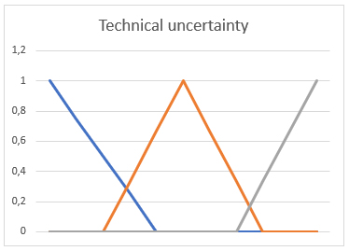
Fig. 3. Graphic example of the fuzzy variable “Technical uncertainty”.
We develop fuzzification rules for other mentioned indicators in the similar way.

Build output rules and conditions
The third step is the development of conditions and rules for output variables.
The main output variable is “Decision”, which defines the management model for a product or a project.
According to the fuzzy production rule: (i):Q;P;A═>B;S,F,N, where
(i) – product/project name,
Q – area of applicability,
P – application condition
A═>B – core of the fuzzy production, A – condition or antecedent, B – conclusion, or consequent,
S – method to define the level of awareness,
F – awareness level,
N – postconditions (optional), we do not apply them in this model.
In the Table 1 below we can see the excerpt of the Decision matrix:

Product niche (A1) | Internal know-ledge (A2) | External know-ledge (A3) | Techni-cal uncertainty (A4) | Environment (A5) | Decision (B) | Aware-ness  Level (F)
High competitive | Low, in person | Low level | High | Chan-ging | Kanban | High
High competitive | formalized knowledge base | exists in the similar area | Low | Chan-ging | Scrum | Middle
Low competitive | High, corporate knowledgebase | Low level | Low | Stable | Predic-tive | High

As shown in the table above, we take into consideration additional parameters. For example, the “Existing knowledge”:
A2.1. Internal knowledge exists in a formalized knowledge base - improves level of knowledge and, also, awareness.
A2.2. Internal knowledge exists in teams – slightly improves level of internal knowledge, and slightly decreases the level of awareness.
A2.3. Internal knowledge exists as personal experience – strongly decreases level of knowledge, and slightly decreases level of awareness.

Conclusion
Unfortunately, most decisions on management model in current practices are based on individual priorities and perception. Those lead to many unsuccessful products and projects (up to 70% in IT area according to [4]
Applying the described model makes the decision on product/project management model more trusted and improves the share of successful projects and products. Though it can take more time at the initiation phase to define the type of the model, we gain the benefits of successful project realization and further product implementation.
As the implementation of hybrid models increases greatly in 2010-s, the author consider that the described method can be applied to phases and/or modules instead of the whole product or project.

References

- PMI® Agile Practice Guide. 2017. Project Management Institute. https://www.pmi.org/pmbok-guide-standards/practice-guides/agile
- Alferov Pavel. Agile or not: are agile methods worth for you. Harvard business Review Russia. August, 19th 2019. https://hbr-russia.ru/management/prinyatie-resheniy/809338
- Dintsis Danil. Chapter “Implementing Complex Fuzzy Analysis for Business Planning Systems” in the “Modern Fuzzy Control Systems and Its Applications”. Academic editor S.Ramakrishnan. ISBN 978-953-51-5391-7. Intech Publishing, 2017
- Hsu, Jack S. , Hung, Yu-Wen, Shih, Sheng-Pao, Hsu, Hui-Mei. Expertise coordination in information systems development projects: willingness, ability, and behavior. 1 August 2016. Project Management Journal. https://www.pmi.org/learning/library/expertise-coordination-isd-problems-10218
- Danil Dintsis. IMPLEMENTING FUZZY ANALYSIS FOR CREATING VIRTUAL TRAINING METHODS IN LIFELONG LEARNING. Proceedings of the IEEE AEIT Annual 2016 Conference. Naples, Italy, October, 2016
- Kosko B. Fuzzy systems as universal approximators // IEEE Transactions on Computers, vol. 43, No. 11, November 1994. – P. 1329-1333
- W.Cellary, “People and Software in a Knowledge-Based Economy”. IEEE Computer, January, 2005, pp.17-24.

