Bioinformatics Expert Guide
Welcome to the Bioinformatics project! Please read through this guide carefully.
Heads up: you need to log the time you spend reading through this document so that you get paid out for it! Please ensure that you have set up an Expert-Hub Account and review the how to track hours and get paid guide.

Onboarding Checklist

Please ensure that the following items have been met before getting started:
- Deel.com
- You have signed your deel.com contract and are able to log in
- You see the time tracking component in deel.com
- 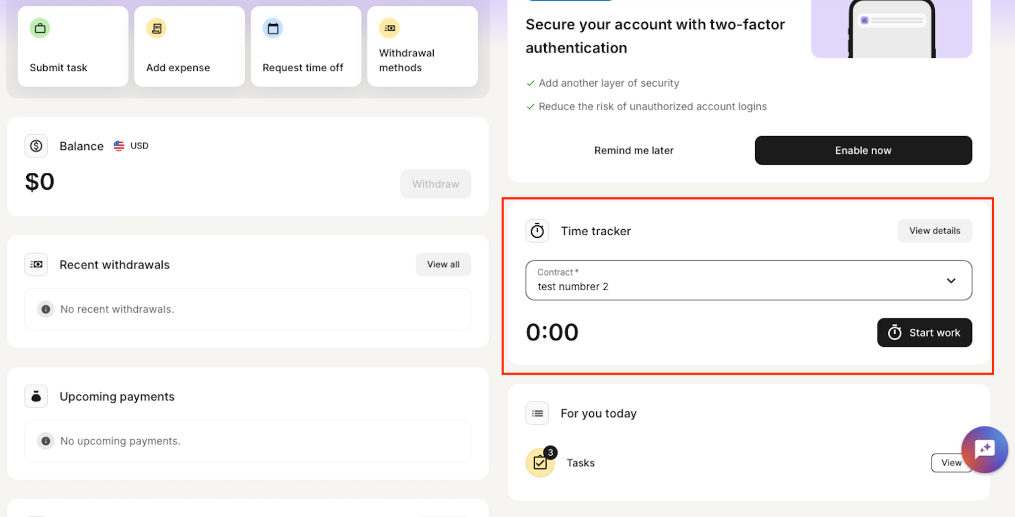
- Slack
- You are able to access our workspace: epistemalabs.slack.com
- Channels you should have joined:
  - #bioinformatics-august
- Expert-Hub
- Your expert hub profile has been completed
- 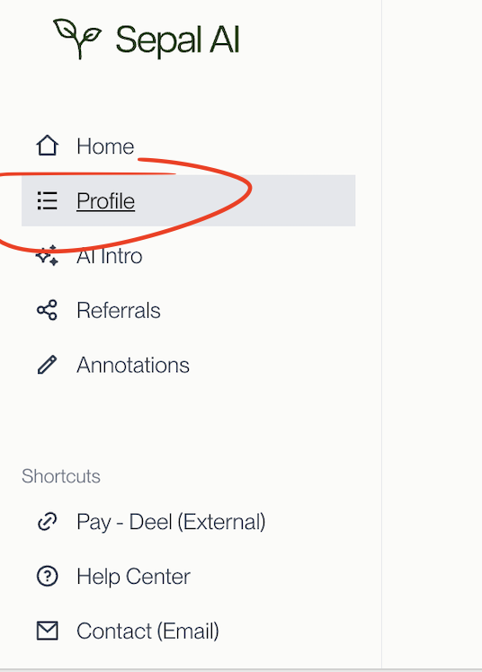
- Project Details
- You have read through the entirety of this guideline document
- Finally
- You’ve messaged in slack with 🌱 :seedling:

How to track hours & get paid
Please see all documentation HERE

Setting Up Payments:
- Log in to Deel and navigate to Finance > Withdrawal Methods > Add Method.
- After your first payment, you’ll also receive an email reminder to set up your banking details.
- 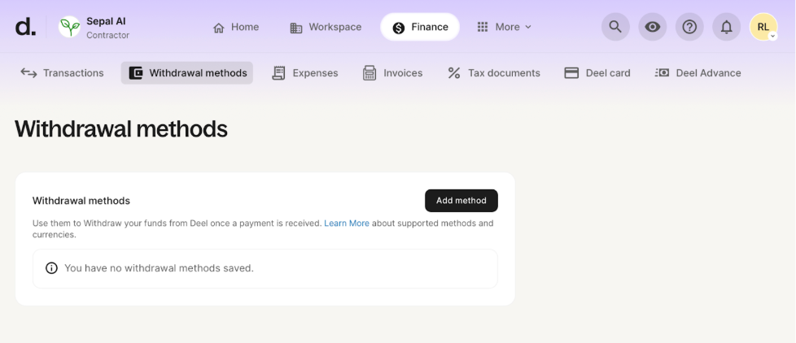

How to Track Hours and Get Paid:
- Time tracking:
  - Log in to Deel and navigate to Home > Quick Access > Time Tracker > Start Work
  - If you have multiple contracts with Sepal AI - please be sure to select the correct project that you are working on before hitting start work.
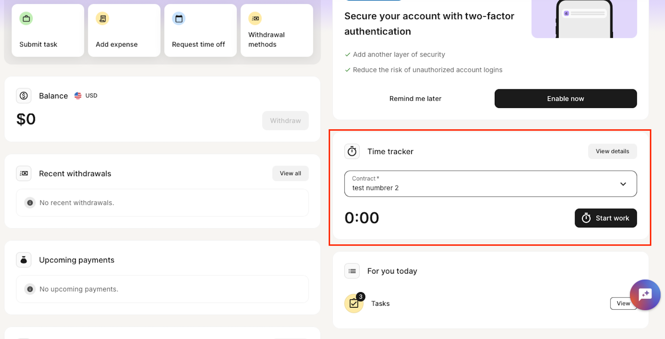
  - For additional information, please see Deel’s time tracking guide HERE
- Manually submitting hours:
  - Log in to Deel and navigate to Home > Quick Access > Submit Work Hours.
    - 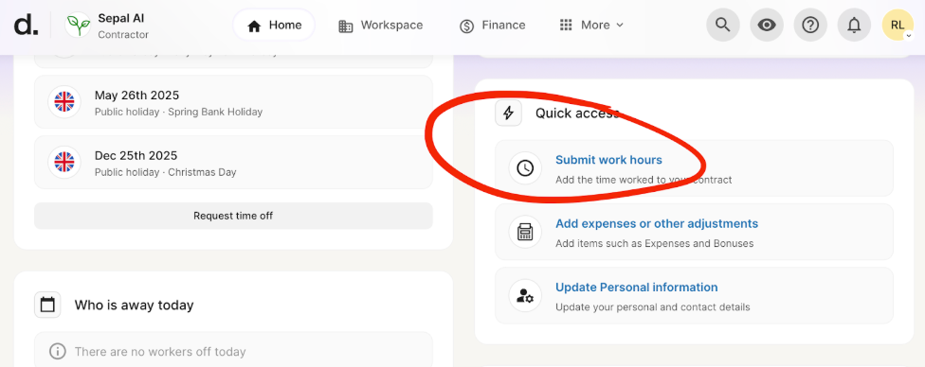
  - Enter the date, number of hours worked, and a brief work description.
    - 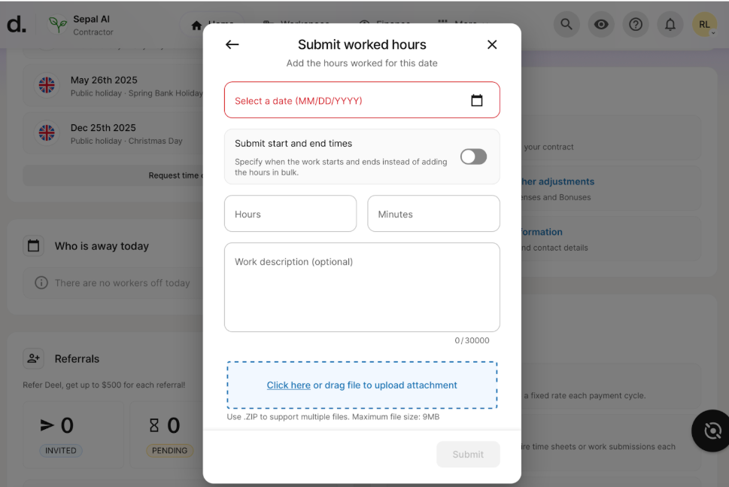
  - You'll be able to withdraw from the home page once your payment has been made.
    - 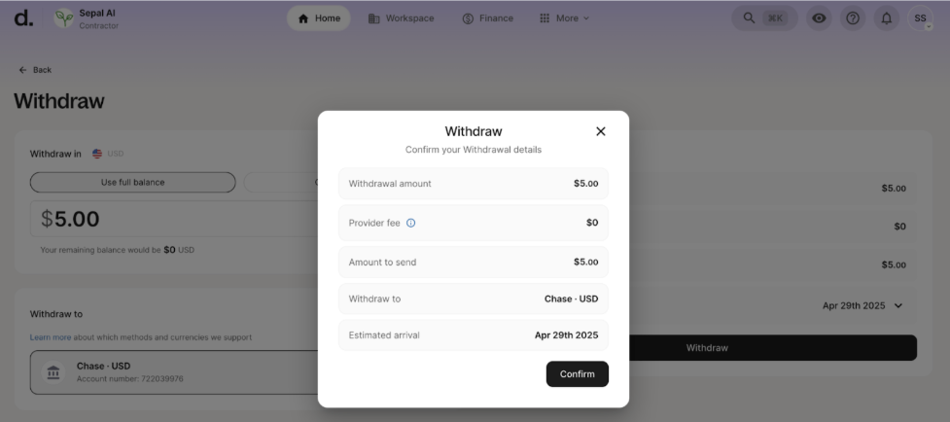

Bonus Structure
$100 bonus for each submission where the time spent on the submission (draft and any revisions) is 8 hours or less.

Communication and Meetings

Who’s Who
- Sepal AI Points of Contact: these are internal Sepal AI employees who are here to help support you throughout the project.
  - Robi Lin, Project Operations Lead
  - Jackie Chen, Project Operations Lead
  - Hugo Vinicius, Talent Operations Lead
- If you have a general question, you should:
  - Post in the #bioinformatics-august channel and tag Robi and Jackie
    - If your question is about a specific task, please always include the task link!
- If the question is payment-related, you should:
  - DM Hugo, or email hugo@sepalai.com

Slack
Slack is our main channel of communication. Please be sure to enable notifications on when you receive a direct message and when a message is posted in the channel.

Meetings
Weekly check-in’s occur on Monday. During these meetings, we share announcements and have discussions on any challenges. In case you cannot attend these meetings, meeting notes are logged on this document under the Meeting Notes tab (GUIDELINES - Bioinformatics Eval Project - August 2025)

Project Timeline

Get to 60 (collectively) submissions by 8/25
Get everything QA’ed and ready to go by 9/1

Project Instructions
Problem statement: Existing methods of measuring AI’s ability to conduct real-world analysis is extremely limited and manual.
Solution: Produce a set of tasks that mirror real-world bioinformatics workflows which AI models can attempt and we can measure their success rates.

Your goals:
- Your goal is to produce a replicable set of questions, answers, and solutions for a complex bioinformatics task based on a paper that you have authored.
- You must 1) select a suitable paper that you are knowledgeable in the workflow (preferably a paper that you have authored) and 2) produce a near replication of the bioinformatics workflow from the paper then 3) produce a set of 5 questions and 5 answers based on the workflow.

Your rough workflow: (emerging - if you follow a more efficient flow, let us know!)
- Select the paper and pull the dataset
- Environment & data prep (subsampling, installing tools)
- Prototype the pipeline (write files to roughly reproduce the workflow from the paper)
- Question & answer authoring
- Test the pipeline in Taiga
- Packaging & docs & finalization

High-level checklist for your submissions:
- Uses FASTQ sequencing data (other post-processed data formats may be considered)
- Input data size is <= 10 gb after “miniaturization”
- Have a runtime of <=1 hr
- Follows and recreates all or most of the workflow of a paper published in 2024 or afterwards
- 5 questions that tests that data outcomes from following the workflow
- Scripts and workflows were tested in Taiga

Expectations:
- Each submission should take <= 6 hours to draft
- At least one submission each week

Submit tasks HERE
Client directions HERE

Selecting a Paper / Dataset
This selection will cover which papers & datasets are in scope versus out of scope

- Primary criteria (must be adhered to)
  - That paper should be published in 2024 or later (biorxiv or arxiv is permitted)
  - The paper relies on sequencing data (FASTQ files) as its inputs. Open to post-processed forms of sequencing data (please reach out to Jackie to discuss)
  - The input sequencing data is accessible on SRA or on a stable URL (you may also provide this directly, assuming it is not too large)
  - The paper must have used at least 3 bioinformatics tools/command lines (BWA, BLAST, samtools, alphafold, etc)
  - The datafiles used MUST be <10GB (after you have subsampled / miniaturized)
  - The bioinformatics tools used in the analysis should be standard (such as tools found in Galaxy Tool List) ; avoid tools that are custom-made for a particular analysis.
- Secondary criteria (ideal, but not a strict requirement)
  - The focus is on one of [DNA sequencing, single-cell sequencing, Transcriptomics]
    - (others are fine including but not limited to: WGS, 16S or other targeted sequencing, Hi-C/chromatin conformation data, Metagenomic data, Crispr screens)
  - You are an AUTHOR of the paper (we highly recommend choosing a paper that you published for your first submission; you may select papers you feel comfortable reproducing all or a large majority of the bioinformatics workflow for.)

Keep in mind:
Throughout the paper selection process, keep in mind:
- You’ll be reproducing all or significant portions of the paper’s workflow
- You’ll be writing 5 questions & answers derived from the research and workflow that you built
- The questions you write should not be answerable simply using the text from the original paper. You may be ‘miniaturizing’ the question or dataset you’re working with to achieve this
  - Eg: “which pathways were enriched from the gene expression data of patients with heart disease compared to healthy controls?” → “using just genes on chromosome 20, which pathways were enriched in patients with heart disease?”
  - Eg: “which pathways were enriched from the gene expression data of patients with heart disease compared to healthy controls?” → “Which pathways were enriched in the patients under 40 with heart disease compared to healthy controls?”
  - You might also choose to modify the sequencing data you are sharing with us, to make it smaller, only encompass a certain group, etc.

Setting up the workflow
This section will cover organizing your work and clarify the output format that is expected.

Key items:
- Submissions tracker (Bioinformatics-Submission-Tracker)
- Template repo (https://github.com/sepal-ai/bioinformatics-template/tree/main)

Deliverables:
- Data files: Raw sequencing files (FASTQ format)
  - NOTE: If you used subsampling to miniaturize your inputs, please provide the resulting subsample. This is so that the model conducting the tasks can arrive at the same answers.
  - When uploading the data to Taiga, it will only take files up to 2GB. We recommend zipping your files to meet the file size requirements.
  - You must provide the datafiles in Taiga as the system is designed to not have any internet access
- Questions: 5 questions per paper, testing different pipeline stages
- Answers: Ground truth answers
- Solution workflow: Executable script demonstrating the complete pipeline
- Metadata:
  - Data source: URL where data was downloaded (e.g., SRA accession)
  - Paper reference: Full citation and DOI
  - Links to Tools: URLs for any tools that are used

The preferred format is a github repository, but other filesharing formats are acceptable.
- Please share all submissions with robert@sepalai.com and jackie@sepalai.com
- Please also log your submissions in the submissions tracker.

We have provided a helpful template repo for contributors to use as a starting point. HERE

Generally we would expect submissions to be structured like this:

├── README.md
└── sample_submission_boilerplate/
├── answers.yaml
├── data/ # currently empty
├── metadata.yaml
├── questions.yaml
└── workflow/ # currently empty

Questions and Answers
This page explains how to write questions and provide corresponding objective answers. These are the core of every submission.

Good Questions:
- Not able to be answered from the paper alone. Do not write questions that can be answered by reading the paper or searching online.
- Objective format only. Each question must produce an answer that can be graded automatically, not free text, no essays, nothing subjective like arguments and perspectives.
- Grounded in the pipeline. Your questions should span the key stages of your workflow (for example., QC → alignment → quantification → analysis). A failure mode is if all 5 questions are based off of the first stage of a workflow.

Good Answers:
- Ensure objective grading. Stick to questions that have answers made of:
  - Single words.("Which chromosome?", "Which gene?”,"Which protein?")
  - Integers or decimal numbers (“what percentage?” “How many?” “what p-value?”)
  - Ordered lists (“rank these genes by expression level”, “rank these mutations by antibiotic resistance fitness”)
  - Sets ("Which pathways are enriched?”)

Writing questions.yaml
Each task includes 5 questions. Questions are grouped under a task description and each has a unique id.
Required fields
task: >
You have been given RNA-seq data comparing drug-tolerant bacteria to controls.
Using the provided FASTQs, answer the following:

questions:
- id: q1
stage: quality_control
text: "What percentage of reads passed quality filtering?"
answer_type: numeric_percent
tolerance: 0.5

- id: q2
stage: quantification
text: "Which gene had the highest TPM value in treated samples?"
answer_type: string_exact

- id: q3
stage: differential_expression
text: "How many genes are upregulated ≥ 4-fold with FDR < 0.01?"
answer_type: integer_exact

Notes
- id: Short, unique ID like q1, q2, etc.
- stage: Optional label for grouping questions (e.g. alignment, enrichment)
- text: The actual question.
- answer_type: Must be one of:
  - string_exact
  - integer_exact
  - numeric_percent
  - ordered_list
  - set_unordered
- tolerance: Optional. Use only for numeric answers when slight drift is expected.

Writing answers.yaml
Answers must match the IDs in questions.yaml exactly. All answers should be machine-readable.

Example:
answers:
q1: 97.8
q2: Rv2152c
q3: 128
q4:
- TP53
- MYC
- BRCA1
q5:
- Apoptosis
- Glycolysis
- DNA_repair

🛑 Don't
- ❌ Use prose answers
- ❌ Refer to figures, tables, or paper text
- ❌ Include units like %
- ❌ Leave out a question ID

Testing and Submission on Taiga

All workflows must be submitted and tested on Taiga.

Overview
- Taiga is an environment where model evaluations and workflows will run
- Using it to make sure that the submissions run properly (additional QA step)

For each submission, you will submit two problems on Taiga:
- Your task with the workflow - this is to test your workflow and help you QA your submissions. Claude MUST get full scores when you provide the workflow.
- Your task without the workflow - this is eventually what will be used to test your submission
  - Only create this after you are able to create the with-workflow task and have Claude score full points on it

Instructions
- Access Taiga at this link: https://taiga.ant.dev/
- Go to the “Bioinformatics” environment by searching the left side
- Create a new Taskforge problem
  - Click on “Create a Taskforge Problem” to start creating a new instance
  - Feel free to update the problem ID so that it’s more easily recognizable; we encourage you to keep the string after the dash to keep the ID unique. Additionally, append either “-with-workflow” or “-no-workflow”. For example, problem-4wkveeag can be lungcancerstudy-4wkveeag-with-workflow and lungcancerstudy-4wkveeag-no-workflow
  - Provide the task prompt. It should include your 5 questions. As a starting point, you can prompt it with the following
    - With workflow “Using the data in the \data folder and provided workflows in the \workflow folder, answer the following questions about *name of dataset, study, or miniaturized sample*. You must run the provided workflows. Do not create any synthetic data. Do not translate the provided workflow into a different language.
q1: ….
q2: ….”
    - Without workflow “Using the data in the \data folder, answer the following questions about *name of dataset, study, or miniaturized sample*. Do not create any synthetic data.
q1: ….
q2: ….”
- Configuration
  - For configuration preset, select “Bioinformatics”
  - List tools being used by your workflow. These should be the package names that will be downloaded using conda or pip
  - Upload your folder containing workflow and data folders. For your no-workflow version, be sure to exclude the workflow folder. You may also provide the readme files if that would be helpful. Do NOT provide the files containing the answers.
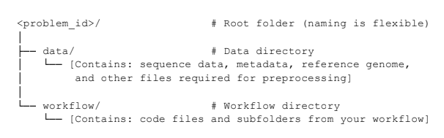
- Provide the rubric
  - This is the answer to each of the questions. Tip: Copy-paste the contents of your answer.yaml file into the “complex criterion breakdown” and it’ll automatically format your rubric. See example below
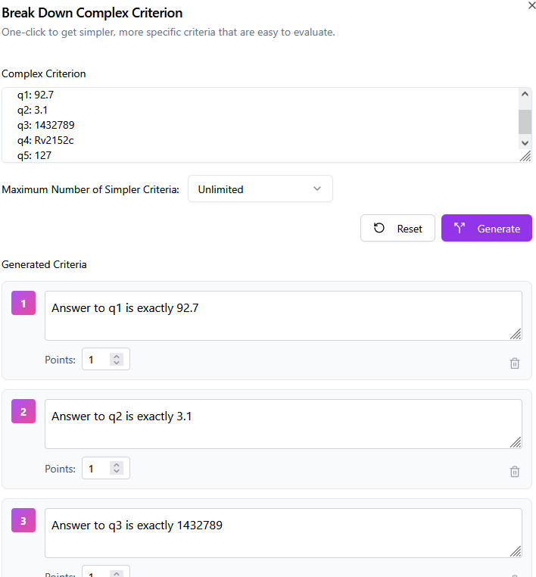
- “Create Problem” and click on “run Problems” to begin the evaluations. Make sure the correct problem version is selected. The default settings should work well!
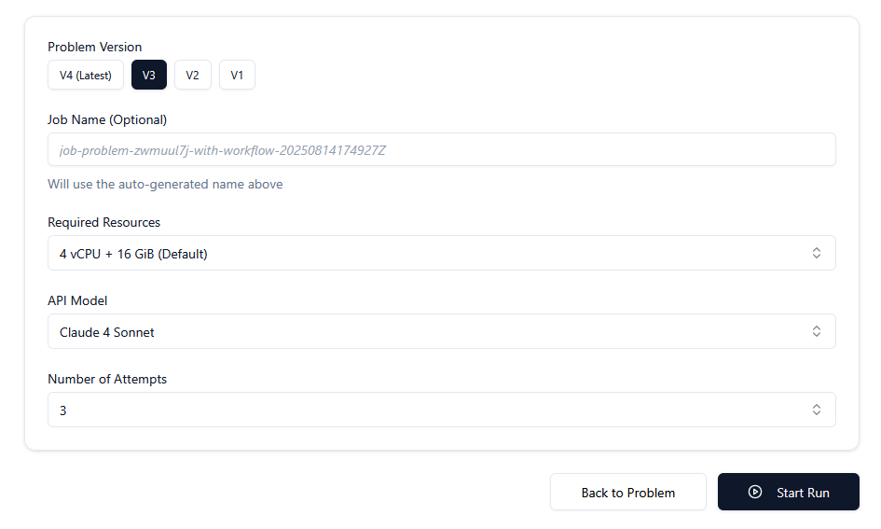
- Reviewing the outputs
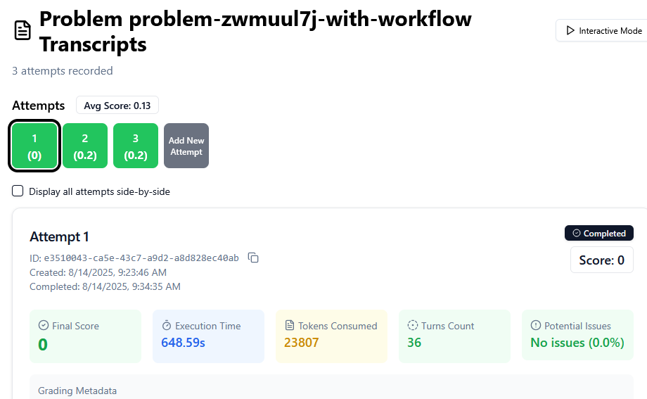
  - The scoring of each attempt is normalized to 1 i.e. a score of 1 is full marks.
  - When you click on one of the attempts, you will see the transcripts. It can be helpful to review these to understand where the prompts may need to change if the model is not getting a full score.
  - Scroll to the bottom of the transcripts to see the final answers from the model
  - You may use interactive mode (button at top right) to prompt the model and understand what the model did

Please notify team leads of any missing configurations and tools needed to run your workflow.

Tips/Debugging
- Check the notes
- Check that Claude is able to access the files. Check the transcripts and one of the first things Claude often does is check the data structure. Provided data is stored in /tmp/files; check that Claude can find the files and the workflow/data. If not, it is likely the data did not upload successfully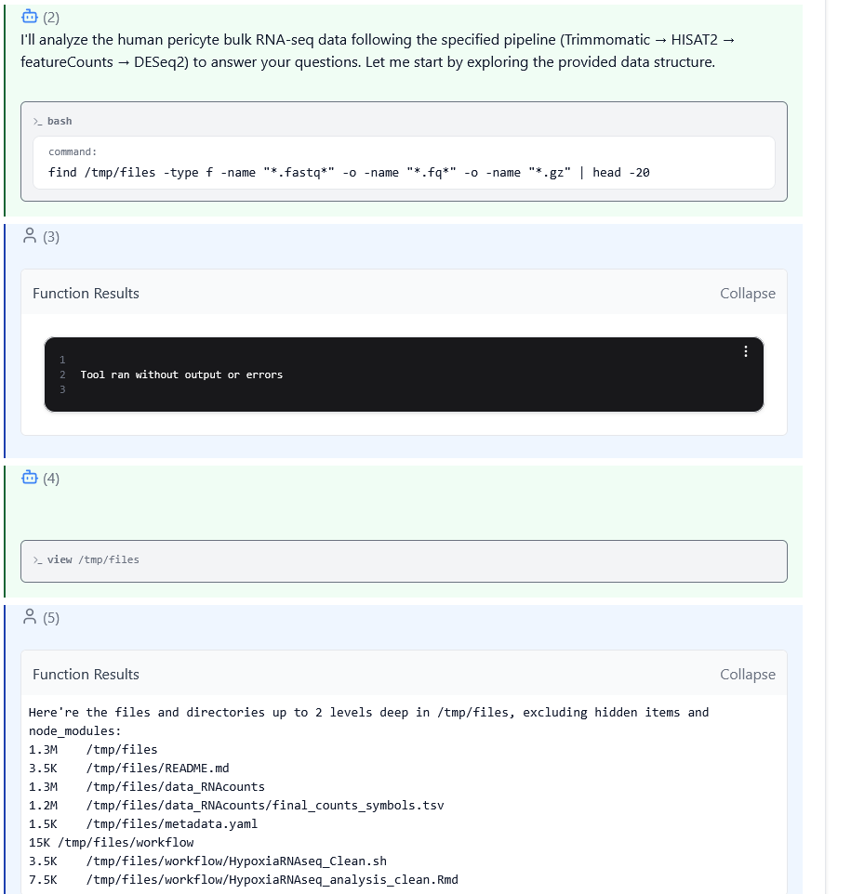
- Check that Claude is able to download the necessary packages/tools in the environment. It’ll try to install the packages using conda, pip, and pip3. If it’s not successful, please inform Jackie or Robi of the missing packages
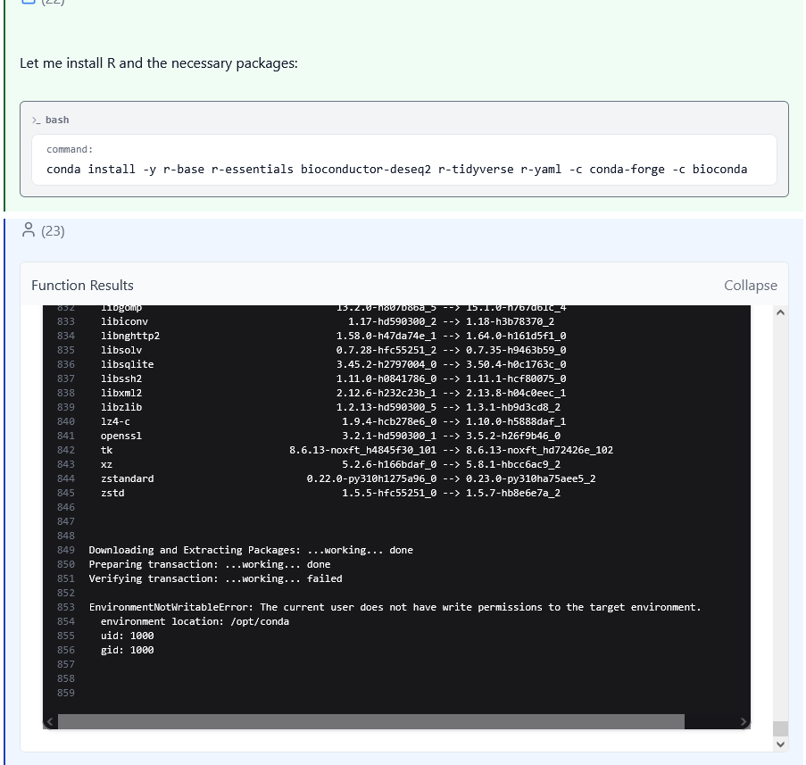

Review Process

WIP

Examples
These are examples provided by the client to drive conceptual alignment. Please adhere to the previously shared question and answer format.

Example 1: Wastewater SARS-CoV-2 Surveillance

Paper: "Tracking cryptic SARS-CoV-2 lineages detected in NYC wastewater" (Smyth et al.,
Nature Communications, 2022)

Task: You have been given raw Illumina sequencing data from a wastewater sample collected in
New York City in January 2022. Using the provided raw FASTQ files:

Questions
- Quality Control: What percentage of reads pass Q30 quality threshold after adapter trimming?
- Host Filtering: How many reads remain after removing human contamination?
- Alignment: What percentage of quality-filtered reads align to the SARS-CoV-2 reference
- genome (NC_045512.2)?
- Variant Calling: Which spike protein mutations occur at >80% frequency?
- Lineage Assignment: Order the cryptic lineages in terms of most to least abundant

Example 2: Hi-C Chromatin Architecture Analysis

Paper: "Chromatin conformation analysis of primary patient tissue using a low input Hi-C
method"

Task: You have been given raw Hi-C sequencing data from mouse embryonic stem cells (ES
cell line E14). Using the provided paired-end FASTQ files:

Questions
- Read Processing: What percentage of read pairs contain valid Hi-C ligation junctions?
- Alignment: How many valid interaction pairs map to chromosome 9?
- Contact Matrix: What is the median interaction distance on chromosome 9?
- TAD Calling: How many TADs are identified on chromosome 9 using a 40kb resolution?
- Loop Detection: What are the genomic coordinates of the strongest chromatin loop involving the FOXE1 promoter?

Example 3: RNA-seq Differential Expression Analysis

Paper: "Transcriptional landscape of drug-tolerant persister cells in Mycobacterium
tuberculosis"
Task: You have been given raw RNA-seq data from Mycobacterium tuberculosis cells comparing
drug-tolerant persister cells to normal growing cells. Using the provided single-end FASTQ files:

Questions
- Quality Control: What percentage of reads have mean quality score >Q25 after adapter removal?
- rRNA Depletion Check: What percentage of reads align to ribosomal RNA genes?
- Alignment: How many reads uniquely map to the H37Rv reference genome?
- Gene Quantification: Which gene has the highest TPM value in the normal growing cell samples?
- Differential Expression: How many genes show >10-fold upregulation in persister cells (FDR<0.01)?

Meetings Notes
8/21:
- If the paper uses a specific version of a tool, how do we account for this?
  - What version of the tools are installed in the docker environment now?
  - AI: JC to extract the version of the tools

8/18:
- Taiga
  - Check transcripts
    - Checking file structure → make sure Claude has access to data files
    - Installing tools → Claude tries using conda and pip to install packages. Make sure that these install properly, if not- please request
      - Configuration should include what tools are needed
    - File size
      - Joao → zipping file, Claude still can’t read
        - Only one attempt managed to access the file, but said it took too long to open the file (note that the file is less than 10GB)
        - Previously, seemingly no file size limit; tried editing and file size restriction came back
    - Submitting a job in general → when running job, it doesn’t save when “create a job” is clicked (seems like the job doesn’t get created)
      - Daria has this issue
    - Parnathi → couldn’t uploading (Mac 15.6), worked when used a different laptop (old version OS 11) and it worked
  - Interface = good; trouble understanding what it does
  - Claude does weird thing where it converts it to a different coding language, or it simulates data
    - Prompting → only use the data found in /data folder and only use the script found in /workflow; do not create any new scripts or synthetic data
      - Joao and Ruslan → Test this
  - Must download data and provide it directly, not give links
  - Tip: click on “Potential Issues: Details” to see a summary of potential issues
- Submission Tracker
  - Project submissions each week
  - Update subdomain
  - Make sure there are no repeat research papers
- Have an example
  - JC to pick one
- Timeline
  - 25 by 8/18
  - 50 by 8/25

8/11:
- H5 RNAseq data (used for fastq) → cellranger
  - JC: Follow-up to make sure h5 is okay. Clarification on distribution of submissions using fastq
- Reproduce: should the focus be on the preprocessing or the actual analysis
- Whole genome sequencing
  - I would select a chromosome
- Can we follow the same workflow but on different subsample/subset?
- It’s okay that the science is not the same as findings in the paper
- Tools → would the AI has access
- Datasize too big?
  - Maybe we can link it to a separate data file/storage
- Nf-Flow → has a good set of starting tools! → maybe this comes standard in the docker environment
- AI: Send me your github email or user tag
- Advice:
  - Need to be precise on how to determine the answers (e.g. which metrics should be used)

