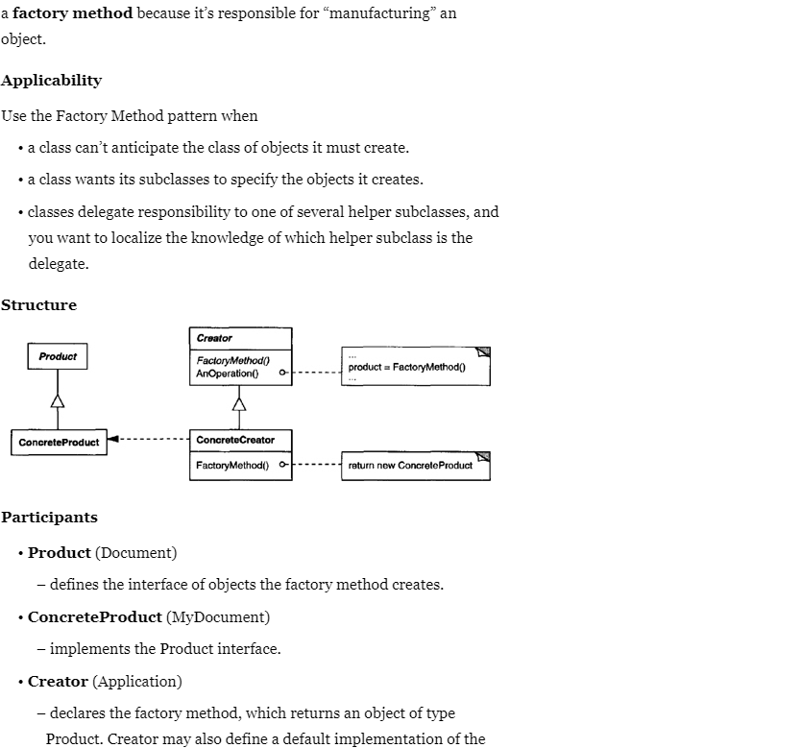

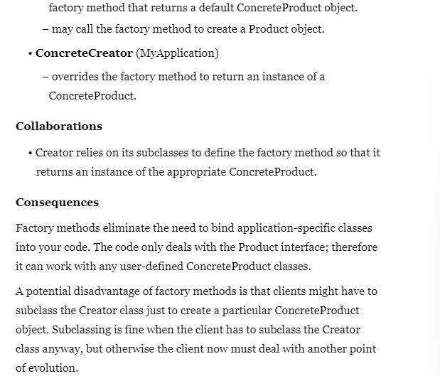

<https://springframework.guru/gang-of-four-design-patterns/factory-method-design-pattern/>