I've done the below test during an interview on Codility:
You are a programmer in a scientific team doing resarch into particles. As an experiment, you have measured the position of a single particle in N equally distributed moments of time. The measurement made in moment k is recorded in array A as A[K]. Now, your job is to count all the periods of time when the movement of the particle doesn't change its velocity: i.e. the difference between any two consecutive position measurements remains in the same. Note that you need at least three measurements to be sure that particle didn't change its velocity.
For example:
1, 3, 5, 7, 9 is stable (velocity is 2)
7, 7, 7, 7 is stable (particle stays in place)
3, -1, -5, -9 is stable (velocity is -4)
0, 1 is not stable (you need at least three measurements)
1, 1, 2, 5, 7 is not stable (velocity changes between measurements)
More formally, your task is to find all the periods of time A[P], A[P+1],..., A[Q] of(length at least 3) during which the movement of the particle is stable. Note that some periods of time might be contained in others (see example test). Write a function:
class Solution {
public int solution(int[] A);
}
That, given array A consisting of N integers representing the results of the measurements, returns the number of periods of the time when the movement of the particle was stable. The function should return -1 if the result exceeds 1,000,000,000. Examples: Given array A = [ -1, 1, 3, 3, 3, 2, 3, 2, 1, 0 ] the function should return 5, because there are five periods during which the movement of the particle is stable, namely: (0,2),(2,4),(6,9),(6,8) and (7,9). Note that the last two periods are contained by (6,9):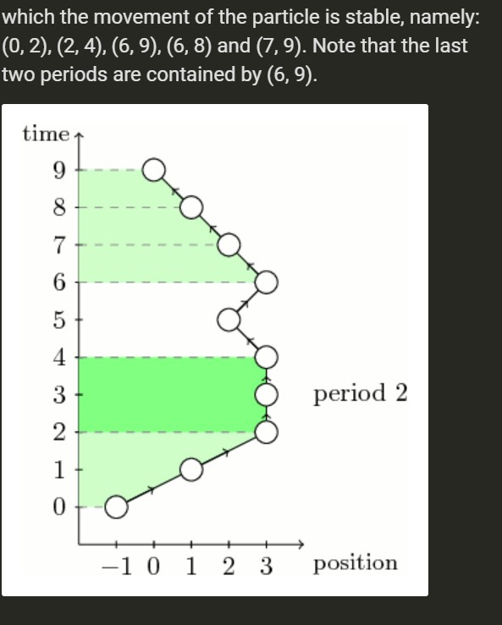
Given A = [2,2, ..., 2] of length 10,000 the function should return 49985001.
So I tried to solve it by dividing it into three parts:
- Looking the difference between the contiguous positions of the particle.
- Checking if the velocity of the particle is constant.
- Checking if period is contained in an another one
- Summation of all periods
below the code of my solution (I can't find a solution for the statement: "The function should return -1 if the result exceeds 1,000,000,000.") :
public int solution(int[] arr) throws Exception {
// System.out.print("arr:\t");
// print(arr);
// System.out.println();

if (arr.length < 3)
return -1;

final int DIFF_LEN = arr.length - 1;
int[] diff = new int[DIFF_LEN]; // difference are
int[] binaryArr = new int[DIFF_LEN - 1];
int[] binaryRecurrence = new int[DIFF_LEN / 2];

// 1 - Start - Finding the difference between the positions of the particle
for (int i = 0; i < DIFF_LEN; i++) {
diff[i] = arr[i] - arr[i + 1];
}

// System.out.print("diff:\t");
// print(diff);
// System.out.println();

// 2 - Analysis of diff array - checking if the velocity of the particle is
// constant.
// I put 1 in an another array if the consecutive
// values are equals: diff[i] == diff[i + 1], similar to something like a
// roll-call
for (int i = 0; i < DIFF_LEN - 1; i++) {
if (diff[i] == diff[i + 1]) {
binaryArr[i] = 1;
}
}
// System.out.print("bin:\t");

// print(binaryArr);
// System.out.println();

// 3 - checking if period is contained in an another one.. I gather all the
// consecutive 1s and summed them up
int count = 0;
binaryRecurrence[count] = 1;
for (int i = 0; i < binaryArr.length - 1; i++) {
if (binaryArr[i] == binaryArr[i + 1] && binaryArr[i] == 1) {
binaryRecurrence[count] += binaryArr[i];
} else if (binaryArr[i] == 1) {
binaryRecurrence[count] += binaryArr[i];
count++;
} else {
// count++;
continue;
}
}

// System.out.print("binary recurrence:\t");
// print(binaryRecurrence);
int n = 0;

/*
summation formula:
∞
∑n = n(n+1)/2
n=1
*/
for (int ele : binaryRecurrence) {
if (ele > 0) {
final int max = ele;
n += max * (1 + max) / 2;

// below doesn't work
// if (exceeds >= 1_000_000_000) {
// return -1;
// }
}
}
return n;
}
The results with int[] arr = { -1, 1, 3, 3, 3, 2, 3, 2, 1, 0 };
arr: -1 1 3 3 3 2 3 2 1 0
diff: -2 -2 0 0 1 -1 1 1 1
bin: 1 0 1 0 0 0 1 1
binary recurrence: 2 1 1 0
periods: 5
It also works with consecutive 10_000 2.
So here to ask you if any ideas to improve it? Any other solutions?
I can't return -1 in case of n > 1_000_000_000 as I wrote above. How can I break and return -1 in case of n > 1_000_000_000?

I haven't done a performance analysis but I did the following:
- First I calculated an array of differences between adjacent terms.
- Then I iterated over them noting where they changed, thus revealing a group of size n.
- Then I realized that the total number of nested groups would be n*(n-1)/2 so I just kept a running sum of those values.
public static int solution(int[] data) {

/*
* Create an array of diffs. If two or more values are equal, that is
* considered a period.
*/
int[] diffs = IntStream.range(0, data.length - 1).map(
i -> data[i] - data[i + 1]).toArray();
/*
* Now simply iterate over the diffs, collecting them into the largest
* periods and Once the boundaries of the largest period have been
* established, simply sum them. The summing process takes into account
* any sub periods.
*/
int d = diffs[0];
int start = 0;
int allPeriods = 0;
for (int i = 1; i < diffs.length; i++) {
if (diffs[i] != d) {
if (i - start > 1) {
int n = i - start;

allPeriods += n * (n - 1) / 2;
}
start = i;
d = diffs[start];
}
}
if (start + 1 < diffs.length) {
int n = diffs.length - start;
allPeriods += n * (n - 1) / 2;
}
return allPeriods;
}
}

